Single-Event Transient Data Classification Using Traditional Statistical Approach and Machine Learning
Sam Teye, Samantha A. Woodward

Abstract—This study explores classifying an experimental dataset of Single Event Transients (SETs) using traditional statistical approaches and machine learning (ML) techniques. These methods are computationally efficient, interpretable, and adaptable to datasets, making them important for initial SET classification and analyses. Traditional statistical approaches, such as thresholding based on the mode and standard deviation, and ML algorithms like k-nearest neighbor (KNN) and k-means clusters are used to identify and classify SETs. Experimental data obtained during radiation testing using an ion-induced SET in an Operational Amplifier (Op-Amp) with Quasi-Bessel Beam (QBB) Pulsed-Laser (PL) are validated. These methods effectively handle noisy and complicated SET data, paving the way for future advancements.

Index Terms- Machine learning (ML), Single-event Transient (SETs), Statistics, k-means clustering, k nearest neighbor (KNN)

INTRODUCTION
The detection and classification of transient radiation effects are critical in radiation environments where sensitive electronics operate, like space environments, nuclear facilities, high altitude aviation or radiation testing labs. Single Event Transient (SET) errors are non-destructive and soft errors [1]. The impact of a single-event particle strike is the generation of a transient signal (SET) that interacts with the legitimate signals propagating through a circuit or disrupts its functionality [2]. The use of supervised machine learning algorithms like KNN investigated by [3], k-means clustering and complex computation has recently been employed to classify and predict SETs. Accurate classification of SET datasets is therefore vital for effectively analyzing these events and ensuring the reliability of microelectronic systems in radiation environments. A traditional statistical approach provides a structured framework, offering reliability and interpretability of the datasets. However, the use of machine learning can yield faster and potentially more reliable outcomes when appropriately optimized.
This study first employs the statistical methodology for classifying transients based on the specific circuit nodes affected by ion-induced SET response within a circuit. The commercial off-the-shelf (COTS) components LM124 Op-Amp was selected as the target device due to the circuit’s numerous transistors with diverse layouts and spatially dependent transient responses [4]. The datasets were obtained
from radiation testing using an ion-induced SET in an Op-Amp

with Quasi-Bessel Beam (QBB) Pulsed-Laser (PL). The
comprehensive dataset provided by the Naval Research Laboratory (NRL), which includes all SET events, is used for the validation of the methodology employed in this study. The dataset has a dimension of (5, 101, 101, 4999), where the first index represents the number of experiments conducted. The second and third indices correspond to the x and y coordinates, respectively, of the evaluated section. Each coordinate pair is associated with a signal, which is represented by the fourth index. This data is illustrated in Figure 11 in the Appendix.
The classification of the data is a crucial element in the analysis of SET datasets. Traditional statistical methods employed in this study were satisfactory in this area due to their ability to manage noise that can be injected into the system by the environment [5], identify anomalies, and discern patterns. These efficient methods are suitable for initial SET analysis. Additionally, they can be computationally less intensive, making them appropriate for real-time applications and resource-constrained environments. Their interpretability allows researchers to make binary classifications of “transient” and “non-transient” regions in the circuit. Furthermore, they provide a solid foundation for integrating advanced methods in later stages of the analysis to make predictions. These methods offer a promising alternative for further classification including leveraging machine learning (ML) algorithms that have the capability to discern statistical patterns and regularities within the data [3].
The use of statistical and machine learning applications in radiation effects is presented in this study. Visualizing transient locations in complex circuits and training ML algorithms to predict them arbitrarily advances these techniques in the field.

METHODOLOGY AND APPROACH

Thresholding Classification
The mathematical concept of thresholding in this approach involves identifying the mode of the entire dataset or each experiment, along with its corresponding standard deviation as illustrated in Fig. 1 and Fig. 2. A non-transient signal with the threshold bounds is showcased in Fig. 1 and a transient signal is shown in Fig. 1 from the first run. For this analysis, the mode was calculated on the entire dataset. This information is subsequently utilized to establish fixed upper and lower threshold bounds. The calculation for the bounds is as follows:
Upper_threshold = mode + k * std_dev
Lower_threshold = mode - k * std_dev
The k value functions as a sensitivity multiplier that requires adjustment for each experiment. A lower k value generates a more sensitive threshold, resulting in tighter bounds, whereas a higher k value leads to less sensitivity and yields looser bounds.
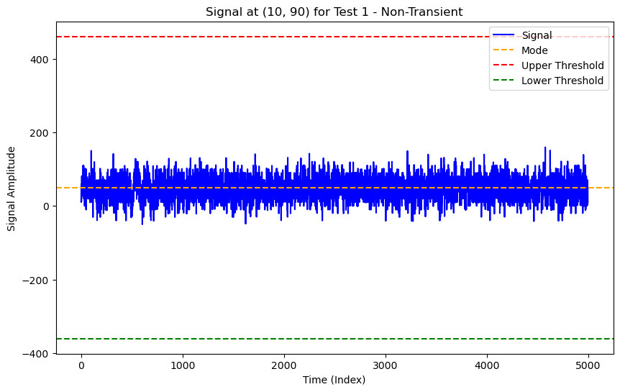
Fig. 1. Non-transient signal at pixel (10,90) for Experiment 1 showing the mode and threshold

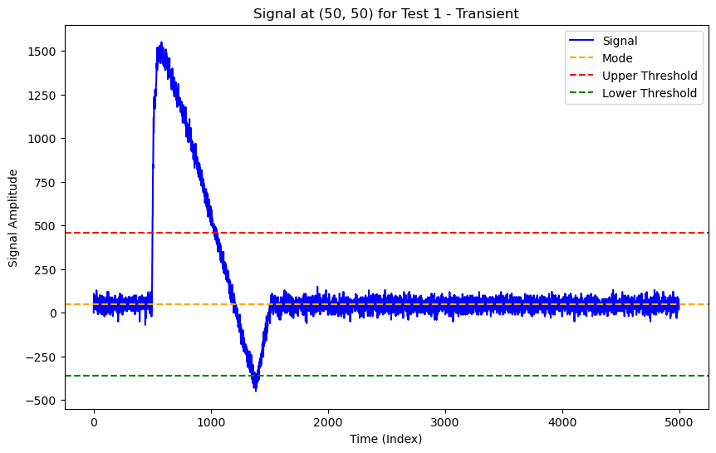
Fig. 2. Transient signal at pixel (50,50) for Experiment 1 showing the mode and threshold

A suitable k value was manually selected, such as 0.5, and subsequently printed as a binary heatmap of the entire experiment. This involves assigning a 1 to transient signals, and 0 to non-transient signals. A transient signal was defined as a signal that exceeded either the lower or upper threshold limits.
The binary heat map, illustrated in Fig.4, was printed with one representing black and zero representing white to classify the datasets. This heatmap was compared to the original data to determine whether the transient regions were comparable. If there were excessive transient classifications, the value of k increased. The opposite was performed if there were insufficient transient detections. To validate these classifications, once visually satisfactory, various signals across the entire experiment were plotted to confirm that the upper and lower bounds were accurately classifying the signals. It is, however, important to acknowledge that achieving 100% accuracy throughout the entire experiment was not feasible due to the substantial number of signals involved. Additionally, there is a possibility of misidentifying some outlier signals using this thresholding approach. The entire process was repeated four times for the dataset with different k values for each test.

Machine Learning Algorithms for Classification
To train a model to predict a signal classification based on signal features, k-nearest neighbors (KNN) was utilized. KNN is a supervised machine learning algorithm used for classification tasks. It extracts features and measures the similarity between signals using distance. Signals closer in the feature space are deemed more similar than those farther apart. KNN was chosen for these classification predictions due to its simplicity and ability to provide meaningful results. The clustering method (k-means) groups signals based on their features, which KNN effectively utilizes to classify new signals.

Training process
The initial phase of the training process entails selecting the training data and determining the optimal k value for clustering. As an illustration, the initial three experiments were trained with k = 7. This clustering k value was determined by testing various k values and visually assessing which one best aligned with the raw heatmap images from the NRL dataset. Fig. 3 illustrates the k-means clustering of the three experiments. It was important to perform clustering only on the training dataset and not the entire dataset. If all the data was clustered and trained on, the model would merely memorize the classifications rather than being able to make predictions. Once clustered on the dataset, each cluster was labeled with “Transient” or “Non-Transient”. The signal counts for each cluster were printed, and the cluster with the highest count was designated as “Non-Transient”. This label was assigned because it represents background noise or signals that may be erroneous. The remaining clusters were labeled as “Transient”.

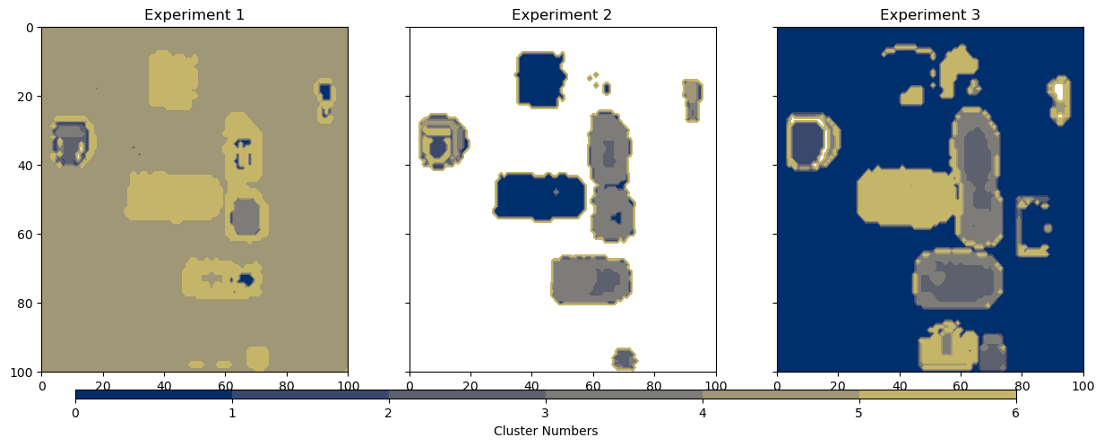
Fig.3. Using k-means clustering to identify patterns and similarities in the dataset for experiments 1-3

Once labeled, the feature extraction phase follows. These features comprise peak amplitude, standard deviation, and the slope. The peak amplitude captures the most significant deviation or spike in the signal. Transients frequently exhibit substantial spikes relative to non-transient signals, rendering peak amplitude a distinguishing feature. Standard deviation quantifies the variability or spread of a signal relative to the mean, indicating the extent of signal fluctuations over time. Transient signals tend to exhibit higher variability due to abrupt changes in amplitude, setting them apart from non-transient signals. The slope of a signal represents its overall trend over time. In contrast, non-transient signals often exhibit minimal overall trends and oscillations around the baseline. The extracted features were derived from the training set, which encompasses experiments 1 - 3. These extracted features were stored as input vectors, and each signal was assigned a label based on the cluster to which it was previously assigned. Transient signals were represented by the sequence of ones and zeros for non-transient signals.
Next, these were partitioned into x and y training sets. The x corresponds to the input feature matrix containing all the extracted features. The y contains the label vector labeled as the classification of the signals. To prepare for training, a StandardScaler was applied to scale the extracted features, ensuring that the features were standardized by removing the mean and scaling the variance to one. This process ensured that the data points had a balanced scale, which was important for models like KNN to avoid dominating the distance calculations due to features with large ranges. Afterwards, the training set, x__{train} and y__{train}, was prepared for training using KKN. Upon successful training, the model was now capable of predicting classifications for new signals.

RESULTS

Mathematical Thresholding
Fig. 4 illustrates the classification results obtained from the mathematical thresholding method applied to the first experiment. The absence of ground truth data impedes the calculation of an accuracy score, which would have provided insights into the performance of this method. Performance was therefore assessed by comparing the binary heatmaps to the corresponding raw data heatmaps. Visually, this method appears to yield satisfactory results, as each transient grouping was correctly classified. Although this method may classify too many signals as transient, the edges surrounding the transient areas may be mistakenly classified, which ultimately falls back on the k value not being the most optimal performance.
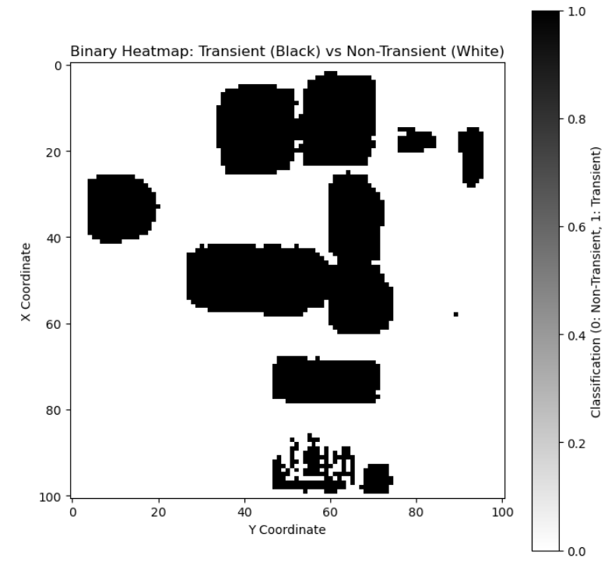
Fig.4. Thresholding method binary heatmap showing transient and non-transient regions for Experiment 1

The k values for these five experiments ranged from 0.4 to 1.1. Notably, the lowest k value appears to be correlated to the number of transient signals observed in each experiment as shown on Table 1 found in the Appendix. Fig. 9 and Fig. 10 show the results for experiment two and three.

KNN Classification
To test the trained KNN model, the predictions were conducted on the fourth and fifth experiment, which involved hardware subjected to higher radiation in the last experiment. Notably, the model demonstrated remarkable accuracy in classifying these signals. The areas with lighter colors on the heatmap had sparse classification by the model as shown in Fig. 5. From Fig. 6, experiment 4’s predictions at the top show this area is sparse, which is inaccurate. There should be more transient classifications in that area. Similarly, the area immediately below exhibits a higher prevalence of transient classifications. Upon examining the predictions in Experiment 5 from Fig. 6, it is notable that some radiation regions on the raw data heatmaps are precisely the same on the predicted heatmap. This observation highlights the performance of the initial training model. The NRL data is right above the predicted heatmap for ease of comparability.

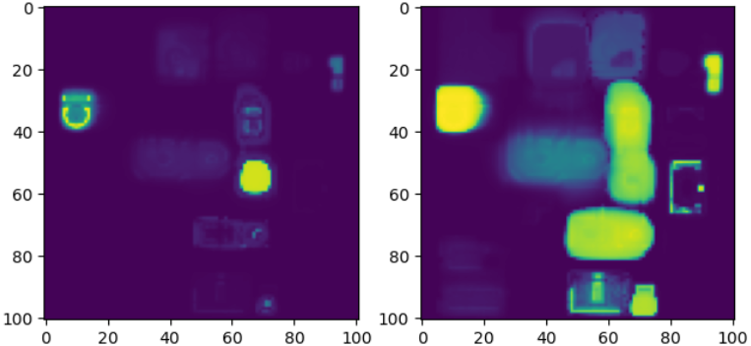Fig. 5: Heatmap of raw dataset illustrating the standard deviation for experiment 4 and 5

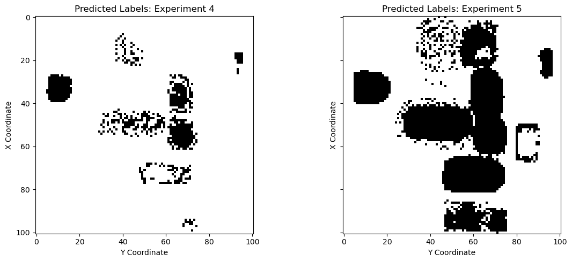
Fig.6. Heatmap showing the classification results from KNN predictions for experiment 4 and 5.

Comparison
Fig. 7 presents a comparison between the thresholding method (left) and the machine learning prediction (right) for the fourth experiment. Fig 8 presents the same comparison for the fifth experiment. Upon examining these two experiments, it becomes evident that the thresholding method yields a higher number of classifications compared to the prediction method. Specifically in the fourth experiment, the thresholding method identified 2,198 transient detections and 8,003 non-transient detections, whereas the prediction method identified 608 transient detections and 9,521 non-transient detections. The machine learning model resulted in a 69% reduction in transient detections compared to the thresholding method. However, it is important to note that these two methods exhibited an 85.1% similarity score. This high similarity score validates both methods and suggests that they are promising approaches for transient classifications.
When analyzing the fifth experiment as shown in Fig 8, there are a significant number of transient signals being detected using the thresholding method. There are two entire sections of transients that were classified at the bottom and top left-hand corner that were not classified using the trained ML method. When visualizing the signals, the corners did contain transient signals, which resulted in a more accurate detection of transient signals by the thresholding method. The thresholding method classified 5,375 signals as transient and 4,826 signals as non-transient. For the machine learning method, there were 2,673 signals predicted as transient and 7,528 signals as non-transient. The machine learning method resulted in 50.29% fewer transient detections with a 73.51% similarity score to the thresholding method. The current similarity score is lower than the previous one, indicating a discrepancy in the classification of smaller transient detections. 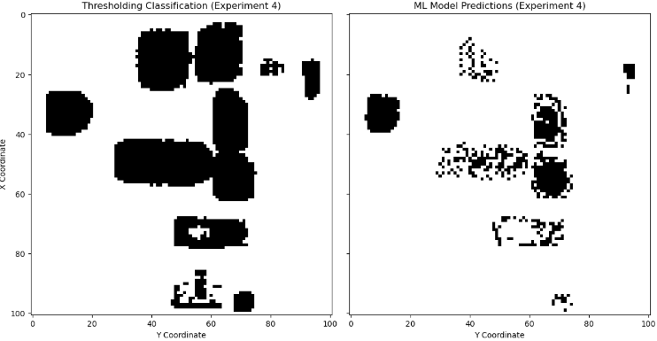
Fig. 7. Methodological Comparison of experiment 4

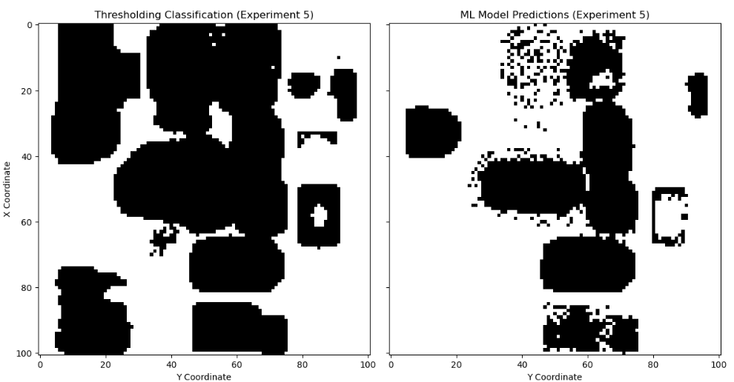
Fig. 8. Methodological Comparison of Experiment 5

CHALLENGES
The initial statistical analysis of the data obtained yielded limited comprehension, particularly when interpreting intricate patterns. For each pixel (x, y), the mode was initially computed, but this value fluctuated across each experiment (1, 2…5), resulting in inconsistent results. This inconsistency rendered it challenging to establish a reliable baseline for subsequent analysis. Identifying the mode for the entire dataset and determining the standard deviation for thresholding proved to be a more effective approach in classifying transient and non-transient regions.
The ambiguity between noise and small transients presented another challenge. Initial noise may represent subtle transient events. Advanced computational techniques will be needed to validate and reclassify the data in such regions. Improved statistical methods and integration of ML algorithms will be required for better data handling and preprocessing.

V. FUTURE OPPORTUNITIES

Thresholding Method
Future endeavors should prioritize enhancing these methods to facilitate a more reliable distinction between noise and low-intensity transient signals by finding the most optimal k value. Furthermore, investigating alternative statistical methodologies might be necessary for deriving more accurate and interpretable conclusions from the data.
The mode thresholding approach requires enhancement in certain aspects concerning the k value. The k value, determined after identifying the mode and standard deviation, influences the sensitivity of the bounds. It should be manually selected through visual inspection to guarantee that it captures transient signals effectively. The current k values may not be optimal. To select the most suitable k value, the signals at the boundaries of apparent transient values should be printed along with their bounds to determine how they would be classified based on the current parameters. If necessary, the parameters may need to be adjusted. It is possible that the current parameters are classifying too many signals within the transient regions.

Machine Learning Methodology
Several areas for improvement exist in the machine learning method. A 60% training and 40% testing split was utilized for training. Increasing the training data could potentially yield more accurate results. The k-value for clustering could have been further optimized as well. While the k-value of seven appeared to include more transient signals compared to five and four, it may have over-classified signals, particularly near the edges of the transient sections. Given the absence of ground truth data, the optimal cluster value could not be confidently and accurately determined. To select the most optimal k-value, each signal within the clusters should be reviewed to ensure proper separation of transient and non-transient signals. After confirmation of the correct cluster groupings, accurate cluster labels could also be confirmed. Labels were assigned based on the assumption that the largest cluster, representing the background, would be non-transient, while the remaining clusters would be transient. If time constraints were not a concern, these steps could be performed meticulously to ensure the acquisition of accurate training data for the model.
Several models can be explored to evaluate their performance for prediction. Convolutional Neural Networks (CNNs) would be an optimal model to test after optimizing the KNN model to enhance its accuracy. CNNs excel at processing complex data and can automatically extract features from raw signals.

Preprocessing as the initial step

Cleaning the Dataset: By identifying anomalous data points in a dataset of SET amplitudes, one can focus on meaningful events rather than noise through the system.

Noise Reduction: Noise can be a pervasive issue in SET data. Statistical methods like averaging help distinguish noise from meaningful signal patterns, ensuring cleaner datasets for further analysis.

Classification: A machine learning algorithm like k-means clustering and KNN can be adapted to identify patterns and similarities in the data which can be useful for further analysis and interpretation.

Analyzing Clusters: One can group SETs into clusters reflecting similar behaviors like high-energy events or repeated transient shapes.
Clustering unsupervised ML algorithms are suitable to be applied to remove noise events without the support of traditional techniques since they do not need previously analyzed samples once they use features such as mean and standard deviation of the input data to classify it by its similarities [6]. Extracting meaningful features in the dataset is important for characterizing SETs. Additionally, peak detection algorithms can identify the amplitude and duration of transient events, which are critical parameters for assessing their impact on microelectronic systems.

CONCLUSION
Classification of SET datasets from experimental work was crucial for our analysis. Traditional statistical methods are reliable, interpretable, and efficient for addressing challenges in analyzing radiation testing experiment data. They enable researchers to extract meaningful features and uncover patterns in SET behavior, improving the resilience of microelectronic systems in radiation environments. By integrating ML algorithms such as k-means clustering and KNN, we successfully classified the SETs. k-means clustering grouped similar transient events based on characteristics like amplitude, identifying patterns, isolating noise, and distinguishing between low-intensity and significant events. KNN classified the transient events based on their proximity to labeled examples, identifying patterns, distinguishing noise from significant events, and categorizing transients into predefined classes.
Future research can concentrate on identifying additional features that can enhance the effectiveness of the clustering algorithms. These techniques can subsequently be applied to a broader spectrum of circuits. Combining traditional statistical methods and machine learning techniques can lead to more precise and automated SET data classification and this combination can improve the classification process, identify subtle transient events, and provide more meaningful interpretations of radiation impact on microelectronic systems.

REFERENCES
[1] A. Balakrishnan, T. Lange, M. Glorieux, D. Alexandrescu, and M. Jenihhin, “Modeling gate-level abstraction hierarchy using graph convolutional neural networks to predict functional de-rating factors,” in Proc. NASA/ESA Conf. Adapt. Hardw. Syst. (AHS), Jul. 2019, pp. 72–78.
[2] T. D. Loveless, D. R. Reising, J. C. Cancelleri, L. W. Massengill, and D. Mcmorrow, “Analysis of single-event transients (SETs) using machine learning (ML) and ionizing radiation effects spectroscopy (IRES),” IEEE Trans. Nucl. Sci., vol. 68, no. 8, pp. 1600–1606, Aug. 2021.
[3] T. Peyton et al., "Supervised Deep Learning and Classification of Single-Event Transients," in IEEE Transactions on Nuclear Science, vol. 70, no. 8, pp. 1740-1746, Aug. 2023, doi: 10.1109/TNS.2023.3268987
[4] J. M. Hales, A. Ildefonso, S. P. Buchner, A. Khachatrian, G. Allen and D. McMorrow, "Quantitative Prediction of Ion-Induced Single-Event Transients in an Operational Amplifier Using a Quasi-Bessel Beam Pulsed-Laser Approach," in IEEE Transactions on Nuclear Science, vol. 70, no. 4, pp. 354-362, April 2023, doi: 10.1109/TNS.2022.3232724.
[5] J. L. Carpenter et al., "Analysis of Single Event Transients in Arbitrary Waveforms Using Statistical Window Analysis," in IEEE Transactions on Nuclear Science, vol. 70, no. 4, pp. 478-485, April 2023, doi:10.1109/TNS.2023.3243496.
[6] Paula R.P. Allegro, Dennis L. Toufen, Vitor A.P. Aguiar, Lucas S.A. dos Santos, William N. de Oliveira, Nemitala Added, Nilberto H. Medina, Eduardo L.A. Macchione, Saulo G. Alberton, Marcilei A. Guazzelli, Marco A.A. Melo, Juliano A. Oliveira, Unsupervised machine learning application to identify single-event transients (SETs) from noise events in MOSFET transistor ionizing radiation effects, Microelectronics Reliability, Volume 142, 2023, 114916, ISSN 0026-2714, https://doi.org/10.1016/j.microrel.2023.114916.

APPENDIX
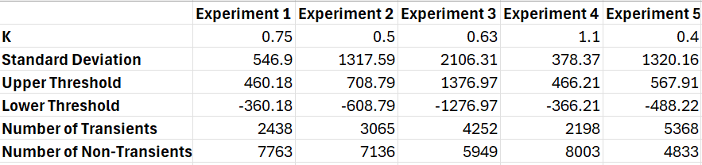
Table 1, Upper and lower thresholds, classification distribution, k value, and standard deviation for each experiment.
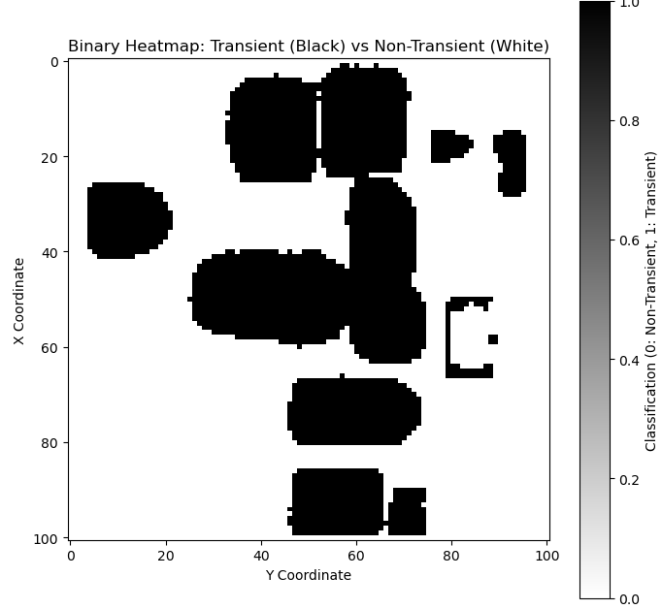

Fig. 9. Binary Classification using thresholding method for Experiment 2
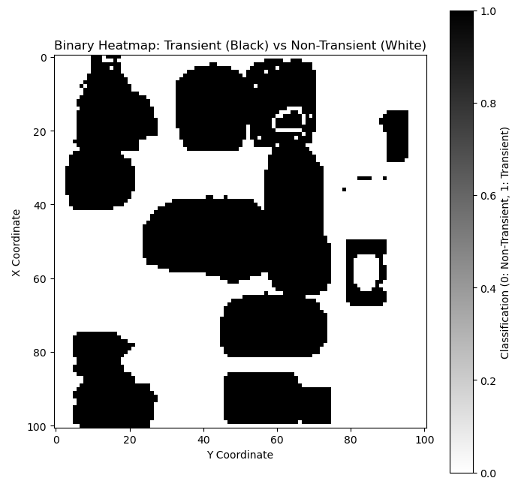
Fig. 10. Binary Classification using thresholding method for Experiment 3

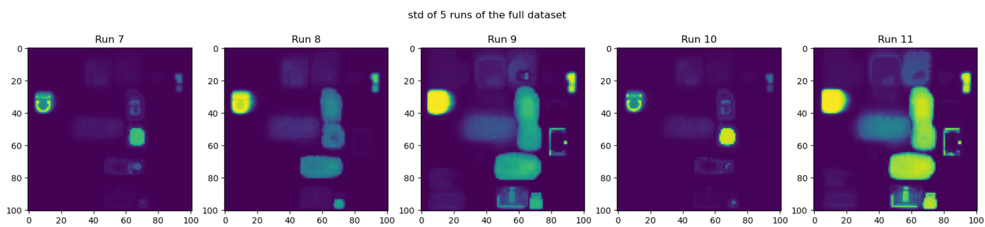
Fig. 11. Standard deviation of NRL data

