**Building Application**

Extract zip file and open CarpoolApp solution file in visual studio.

Build Solution

**Deploying Database:**

Application uses Entity Framework with Code First approach with Automatic Migration as false.

Create New Database CarpoolModel in SQL Server

Add connection string in web.config

<connectionStrings>

<add name="CarpoolModel" connectionString="<<Your connection string>>" providerName="System.Data.SqlClient" />

</connectionStrings>

Open Package Manager Console.

Select CarpoolApp.Model for Default Project.

Run the **Update-Database** command to deploy database.

**Building JS Application:**

All third party js files are already included in scripts/vendor folder.  
If it is empty, it can be downloaded using following commands CarpoolApp.Web project

Npm install  
Bower install  
Gulp build

Once these are run successfully, application can be run from VisualStudio

**Note:**To run above command, node.js, git and bower should be present on machine.

**Use Case:**

**Login:**

User Name: Test

Password: ABCD

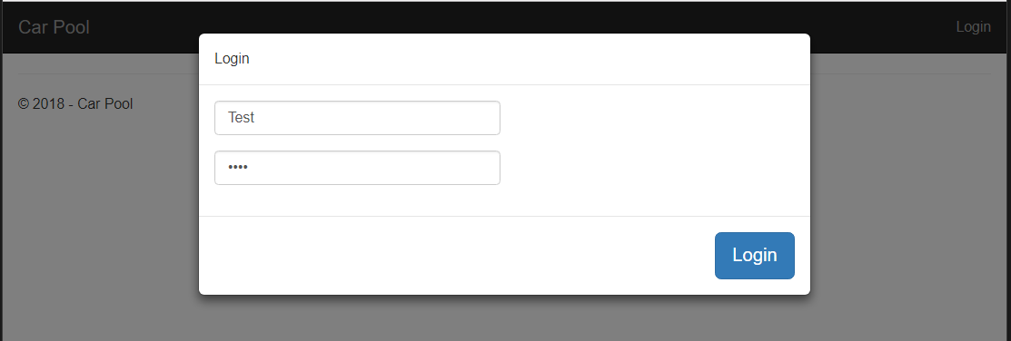

**My Cars:**

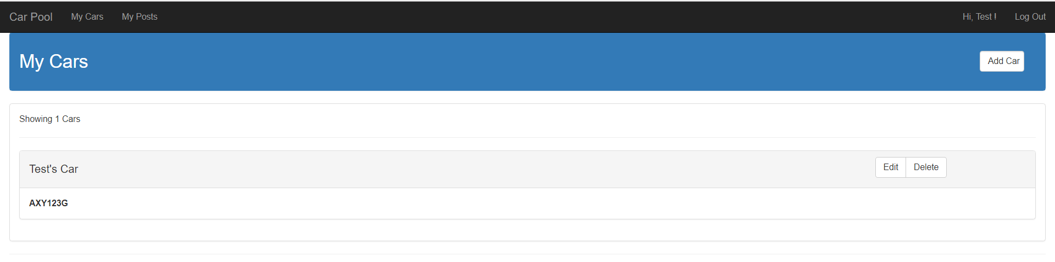

1. Add Car

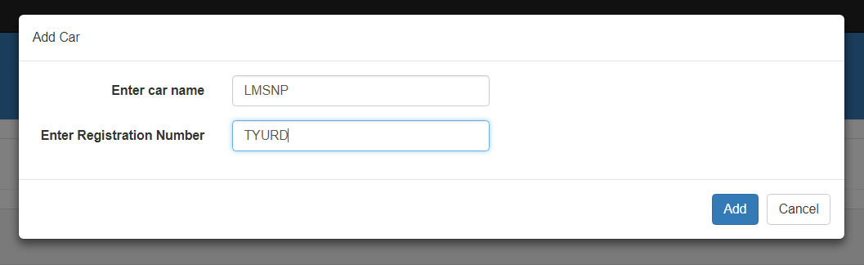

1. Edit Car

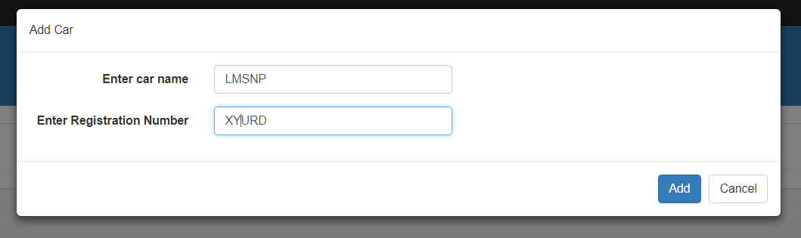

1. Delete Car

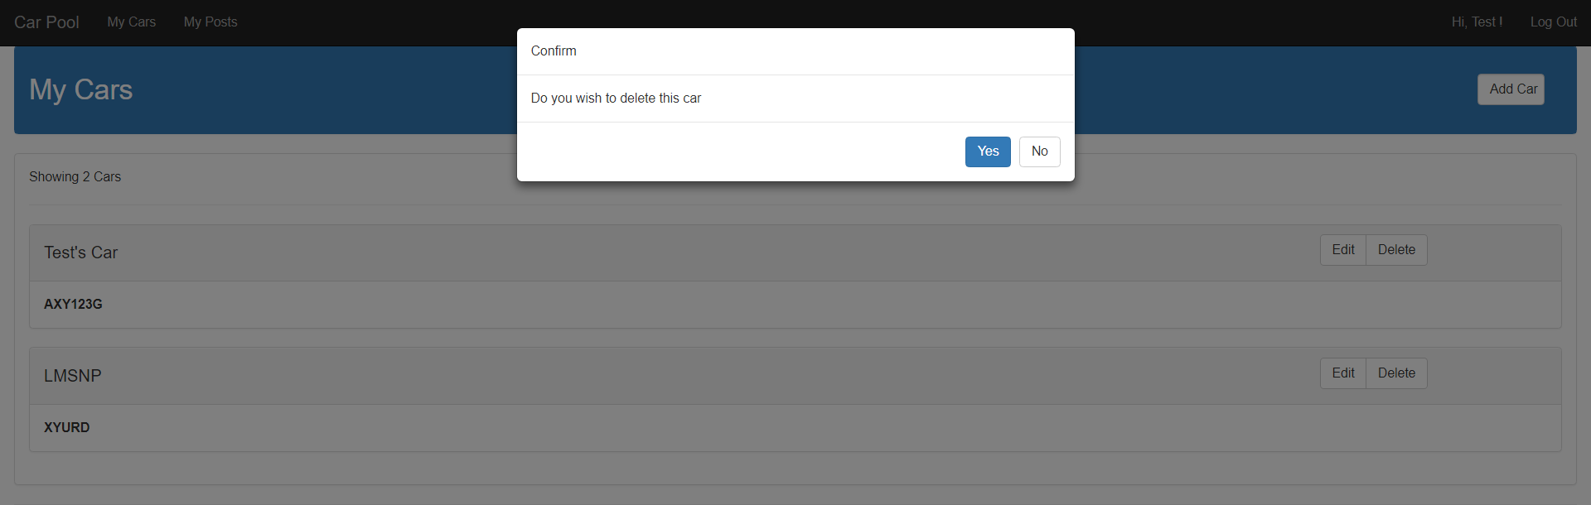

**My Posts**

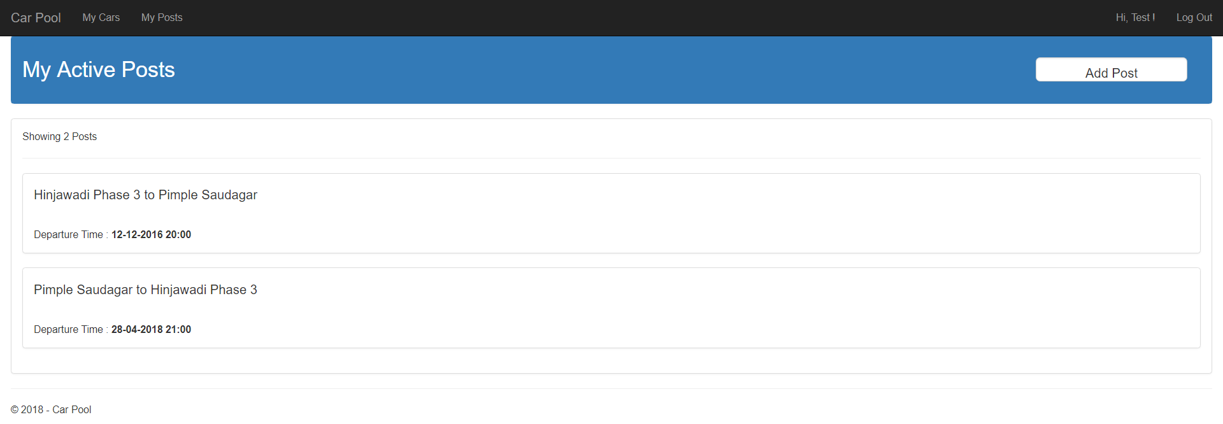

1. Add Post

