

**Department of Computer Science & Engineering**

**Jatiya Kabi Kazi Nazrul Islam,Trishal**

A Project Report on

**ATM MACHINE SYSTEM**

**Course title:** Software Development II

**Course Code:** CSE 200

**Submitted by**

Sadia Afrin Urmi

Roll: 18102038

Mst. Shahnaj Parvin

Roll:18102040

**Supervised By:**

Rubya Shaharin

Assistant professor

Dept. of CSE, JKKNIU

**Submission Date:** 24/02/2020.

**CANDIDATE’S DECLARATION**

We declare that this project is our own work and has not been submitted in any other form for another degree or diploma at any university of other institute of tertiary education. Information derived from the published and unpublished work of others has been acknowledged in the text and a list of references is given.

Date: Name and Signature of the Candidates:

.............................................

Sadia Afrin Urmi

.............................................

Mst.Shahnaj Parvin

**Certification**

The undersigned have examined the report entitled “**ATM Machine System**” presented by **Sadia Afrin Urmi & Mst. Shahnaj Parvin**, for the course CSE-200 (Software Development Project-II) and hereby certify that it is worthy of acceptance.

Date Advisor’s signature

.

some basic knowledge of “Java Programming Language”. At the same time, he gave me

**Acknowledgement**

A project is a golden opportunity for learning and self-development. Many people  
deserve our cordial thanks for their help in completing this project. First and  
foremost, we would like to thank our honorable Supervisor Rubya Shahrin,  
Assistant Professor, Dept. of CSE, JKKNIU who is so dedicated to help us in our  
times of need. We are really honored to make this project under her guidance that  
provides us her valuable time and knowledge, motivating thought and  
encouragement.

We wish to express thanks to **Dr. Mst. Jannatul Ferdous**, Head, Department of Computer Science & Engineering, Jatiya Kabi Kazi Nazrul Islam University for providing us lab opportunities with lab materials related to our project work.

Finally, we express our thanks to the Department of Computer Science and Engineering for giving us the opportunity to study here and supporting us greatly.

**Abstract**

This report attempts to understand the design of like as an Automated Teller Machine (ATM) system, a device used by users to process account transactions. In our project user can easily withdraw their needed money. They also deposit their money in our project, deposit slot allows that user to deposit to their bank account. If user want to withdraw or deposit their money, they must enter correct password. We also create bank account for interested customer in our project. Every customer or user identify their bank account with their details like user’s name and password.

|  |  |  |  |
| --- | --- | --- | --- |
| **CHAPTER N0.** |  | **Table of Contents**  **Topics** | **Page No.** |
|  |  | Acknowledgement. | iv |
|  |  | Abstract | v |
| **01** |  | INTRODUCTION | vii |
|  | 1.1 | Introduction | vii |
|  | 1.2 | Purpose of the Proposed System | vii |
| **02** |  | SYSTEM SPECIFICATION | ix |
|  | 2.1 | Hardware Requirements | ix |
|  | 2.2 | Software Requirements | ix |
|  | 2.2 | Display Mode | ix |
| **03** |  | PROJECT DESCRIPTION | x |
|  | 3.1 | Need for the software | x |
|  | 3.2 | Problem Description | x |
| **04** |  | SYSTEM STUDY AND ANALYSIS | 1 |
|  | 4.1 | Proposed System | 1 |
|  | 4.2 | System Analysis | 1 |
|  | 4.3 | System Planning | 1 |
|  | 4.4 | Feasibility Study | 2 |
| **05** |  | METHODOLOGY | 3 |
|  | 5.1 | Methodology | 3 |
|  | 5.2 | Methodological steps | 3 |
|  | 5.3 | Flow chart | 4 |
| **06** |  | Result and Discussion | 5 |
|  | 6.1 | Result | 5 |
|  | 6.2 | Discussion | 7 |
| **07** |  | CONCLUSION | 8 |
|  | 7.1 | Limitation | 8 |
|  | 7.2 | Future scope | 8 |
|  |  | **REFERENCES** | 9 |

**CHAPTER 1**

**INTRODUCTION**

* 1. Introduction

This assignment is based on developing an ATM (Automated Teller machine) using “Java

This assignment is based on developing an ATM (Automated Teller machine) using “Java Programming Language”. For that we used GUI (Graphical User Interface) in this development so that it will become more users friendly to interact.

Besides, we also added text files for user’s records that are directly linked with this program. It is so called a heart of this program where all the functions depend on it.

The automated teller machine (ATM) is an automatic banking machine (ABM) which allows customer to complete basic transactions without any help of bank representatives. There are two types of automated teller machine (ATMs). The basic one allows the customer to only draw cash and receive a report of the account balance. Another one is a more complex machine which accepts the deposit, provides credit card payment facilities and reports account information.

## **Background Study**

In this system, we can easily create account .After creating account ,user can deposit their balance click deposit button,they also withdraw their needed money after click withdraw button. It’s easy to operate and understand by users. To prevent unauthorized transactions, a personal identification number (PIN) must also be entered by the user using a keypad. The computer then permits the ATM to complete the transaction; most machines can dispense cash, accept deposits, transfer funds, and provide information on account balances.

## The design is so simple that user won’t find it difficult to use and navigate.On the basis of our country demand many software based company ,university used ATM system for their own demand. ATMs are convenient, allowing consumers to perform quick, self-serve transactions from everyday banking like deposits and withdrawals to more complex transactions like bill payments and transfers.

we can execute this program in to download the IDE (Integrated Development Environment) on our system. We can download NETBEANS depending on the windows (32bit/64bit).

* 1. Purpose of the Proposed System

An automated teller machine (ATM) is an electronic telecommunications device that enables customers of financial institutions to perform financial transactions, such as cash withdrawals, deposits, funds transfers, or account information inquiries, at any time and without the need for direct interaction with bank staff.

**ORGANIZATION OF THIS PROJECT**

This report is organized in seven chapters. The introductory information of the project work have already discussed in this chapter.

**CHAPTER 1: INTRODUCTION**

This chapter introduces what the project is and how it can help us. We also include this chapter background study and proposed system.

**CHAPTER 2: SYSTEM SPECIFICATION**

In this section, we have to try to describe system specification of this project.

**CHAPTER 3: PROJECT DESCRIPTION**

This chapter contains description of atm machine system like need for the software and problem description.

**CHAPTER 4: SYSTEM STUDY AND ANALYSIS**

The content of this chapter is about system study and analysis.

**CHAPTER 5: METHODOLOGY**

This chapter contains the methodological steps which have used for implementing this system.

**CHAPTER 6: RESULT & DISCUSSION**

This section is described and shown the final output of ATM Machine System.

**CHAPTER 7:** CONCLUSION

This section is described limitations and future scope.

**CHAPTER 2**

**SYSTEM SPECIFICATION**

**2.1. Hardware Requirements:**

1. Processor                     – Pentium 4
2. RAM                           – 1 GB
3. Hard Disk                    – 40GB
4. Mouse                          – Standard Mouse
5. Keyboard                     – Logitech Keyboard
6. Processor Speed          – 2.4GHZ

**2.2. Software Requirements:**

1. Operating System                     – Microsoft Windows XP With Service Pack 2
2. Front-End                                – Microsoft Visual Studio 2005
3. Back-End                                 – Microsoft Access 2003

**2.3. Display Mode:**

1. Color Quality                            – Highest[32 bit]
2. Screen Resolution                     – 1024 by 768 Pixel

**CHAPTER 3**

**PROJECT DESCRIPTION**

**3.1 Need For The Software:**

Now a days every one very busy in their work.  So they feel that the job must be easier so the system is used to reduce their work which is done in the ATM system.  Instead of keeping lots of paper into a record or file and it may be missed somewhere so, this system help to keep the record of the customer it also keeps the details of he customer.  It is also easy to access.

**3.2 Problem description :**

The system mainly used by the bank clients.  When a client comes to ATM center to update and delete their account.  It reduces the time consumption and lot of paperwork.  For any single operation it involves numerous references and updating also takes subsequent changes in other places.

Besides, we also added text files for user’s records that

**CHAPTER 4**

**SYSTEM STUDY AND ANALYSIS**

**4.1 Proposed System:**

The system customer transactions, satisfies the requirements of the existing system in full-fledged manner.  Through this system, customer can make fast transactions and view the last transactions easily.

**4.2 System Analysis:**

Understand the problem before the system to create analysis model there is a tendency to rush to a solution, even before the problem is understood.

Record the origin of and the reason for every requirement.  This is the first step-in establishing traceability back to the customer.

Use multiple views of requirements building data, functional and behavioral models provide the software engineer with three different views.  This reduces the likelihood that something will be missed and increases the likelihood that inconsistency will be recognized.

Rank requirements.  Tight deadlines may preclude the implementation of every software requirements to be delivered in the first increment must be identified.

Work to eliminate ambiguity because most requirements are described in a natural language, the opportunity for ambiguity abounds.

**4.3. System planning:**

i.  Analysis principles are applied and a model of the software to be build called a planning (prototype) is constructed for customer and developer assessment.

ii. The close-ended approach is often called throwaway prototyping using this approach a prototype serves solely as a rough demonstration of requirements it is then discarded and the software is engineered using a different paradigm.

iii.  An open-ended approach, called evolutionary prototyping uses the prototype as the first part of an analysis activity that will be continued into design and construction the prototype of the software is the first evolution of the finished system.

**4.4 Feasibility Study:**

Technology:

This system is technically feasible, because the system activated by computers and recent technology.  We use client / server technology which is powerful and very user friendly.

Finance:

It is financially feasible.  There is no need of spending over money.  Mainly this system constructed by existing devices only.  Since we use visual studio dot net as a front-end it was most power-full, small and portable across platforms and operating systems both at the source and at the binary level.  This project reduces the number of workers wage also.

Time:

This system really time-to-market beat the competition.  Because the system developed with in a time span and worked based on time event.  The time taken to access the account is very less and avoids unnecessary waiting that was in the traditional system.  Although it uses less time but its performance is very well.

Resources:

This system will use the well known resources.  Where there is no need of any special kind of resource.  It uses only the required databases, tables only.

**CHAPTER 5**

**METHODOLOGY**

**5.1 Methodology:**

In our project, we means methodology how to work our project step by step in transaction process. It helps every user to understand how they can access or use this system easily. It also gives clear reflection for every users about our project.

**5.2 Methodological steps:**

1.When we start this system, we must log in by giving pin number.

2.Then it shows main menu in the monitor, where balance check, withdraw, deposit are existing there.

3.User can easily withdraw or deposit balance by using this system.

**5.3 Flowchart:**



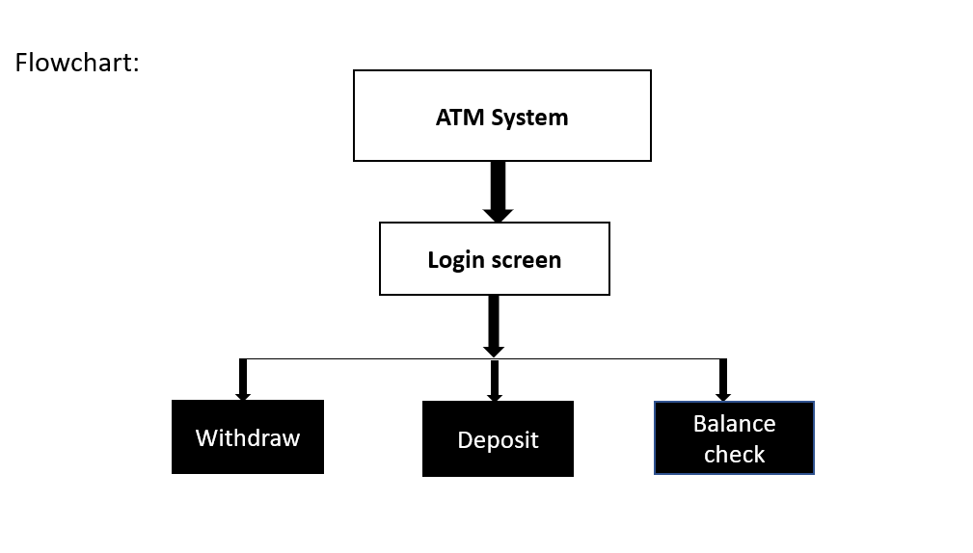

**CHAPTER 6**

**RESULT & DISCUSSION**

**6.1 Result:**

Execution Procedures:

When user executes this program it will show the successful output, that is:

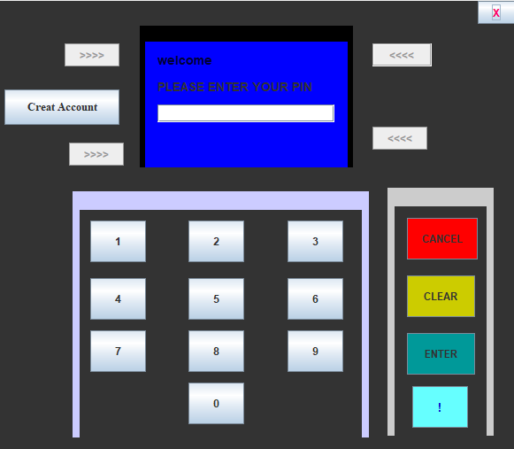

When user executes this program it will show the details (username, password and current balance) from the text file in the console. We will also see the startup GUI (Graphical User Interface) of this program.

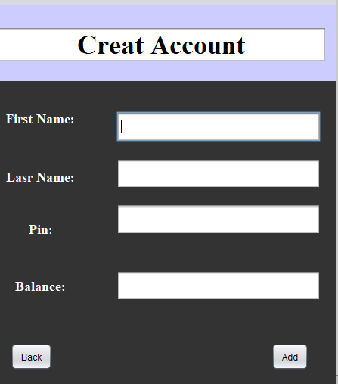

When we create account successfully,it will show:

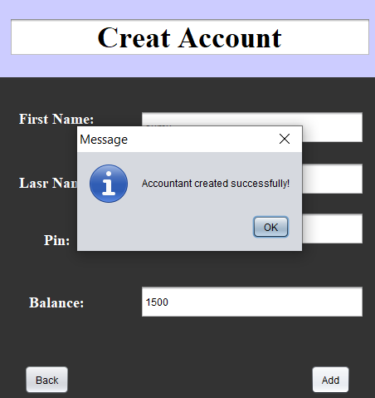

When user click the button “USERS” it will show the new GUI for entering their registered

When user click the button “USERS” it will show the new GUI for entering their registered

When we create account it will show the new GUI for entering password. We need to enter the correct password.

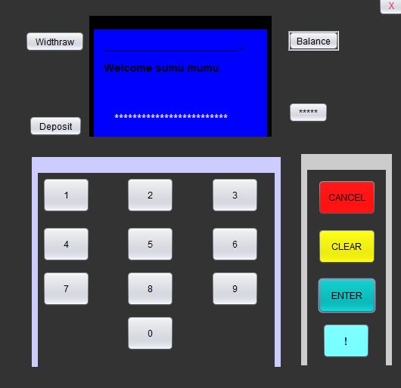

If we enter invalid password the system will show the warning message.

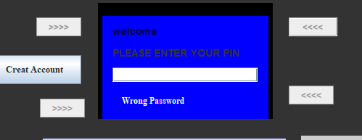

When users click the button “BALANCE”, it will show their current balance.

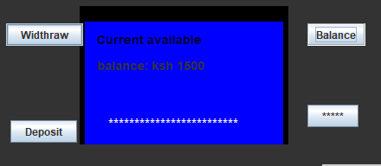

To withdraw from our account, click on the button “WITHDRAW”. It will pop out new withdraw screen where user need to key in the total amount to withdraw from our account.

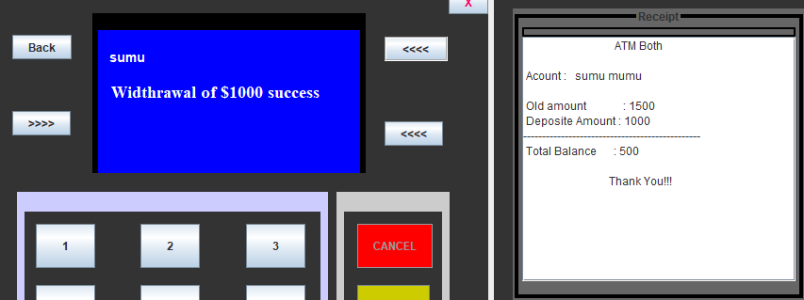

To deposit into the account click on the button “DEPOSIT”. It will show a deposit GUI on the

To deposit into the account click on the button “DEPOSIT”. It will show a deposit GUI on the screen. We need to enter the amount to deposit into our account.

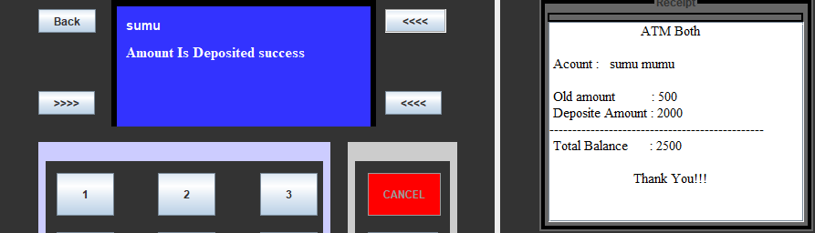

6.2 Discussion:

We see here our project perfectly working. It not works for card punch but it work  
for card number as pin. To use an ATM, consumers need to have a debit or credit

card, and a personal identification number.

**CHAPTER** 7

CONCLUSION

7.1 Limitation:

### • We can’t change pin in this project.

• We can’t provide security process in this project.

• We can’t use magnetic card reader in this project.

7.2 Future Scope:

Provides customer to:

• Change pin.

• Secure

• Magnetic card.

7.3 Conclusion

From this presentation, one can observe that an ATM system is associated with the bank transactions of the consumers.Majorly, the ATM system is utilized for the money associated transactions from the consumers.

In this project we can’t change pin ,provide security process and use magnetic card reader. In future we can provides customer to change pin,secure and magnetic card.

References

[1]Java: The Complete Reference,Ninth-Editon,Written by Herbert Schildt

[2]https://github.com/topics/java-swing-applications

[3] <https://www.elprocus.com/automatic-teller-machine-types-working-advantages/>