Auckland Seventh-Day Adventist High School | 

Digital Technologies Internal Assessment
Achievement Standard ASG1G03 and ASG1G07

Standard Title:  AS91903 AS91907 | Use complex techniques to develop a digital outcome (4 credits)  Use complex processes to develop a digital technologies outcome (6 credits)
Credits | 10 | Level | 3 | Assessment | Internal
Reference | Digital Technologies | Hangarau Matihiko 3.8

Achieved (A)/ Paetae | Merit (M)/ Kaiaka | Excellent (E)/Kairangi
Use complex processes and techniques to develop a digital technologies outcome | Use complex processes and techniques to develop an informed digital technologies  outcome | Use complex processes techniques to develop a refined digital technologies outcome

Level of performance: | Achieve

Authenticity Statement
Student: I understand that the work I submit for this assessment must be my own. I understand that if it was appropriate to source information, it must be acknowledged appropriately. I understand that I may be required to identify my sources if there is any question about the authenticity of this work. I have acknowledged that plagiarism and/or collusion will result in disciplinary action, which may make me ineligible for a grade in this standard.

Student Name: | Lilieta Bloomfield | Whanau Class: | 13SO

Auckland Seventh-Day Adventist High School

Introduction/Kupu Arataki
This assessment activity requires you to plan and create a website with a well-designed homepage and multiple pages. You will be assessed on the iterative improvements made throughout the development and testing process, as well as your use of efficient tools and techniques in producing the final outcome.

Task/ Hei Mahi
You are tasked with creating a multi-page website on a theme that you care about, such as the environment, youth mental health, developing safer communities, careers, culture, and heritage. The website must include a well-designed homepage, multiple pages with relevant content, and follow website design conventions for readability and navigation. You will use complex tools and techniques, such as custom code or third-party libraries, while ensuring the site is responsive and optimized for web use. Throughout the process, you must identify the purpose and target users, apply testing procedures, and iteratively improve the site based on feedback. Additionally, you will address relevant implications, including legal, ethical, and accessibility considerations, and provide evidence of your testing and improvements, such as screenshots or screencasts. The outcome should demonstrate efficient use of tools, thoughtful design, and adherence to web standards.

Auckland Seventh-Day Adventist High School | 

Use complex processes and techniques to develop a digital technology outcome  involves: |  |  | A
A1 | Using recognised and appropriate project management tools and techniques to plan the development of a  digital technology's outcome | - Kanban  - Agile Methodology  - Trello
A2 | Decomposing the digital technologies  outcome into smaller components | - Table of components (MVP)  - List of components (photo)
A3 | applying appropriate tools and techniques to meet the purpose and end-  user requirements | - Student must complete a table with the tools they will use. Explain pros  and cons. Why do you think it is appropriate.
A4 | Trialling components of the outcome.  Applying appropriate data integrity and testing procedures. | - Fill a table (Trailing)  - Describe the testing (How do you test your components)
A5 | Testing that the digital technologies outcome functions as intended.  Apply user experience principles  relevant to the purpose of the outcome. | - Develop different test and fill the table.  - Describe your UX and how do you apply it.
A6 | Explain relevant implications. | - Describe Relevant implications.
Use complex processes and techniques to develop and informed digital technologies  outcome: |  |  |  | M
M1 | effectively using project management tools and techniques to manage development, feedback and/or  collaborative processes | - Evidence of feedback and iterative process (Updating frequently). Evidence of documenting process and  collaborative.
M2 | Effectively trialling multiple components and/or techniques | - Students show evidence of  - Select a component, 2. Plan 3.  Make, 4. Trial 5. Change.
M3 | Effectively using information from testing and trialing to improve the functionality of the digital technologies Outcome.  Using information from testing procedures to improve the quality of  the digital media outcome | - Describe how you use the feedback from the end users.  - Describe how you use information from testing procedures to improve the quality of the digital outcome. And how do you apply to UX?
M4 | Addressing relevant Implications | Explain how the R.I was addressed

Use complex processes techniques to develop a refined digital technologies outcome  involves: |  |  |  |  | E
E1 | synthesising information gained from the planning, testing, and trialling of components | - Summarize how the information from planning, testing, and trialing of components assisted in the  development of a high-quality outcome.
E2 | discussing how this information led to the development of a high-quality  digital technologies outcome. | - Discuss how the information from planning, testing, and trialing of components assisted in the  development of a high-quality outcome.
E3 | using efficient tools and techniques in the outcome’s production. | - Shows evidence of the use of efficient tools and techniques to develop your  prototype.
E4 | Iterative improvement throughout the design, development, and testing process to produce a high-quality  outcome | - Evidence of the iterative trial.  Annotated screenshots must be included.

For Excellence, iterative improvement requires that students develop a functional outcome using documented cycles of improvement. This may include adding features to the outcome. Student evidence needs to show deliberate cycles of improvement based on testing and trialing, rather than just incremental development.
Iterative improvement goes beyond just debugging or correcting errors in a non-functioning outcome. It is expected that the student will produce a functioning outcome for an Achieved grade. Iterative improvement should be aimed at making a better product, and evidence of the improvement needs to be provided.
Students may be able to provide sufficient evidence of the development of the outcome. Examples of this include annotated screenshots, ‘commit’ messages and comments made within the source files, all related to the outcome. Student evidence does not need to contain all previous versions of the outcome. Evidence should show the existence of previous versions and ensure that the definitive version is clearly labelled, to include comments, and that it functions as expected.

Final grades will be determined on a holistic examination of the evidence provided against the criteria in the achievement standard.
Comments:

Digital technologies
Evidence – Develop a digital outcome ASG1G03
Digital Outcome Website: https://lilb575.github.io/Ditigal-L3-Website/

My website is about how high school students in New Zealand can overcome poverty. It aims to educate and inspire youth by showing practical ways they can rise above financial struggles through education, community support, and positive lifestyle choices. The problem it solves is the lack of accessible information for teenagers about how poverty affects them and what steps they can take to build a better future. The target audience is high school students who want to learn more about poverty and how to make positive changes in their own lives.

Project Management Tools
Trello: https://trello.com/b/w4zlKQpL/website-research
To make my work easier to manage and organize, I used Trello. It is a visual project management and task management tool that uses a Kanban-style board system to help manage and sort my work into sections to make it easier to complete within a timeframe. Using the board system I created several boards, three boards for “To Do”, “Doing” “Done” and then one board for each page of the website. Each task related to my project, like designing the website layout, writing content and coding features, is represented by a card.
Working on each task, each card is then moved through the columns until they are finished. This helps keep track of what needs to be done and makes sure everything important is forgotten.
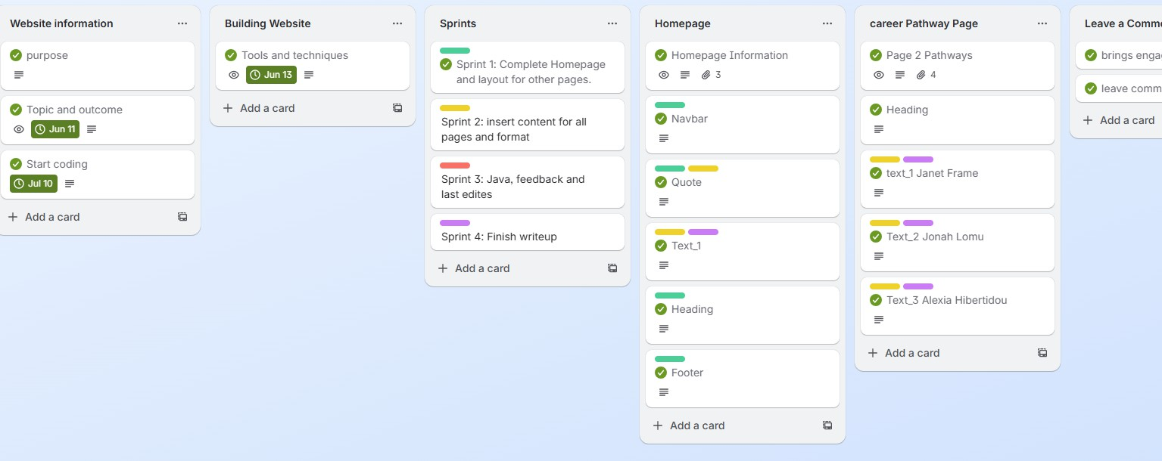

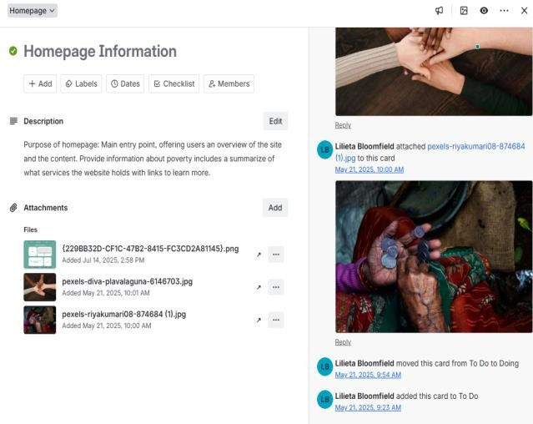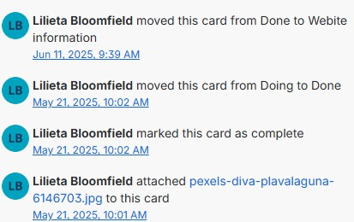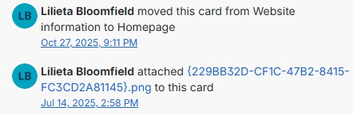
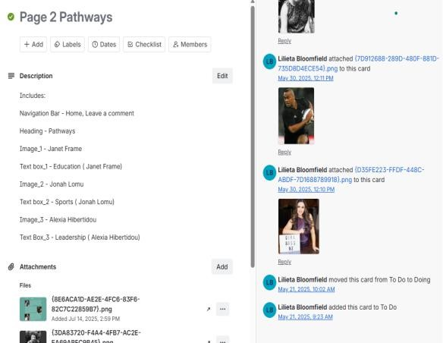
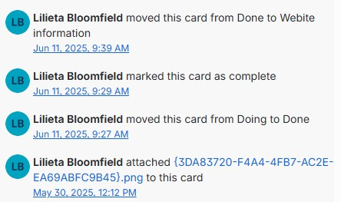
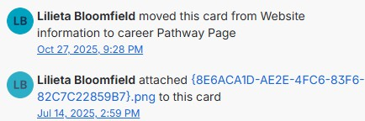

GitHub: https://github.com/Lilb575/Ditigal-L3-Website/commits/main/
GitHub was used to manage the code for my project. Setting up a GitHub repository where all my code was stored, tracking changes, and working on different parts of the project using branches.
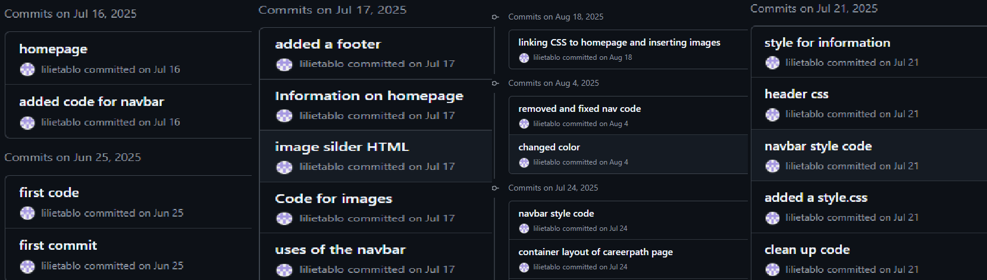
This helps me keep the code organized and makes it easy to go back to earlier versions if I need to.

Project Management Techniques
For my website project about poverty, I used a combination of Agile and Kanban methodologies to manage development effectively. I used Trello to plan and track progress by moving tasks between columns (To Do, Doing, Done) and updating cards based on testing. This allowed me to manage components of my website, prioritize work, and make improvements iteratively. Throughout development, I regularly refined tasks based on user feedback, developer tester, and performance audit results.

Tool | Purpose | Pros | Cons
Visual Studio Code | Coding program for writing HTML, CSS  and JavaScript | Supports live preview, easy to connect with  GitHub | Doesn’t have drag and drop which would be easier
HTML | Structure and  content of website | Easy to use and works on  all browsers | Can look plain without CSS  styling
CSS | Styling layout and visual design | Can be creative with layouts and make pages  look professional. | Can be complex if your design is harder
JavaScript | Adds interactivity  like buttons image, slideshows | Makes website engaging and fun | Can be tricky to debug harder to code
Image tools Canva | Creating graphics banners and icons | Easy navigation, high-quality | Some features require a paid subscription.
Responsive Design | Ensures website works on all screen sizes (Phone, iPad  computer) | Improves user experience and accessibility | Lots of testing and adjustments
Version Control: GitHub | Store, tracks and manages changes to code | Keep old versions safe, easy to manage tracks changes. | It can be confusing for beginners. I need to understand how to work  branches and commits.
Photo app | Resize and crop images for consistent carousel  display | Easy to use, maintains aspect ratio, improves quality | Only supports basic editing, so i had to use resizing techniques carefully to avoid  image distortion.
These tools were appropriate because they allowed me to effectively plan, develop, and refine my website using industry-standard techniques. Visual Studio Code enables efficient coding, and GitHub allows version tracking and rollback. Trello supported ongoing management of development and feedback, while responsive design tools and testing methods helped optimize user experience. The inclusion of Canva and photo resizing ensured image quality was improved before implementation, which directly enhanced performance and usability. Using these tools efficiently contributed to producing my refined digital outcome.

Complex Coding Techniques
During the development of my website, I applied a range of complex techniques to ensure it was functional, engaging, and user-friendly.
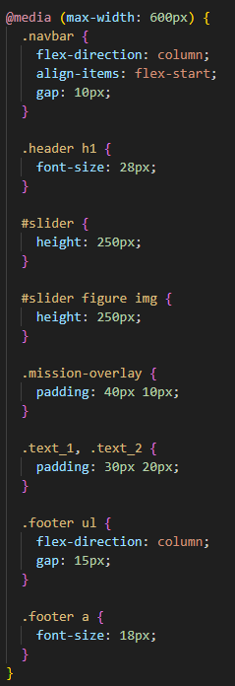
I implemented a carousel using Java and CSS animations and transitions to visually present images effectively. To improve accessibility, i used responsive web design approaches, including percentage-based layouts and @media queries, so the website adapts to different screen sizes such as mobile phones and tablets.
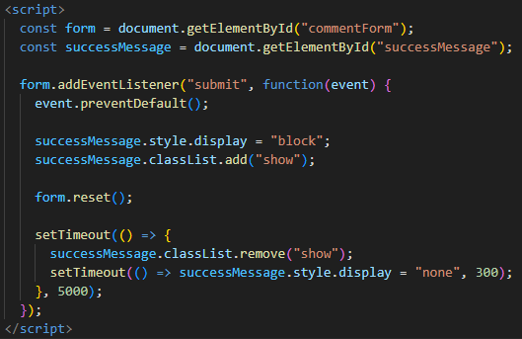
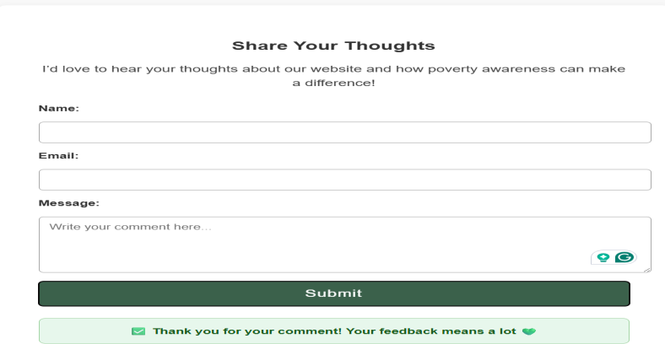
For interactivity, I used JavaScript on the Leave a Comment page to enhance user experience. This script prevented the page from refreshing when the form was submitted, displayed a temporary success message using timed functions, and automatically reset the form that was easy to reuse. I also refined layout using CSS grid and spacing techniques and optimized performance by resizing images before uploading to reduce loading times. To ensure quality, I used HTML and CSS validation services to correct errors and improve code structure.

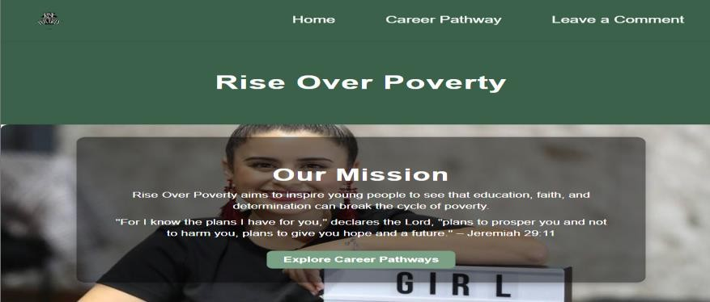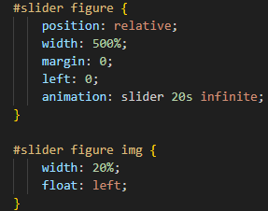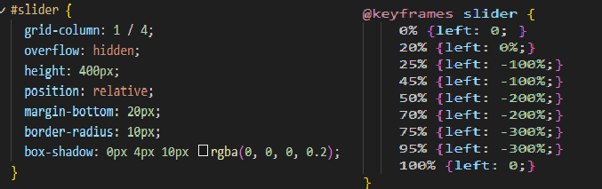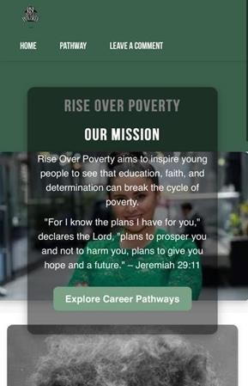
On the homepage, I created an image slider using CSS animations, I placed five images inside a <Figure> that is 500% wide and used an @keyframes animation to move the figure horizontally, so each image slides into view. This creates an automatic carousel without JavaScript and is combined with a mission overlay box on top of the slider, which presents my key message and a call-to-action button. I then refined the slider's height in my media queries, so it scales correctly on tablets and phones.
Using these techniques and tools iteratively based on user and teacher feedback led to a refined, high-quality digital outcome that is engaging, responsive, and aligned with the needs of my target audience.

Decomposition of components

Outcome | Components | Descriptions | MVP | Extras features
Homepage  index.html | Navigation bar, Carousel images, introductory text and  footer | The homepage introduces the website, captures the user’s attention, and provides links  to other pages. | Navigation bar must work correctly, and carousel images must display and rotate properly | Include a logo or site branding for a professional  look.
Pathway Page pathway.html | Headings, Paragraphs, Images, Links Buttons | Shows educational and career pathways students can take to overcome poverty | Text content and links function correctly | Embedded video, downloadable  PDFs
Help Page | Resource list, links | Provides section where users can leave comments | Links functional information east to read | Hover effects
Responsiveness | Responsive layout, Grid system, Media queries | Ensures the website works on phones, tablets, and desktops. | Website adapts correctly on all devices | Adaptive font size.
interactivity | Buttons, Image carousel, Hover effects, Slideshow | Adds interactive features to engage users | Buttons and carousel function correctly | Smooth animations, fade-in effects
Layout and design | Colors, Fonts, spacing Alignment | Consistent readable, visually appealing and media for the website | Clean and consistent layout | Themed color palette background gradients, Parallax  scrolling
Media management | Images, Logos, Graphics, icon | Organizes and optimized all image and media for website | All images display correctly and load properly | Optimized images for faster loading, responsive  image size

Testing and Data Integrity | Browers testing HTML/CSS validation, User testing | Ensures all components work as intended across devices and browsers | 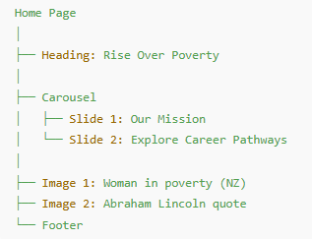  Functional website with no broken links | Testing cycles, detailed user feeback, UX improvements.
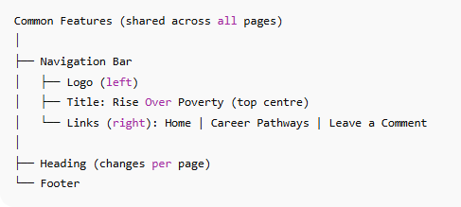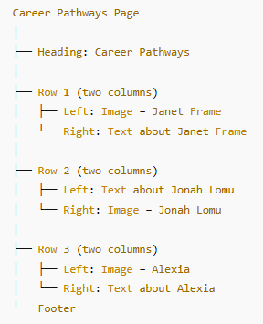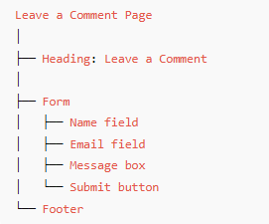

Trialing Components
Sprint 1:
Throughout the trialing process I've struggled with pushing my work onto GitHub, so some of the timelines are not accurate.

Component tested | What was tested | Testing procedure | Result | Data integrity | Retest
Layout | Overall page layout – readability, spacing, and visual appeal | Open the website on browser and checked alignment, spacing etc. I also asked for feedback  from classmate | Pass: Tested and retested in the previous assignment; minor tweaks only | Layout is simple, attractive, and consistent across all pages | NA
Navigation bar | Link between pages | Click each button and test navigation bar | Pass | Consistent across all pages, links correctly to each page, and is clearly identifiable in  the top right corner. | NA
Check if all links work for each page.  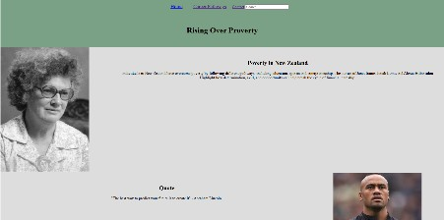 |  |  | Made navbar clear and readable for all users.  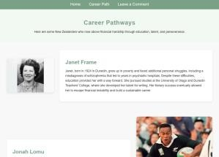
Footer | Content, background color and layout | Scrolled through each page | Change background color to lighter color | Confirm consistent footer content and clear readable layout | Tested different colors and passed with the  final selected one

Images | Display, Size and File paths | Opened each page to confirm images load correctly,  checked alt text | Change position of images on homepage | All images linked correctly, appropriate file size and format | Retested images

Text boxes | Font size, color and alignment | Reviewed all text areas on desktop and mobile for  readability | Pass – text readable and evenly spaced | Font and spacing consistent | NA
Logo | Display and position | Checked logo placement on homepage and compared across  pages | Pass – logo positioned clearly in header | File paths correct, consistent placement | Retested after resizing logo for better fit
Carousel images | Image rotation and speed | Tested automatic slideshow rotation and navigation  buttons | Pass – smooth transition, correct image order | Images properly linked and functional | Slowed transition speed slightly for readability
Responsive | Layout across mobile, tablet and desktop | Used chrome developer tools to simulate devices | Pass – Layout adjusts well to all screens | Consistent grid layout and spacing | Adjusted font size for smaller screens, retested
Browser Testing | Functionality across browsers | Tested in Chrome, Edge and safari | Pass – all pages loaded correctly | HTML/CSS compatible with major browsers | NA

Relevant implications
Throughout the development of Rise Over Poverty, I carefully considered a range of relevant implications to ensure that my website was accessible, culturally sensitive, ethical, sustainable and future proof.
Before creating my pages, I planned how I would respond to each implication, and during development I implemented design decisions, coding techniques, and content choices that addressed these considerations. The screenshots I collected provide evidence that these implications were not only considered but actively applied in my final outcome.

Implication | Explanation | Screenshots
Accessible | I considered accessibility early in my planning to ensure that all users could navigate and understand my website, regardless of device or ability. During development, I used responsive design techniques such as percentage-based widths, flexible images, and media-friendly layout styles, so the site automatically adapts to mobile, tablet, and desktop screens. I also applied descriptive alt text to all images and used clear, readable fonts to support users with visual impairments and those using assistive technologies. These decisions ensured my website remained usable, readable, and accessible for a wide range of audiences. | 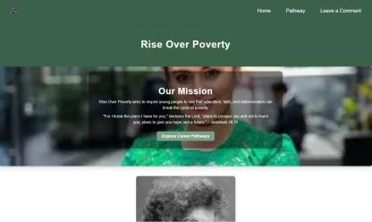  Homepage on laptop. This screenshot shows my homepage on a laptop. The layout and text are clear and well-spaced, making it accessible and easy to navigate on larger screens.  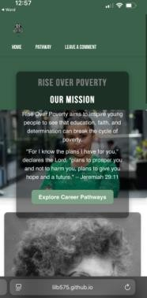  Homepage on mobile. This screenshot shows that my website adjusts automatically to smaller mobile screens. The text and navigation remain readable and functional, proving that my website is responsive and accessible on all devices.  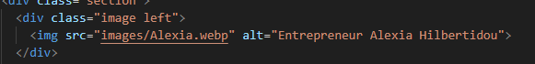  This screenshot shows how I used descriptive alt text for images, which supports accessibility for users with visual impairments using screen  readers.
Cultural Sensitivity | Before writing any content, I planned to represent people and communities respectfully,  especially because poverty affects | 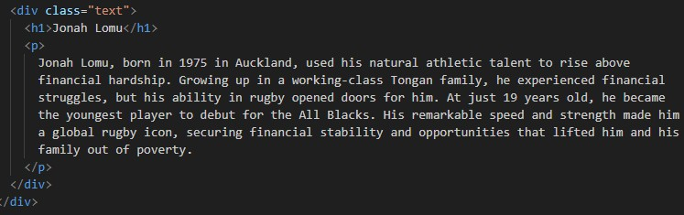

 | diverse groups in New Zealand such as Māori, Pasifika, and migrant families. During development, I wrote my own content using positive, strengths-based language to avoid  stereotypes and negative framing. I chose calm colors and appropriate imagery that promote hope, resilience, and achievement.  These decisions ensured my website stay inclusive and culturally respectful while encouraging readers to feel inspired rather than judged. | This HTML code shows how I wrote my own content using inclusive and respectful language to avoid stereotypes.  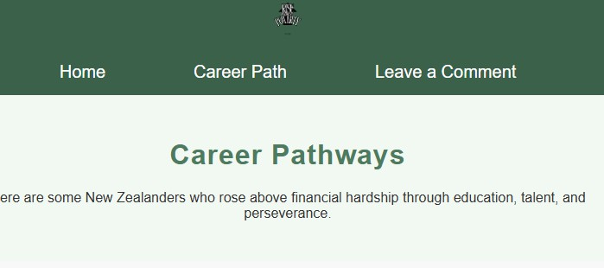  The screenshot shows how my neutral and calming design supports inclusivity and cultural sensitivity for all audiences.    This image I chose shows how positive and appropriate imagery reflects hope and achievement, not stereotypes.
Ethical | I considered several ethical implications while designing the structure and content of my website. During development, I made sure my writing avoided stereotyping people living in poverty and instead highlighted inspirational stories based on dignity and empowerment. I also thought carefully about user privacy: my comment form does not collect unnecessary data and avoids storing or sharing sensitive information. By keeping my content encouraging, respectful,  and safe for users, I ensured my | 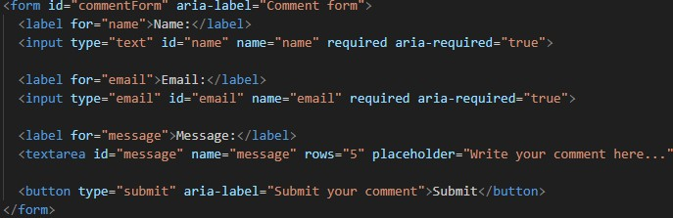  This screenshot shows that my comment form only asks for basic, optional information, ensuring user privacy and ethical data collection.  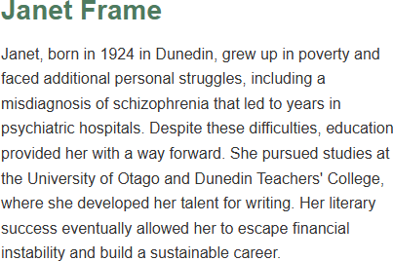  In my website I wrote about people living in poverty in a positive and respectful way, focusing on how they overcame challenges.

 | website aligned with ethical digital practice and protected user wellbeing. | 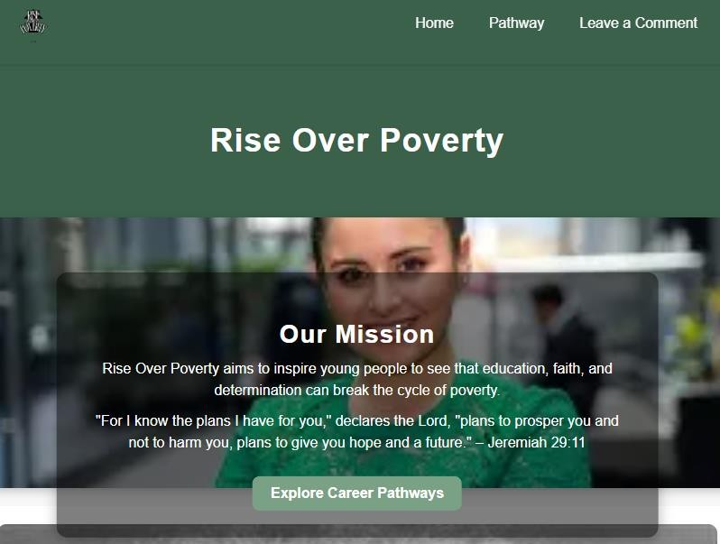  Calm color scheme and simple design create a  safe, respectful atmosphere for visitors that supports ethical website design.
Sustainable and future proofing | Before building my website, I planned a structure that would be sustainable and easy to maintain in the future. During development, I used clean, modern HTML and CSS so new content or pages can be added without redesigning everything. I kept consistent colors, layouts, and fonts across all pages, making long-term updates simple and efficient. I also organized my folder structure clearly and hosted my files on GitHub, ensuring my website can be improved, expanded, or rebuilt as technology changes. These choices help keep my website relevant, functional, and future proof. | 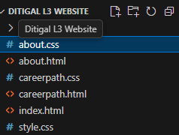  This screenshot shows my organized folder structure, which supports sustainability by making it easy to update or reuse my website in the future  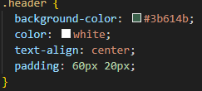  This shows that i used clear, modern CSS layout code, making my website easier to maintain and compatible with future technologies.  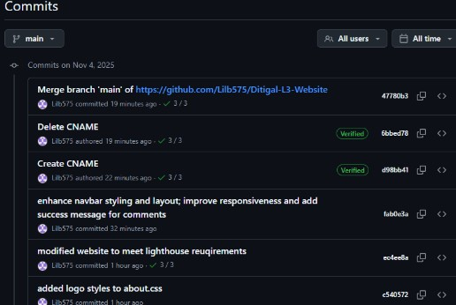  By storing my website on GitHub, i ensure it can be easily updated or improved in the future, supporting sustainability and future proofing

Feedback

Feedback | Before | After | Explanation (what you  changed why) | Why this feedback was  good or not
Tivinia - year 13 high school student  “Added links to footer so users can easily navigate between pages.” |  | 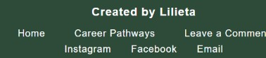 | I agreed because it improved accessibility and made navigation easier. | This feedback was good because it made my website easier to use and more professional, especially for people viewing on mobile  devices
Sela – Year 12 high school student “You should add background music to make your website more lively.” |  |  | I chose not to add music because it could distract users and slow down page loading. My goal was to keep focus on the stories and information. | This feedback was not good for my website because adding background music could make it less accessible, distracting, and less professional. Keeping it simple supports ethical and inclusive  design
Cardel – Year 13 Highschool student “It would be nice if your ‘Leave a comment’ page displayed a small thank-you message after someone submits their comment.” | 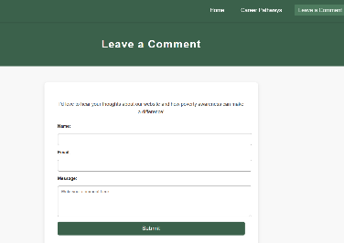 | 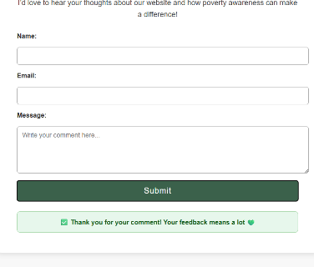 | I added a thank-you message to make the website more user-friendly and interactive. It gives visitors feedback that their comment was received successfully. | This feedback was good because it made the comment form more engaging and polite. It helps improve user experience by showing appreciation and confirming  that their

message went
through.
Mrs. Kalekava " feedback, can you make sure your navbar does not move where you click on the other pages” |  |  | I changed the navbar to be consistent throughout all pages, so the users expect to find navigation links in the same place on  every page. | This feedback helped improve my website by making it user-friendly and easier to navigate and improve  usability.

Final Testing
This table shows screenshots from the audit report of the Lighthouse tool (ChromeDevTools), for each page. The Lighthouse tool audited the pages performance (Fast loading) Accessibility (all users. Including the disable, can interact with the website), best practices (code has no bugs and aligns to industry expectations), and SEO (content of my website is optimized to be favored by search engines, making it easier for users to find it). These measures improve UX by improving the quality of the website.

Homepage
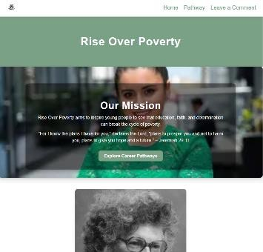  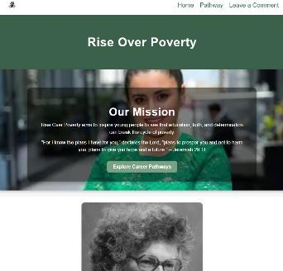 | 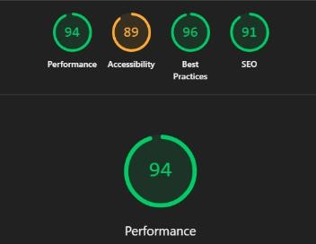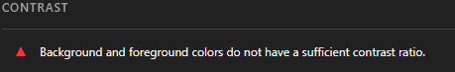  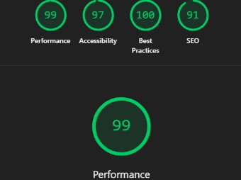 | Some people with low vision experience low contrast, which makes it hard to distinguish outlines, borders, edges, and details. Text that is too close in luminance (brightness) to the background can be hard to read.  I improved accessibility by adjusting my color palette to meet WCAG AA contrast ratios. I used darker green tones (#4e7b5f and #3b614b) to maintain the theme of growth while ensuring all text remains readable on white and colored backgrounds. After these changes, my Lighthouse accessibility score increased from 89 to 97, demonstrating a high-quality, inclusive outcome.
Careers Page
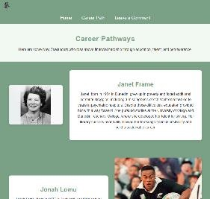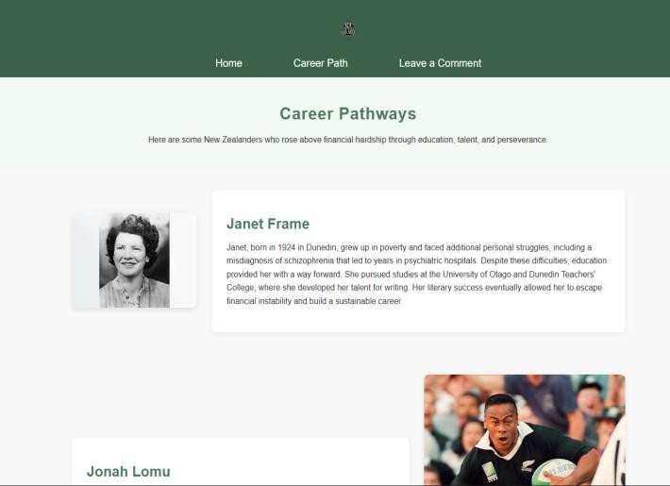 | 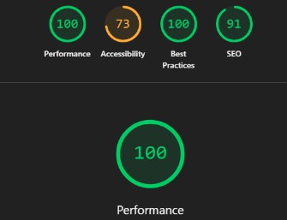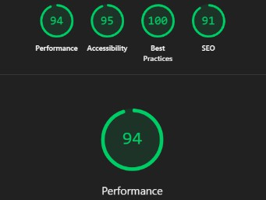 | Lighthouse identified that some images were much larger than needed for their displayed size. I resized and converted them to .web format to reduce download size and loading time.  This change improved my website’s performance and enhanced user experience by making the site load faster without losing image quality. I improved my footer’s accessibility by increasing colour contrast and link padding for better touch targets.

Comments Page
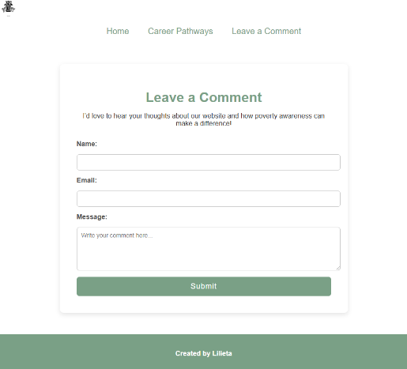  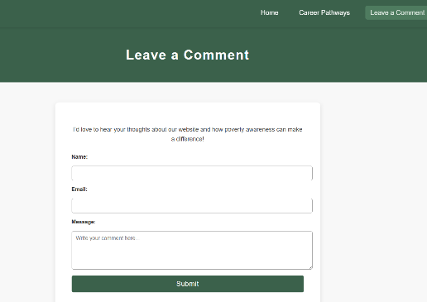 | 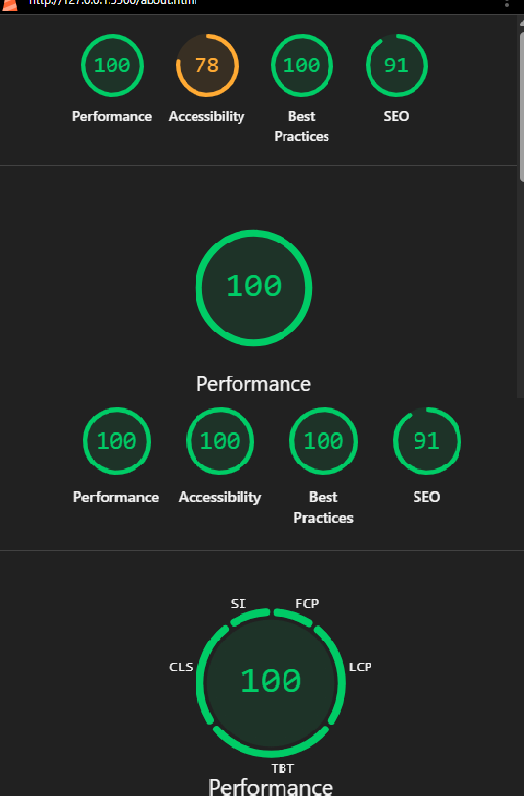 | According to Lighthouse, the Comment page performed well overall, but some accessibility issues were identified. I improved the page by increasing colour contrast, adding clear link labels, and adjusting heading order. These updates enhanced both the  website’s performance and accessibility score, creating a smoother and more user-friendly experience.

Validation Service
HTML checker
Ready to check - Nu Html Checker

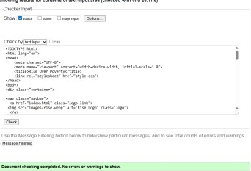  Hompage HMTL | 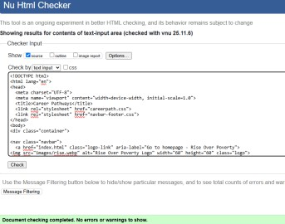  Careerpathway HMTL | 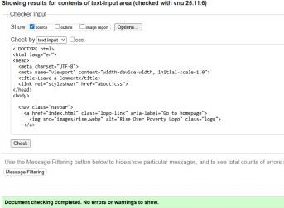  About HTML | All webpages were validated using the Nu HTML Checker. The validator confirmed that each page contains clean, well-structured, and accessible HTML, with no errors or warnings detected. This shows that my code meets Modern web standards, follows correct semantic structure and is fully compliant with best practice guidelines for HTML  development.

The W3C CSS Validation Service

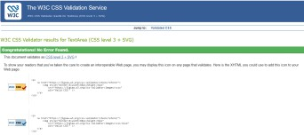  Style.css | 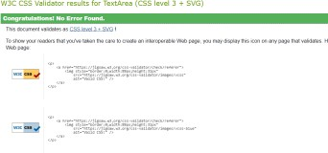  Careerpath.css | 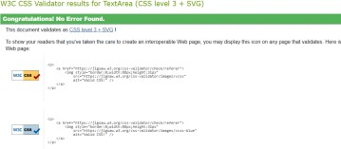  About.css | The stylesheets were tested using the W3C CSS Validation Service and successfully validated as CSS level 3 + SVG. This confirms that my CSS follows current web standards and is fully interoperable across modern browsers.

Reflection
In this section, summarize how the insights you gained from planning, testing, and trialing influenced your final website. Explain how the changes you made during the process improved your website and resulted in a refined and high-quality outcome. It will also be helpful to include screenshots showing how your plan looked, how the first version of your website appeared before feedback, and how your website looks now after incorporating feedback. This clearly shows the progression and improvements you made.
Throughout the development of my website Rise Over Poverty, I learned how important planning, testing, and feedback are in creating a professional and effective digital outcome. My original plan focused on informing users about poverty in New Zealand through real-life success stories.
At the beginning of my project, I created Trello to plan and organize my website, but during development i sometimes forgot to update it consistently. I used Trello to track key actions such as completing the homepage, layout, attaching research images, and confirming when content was finished. The activity logs shown in my screenshots demonstrate that I moved cards as tasks were completed. This taught me the importance of actively using project management. If I were to do this again, I would update Trello more consistently and use features like deadlines and checklists to improve time management.
Although I could have used Trello more effectively, I still applied it to support progress tracking and development to the successful outcome of my project.
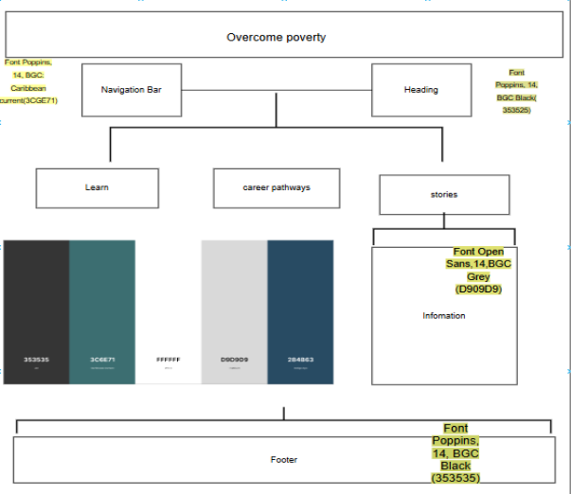
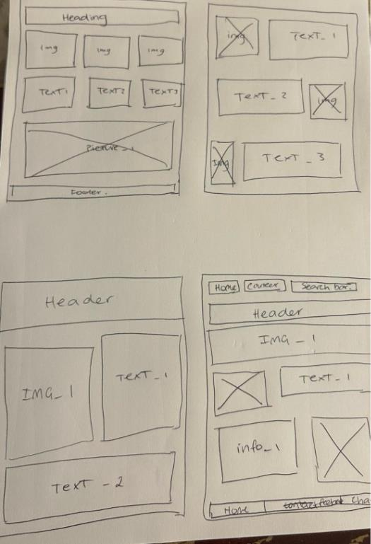
My Original plan and layout sketch before building the first version.
As I began building my first version, I focused mainly on the layout and navigation. Early testing showed that while the design looked good on my laptop, it didn't fit properly on smaller devices. After this, I adjusted my CSS by using responsive units such as percentages and flexible image widths, which made the site accessible across different screen sizes.

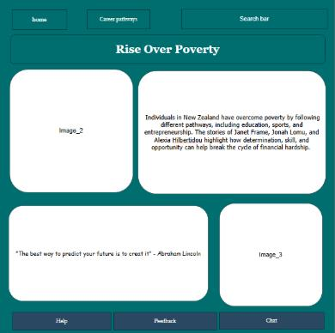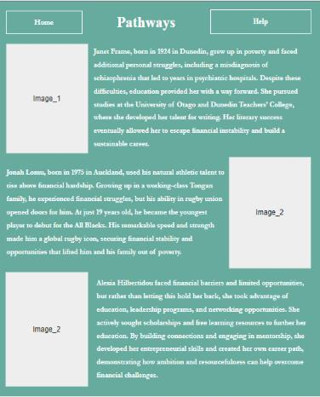
The First version of my website before I made changes based on feedback.

Feedback from users and professionals helped me refine my work even further. For example, I added navigation links to the footer, resized images to improve loading speed, and changed my header color to make the title more readable. I also changed the color theme of my website from feedback, and the lighthouse requirements had failed.
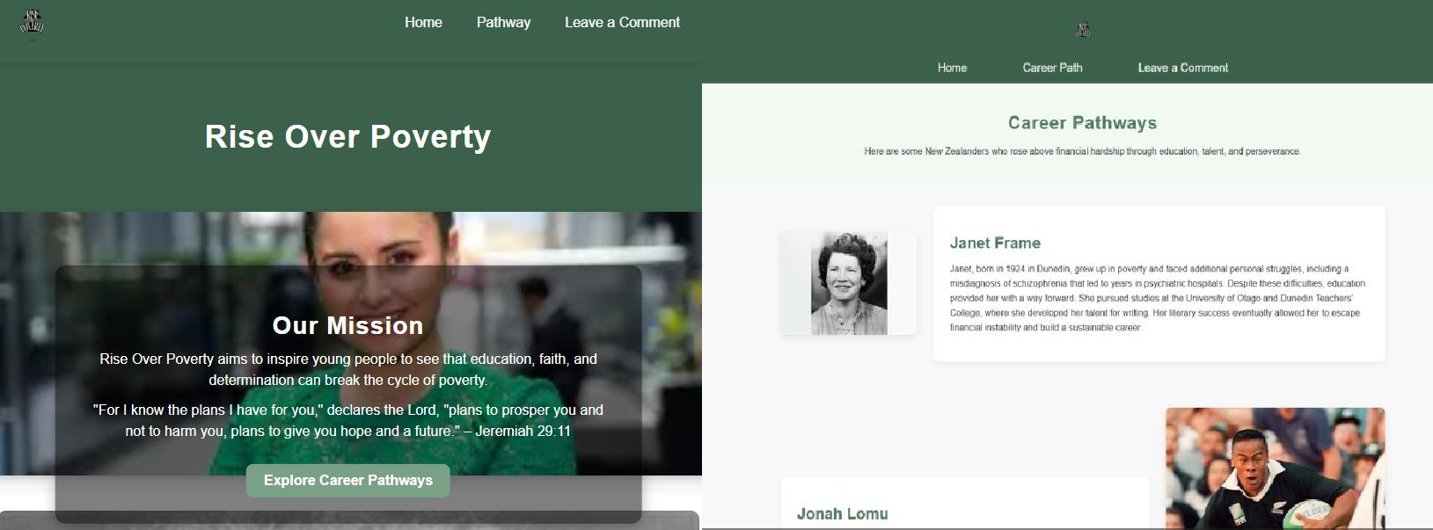
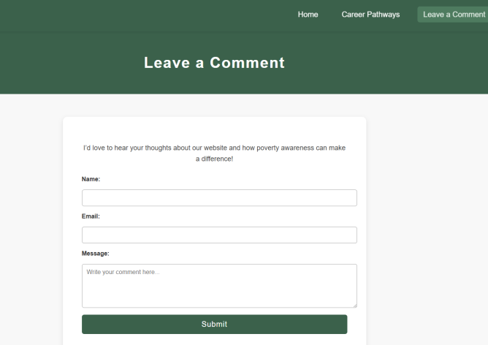

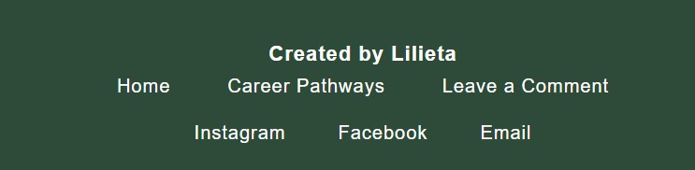

The final version of my website shows improvements after applying feedback.

https://lilb575.github.io/Ditigal-L3-Website/

Overall, planning, testing and trialing help me produce a high-quality website that is visually appealing, accessible and respectful.
In conclusion, my Rise Over Poverty website meets its purpose of helping high school students understand how poverty affects young people in New Zealand and how they can rise above it. The website provides encouraging information, real success stories, and useful guidance in a way that is easy for teenagers to read and understand. I designed the pages using calm colours, clear text, and simple navigation to make the website user-friendly and comfortable to use.
Testing and feedback played an important role in improving my website. After checking how the website worked on different devices, I changed my CSS to make the layout more responsive on mobile screens. Feedback from classmates and my teacher also helped me make useful changes, such as adjusting colors for better readability, improving image sizes for faster loading, and adding a thank-you message to the Comment page. This change made my website easier to navigate and imporved the overall experience for users.

I intentionally designed the website to feel calm, positive, and uplifting by using soft green tones, clean layouts, and easy-to-read fonts that support a smooth and welcoming user experience. My written content uses a clear, encouraging tone so students feel supported rather than overwhelmed while they read. Simple navigation menus, responsive layouts, and clearly labelled buttons help guide users naturally through each page, allowing them to access information with confidence and ease. The inclusion of a Comment page also gives users a chance to interact with the website and contribute their thoughts, adding a sense of community and personal connection.

Even though my website works well now, there are still improvements I would like to make in the future. These include adding a profile system so users can save information, creating a Resources page with extra support links, and eventually developing a mobile app version so more students can access the content easily:
- Adding a login/profile system so students can save pathways, resources, or helpful pages for later.
- Creating a dedicated Resources or Support page, linking students to scholarships, budgeting tools, tutoring programmes, mental health services, and community organisations.
- Building a community section, where users can share testimonies, motivation, or advice to encourage others.
Overall, the Rise Over Poverty website is a strong and effective digital outcome. Planning, testing, and user feedback played a key role in refining the final design. These processes helped me improve the
website’s accessibility, responsiveness, and overall user experience. As a result, the final outcome is not only visually appealing and easy to use, but also meaningful, respectful, and supportive toward the young people it was designed for.

