COSC 2P03

Assignment 1

May 25th, 2018

Sawyer Fenwick

6005011

14/14

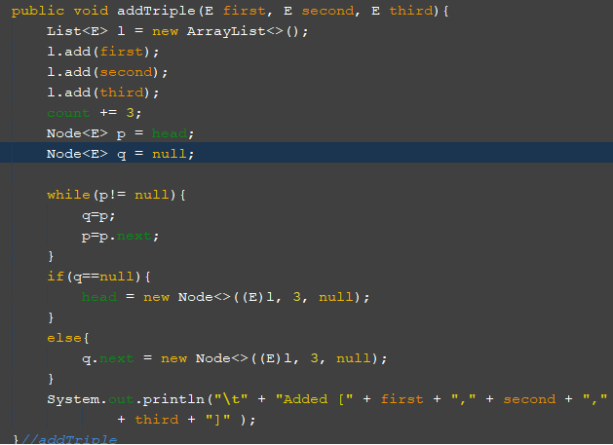

My addTriple method is O(n). Adding the elements to the list is O(1), the while loop goes over each node in the list which is O(n). Both cases in the if-then-else statement are O(1) so it is O(1). This gives O(1) + O(n) + O(1) which gives O(n).

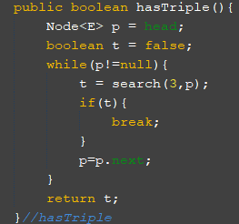

My hasTriple method is O(n). The while loop is O(n) since it must go through “n” nodes at worst case. The if statement is O(1). Therefore the method is O(n).

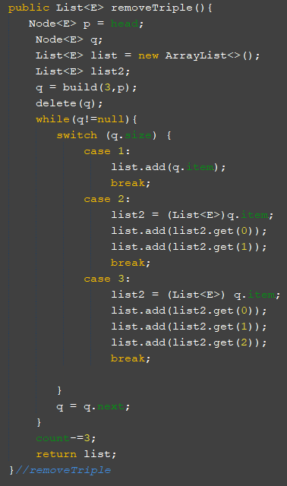

The complexity of my removeTriple method is O(n2). The while loop is O(n) and so is the switch. Which gives O(n)\*O(n) which gives O(n2).

For the generalized “add(E…item)” I would ask the user how many items they would like to add, and then add them one at a time. Ex/

“How many items?”

6 (n=6)

For(x<n)

Get item input

List.Add(E…item)

Return list

For the generalized “remove(int n)” I would search the list for the number requested but I would follow the same delete method I used, building a new list that holds all the elements I want to delete from the main list and then comparing the two lists. It would just be in a different method call.