Daniel Sawyer

1-17-18

Project 1

For this retarded project I used the HollywoodsMostProfitableStories.csv dataset from the tableau website. The datasets were mostly garbage and the software sucks but I was able to get some questions out of it and one graph for each question, which was also an extreme pain in the ass to export because the public version of tableau seems to not support copy or export, yay! Anyways, here are the questions I came up with from the data available.

Question 1:

Gross Sales vs. Audience Review. This data shows the gross amount of money a movie made in the millions vs the audiences’ rating of the movie from 0 to 100.

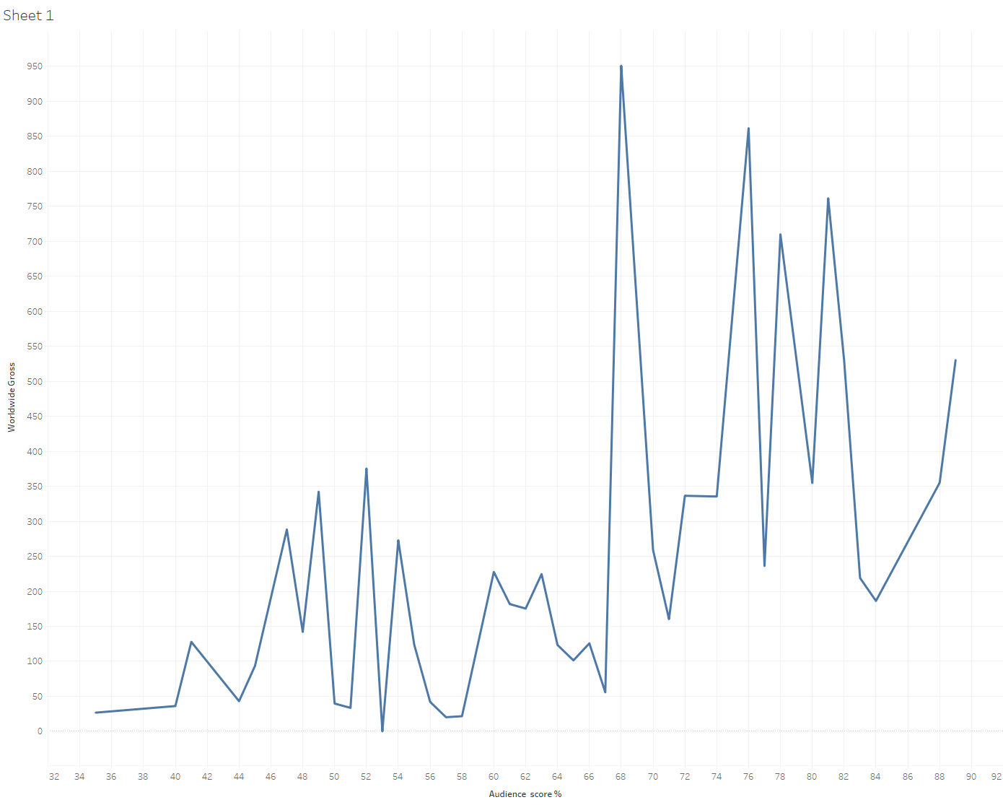

Question 2:

Gross Sales vs. Critics Review(via Rotten Tomatoes). This data shows the gross amount of money a movie made in the millions vs the critics rating of the movie from 0 to 100.

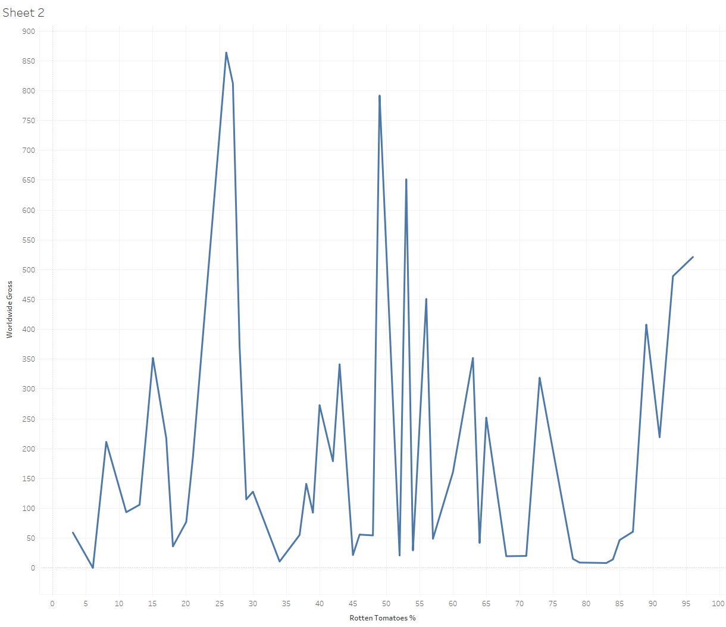

Question 3:

Profitability vs Critics & Audience Reviews. This checks the profitability of the movies compared to how well they are received by both critics and audiences.

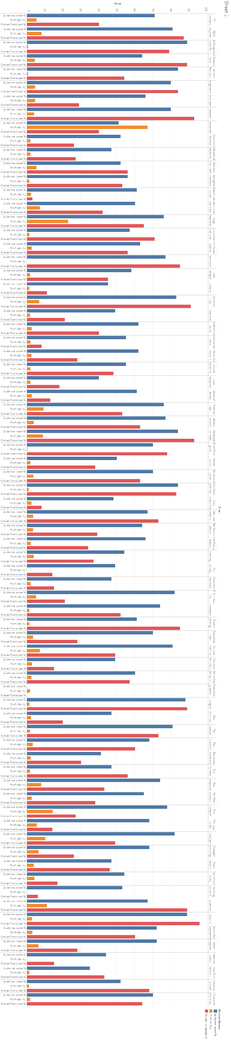

These datasets were terrible except for the pokemon dataset but everyone I knew was using that so I decided to try and find another one. Most were lacking any comparative data and the ones that did were incomplete. I loathed this project and the tableau software. The public tableau software does not allow you to export the the sheets/graphs to images so I had to manually screen shot them, which was a major pain in the ass. I really hope I never have to use this shit software ever again in my life. Also, the available data in the dataset I used is mostly useless. There aren’t any amounts of what the movie cost to make, to market, movie theater percentage, etc. It also states it has movies from 2007-2012, which it doesn’t. There are only 74 movies listen in the whole damn set. Either way, I completed the assignment and all of its requirements, I am glad this assignment is over.