**Introduction to Operating Systems**

**COP 4600-001**

Name and ID _________________________

**Worksheet #10**

Q1. A particular OS manages real memory organized as multiple variable partitions. At the present time there are free memory partitions of 100K, 510K, 200K, 300K and 600K. In the input queue we have several processes waiting to be assigned memory. Process 1 is at the head of this queue and requires 212K, next in line is process 2, which requires 417K, followed by process 3 requiring 112K and then process 4 requiring 426K. Assume that the free storage list is appropriately updated right after process is assigned main memory.

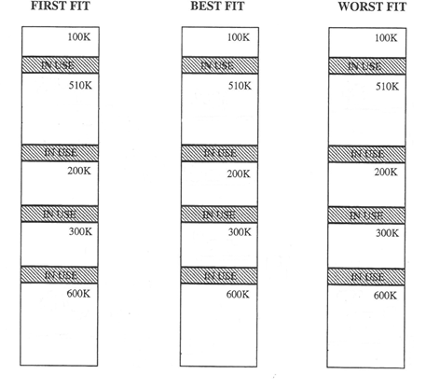

Q2. Consider a paging system with the page table stored in main memory.

1. If access memory reference takes 150 nanoseconds, how long does a paged memory reference take?
2. If we add TLBs, and 55 percent of all page table references are found in the TLBs what is effective memory reference time? (Assume that finding a page table entry in the TLBs takes 5 nanoseconds)