class04.R

sawyerrandles

2024-10-11

# My first Rscript  
x <- (seq(1,50, by=0.1))  
plot(x)

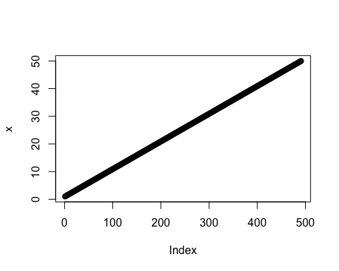

plot(x,sin(x), col="blue", lwd=.5)

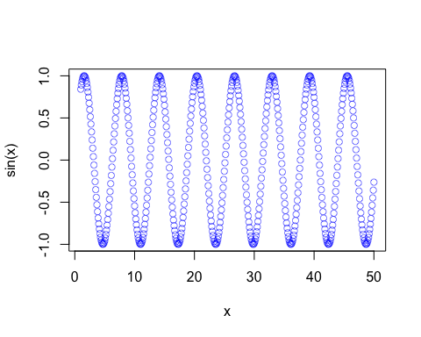

plot(x,sin(x), typ="l", col="blue")

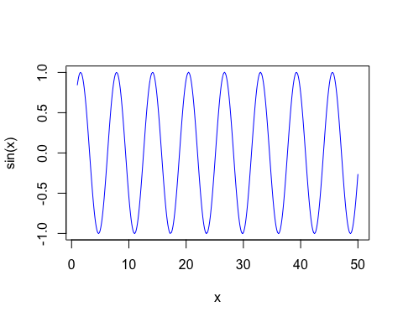

y <- 1:50  
plot(y,sin(y), col="red")

