Chapter I: Introduction
The Music Learning Theory developed by Edwin E. Gordon provides a framework for music education, the goal of which is to increase musical understanding and appreciation. In Gordon’s words, it is a description of “how we learn when we learn music.” Fundamental to musical learning is the process of audiation, a term coined by Gordon for the hearing and comprehension in one’s mind of musical sound that is not necessarily physically present. Music Learning Theory outlines a progression of skills and two types of content that aid the learner in comprehending music. It provides guidelines on how they interact and how proper sequencing leads to more effective music learning. Effective learning creates greater enjoyment of the learning process and intrinsic motivation to attain higher degrees of mastery. Ultimately, the learner will make decisions about music based on more than superficial musical characteristics.
This thesis provides resources that are specifically adapted for training beginning saxophonists using Music Learning Theory principles. Saxophonists can benefit from a curriculum organized so that musical understanding guides the development of instrumental skill. The impetus to master the instrument then arises from a need to express music the student has already audiated. Tone production, articulation, and technical facility then become means to realizing that music. Over the relatively short history of the saxophone, there has been significant development of the pedagogy addressing the issues of these executive skills for manipulating the instrument. However, traditional curricula do not usually address audiation in an efficient manner, if indeed they address it at all. Without audiation, performance becomes a mechanical process of decoding instructions on a page, which Gordon and others liken to typing in a language the typist does not understand. Typical of such “performance” is the student who repeatedly neglects to play C in a D-Major etude, adds or drops beats, or fails to keep a consistent tempo. When audiation is developed concurrently with executive skills, the student becomes aware of and takes action to correct such errors. Further, the student develops sensitivity to musical syntax, allowing for more expressive performance of even the simplest exercise such as a scale.
Saxophone students in the United States experience music education through two venues, the school ensembles (concert band, stage or jazz ensembles, etc.) and/or private instruction. School ensembles, in the beginning years, face the challenge of training instrumentalists of varying aptitude and musical experience on a variety of instruments. In order to train the musicians of an ensemble together at the same pace, instructors often make choices that would compromise efficient learning of one instrument in favor of helping another. Private instruction does provide a more focused learning experience tailored to the individual needs of the student and the idiomatic techniques of the instrument. However, the private lesson lacks the exposure to other instruments, ensemble skills (such as balance and blend,) and the opportunity for students to learn from their peers. Thus, the two venues are complementary; while overlapping in some aspects of instruction, each provides unique experiences to the student’s overall musical development.
While it is not valid to generalize about how teachers do or do not address the audiation in ensemble or private instruction, it is possible to examine the materials that a teacher may use to see how these materials (often in the form of method books) support the development of both audiation and executive skills for the saxophone. Table 1 below shows (along the vertical dimension) the type of method (ensemble or individual). The horizontal dimension shows the approach to audiation—Music Learning Theory or “Traditional”.
Table 1: Methods by Ensemble/Individual Instruction and Traditional/Music Learning Theory Paradigms
 | Music Learning Theory | “Traditional”
Ensemble | Jump Right In: The Instrumental Series by Richard Grunow, et. al. | Standard of Excellence by Bruce Pearson  Accent on Achievement by John O’Reilly and Mark Williams
Ensemble | Do It! Play the ... by James Froseth (hybrid of Music Learning Theory and “Traditional” approaches)
Individual | None | The Eugene Rousseau Saxophone Methods  Alto Saxophone Student by Frank Weber

At this time there is no Music Learning Theory resource which addresses saxophone-idiomatic concerns or saxophone-idiomatic resources that comply with Music Learning Theory principles. This document seeks to fill this niche.

Edwin Gordon and his Contributions to Music Education
Dr. Edwin E. Gordon has had a distinguished career in music education and research. After completing doctoral studies at the University of Iowa, he taught there from 1958 to 1972, followed by positions at the State University of New York at Buffalo, 1972 to 1979, at Temple University (where he held the Carl E. Seashore Chair for Research in Music Education), and at the University of South Carolina. Before taking a professional interest in research into musical aptitude and audiation, he earned degrees in String Bass Performance from the Eastman School of Music and toured as bassist with the Gene Krupa band. For his contributions to music education, he was inducted into the Music Educators National Conference Hall of Fame.
Dr. Gordon is responsible for contributions in key areas of music education. He has published several standardized tests that purport to measure musical aptitude through audiation. These tests include the Musical Aptitude Profile (MAP), the Primary Measure of Musical Audiation (PMMA), the Intermediate Measure of Musical Audiation (IMMA), and the Advanced Measure of Musical Audiation (AMMA). The MAP test is designed to give a profile of a student’s musical aptitude across seven dimensions, two tonal, two rhythm, and three preference. It is intended for students in the fourth through twelfth grade. The PMMA, IMMA, and AMMA are considerably shorter tests with only two dimensions, one each of tonal and rhythm. They are designed for students in kindergarten through third grade, first through fourth grade, and junior high school and beyond respectively. The PMMA and IMMA both measure developmental musical aptitude, which fluctuates from birth to approximately age nine. The AMMA and MAP measure stabilized musical aptitude and, according to Gordon, need only be administered once in a student’s school career. The primary purpose of testing a student’s musical aptitude is to improve instruction by adapting teaching to the student’s individual needs.
In addition to standardized tests, Gordon has published numerous books and articles relating to audiation and its relationship to musical aptitude and achievement. It is in these works that the Gordon has expressed the developing principles of Music Learning Theory, beginning with How Children Learn When They Learn Music (1968), followed by The Psychology of Music Teaching (1972), and several editions of Learning Sequences in Music (1980, 1984, 1988, 1993, 1997). The 1997 edition served as a primary source for information about Music Learning Theory. This author was able to compare the 1997 edition with the 1988 edition, and notes that, while there is much in common in the language, each edition contained unique attributes such as illustrations, examples, and figures. Unique to the 1997 edition are the inclusion of the Locrian Tonality in the taxonomy of tonal content, eight types of audiation instead of seven, and chapters on early childhood musical education and the current state of music education. However, the 1997 edition does not include the taxonomies of tonal and rhythm patterns. Instead, the reader is instructed to purchase the Jump Right In tonal and rhythm register books, which contain the respective taxonomies.

Criticism of Gordon’s Work
In his time, Gordon has stirred up a significant amount of controversy regarding the nature of his research. Though he does not claim this title for himself, he has been labeled as a behaviorist in the same camp as B.F. Skinner and A. Pavlov. In some respects, the application of his theory is marked by the characteristic trait of behavioral psychology, that it concerns itself only with measurable stimuli and overt behaviors in response. However, audiation, as Gordon posits, is a phenomenon that takes place entirely in the mind. It can only be observed indirectly by trusting the subject/student to report truthfully and accurately on this internal phenomenon. This association with behaviorist psychology, whether warranted or not, tends to cast the shadow of an outmoded educational philosophy on Gordon’s work for those who favor a more holistic, cognitive approach to learning.
Others take issue with Gordon on the basis of elements of his research methodology. Colwell and Abrahams cite numerous instances in Gordon’s work on musical aptitude testing in which they question whether the test is really measuring what it claims to be measuring. They also assert that he makes many statements regarding teaching that, though pedagogically sound, are not substantiated by research. Thus, he may be seen more as an advocate for his teaching philosophy than an objective researcher. Nonetheless, these same authors praise Gordon for being very meticulous in other aspects of his research to establish validity and reliability for his tests.
Gordon has challenged the music education and theory communities in other ways as well. One author postulates that Gordon’s ideas and practices have not gained wider acceptance and application because they require so much from the teacher, whether in the classroom or in a private lesson setting. First, the teacher must learn a very specialized vocabulary just to be able to comprehend Gordon’s writing. Gordon introduces new terms for familiar concepts in order to avoid unintentional associations, for example, audiation instead of aural imagery. He also redefines familiar terms to suit his own purposes, such as representing Usual Triple meter (Gordon’s taxonomy) as 6/8, which is traditionally labeled as Compound Duple. Second, the teacher must be extremely competent and confident in his/her own ability to perform the tonal and rhythm patterns appropriately in order to conduct Learning Sequence Activities based on Music Learning Theory. Third, the teacher must spend a significant amount of time to organize appropriate materials to teach to the individual needs of each student.
In spite of these challenges, I believe that Gordon’s work has much to offer. It has close ties to the work of educational psychologist Robert Gagné, whose “chain learning” concept serves as a model for Gordon’s Skills Learning Sequence. Gordon’s work with musical aptitude and audiation also indicate a strong correlation with Howard Gardner’s work on Multiple Intelligences. Musical intelligence is among the seven discreet intelligences. A significant criteria for Gardner’s classification of a separate intelligence is its low correlation with other types of intelligence, which Gordon’s work appears to support. Gagné’s and Gordon’s work is entirely psychological, but Gardner’s work with Multiple Intelligences also includes a neurological factor: In order for a proposed intelligence to qualify as discreet, it must be localized to a specific region of the brain. The debate about learning theories may be leaning away from the behaviorist toward the cognitivist paradigm, but Gordon’s theory may turn out to be in harmony with emerging research about learning from a neurobiological perspective.

Methodology
The purpose of this document is to provide a resource for the saxophone instructor who wishes to incorporate the principles of Music Learning Theory into a saxophone curriculum. As such, it gives an overview of Music Learning Theory’s central tenets. Following this overview is a review of Music Learning Theory literature that address the topics of audiation and application of the theory to teaching instrumentalists, and an examination of several representative, beginning ensemble and individual method books for alto saxophone. From this examination, a set of guiding principles will be derived for the development of a saxophone method suitable for private instruction. Finally, comprehensive and sequential objectives will be developed from these principles for a method to be used in the first year of saxophone study with a private or homogeneous-instrument class lesson program, and one possible realization of those objectives.

Limitations
The focus of this document is to implement learning sequences in a private-studio learning environment. Certain assumptions will be made regarding the readiness of students to engage in this approach to the saxophone. Specifically, the student has emerged from what Gordon refers to as a “music babble stage”, and the student is at least somewhat familiar with his/her singing voice. While these issues are significant in applying a Music Learning Theory based method, they are addressed in Gordon’s and others’ writings and are not central to the primary issue of integrating the Music Learning Theory framework with a saxophone curriculum. This overview of Music Learning Theory is intended to give enough information about the breadth of skills and contents to demonstrate that it is suitable for a comprehensive curriculum, and that it provides a rationale for the sequencing choices in defining comprehensive and sequential objectives for the method outlined. It also gives specific instructions on how to teach at specific levels of learning using appropriate techniques.

Another ‘Sound-Before-Sight’ Method?
Music Learning Theory dictates an approach commonly referred to as ‘sound before sight’. This approach is not new with Gordon, but has been advocated by many music educators. One particular pedagogical method advocating ‘sound before sight’ is that developed by Shin’ichi Suzuki. He calls his approach the ‘Mother Tongue’ approach, asserting that little children can learn music the same way they learn even the most complex native language, by immersion in a listening environment. Given the prior development of the Suzuki method, first for violin, then for other string instruments and even flute, one might ask whether another ‘sound-before-sight’ method is truly necessary, or whether they are competing approaches. I would assert that they are not competitive, but rather complementary. Though Suzuki and Gordon both emphasize aural experience as the foundation for music learning, Suzuki focuses on performance and violin technique. Reading is later taught in a properly sequenced Suzuki curriculum. Gordon, on the other hand, emphasizes the development of musical understanding through the careful sequencing of skills and contents. Instrumental proficiency then comes as an outgrowth of musical understanding, but Gordon does not address the sequencing of instrumental skills as part of Music Learning Theory. Therefore, a method which incorporates Music Learning Theory principles is warranted, even given the prior existence of another ‘sound-before-sight’ method such as the Suzuki Method.

Chapter II: Music Learning Theory—an overview
The following overview of Music Learning Theory summarizes Edwin Gordon’s presentation in Learning Sequences in Music (1997).

Audiation
Audiation is the hearing and comprehension of sound that is not necessarily physically present. It is distinct from immediate aural perception which is linear by nature. Audiation is cyclical and takes place at a delay from the moment of perception. Linear means that perception proceeds only from one moment to the next as sound vibrations are converted to nerve impulses in the brain. Audiation, on the other hand, involves mental processes by which sounds which were just heard are analyzed and compared to previous musical experiences. At the most advanced stages of audiation, predictions are made on the basis of what came before. Audiation occurs when one is listening to, performing from memory, creating and improvising, reading, and/or writing music. The term “notational audiation” refers to audiating a musical sound in response to musical notation.

Types of Audiation
The following types of audiation are non-sequential, but demonstrate the variety of activities that invoke audiation, as well as the end product of such activities.
Type 1: Listening to music — Gordon identifies this as the most common type of audiation, in which the listener consciously attends to patterns of pitches and durations, and gives musical meaning to what is heard.
Type 2: Reading music — notational audiation. This takes place when reading silently, performing from a score, conducting from a score, or listening to music while reading. What distinguishes notational audiation in all these situations is that music is being predicted on the basis of the notation. By contrast, an instrumental performer who is not audiating while reading a score, is using the notation as a guide for manipulating the instrument and may be likely to perform incorrect pitches and/or rhythms without his/her realization.
Type 3: Writing music from dictation — another form of notational audiation, the reverse process of reading. What has been audiated is then represented in notation.
Type 4: Recalling music from memory — performed silently, vocally or instrumentally, this type of audiation occurs as one recalls patterns of pitches, durations, and other aspects of music. This process is distinguished from memorization, in which physical movements are entrenched (whether instrumental techniques or vocal fold movements), and does not involve hearing the music to be performed or recalled.
Type 5: Writing music from memory — this process is the same as Type 4 except that the end product is notation. In Type 4, the end product is some form of performance.
Type 6: Creating or improvising music — in silence or in performance, new (unfamiliar) music is created by the organization of familiar or unfamiliar tonal and rhythmic patterns.
Type 7: Reading and creating or improvising — in response to notational stimulus, such as aleatoric notation, figured bass or chord symbols, or even a melodic line, creates or improvises new music.
Type 8: Writing and creating or improvising — organizing tonal and rhythmic patterns into unfamiliar music as in Type 6, culminating in a notational form of the music which has been audiated.
Table 2 summarizes the types of audiation in terms of the type of content, stimulus, and response.

Stages of Audiation
The stages of audiation are sequential, with each stage encompassing all previous stages.
Stage 1: Momentary Retention — not audiation itself, momentary retention is a necessary precursor in which sensory perceptions (present) are stored in a sensory register and recalled (immediate past) for further processing.
Stage 2: Imitating and audiating tonal patterns and rhythm patterns and recognizing and identifying a tonal center and macro-beat — by mentally rehearsing (imitating) what was just heard in Stage 1, the listener organizes what was heard to identify one or more tonal centers and macro-beats (underlying pulses) and distinguishes essential pitches and durations from non-essential in the context of the underlying tonal center(s) and macro-beat(s).
Stage 3: Establishing objective or subjective tonality and meter — As Stages 1 and 2 are engaged, the listener may make a determination of the tonality and meter of a piece of music on the basis of the patterns that have been audiated. The terms objective and subjective as applied to tonality and meter refer to a general consensus regarding what has been audiated. Where there is agreement regarding a tonality and meter, these dimensions are considered objective. However, if two listeners disagree about whether there are two or four macro-beats covering a specific phrase or time, the meter would be considered subjective. All audiation is dependent upon the listener’s frame of reference and past experience, and therefore, subject to other possible interpretations.
Table 2: Types of Audiation
Type | Action | Content | Stimulus | Response
1 | Listen | Familiar/Unfamiliar | External Aural sensation | Internal Processing
2 | Read | Familiar/Unfamiliar | External Visual impressions | Performance: silent internal, vocal or instrumental external
3 | Write | Familiar/Unfamiliar | External Aural sensation | Notation
4 | Perform | Familiar | Internal audiation | Performance, as in type 2
5 | Write | Familiar | Internal audiation | Notation
6 | Create/Improvise and perform | Unfamiliar | Internal audiation from immediate past, including self-generated prompt | Performance, as in type 2
7 | Create/Improvise and perform in response to notation | Unfamiliar | Internal audiation (as in type 6) and External Visual | Performance, as in type 2
8 | Create/Improvise and write | Unfamiliar | Internal audiation (as in type 6); may also include External Visual | Notation
Note: Type 7 of audiation was introduced in the 1997 edition of Learning Sequences in Music; Type 8 from the 1997 edition is listed as Type 7 in earlier editions.
Stage 4: Retaining, in audiation, tonal patterns and rhythm patterns that have been organized — At this stage of audiation, in conjunction with the three preceding stages, the listener is constantly assessing and possibly reorganizing not only what is presently audiated but also music that has been retained in audiation. Gordon points out that at this stage of audiation, the listener may more fully recognize other elements of music such as “sequence, repetition, form, style, timbre, dynamics, and other relevant factors that enable us to give meaning to music.”
Stage 5: Recalling tonal patterns and rhythm patterns organized and audiated in other pieces of music — As the listener’s exposure to music literature increases and his/her vocabulary of tonal and rhythm patterns expands, he/she will begin to engage in this stage of audiation. At this stage, the listener is making comparisons and evaluating similarities and differences between previously audiated music and that which is being audiated at present.
Stage 6: Anticipating and predicting tonal patterns and rhythm patterns — Using understanding from what has already been audiated from a piece of music, as well as what has been audiated in other pieces of similar tonality and meter, the listener begins to make and confirm or refute predictions about what tonal and rhythmic patterns might occur next in unfamiliar music, and to anticipate that which is known to occur in familiar music. When a listener anticipates or predicts with high accuracy, he/she can be said to comprehend the music. If there is little or no accuracy in making predictions, the music will seem incomprehensible, and the listener will most likely engage only in Stage 1 of audiation, and assign relatively little musical meaning to the sensations.

Learning Sequences
Although there are other aspects of music that are not sequenced, such as timbre and dynamics, Music Learning Theory addresses three specific sequences for effective learning: Skills, Content, and Patterns.

Skills Learning Sequence
There are two fundamental types of skills within this learning sequence: discrimination learning and inference learning. Although the division of the two types is somewhat contrived, it aids in distinguishing what types of teaching techniques are appropriate. In reality, though a teacher may be giving rote instruction at a discrimination learning level, the student will also engage in inference learning to a degree commensurate with his or her musical aptitude. This is particularly relevant beginning with the Partial Synthesis stage. Table 3 outlines the levels and sub-levels of discrimination learning and inference learning within the skills learning sequence.

Discrimination Learning
Discrimination Learning takes place when the student is conscious of what needs to be learned. It is characterized by rote instruction and, within Music Learning Theory, takes place on five discreet levels: Aural/Oral, Verbal Association, Partial Synthesis, Symbolic Association, and Composite Synthesis.

Aural/Oral
Aural and Oral learning is the fundamental skill upon which all other skills are based, whether Discriminatory or Inference learning. This is actually a composite skill because the aural component involves listening while the oral requires performance
Table 3: Skills Learning Sequence
Discrimination Learning | Inference Learning
Aural/Oral  Verbal Association  Partial Synthesis  Symbolic Association–Reading/Writing  Composite Synthesis–Reading/Writing | Generalization  Aural/Oral  Verbal  Symbolic–Reading/Writing  Creativity/Improvisation  Aural/Oral  Symbolic–Reading/Writing  Theoretical Understanding  Aural/Oral  Verbal  Symbolic–Reading/Writing

through singing or chanting. The two combine in a feedback cycle where what is heard (Aural) is compared to what is performed (Oral). By noting similarities and differences, the student audiates and performs with greater accuracy. Aural and oral learning are necessary to begin the development of audiation.
Teaching procedure: At the Aural/Oral level of learning, the teacher begins by establishing the tonality or meter, depending on the content, then singing or chanting a tonal or rhythm pattern using a neutral syllable such as “bah” for rhythm content or “bum” for tonal content. When working with tonal content, the student then pauses (Gordon recommends taking a breath to ensure the proper pause) and echo sings the pattern back to the teacher. With rhythm content, the student echo chants the pattern back without pause so as to maintain a consistent tempo. In this way, the student builds a vocabulary of tonal and rhythm patterns in a tonal and metric context. Tonal patterns are presented at a constant rate, one pitch at a time, without rhythm, slightly separating each pitch. Rhythm patterns are presented on a single pitch, but with vocal inflections. When the tonal and rhythmic aspects are joined during rote pattern instruction, the student is less likely to recognize the familiar tonal pattern when it occurs with a different rhythm pattern. Presenting tonal patterns without rhythm and rhythm patterns without melodic contour minimizes this situation.

Verbal Association
Verbal Association builds upon the Aural/Oral learning by associating tonal and rhythmic solfege syllables with previously learned patterns. Verbal Association systems should be based on the function within an aural context, not on a theoretical framework, and should possess an internal logical consistency for each function. For tonal content, Gordon recommends using a moveable ‘Do’ system with a ‘La’ based minor. For rhythmic content, Gordon has devised a system of rhythm solfege syllables. While patterns are learned at the Aural/Oral level using neutral syllables, the number of discreet patterns a student can retain is comparatively limited. As Verbal Association is introduced, the student gains a system to categorize patterns, thereby significantly increasing the ability to acquire new vocabulary. The student also learns proper names such as Major and Minor Tonality and Duple and Triple Meter, as well as Tonic, Dominant and other harmonic functions, and Macro- and Micro-beats as metric functions.
Teaching procedure: To teach at the Verbal Association level, the teacher follows a similar procedure to teaching at the Aural/Oral level. First, a tonality or meter is established. Then the teacher sings or chants a familiar pattern, one learned previously at the Aural/Oral level, using appropriate tonal or rhythmic solfege syllables. As before, the student then echoes the pattern back to the teacher with appropriate syllables. Gordon notes that syllables should always be sung or chanted. Syllables should not be spoken without the tonal or rhythmic aspect. Further, syllables should not yet be presented in written form. At this stage, it is not appropriate for the teacher to present a pattern using a neutral syllable and ask the student to identify or sing/chant the appropriate syllables. Such activities are “Inference Learning” and are more appropriately pursued at a later stage.

Partial Synthesis
When the student has successfully engaged in Verbal Association, he/she is ready to develop a Partial Synthesis of patterns that have been learned thus far. In Partial Synthesis, the student is now asked to discriminate the tonality or meter of a series of familiar patterns. Here, the focus is not on individual patterns, but on the relationship among the patterns.
Teaching procedure: At the Partial Synthesis level of learning the teacher no longer establishes tonality or meter before the content is presented, nor are solfege syllables used. Instead, the teacher performs with a neutral syllable a pair of tonal sequences or rhythm sequences consisting of up to four familiar patterns in an unfamiliar order. The student then compares the two sequences and determines what the tonality or meter is based on audiation. Use of a solfege syllable would undermine the purpose of the Partial Synthesis level of learning because the student may rely on the syllable instead of his/her audiation of the series of patterns in order to determine the tonality or meter.

Symbolic Association
In Symbolic Association, the student is introduced to standard musical notation for the previously learned tonal and rhythm patterns. Gordon discourages the use of pre-notational iconic systems as unnecessary and potentially confusing to the student. Symbolic association takes place in two parts: First, reading; second, writing familiar patterns in familiar and unfamiliar orders.
Teaching procedure: The student’s first introduction to tonal notation at the Symbolic Association level occurs as the teacher introduces a musical staff and assigns ‘do’ to a given line or space. At this stage it is not important which pitch is used as ‘Do’. Gordon recommends using the terminology of ‘Do’ signature, instead of key signature, which emphasizes the audiation of many tonalities. After ‘Do’ has been identified, the teacher points out that if ‘Do’ is on a line, the line above is ‘Mi’, and the next line is ‘So’. Likewise, if ‘Do’ is on a space, ‘Mi’ and ‘So’ are the subsequent spaces above. At this early stage it is important, according to Gordon, to place ‘Do’ on at least two spaces and two lines so students become familiar with a moveable ‘Do’.
When the student becomes familiar with the staff and the concept of moveable ‘Do’, he/she is ready for the teacher to proceed with teaching familiar patterns in notation. This consists of a familiar pattern while showing the notation, then directing the student to look at and read the pattern while echo singing the pattern. After a few tonic and dominant patterns have been taught in this manner, the teacher should change to a new key signature, or keyality, and repeat those patterns and teach other familiar patterns. When teaching tonalities other than Major, ‘Do’ is still identified as the visual landmark for each key signature.
Teaching rhythm patterns follows a similar pattern. The teacher initially establishes the meter. Once the meter is established, the teacher chants a familiar pattern solo, the student echo-chants with the teacher, and finally the student reads the pattern in standard notation. Duple-meter patterns are taught initially using the signature 2/4 and triple-meter patterns using 6/8 without specific pitches. Gordon emphasizes that the meter sign should not be explained as a fraction and that “[t]erms such as time signature, measure, bar line, and syncopation should not be used” at this stage. Equivalent, or enrhythmic patterns using different meters, such as 2/2 and 6/4 (by analogy to 2/4 and 6/8 meters), should be introduced so that students develop facility in audiating familiar patterns with a variety of time signatures.
The writing component of symbolic association is a natural extension of reading. Once a student can comfortably audiate and perform familiar patterns in a variety of keyalities or meters, the teacher can follow this procedure: establish a tonality or meter, perform a pattern while showing the notation, have the student echo-sing or chant the pattern, then remove the notation for the pattern and ask the student to notate the pattern. Writing patterns reinforces reading skill at the symbolic association level.

Composite Synthesis
Just as Partial Synthesis learning brings together and solidifies the previous levels of Aural/Oral and Verbal Association learning, Composite Synthesis combines Partial Synthesis and Symbolic Association. Again, the focus moves away from individual patterns to series of patterns. The student is asked to audiate (and perform) from notation a series of tonal or rhythm patterns, recognizing from audiation the tonality or meter of the series.
Teaching procedure: Gordon and others writing about the teaching procedure for Composite Synthesis are vague. I propose the following: First, the teacher presents notation for a pair of series of up to four familiar patterns. Next, the student identifies the tonality or meter from the notation. The teacher then establishes the tonality or meter. Finally, the student sings or chants the pair of series while reading the notation. For writing, the teacher presents an appropriate ‘Do’ signature for tonal writing, but no measure signature for rhythm writing. The teacher then performs a series of familiar patterns in familiar or unfamiliar order. The student identifies the tonality or meter and writes the notation for the series. No measure signature is given initially.

Inference Learning
Inference Learning differs from Discriminatory Learning in that, when a student engages in discriminatory learning, the teacher specifies what is to be learned by rote, as well as the method by which it is to be learned. A student engaging in Inference Learning “infers” what is to be learned from the unfamiliar content as the teacher guides with appropriate techniques. In other words, the teacher no longer controls what is being learned. When rote teaching techniques are employed, the result is a reversion back to discriminatory learning. In actual fact, the division between discriminatory and inference learning is artificial because the student will be engaged in both types of learning to some degree at all levels. Gordon points out that Partial Synthesis is a crucial, yet often overlooked, skill level because it requires the student to begin engaging in inference learning while the teacher is giving rote instruction with familiar patterns in series.

Generalization
In Discrimination Learning levels, the teacher leads the student to acquire a vocabulary of tonal and rhythm patterns, first aurally, then with verbal association, and finally notation. In Generalization (the first level of Inference Learning,) the student is asked to begin making inferences about unfamiliar patterns by first recognizing the differences between the familiar and unfamiliar. Secondly, the student draws conclusions about the unfamiliar patterns based on similarities to the familiar. Thus, the focus is on what is different. Discrimination Learning is focused on sameness in the learning process.
Skill in Generalization learning consists of three sub-skills that correspond to three types of discriminatory learning: aural/oral, verbal, and symbolic (reading and writing.)

Aural/Oral
Skill at the Aural/Oral level of discrimination learning serves as readiness to begin aural/oral generalization. Here the teacher establishes tonality or meter using a neutral syllable, then performs two sets of familiar and unfamiliar patterns and asks the student to identify whether the sets sound the same or differently. The student may also echo part or all of either or both sets in determining whether the sets are the same or different. Each set in the pair should contain the same number of patterns and contain at least one familiar pattern and one unfamiliar pattern. Difficulty in exercising Generalization skill at the aural/oral sub-level indicates that the student may need help with discriminatory learning at the aural/oral level.

Verbal
Skill at the Verbal Association discrimination learning and Generalization–Aural/Oral inference learning both indicate readiness to begin Generalization at the verbal sub-level. At this stage the teacher establishes tonality or meter with a neutral syllable, then performs one or more familiar and unfamiliar patterns with a neutral syllable. The student responds by performing the patterns with appropriate syllables. If the student is unsuccessful, the teacher can redirect the student to Verbal Association and/or Generalization–Aural/Oral skill levels for further preparation to achieve success at Generalization–Verbal.
In addition to correctly applying tonal or rhythmic solfege to the pattern or patterns performed by the teacher, the student that has engaged in Partial Synthesis learning can also be asked to identify the tonality or meter of the patterns performed with a neutral syllable. Lack of success with this particular task indicates the need for further preparation at the Partial Synthesis level and/or Generalization–Aural/Oral sub-level.

Symbolic
Generalization at the Symbolic-Reading sub-level is the level of learning that is commonly referred to as sight-reading. Students perform a mix of familiar and unfamiliar patterns without the assistance of the teacher. Also, students should be expected to identify what tonality or meter the patterns they are reading actually indicate.
The writing phase of Generalization-Symbolic learning operates similarly. After indicating an appropriate ‘Do’ signature or time signature, the teacher performs one or more familiar and unfamiliar patterns and asks the students to notate them and identify the tonality and meter based on what they audiated. Students may require additional instruction at the Symbolic Association and Composite Synthesis discrimination levels or at the Generalization-Verbal inference level of instruction to be successful at the Generalization-Symbolic learning level.

Creativity/Improvisation
Creativity and Improvisation, as defined in Music Learning Theory, consist of the student originating individual responses to musical prompts, whether from the teacher or self-generated. One engages in Creativity learning when the student imposes his/her own parameters for an appropriate type of response. Improvisation learning takes place as the student originates unique responses that are nevertheless bound by external parameters or frameworks, such as a harmonic progression. Clearly, there are many degrees to which musical responses can be shaped by external parameters.

Aural/Oral
Creativity/Improvisation activities take the form of a dialogue between teacher and student, or between students in a classroom situation. The teacher initially establishes a tonality or meter, then begins the dialogue by performing a familiar or unfamiliar pattern. Finally, the student responds with a different pattern. When engaging in Creativity, the student is free to choose any pattern that fits the tonality, for example, a tonic or dominant pattern in response to the teacher’s tonic. When engaging Improvisation, the student chooses a different pattern based on predetermined criteria, such as a macro-beat pattern in response to the teacher’s micro-beat pattern, or division patterns in response to an elongation pattern.
Creativity/Improvisation activities should not be confused with the end product of improvising melodies in any given style. The goal is to engage the student’s ability to originate musical responses to musical stimuli, whether external, as in a teacher’s prompt, or internal, generated by a previous musical impulse that the student experiences in audiation.
Unlike the other levels of inference learning, Creativity/Improvisation does not have a verbal association sub-level. Instead, verbal association is used as a technique for achievement at the aural/oral level of Creativity/Improvisation. The dialogue can take place using either a neutral syllable or using tonal or rhythmic solfege.

Symbolic
The Symbolic-Reading sub-level of Creativity and Improvisation involves students reading chord symbols or figured bass notation and performing tonal patterns appropriate to the symbol given. Students infer the tonality in which they are performing. This level of learning, Gordon points out, does not have a rhythmic counterpart. Although this aspect could theoretically be possible, as in improvising any number of Brazilian or Afro-Cuban styles of jazz that have a distinct rhythmic component (such as the clavé), Gordon does not address these possibilities. The Symbolic-Writing sub-level has students writing their responses instead of performing them when given a tonal or rhythm pattern.

Theoretical Understanding
Theoretical Understanding serves as the final stage of the Skill Learning Sequence and deals with the fundamentals of what is commonly taught as music theory. It is at this stage that letter names, intervallic relationships, and proportionality of durations are appropriately set out. It should be emphasized that this stage builds upon a solid aural foundation so that, as a student theorizes, he/she is audiating the relationships, and giving meaning to the symbols instead of trying to take meaning from them.
This level of learning involves the rote teaching of some aspects such as letter names of pitches, time-value names, key signatures, meter classifications (simple/compound, duple/triple/quadruple), etc., to act the same way that tonal syllables and rhythm syllables acted for facilitating verbal association. Only key aspects of patterns occupy the student’s attention at this level of learning.

Aural/Oral
For example, at the Aural/Oral sub-level the student may focus on whether two pitches or durations within a pattern, or two cadences, two intervals, or two of any other aspect of the patterns sound either the same or differently.

Verbal
At this sub-level, students may name the aspects being attended to and discuss why they are being perceived as the same or different.

Symbolic
At the Symbolic sub-level, reading and writing of the specific parts of the patterns are the focus.

Tonal Content Learning Sequence
One of Music Learning Theory’s objectives is to train students to audiate tonalities in terms of a distinct resting tone. Objective tonalities are those for which there is general consensus about the tonal center. Subjective tonalities lack such consensus, being interpreted by various listeners differently. What is commonly referred to as ‘atonal’ music, Gordon contends, is more appropriately referred to as ‘multi-tonal’ because, although there is no objective tonality, the listener will assign various tonalities and keyalities to the perceived patterns, depending on the listener’s ability to audiate.

Tonality vs. Keyality
Within each tonality there is a distinct resting tone independent of the actual pitch level. In order to distinguish the pitch level from the tonality, Gordon coined the term ‘keyality’ to designate the letter name of the resting tone. What is traditionally referred to as E major is in keyality E with ‘Do’ as the resting tone. The same key signature could indicate C keyality and ‘La’ as the resting tone, or F keyality and ‘Re’ as resting tone (indicating Dorian Tonality). When teaching Symbolic Association, it is more appropriate to refer to key signatures as ‘Do’ signatures because, for each relative objective tonality, ‘Do’ will be located on the same line or space.

Tonal Syllables
At the verbal association level of learning, tonal syllables are associated with patterns in the tonalities being taught. Gordon advocates the use of a moveable ‘Do’ system with a ‘La’-based minor. Chromatic alterations to the tonality are reflected in inflections of the syllable. Thus, the ascending syllables (with primary tones in bold) are as follows: Do, Di, Re, Ri, Mi, Fa, Fi, So (Sol), Si, La, Li, Ti. The descending syllables are as follows: Do, Ti, Te, La, Le, So, Se, Fa, Mi, Me, Re, Ra.

Tonalities and Functions within Tonalities
The eight objective tonalities are listed in Table 4.
Table 4: Objective Tonalities
Tonality | Sequence of pitches
Major | Do Re Mi Fa So La Ti
Harmonic Minor | La Ti Do Re Mi Fa Si
Mixolydian | So La Ti Do Re Mi Fa
Dorian | Re Mi Fa So La Ti Do
Lydian | Fa So La Ti Do Re Mi
Phrygian | Mi Fa So La Ti Do Re
Aeolian | La Ti Do Re Mi Fa So
Locrian | Ti Do Re Mi Fa So La

Within each tonality, patterns are classified according to function. In Major and Harmonic Minor tonalities, there are eight categories of functions: Tonic, Dominant, Subdominant, Cadential, Multiple, Modulatory, Chromatic, and Expanded. Tonic, Dominant and Subdominant functions within Major refer to any combination of ‘Do Mi So’, ‘So Ti Re Fa’ and ‘Fa La Do’; within Minor, ‘La Do Mi’, ‘Mi Si Ti Re’ and ‘Re Fa La’. Cadential patterns may move by skip and/or step, ending on the resting tone. Multiple patterns contain tones from more than one primary function and are often diatonic. Modulatory patterns suggest a change of either tonality, as in Major to Harmonic Minor, or keyality, as in C to G. Chromatic patterns include one or more chromatic alterations and may be arpeggiated, stepwise, or both. Finally, Expanded functions include all arrangements of supertonic, mediant, submediant, and leading tone arpeggios.
In the remaining tonalities, functions consist of Tonic, two or three other triads, Cadential, and Characteristic Tone patterns. Cadential patterns function in the same way as in Major and Harmonic Minor categories. Table 5 shows the functions and characteristic tones of each tonality.
Clearly, several tonalities share patterns, such as Major Tonality Subdominant and Lydian Tonality Tonic ‘Fa La Do’. In learning sequence activities and classroom activities, these patterns which overlap are taught differently in order to emphasize the context of the particular tonality.

Multitonal, Multikeyal, Polytonal, Polykeyal, Monotonal, Monokeyal
Individual patterns are Unikeyal and Unitonal, that is, they are in only one tonality and one keyality. When a succession of patterns contains patterns of the same tonality and keyality, the music is considered to be Unitonal and Unikeyal. If a Unitonal/Unikeyal pattern or sequence of patterns is followed by a pattern of a different keyality but the same tonality, the music is Unitonal and Multikeyal. For example, many marches traditionally begin in a major tonic key and modulate to the major subdominant key at the trio. Likewise, if a Unitonal/Unikeyal sequence is followed by a pattern of a different tonality but the same keyality, the music is Multitonal and Unikeyal, as in a modulation from a minor key to a parallel major key. Finally, a Unitonal/Unikeyal sequence followed by a pattern of a different tonality and a different keyality is Multitonal and Multikeyal. A melody in A Mixolydian that modulates to F Lydian would fit into this category.

Table 5: Functions of Other Objective Tonalities
Tonality and Tonic Triad | Other Triads | Characteristic Tones
Dorian ‘Re Fa La’ | Subtonic ‘Do Mi So’  Subdominant ‘So Ti Re’ | Ti (Raised 6th)  Do (Lowered 7th)
Phrygian ‘Mi So Ti’ | Subtonic ‘Re Fa La’  Supertonic ‘Fa La Do’ | Fa (Lowered 2nd)  Re (Lowered 7th)
Lydian ‘Fa La Do’ | Dominant ‘Do Mi So’ (not 7th chord)  Supertonic ‘So Ti Re’ | Ti (Raised 4th)
Mixolydian ‘So Ti Re’ | Subtonic ‘Fa La Do’  Subdominant ‘Do Mi So’  Dominant ‘Re Fa La’ (not 7th chord) | Fa (Lowered 7th)
Aeolian ‘La Do Mi’ | Subtonic ‘So Ti Re’  Subdominant ‘Re Fa La’  Dominant ‘Mi So Ti’ (not 7th chord) | So (Lowered 7th)
Locrian ‘Ti Re Fa’  do not use ‘So’  (Locrian tonality first appears in Gordon’s taxonomy in the 1997 edition) | Subtonic ‘La Do Mi’  Mediant ‘Re Fa La’ | Do (Lowered 2nd)  Mi (Called a Raised 3rd by Gordon)  Fa (Lowered 5th)  La (Lowered 7th)  Gordon includes a raised 6th, but this appears to contradict the statement that “So” is never used in Locrian.

Unlike Unitonal, Unikeyal, Multitonal and Multikeyal, which refer to music in one part sequentially, Polytonal, Polykeyal, Monotonal and Monokeyal refer to music in two or more simultaneously sounding parts. Polytonal music is comprised of parts in two or more tonalities. Polykeyal music is comprised of parts in two or more keyalities. Monotonal and Monokeyal music contains patterns of the same tonality and the same keyality respectively.

Taxonomy of Tonal Content
Tonalities are taught according to the sequence shown in Table 6. Major and Harmonic Minor are taught concurrently to facilitate discrimination between the two tonalities. By learning Harmonic Minor tonality, one comes to understand Major tonality more profoundly. Once Major and Harmonic Minor are learned, the remaining tonalities may be taught individually because a basis has been established for discrimination within already learned tonalities. Aeolian and Harmonic Minor tonalities are considered distinct because Aeolian uses ‘So’ as a leading tone, whereas the Harmonic Minor uses ‘Si’ as a leading tone. The leading tone ‘Si’, by comparison to major tonality, functions to establish the tonic in a similar way to ‘Ti’. Melodic Minor is considered to be a variant of the Harmonic Minor tonality and not taught separately at first.

Rhythmic Content Learning Sequence

Rhythmic Function vs. Time Value
While Gordon’s taxonomy of Tonal Content resembles traditional definitions of tonalities, his definitions of rhythmic constructions differ significantly from more traditional approaches. Although traditional approaches focus on time-value names (such as quarter notes), and mathematical definitions of meters (4/4 means four beats to a
Table 6: Tonal Content Learning Sequence
MAJOR and HARMONIC MINOR TONALITIES
Tonic and Dominant
MAJOR and HARMONIC MINOR TONALITIES
Subdominant
MAJOR and HARMONIC MINOR TONALITIES
All functions
MIXOLYDIAN TONALITY
Tonic and Subtonic
DORIAN TONALITY
Tonic, Subtonic, and Subdominant
LYDIAN TONALITY
Tonic and Supertonic
PHRYGIAN TONALITY
Tonic, Supertonic, and Subtonic
AEOLIAN TONALITY
Tonic and Subtonic
LOCRIAN TONALITY
Tonic, Subtonic, and Mediant
MIXOLYDIAN, DORIAN, LYDIAN, PHRYGIAN, AEOLIAN AND LOCRIAN TONALITIES
All functions
MULTITONAL AND MULTIKEYAL
Unitonal and Multikeyal, Multitonal and Multikeyal, Multitonal and Unikeyal
MONOTONAL AND MONOKEYAL
POLYTONAL AND POLYKEYAL
measure, and a quarter note gets the beat), Gordon focuses on the function of rhythms and their interactions.

Macro-beats, Micro-beats, and Melodic Rhythm
In Gordon’s taxonomy, the foundational unit is the macro-beat. Gordon defines a macro-beat kinesthetically as the longest unit of time to which one might move when singing or chanting a melody. Micro-beats are the equal division of macro-beats into two or three parts. Melodic rhythm is then superimposed over macro-beats and micro-beats.

Usual and Unusual Meters
Micro-beats provide the basis for various meters. Usual meters consist of paired macro-beats of equal duration. When there are two micro-beats for every macro-beat, the meter is Usual Duple meter, and could be represented as a measure of 2/4 with four eighth notes as micro-beats. When the macro-beat is divided into three micro-beats, the meter is Usual Triple meter, and could be represented as a measure of 6/8 with six eighth notes as micro-beats. With paired macro-beats in which one macro-beat is divided into two and another is divided into three micro-beats, the meter is Usual Combined. Such meters could be represented as either a measure of 2/4 with one beat of two eighth notes and one beat of three triplet eighth notes, or a measure of 6/8 with one beat of three eighth notes and one beat of two duplet eighth notes. It should be emphasized that the meters of 2/4 and 6/8 are but one representation in notation of these meters. The same meters could be represented in any number of traditional time signatures. Further, this taxonomy of meters competes directly with traditional labels. The meter signature 6/8, used as a basic representation of Usual Triple meter in Gordon’s taxonomy, has traditionally been categorized as a Compound Duple meter. Such traditional labels may be taught as part of the Theoretical Understanding level of learning.
Unusual meters consist of either paired or unpaired macro-beats of unequal duration, and micro-beats of equal duration. When unequal macro-beats of two and three micro-beats are paired, the result is Unusual Paired meter, and may be represented as 5/8 with five eighth notes grouped either as two and three or three and two. When unequal macro-beats of two and three micro-beats are unpaired, the result is Unusual Unpaired meter. An example of such a meter could be 7/8 meter with any configuration of two duple macro-beats and one triple macro-beat.
Two other meters involve what Gordon identifies as an intact macro-beat. Intact macro-beats consist of only one micro-beat, which is heard simultaneously, and are found only in unusual meters. Meters containing intact macro-beats are Unusual Paired Intact and Unusual Unpaired Intact meters.

Melodic Rhythm Functions
Table 7 outlines the different types of rhythmic functions. Gordon notes that rest, tie, and upbeat patterns may be considered configurations of macro-beat/micro-beat, division, elongation, and division/elongation patterns.

Rhythmic Solfege Syllables
Gordon’s system of rhythmic syllables for use with Verbal Association is based on function rather than notation. All macro-beats, regardless of meter, are chanted with the syllable ‘Du’ (as in ‘duple’). For duple micro-beats in usual meter that do not coincide with macro-beats, the syllable ‘De’ (sounds like ‘day’ or ‘depth’) is used; for triple micro-beats, ‘Da Di’ (as in ‘dark’ and ‘deep’) are the syllables for the second and third micro-beats. For unusual meters, micro-beats are given the syllables ‘Be’ for duple and ‘Ba Bi’ for triple. All divisions use the syllable ‘Ta’ regardless of meter. Figure 1 illustrates patterns in several meters and their corresponding rhythm syllables.
Table 7: Rhythmic Functions
Function | Description
Macro-beat and Micro-beat | May contain combinations of macro-beats and micro-beats, only macro-beats or only micro-beats
Division | One or more divisions of macro-beats other than micro-beats, or one or more division of micro-beat
Elongation | Elongation of one or more micro-beats other than macro-beat, or of one or more macro-beats  * some division patterns may sound identical to some elongation patterns  ** elongation of micro-beat must begin on micro-beat, elongation of macro-beat must begin on macro-beat
Division/Elongation | Contains at least one division and one elongation
Rest | Contains one or more rests; underlying macro-beats and micro-beats are audiated, rests act as silent elongation of pattern it follows and/or pattern it precedes. Rests become integral parts of adjacent patterns
Tie | Ties function between patterns, unlike elongations that function within a pattern. Connects part of or entire final macro-beat of initial pattern to part of or entire initial macro-beat of following pattern
Upbeat | Generally shorter than other patterns, occur before first macro-beat of complete rhythm pattern. Become integral parts of patterns they precede
Figure 1: Rhythm Syllables in Various Meters

Multi-Metric and Multi-Temporal, Poly-Metric and Poly-Temporal, Mono-Metric and Mono-Temporal
Two distinct meanings are assigned to tempo in discussing multi-temporal music. The first meaning is the speed of underlying macro-beats, as in a gradual or sudden change of tempo with a ritard or other tempo indicator. The second relates to macro-beats of different lengths in rhythm patterns.
Music is multi-temporal when underlying macro-beats proceed at different speeds. Music in usual meters can only be multi-temporal when there is a specific tempo change, as in accelerando or Andante to Allegro. Music in unusual meters are always multi-temporal because of the unequal durations of macro-beats that define unusual meter. Usual combined meter does not fulfill this requirement because the underlying macro-beat remains steady in the absence of tempo changes.
When music contains patterns of one meter followed by another meter, the music is multi-metric. Music can be uni-temporal and multi-metric, as in a passage in 2/4 followed by a passage in 6/8 in which the macro-beats remain constant. It can also be multi-temporal and uni-metric in any unusual meter, or a usual meter with a tempo change. Music is both multi-metric and multi-temporal when there are changes in both dimensions, as in a 2/4 passage followed by 6/8 in which the micro-beat is held constant, resulting in a slower macro-beat for the triple-meter 6/8.
Uni-temporal, Uni-metric, Multi-temporal, and Multi-metric all refer to sequential patterns in a single voice. The designations Mono-temporal, Mono-metric, Poly-temporal, and Poly-metric all refer to music with two or more patterns sounding simultaneously in different voices. Mono-temporal music has all voices proceeding with the macro-beats synchronized. Mono-metric music have all parts in the same meter simultaneously. Poly-metric music has simultaneously sounding patterns of different meters. Poly-temporal music has simultaneously sounding patterns with either different tempos or durations of macro-beats, or both.
Certain rhythmic phenomena are necessarily audiated as multi-metric and multi-temporal. In the case of quintuplets and septuplets, the groupings are audiated as two or three macro-beats of unequal length, such as five sixteenth notes as a dotted eighth and eighth note underlying macro-beats. When two or three macro-beats are audiated in the duration in which one expects single macro-beat, the result is a transfigured macro-beat. The same occurs when fewer macro-beats than are expected are audiated, as in a quarter-note triplet in 2/4 meter. More complex rhythms and meters are discussed in Learning Sequences in Music.

Taxonomy of Rhythmic Content
Rhythmic Content is taught according to the sequence shown in Table 8.

Observations about 3/4 Meter
The signature 3/4 is usually interpreted as three beats to a measure, with a quarter note getting the beat. This interpretation, however, seems to violate Gordon’s assertion that usual meters have paired macro-beats, and it fails to meet the criteria for unusual meters (unpaired) to have unequal macro-beats. If one interprets this meter to mean that the dotted half note corresponds to the macro-beat and the quarter note the micro-beat, then one measure constitutes one half of a pattern in usual triple meter. This interpretation works for most situations, but does not cover certain situations such as the melodies to ‘Down in the Valley’ and ‘Beautiful Dreamer’. When written using 3/4, the phrases do not correspond to paired macro-beats of dotted half notes. In actuality, there are three measures of 3/4 for each phrase. The melody could just as easily be written in 9/4; by analogy to the enmetric equivalent 9/8, the melody then is clearly in Usual Triple meter with triple divisions of the micro-beat, although with an exceptionally long macro-
Table 8: Rhythmic Content Learning Sequence
USUAL DUPLE AND TRIPLE METERS
Macro-beat/Micro-beat functions
USUAL DUPLE AND TRIPLE METERS
Division functions
USUAL DUPLE AND TRIPLE METERS
Division/Elongation functions
USUAL DUPLE AND TRIPLE METERS
Elongation functions
UNUSUAL PAIRED AND UNPAIRED METERS
Macro-beat/Micro-beat functions
USUAL COMBINED METER
Macro-beat/Micro-beat, Division, Division/Elongation, Elongation functions
USUAL DUPLE, TRIPLE AND COMBINED METERS
All functions
UNUSUAL PAIRED INTACT AND UNPAIRED INTACT METERS
Macro-beat/Micro-beat functions
UNUSUAL PAIRED INTACT AND UNPAIRED INTACT METERS
All functions
MULTIMETRIC AND MULTITEMPORAL
MONOMETRIC AND MONOTEMPORAL
POLYMETRIC AND POLYTEMPORAL
beat. When a single measure of 3/4 occurs in a passage of 2/4, for example, the passage may be audiated as Unusual Unpaired meter with the quarter note serving as micro-beats (and the macro-beats may be considered transfigured.)

Pattern Learning Sequence
Through extensive research, Gordon has developed a taxonomy of Tonal and Rhythm patterns for each category of tonal and rhythm content. This taxonomy was determined by presenting pairs of patterns to students (not necessarily music students) and asking them to determine if the patterns were the same or different. The measure of a pattern’s difficulty corresponded to how well sameness was recognized when the patterns presented were identical. Though important to audiation, recognizing differences did not play a part in assigning a difficulty level. Each pattern falls into one of three difficulty levels: Easy, Moderate, and Difficult. The lowest 20 percent were designated as Hard, the highest 20 percent as Easy, and the middle 60 were considered as Moderate.
In a classroom setting, all students are taught the same skill and content during Learning Sequence Activities. The teacher can give appropriate instruction to students of different aptitudes with the same Learning Sequence Activity by assigning easy patterns to those students that demonstrate a low aptitude in the particular content (tonal or rhythmic) for the Activity, and, high-aptitude students benefit from working on more difficult patterns and on a greater number of patterns. While Gordon strongly promotes the practice of administering standardized tests, such as those he has developed (the Music Aptitude Profile, Primary Measure of Musical Audiation, Intermediate Measure of Musical Audiation, and Advanced Measure of Musical Audiation), he points out that such tests should never be used as the basis for denying or restricting musical instruction, but only to guide the teacher in teaching to the individual differences among students. Because these tests pertain to pattern difficulty, Gordon notes that a high-aptitude student should be expected to learn patterns of higher difficulty; on the other end of the spectrum, a student that has been identified through a standardized test as low-aptitude should be given the opportunity to learn moderately difficult or difficult patterns after mastering easy patterns. When a “low-aptitude” student consistently demonstrates the ability to achieve success with moderately difficult or difficult patterns, the student should be considered an average student. It may be that on the day the test was administered, circumstances outside of the test could have prevented full concentration. On the other hand, the likelihood of a student being measured at higher than his/her actual aptitude as a matter of chance is very unlikely. Therefore, standardized test results should never limit the student’s actual achievement as demonstrated by successfully performing with more difficult material.
Teachers that do not have the benefit of measurements from standardized test scores may be able to approximate a student’s aptitude by presenting patterns of varying difficulty and noting how successfully the student handles the material. While this is not a substitute for an appropriately administered test, it may provide a private studio teacher with adequate information to proceed with confidence in individualizing instruction for each private student. Again, the teacher should bear in mind that expectations should be increased as a student consistently achieves success with patterns of greater difficulty. Expectations should not be lowered when a student fails to achieve at a level he previously attained. Further, Learning Sequence Activities will not be the only opportunity for the student to acquire a particular pattern as part of his/her vocabulary.

Learning Sequence Activities
Whenever a skill level is taught, it must be taught in conjunction with some content, either Tonal or Rhythmic. Likewise, when tonal content or rhythmic content is taught, it must be taught with regard to some skill level. The combination of audiation skill and content constitutes a Learning Sequence Activity. While the two content sequences individually can be combined with the skill sequence, tonal content and rhythmic content are never combined for Learning Sequence Activities. For Tonal Content Learning Sequence Activities, all pitches are sung at a steady pace without rhythm. Rhythmic Content Learning Sequence Activities are chanted on a single pitch with vocal inflections. When Tonal and Rhythmic Content within Learning Sequence Activities are separated, the likelihood that the student will be able to recognize familiar patterns taught in Activities increases. Conversely, when tonal and rhythm content is combined, the student will be less likely to recognize the tonal pattern in combination with a different rhythm or the rhythm pattern with a different tonal pattern.
Guidelines for incorporating learning sequence activities are:
1. Learning sequence activities should take around five, but not more than ten minutes at the beginning of an instruction period.
2. It is not necessary to coordinate the skill level being worked on in conjunction with tonal content and that worked on in conjunction with rhythmic content.
3. It is recommended that instruction in tonal content and rhythmic content alternate each week.

Progression in Learning Sequence Activities
Gordon defines “method” as the logical ordering of sequential objectives to achieve a comprehensive objective. By contrast, techniques, such as the use of solfege syllables or folk tunes and etudes, facilitate achieving sequential objectives. Often the two are confused. According to Gordon, a collection of techniques without a clear framework of sequential objectives is often mistakenly called a method.
In terms of a comprehensive objective of teaching musical understanding (audiation), learning sequence activities constitute the sequential objectives. By combining the taxonomies of both skills (18 levels) and tonal content (13 levels), the result is 234 possible Tonal Content Learning Sequence Activities. Likewise, skills and rhythmic content (12 levels) combine for a total of 216 Rhythmic Content Learning Sequence Activities.
Progressing from one learning sequence activity to another involves four basic types of “movements”: stepwise forward, stepwise backward, bridging forward, and bridging backward. Stepwise movements, forward or backward, simply progress from one skill or content level to an adjacent skill or content level.
Bridging movement is more sophisticated. Forward bridging movement is generally from a level of discrimination learning to a level of inference learning and serves to delay forward stepwise progress in skill and/or content while simultaneously solidifying the skill and/or content from which the bridging movement originated. It is always followed by a return bridging movement either to the same level or the next step forward with either skill or content. Possible forward bridging movements are very specifically laid out so that the lower level of learning can serve as some kind of preparation for the higher. For example, learning may bridge forward from the Verbal Association level to Generalization-Aural/Oral because Aural/Oral learning has already taken place before Verbal Association. On the other hand, it makes no sense to bridge forward from Verbal Association to Creativity/Improvisation-Symbolic-Reading. It is unlikely that the student will be able to engage in Inference Learning through forward bridging movement, and therefore the same level of skill learning in conjunction with content level will need to be taught again when the student has a stronger basis by experiencing all levels leading up to the higher level in the bridge. However, it is valuable to help establish the lower level of learning, such as Verbal Association, by brief exposure to the higher level of learning.
Backwards bridging movement functions as a means to review previously learned skills and/or content and a way to revert to the Aural/Oral level of discrimination learning when a new tonality or meter is first introduced. Unlike forward bridging movement, the returning movement following a backwards bridge can be either a step forward from the lower level of the bridge or a bridge to any level of learning up to the level from which the backwards bridge originated.
So far, stepwise and bridging movements have been considered for only one of the two dimensions of a learning sequence activity. But movement can occur in two dimensions, according to the following guidelines:
1. When one dimension (skill or content) moves forward by stepwise or bridging movement, the other dimension should remain constant or move backward by stepwise or bridging movement.
2. When one dimension (skill or content) moves backward by stepwise or bridging movement, the other dimension should remain constant or move forward by stepwise or bridging movement.
3. When one dimension (skill or content) remains constant, the other dimension should move either forward or backward by stepwise or bridging movement.
Moving forward in both dimensions or backward in both dimensions is not recommended because of detrimental effects on learning.

Coordinating Learning Sequence Activities and Classroom/Performance Activities
Learning sequence activities comprise the middle phase of a three-phase learning process characterized as whole-parts-whole. The other parts of the learning process involve classroom and performance activities. Such activities range from learning melodies and accompaniments, as in performance ensembles, to movement activities, improvisations, sight-reading, dialogue-type exchanges, and any number of other musical pursuits. The whole-parts-whole paradigm involves first giving students a general, holistic impression of what is to be learned, as in the rote teaching of a song. Then, through learning sequence activities, skills, tonalities and meters are studied in depth. Finally, the whole is experienced again, this time with a greater depth of understanding as a result of studying the parts.
In coordinating classroom and performance activities with learning sequence activities, two guidelines apply. First, new content in terms of tonalities and meters should be introduced in classroom and performance activities before it is studied in learning sequence activities. In fact, the earlier a new content level is introduced in advance of its study in learning sequence activities, the greater the comprehension will be when it is studied in isolation. Second, new skill levels and functions of tonalities and meters should be introduced in learning sequence activities before being applied in classroom activities.

Chapter III: Literature Review
This chapter presents a summary of materials related to Music Learning Theory and to beginning saxophone methods.

Music Learning Theory-related Literature

Books and Dissertations

Gordon, Edwin. Learning Sequences in Music: Skills, Content, and Patterns: A Music Learning Theory. GIA Publications, Inc.: Chicago, 1997.
This volume is the most recent exposition of Music Learning Theory as of the time of this writing. The first part deals with the theory itself and the second part with practical applications, including a chapter on beginning instrumental music. Gordon details conclusions from his research findings about audiation, music aptitude and its relationship to music achievement, skill, content and pattern sequences, appropriate tonal and rhythmic solfege systems, and combining skill and content to create learning sequence activities. This edition expands on previous editions with the inclusion of more categories in the tonal and rhythm content taxonomies. Previous editions, however, include more illustrations of concepts such as multi-temporal music, as well as the actual tonal and rhythmic patterns grouped according to difficulty. In the present edition, reference is made to Jump Right In: The Music Curriculum by Gordon for the pattern taxonomies.

Walters, Darrel L. and Cynthia Crump Taggart, ed. Readings in Music Learning Theory. GIA Publications, Inc.: Chicago, 1989.
This volume comprises articles by diverse authors, each devoted to a specific subset of Music Learning Theory. The first section is devoted to theoretical concerns, such as the nature of audiation, learning sequences, and tonal and rhythm syllables. The remainder, and by far the greater part, focuses on topics related to practical applications of the theory. All of the material was endorsed by Gordon at the time of publication, and Gordon himself wrote the foreword. Articles on topics of particular relevance will be cited individually.

Schleuter, Stanley L. A Sound Approach to Teaching Instrumentalists: An Application of Content and Learning Sequences. Schirmer Books: New York, 1997.
This edition of A Sound Approach addresses issues of instrumental training from a Music Learning Theory perspective. Schleuter begins with a retrospective of instrumental music education in the United States. He describes ways of teaching tonal content and rhythm content to instrumentalists. He also includes a chapter devoted to evaluation methods for the various criteria of Learning Sequence Activities and executive skills. This book does not address any specific instrument’s needs. Rather, it functions as a template for music educators to create materials based on Music Learning Theory. One particularly useful feature of Scheuter’s book is his compilation of tunes organized by tonal range in terms of solfege, by meter, and by tonality. This book, significantly, introduced me to Edwin Gordon’s ideas and induced me to research Music Learning Theory more in depth.

Otero, Erica Yvonne. “Beginning Horn Method Book Based on the Music Learning Theory of Edwin E. Gordon.” DMA diss., University of Northern Colorado, 2001.
Otero’s dissertation provides a brief overview of Music Learning Theory and examines several beginning method books for horn for pedagogically significant concepts, strengths and weaknesses. She also examines the horn volume from Gordon’s own Jump Right In series for band and concludes that, while it is a valuable and innovative resource, it is ill-adapted to use in a private teaching studio. Having identified the need for such a resource, she compiles a unique method for beginning horn students using Music Learning Theory as the basis, comprised of a student book, a teacher manual, and a compact disc for home study. Though this document is structured similarly to Otero’s

Articles

Beall, Gretchen Hieronymus. “Learning Sequences and Music Learning,” The Quarterly Journal of Music Teaching and Learning, 2:1-2 spring-summer 1991, pp. 87-96.
Beall gives a very brief overview of the skill and content learning sequences and demonstrates the similarities between Gordon’s Music Learning Theory and the work of educational psychologist Robert Gagné, especially stages of learning that bridge the gap between behaviorist theories and cognitive. She is critical of Gordon’s writing for the assumption that his previous writings are familiar to the reader, and for giving only general footnotes of a parenthetical nature with little supporting citations outside of his research. She also indicates that no acknowledgement is given that other research between the 1983 and 1988 editions of Gordon’s Learning Sequences in Music is taken into account, either to support or refute Gordon’s work, leaving the impression that Gordon’s work stands alone, when in fact there is much research into learning theories in general and music learning particularly that give a broader context for Gordon’s own research. This article then proceeds to fill this apparent gap, linking Gordon to other researchers.

Colwell, Richard and Frank Abrahams, “Edwin Gordon’s Contribution: An Appraisal,” The Quarterly Journal of Music Teaching and Learning, 2:1-2 spring-summer 1991, pp. 19-37.
Colwell and Abrahams present several arguments challenging Gordon’s work. Particularly relevant to this thesis are those directed towards his methods and classification system for Rhythm Content. They take issue with Gordon’s assertion that all usual meters have paired macro-beats (called tempo beats in this article and in earlier writings of Gordon) and cite several counter-examples, namely the melodies of “Beautiful Dreamer” and “Down in the Valley”. Their article also traces some of the developing changes Gordon’s thinking passed through from the earliest manifestations of Music Learning Theory to the time of the article’s publication. While they are critical of some of his research methods and assertions, they praise him for being meticulous in the application of his methods, and in the case of his Rhythm Content classification system, for taking on the challenge in the first place, noting that few others have satisfactorily addressed theoretical issues pertaining to rhythm and meter. Colwell and Abrahams conclude by contrasting Gordon’s objectives and work with that of Bennett Reimer as an alternative philosophy of music education.

Creider, Barbara Hanna. “Music Learning Theory and the Suzuki Method,” in Readings in Music Learning Theory, GIA Publications, Inc.: Chicago, 1989, pp. 260-271.
Creider brings her experience with both Music Learning Theory and the Suzuki Method together in this article. She discusses the emphases of both Suzuki and Gordon in depth, highlighting their differences: Suzuki is the “philosopher-educator”, Gordon the scientist. Their methodology by which they arrived at their approaches is profoundly different. Due to the differing philosophical assumptions at the foundation of each method, Creider states that “direct comparisons between Gordon’s and Suzuki’s discoveries are . . . difficult to make and probably not very useful.” After highlighting the philosophical differences between the two pedagogues and their approaches, she proceeds to illustrate how the findings of each actually enrich the understanding of the other. She makes particular mention of Gordon’s research into “music babble” and its relevance to Suzuki teachers who work with extremely young students. Another key aspect Creider highlights concerns the criticism leveled against the Suzuki Method’s first book being limited harmonically and rhythmically. Since there are sound pedagogical reasons related to the child’s psychomotor development, she would maintain the book as it is. However, Music Learning Theory offers a complementary remedy so that the developing violinist has opportunities to gain understanding of a broader musical palette than Suzuki’s first book offers. She concludes by stating that, while both Gordon’s and Suzuki’s approaches require significant effort to master, and integrating the two approaches is not a task to be undertaken quickly or lightly, the potential for the two approaches to complement each other makes the effort worthwhile.

Dalby, Bruce. “Teaching Audiation in Instrumental Classes,” Music Educators Journal, 85:6 May 1999, pp. 22-25, 46.
Dalby offers a four-stage approach to beginning to use principles of Music Learning Theory in instrumental ensemble instruction. He uses the metaphor of entering a pool, beginning with “testing the waters” by the use of singing in rehearsal to solve musical issues; then “knee deep” with activities such as establishing tonal and rhythm context, teaching bass lines, and internalizing rhythm and meter through movement; “wet to the waist” by using tonal patterns for improving intonation and Gordon’s rhythmic solfege system; and “totally immersed” with the use of tonal learning sequence activities, the teaching of rhythm patterns instead of beginning with whole notes, and approaching notation as a matter of recognition of the familiar instead of the decoding of the unfamiliar. He provides specific examples of approaches to tuning an ensemble, using a cadential pattern to establish tonal context, and applying rhythm syllables.

Ranke, Mary Veronica. “The Application of Learning Sequence Techniques to Private Piano Instruction,” in Readings in Music Learning Theory, GIA Publications, Inc.: Chicago, 1989, pp. 246-259.
This article from Readings in Music Learning Theory gives particular attention to the idea of integrating traditional techniques for teaching piano skills with content taught through learning sequence activities. Ranke gives specific examples of these techniques such as finger-strengthening exercises executed using rhythm patterns. The method outline in this document seeks to incorporate similar ideas adapted to the saxophone.

Shuler, Scott Corbin. “A Critical Examination of the Contributions of Edwin Gordon’s Music Learning Theory to the Music Education Profession,” The Quarterly Journal of Music Teaching and Learning, 2:1-2 spring-summer 1991, pp. 37-58.
Shuler’s contribution examines four areas pertaining to Music Learning Theory: 1) its place in the landscape of so-called comprehensive music curricula in use in the United States, 2) an overview of the learning sequences and pattern sequences, 3) research studies pertaining to the effectiveness of the theory, and 4) the acceptance of Music Learning Theory in classroom instruction, including speculation about obstacles to more widespread acceptance.

Trusheim, William H. “Audiation and Mental Imagery: Implications for Artistic Performance,” The Quarterly Journal of Music Teaching and Learning, 2:1-2 spring-summer 1991, pp. 139-147.
Trusheim investigates the nature of audiation within the larger context of research into imagery. His research consists of interviews with professional brass players about their use of audiation and mental imagery in performance and preparation. He emphasizes that mental imagery, in terms of psychology research, is not limited to visual imagery but encompasses all sensory modalities. His findings also indicate that audiation includes other aspects of music beyond tonal and rhythm content, including timbre variations, vibrato, dynamic intensity, and all other dimensions of music.

Selected Saxophone Methods
The following is an examination of method books commonly used to teach saxophone students. The band methods presented here were selected as representative of the traditional paradigm of teaching both musical literacy and instrumental skills. The individual methods were also selected based on their initial release after Gordon’s early expositions of principles that developed into Music Learning Theory in its present form. While there are many more band methods and individual methods available, it was found that the similarities with regard to both the instructional paradigm and the approach to teaching saxophone skills did not warrant inclusion in this review. The abbreviations RSK and LSK represent Right Side Key and Left Side Key respectively, following the designations in Rousseau’s method.

Band Methods

Pearson, Bruce. Standard of Excellence: Comprehensive Band Method. Book 1. San Diego: Neil A. Kjos Music Co., 1993.
Book One comprises 155 ensemble exercises, 2 band arrangements, 2 solos with piano accompaniment and a collection of supplementary scale, rhythm and idiomatic saxophone exercises. The exercises are loosely organized into lessons by page and consist of a variety of familiar melodies, technical etudes, short patterns used to introduce new notes and fingerings, theoretical and compositional studies, and ensemble issues. New concepts and notes are presented at the top of the page; new fingerings are presented at the heads of exercises which first use them. No instruction is given initially regarding articulation. The first notes are B1, A1, and G1, followed by C2 and D2, going into the upper register by the third lesson. The melodies heavily emphasize major tonality in G Major, C Major, D Major and A Major. Minor keys presented are A Minor beginning in lesson 14 and B Minor in lesson 20. The lowest pitch taught is C1 in lesson 19; the highest C3 in lesson 22. Of the band methods reviewed, this range is the largest, though still narrower than the individual methods. Saxophone concepts presented are breath support, dynamics and alternate fingerings. Notation is central from the first lesson, and rhythms are taught beginning with whole and half notes and progress on the basis of adding or subtracting time values to derive more complex rhythms. Meters covered are 4/4, 2/4, 2/2 and 3/4. A CD is available separately with accompaniments to selected melodies.

O’Reilly, John and Mark Williams. Accent on Achievement. Book 1. Alfred Publishing Co., 1997.
This method consists of 134 exercises, 4 band arrangements, 1 solo with piano accompaniment, and a collection of supplementary scale, rhythm and idiomatic saxophone exercises. The exercises are loosely organized into lessons by page and include short compositions to introduce notes, familiar melodies, technical etudes, theoretical exercises, and ensemble issues. Articulation is first taught in preliminary exercises with the syllable Too-Too-Too-Too . The first notes are B1, C2, and D2, introducing the upper register from the first lesson. The majority of exercises are Major, but minor exercises are represented moderately well and are introduced by lesson 5. Major keys represented are G, C, D and F Major; minor keys A, B, E and G Minor. The range covered in this volume is narrow: the lowest pitch is D1 (Lesson 16); highest is A2 (Lesson 25). Saxophone concepts presented include breath support, dynamics, articulation, and some alternate fingerings. After the preliminary lesson there is a primer on music notation, and all exercises are notated. Rhythms begin with whole notes, then quarter notes. Rhythmic progress is based on time values of notes. Meters covered are 4/4, 2/4, 2/2 and 3/4 The method includes a CD-ROM with audio tracks for the first 42 exercises and MIDI accompaniment tracks for all exercises and arrangements.

Froseth, James O. Do It! Play Alto Saxophone. Book 1. Chicago: GIA Publications, 1997.
Do It! Play Alto Saxophone is a band method in 33 lessons with four to six exercises per lesson. At the end of the volume is a solo, “Sakura”, with piano accompaniment. The content of this method is almost entirely traditional and folk tunes and melodies by known composers, all with accompaniments on CD. Other items include projects to learn certain tunes by ear, to perform tunes in different styles, and improvise using a limited repertoire of pitches. Many of the tunes include words. Tonguing is mentioned in preliminary material but no instruction is given about what constitutes tonguing. Articulation styles include legato, staccato, slurs and accents. First notes are B1, C2 and D2, introducing the upper register in the first lesson. Tonalities are slightly leaning toward major, with minor quite well represented. Keys used include G, D, C, F, A Major; A, B Minor. The range for this book is limited, from D1 to A2. At least 25% of the exercises are not notated. Instead, this method relies on learning a tune by ear or creating or improvising with an accompaniment. Saxophone concepts presented include breath support, articulation, and dynamics. Rhythms begin with quarter notes, and tunes are frequently presented in more than one meter (and tonality) and eighth notes are introduced very early on. Meters covered include 4/4, 2/4, 3/4, 6/8. The CD included is an integral part of this method, and features a prominent saxophonist to model a characteristic tone. Although Do It! is listed with the other ensemble method books, it is more appropriately viewed as a hybrid method, incorporating many elements of Music Learning Theory with a more traditional format.

Individual Methods

Rousseau, Eugene. The Eugene Rousseau Saxophone Method. Vol. 1. San Diego: Neil A. Kjos Music Co., 1973.
Rousseau’s method is a collection of 165 exercises loosely organized by page into 25 progressive lessons. Musical content consists primarily of melodies composed by the author; toward the second half, traditional tunes and melodies by known composers are also included. Articulation skills are incorporated into the melodic material. Preliminary material includes a primer on musical notation, a detailed procedure for breathing and embouchure formation (with photographs), and a list of characteristic mouthpiece pitches produced when embouchure formation is correct. The last item is unique to Rousseau’s method. Articulation concepts include basic syllable for tongue action, slur, accents, and staccato. First notes are B1, A1, G1, and pitches are systematically introduced leading downward to C1. The upper register is delayed until lesson 13, at which time all previously learned pitches are learned in the upper octave. When the octave key is introduced, attention is drawn to keeping the embouchure and jaw stable and the thumb action smooth. The melodies heavily emphasize major tonality, but minor tonality is introduced early on. This method also uses a narrow range of keys: G, C, F and D Major; and G Minor. All pitches are covered from B0 to F3, as well as alternate fingerings for F and B, but not for C (RSK 2). Saxophone concepts covered are breath support, embouchure, articulation, dynamics, alternate fingerings. All exercises are notated. Rhythms begin with whole notes, then half and quarter notes, and progress based on time values to the eighth note level. Meters in this volume are 4/4, 3/4, and 2/4. There is no audio component to this method.

Weber, Fred and Herman Vincent. Alto Saxophone Student. Level 1. New York: Belwin-Mills, 1969.
Alto Saxophone Student is a collection of 33 progressive lessons, each with six to twelve exercises. There is also an arrangement of “Onward Christian Soldiers” and references in certain lessons to begin work with an accompanying collection of solos, duets or technical studies. Every lesson includes at least one traditional melody; other content includes technical etudes, tone and articulation exercises, duets, and theory drills. No initial instruction is given for articulation, but staccato, legato and accents are illustrated with shapes, as well as illustrations of common mistakes made with articulation. First notes taught are B1, A1, G1, F1 and C1. The upper register is introduced in lesson 3 with F2, E2 and D2. With the exception of one melody in lesson 31, this volume is exclusively major or segments of the chromatic scale. Keys introduced are G, F, C, D, B and A Major; the single minor melody was in A minor. This book covers nearly the entire range of the saxophone, from C1 (lesson 15) to F3 (lesson 33), leaving only B0 and B0 untaught. Saxophone concepts presented include breath support, dynamics, articulation, and alternate fingerings. Preliminary instruction is very minimal, and all exercises are notated. Rhythms begin with whole notes, followed by quarter notes, and progress is based on time value of notes, up to sixteenth notes in lesson 29. Meters covered include 4/4, 2/4, 3/4, 2/2, 3/8, 6/8. There is no audio component to this method.

Music Learning Theory-Based Method

Grunow, Richard F., Edwin E. Gordon and Christopher D. Azzara. Jump Right In: The Instrumental Series. Book 1. Chicago: GIA Publications, 2000.
Jump Right In is significantly different than other band methods reviewed here. The content of the CD is organized in 8 units, each in two parts. It is inaccurate to call this a method book in the same sense as others because the majority of the instruction is given with the spoken word recorded on the compact disc. Musical content consists of tonal and rhythmic patterns, traditional and folk melodies, some melodies composed or adapted for instructional purposes, melodic fragments from tunes, print versions of patterns and melodies, sight-reading materials, root melodies and accompaniments, and chord symbols for improvisation. The printed materials are organized according to Gordon’s tonal and rhythm taxonomies and grouped by keys and meters. This method, then, more resembles a kit for assembling a custom curriculum. As such, it is well suited for implementing learning sequence activities and classroom activities in accordance with Music Learning Theory, but clearly requires a more active teacher role in arranging the parts.
Preliminary material includes instruction on the use of the CD, as well as how to assemble the instrument and form the embouchure. Articulation is introduced on the CD with Du Du for legato (Connected Style) and Tu Tu for staccato (Separated Style) in the same exercise. These syllables are chanted first, then applied to the mouthpiece and neck assembly, and finally to the whole instrument on G1. First notes are G1 and F1, presented as G-DO and TI. By Unit 4-B, the pitches extend up to E2 in the upper octave. The tonal content is balanced between major and minor, with some major tunes being converted to minor for pedagogical purposes. Keys used are G, C, and D Major; and A Minor. The range covered is narrow, from D1 to B2, although the fingering chart does extend to the full range of the instrument and includes some alternate fingerings. Saxophone concepts covered include breath support, embouchure formation, articulation, and alternate fingerings. This method is clearly following a sight-before-sound approach to teaching music, delaying music notation until later stages of development. Rhythms are organized by function according to Gordon’s taxonomy of rhythm content, beginning with macro- and micro-beats. These are represented in a variety of meter signatures: primarily in 2/4 for duple meter, then 4/4 and 2/2; and primarily in 6/8 for triple, then 3/8 and 3/4. The CD is integral to this method. The final tracks on the CD include “Musical Enrichment” exercises, twelve tunes, each with seven different activities associated such as sing; perform in the tonality on the CD; transpose to a different keyality, a different meter, or a different tonality; play as a duet; and improvise or create a harmony part.

Differences Between Jump Right In and the Method Outlined in this Document
Having been developed with Gordon’s direct influence, Jump Right In epitomizes the integration of Music Learning Theory principles with the practice of teaching instrumentalists. However, with regard to teaching the saxophone, it could do more. Using Jump Right In as a model for how to present Learning Sequence Activities, this method outline focuses on developing the full potential of saxophone students in the following ways. In the area of tone production and technical facility, this method follows the pattern of Rousseau’s method in developing the lowest register. This method then systematically introduces the upper register by teaching, using tonal patterns, octave relationships with the register key. Special attention is also given to the technical challenges of crossing the register break. Jump Right In introduces the upper register by teaching a melodic pattern that crosses the register break up to D2 without consideration for either the technical challenges or the lack of tone development in the lower register. In this respect, it more closely resembles the ensemble methods previously examined. Further, Jump Right In uses the range from D1 to B2 (the tonal patterns learned aurally from the CD only cover F1 to B2), leaving the extreme low range and the highest range of the saxophone unused. This method will develop facility from B0 to F3, covering the full extent of the standard range of the saxophone.
Regarding articulation, this method will follow the Jump Right In approach by introducing legato and staccato styles immediately so the student can discriminate between the two styles. In addition, it will address to technique of mixed slurring and articulation patterns by analogy to Rhythm Content patterns and a Verbal Association approach that links specific articulation patterns to syllables based on the attack, sustain, and release of notes. Jump Right In includes a limited number of slurs in the sight-reading examples with no instruction as to how they are to be accomplished.
As stated before, this method will emphasize development of the full range of the saxophone. This will necessarily include teaching the fingerings for pitches in those ranges. Additionally, all twelve chromatic pitches will be taught in the low register using three major and three minor keys. Once the octave key is introduced, the number of keys will increase to five major and five minor keys. Alternate fingerings will also be taught where the context warrants their use, such as the bis and side key fingerings for B1,2 and long and short (open) fingerings for C2. Other alternate fingerings, such as side F, are reserved for the context of chromatic passages or G Major keys (not covered in this method outline.) Jump Right In includes some alternate fingerings in the fingering charts, but no information about how they are to be used appropriately. With the limited number of keys covered (three major and one minor) there is no context for learning the pitches B/A or E/D.

Chapter IV: Technical saxophone concepts
This chapter synthesizes the approaches the reviewed saxophone methods apply to issues of tone production, articulation, and technical facility. It also lays out preferences that are applied in the method outlined in this document.

Tone Production

Range
The general pattern for building range on the saxophone has been to start with a middle range pitch, almost universally B1, and to alternate expanding outward toward the lower and upper extremes. One notable exception to this pattern is The Eugene Rousseau Saxophone Method, vol. 1, which begins at the same point but proceeds directly and systematically to the lowest range before introducing the upper range. All pitches in the upper range are introduced as a group with the addition of the octave vent key. This approach suggests the overtone series of the saxophone as the basis for organizing the introduction of pitches.
For the purposes of this document, the pitches B0 to C2 constitute the fundamental range, and D2 to F()3 the first overtone range. This first overtone range can be further subdivided as follows: D2 to G2, A2 to C3, and D3 to F3. The first subdivision is produced using the lower octave vent, the second and third with the upper (neck-pipe) octave vent. The third sub-range, often referred to as “palm-key” notes, is unique among first-overtone pitches in that they do not correspond to pitches one octave lower produced by the fundamental of each fingering. The fundamentals are flat in comparison to the pitches produced with the aid of the octave key. Use of the fundamentals from these fingerings constitutes a special technique for ornaments and soft dynamics which will not be addressed in this method.
While this approach is the exception, it has several strengths. First, the low notes of the saxophone are notorious for their difficulty to play for beginning students. The band methods surveyed give minimal attention to this range of the instrument. Yet with proper instruction, beginning saxophonists can achieve success in producing a characteristic tone in the low range early on in their development. This paves the way for future success as the demands of musical literature incorporate this range more and more. Second, delaying exposure to the upper range of the instrument allows for the development of embouchure muscle strength. Third, when the upper range is finally introduced, it is not necessary to teach each pitch/fingering individually, with the exception of the very highest range. This range is also not introduced in the first volumes of the band methods. Fourth, by introducing this range by the simple addition of the octave key, the teacher can emphasize the stability of the embouchure and oral cavity between the ranges, as demonstrated by ascending and descending octave slurs. Fifth, taking the overtone series as the basis for expanding range on the saxophone helps prepare the student conceptually and physically for what is commonly referred to as the altissimo, or third range of the instrument.

Dynamics
Universally, dynamics are introduced first after significant exposure to basic tone production technique. The first dynamic concept is simply a loud-soft contrast, represented as forte and piano, then expanded upon by mezzo-forte  and mezzo-piano dynamic levels, and finally gradual changes in the form of crescendo and diminuendo. The method books do not provide information about how dynamic differences are achieved. This method outline follows this trend, emphasizing tonal development at a forte level before introducing relative loud and soft levels. A true piano would not be expected, however, until much later, when the mezzo-forte and mezzo-piano levels are introduced. This will allow the student saxophonist’s oral cavity control to mature over a longer period.

Articulation

Note Shapes
When articulation is taught, syllables beginning with ‘T’ or ‘D’ are used to simulate the action of tonguing. Rousseau’s method introduces tongue action with the syllable ‘tAW’ in the third lesson. Grunow’s Jump Right In introduces articulation styles with ‘Doo’ for legato and ‘Too’ for staccato. Consistent with the principle of Discrimination Learning that, to discriminate one thing from another, there must be at least two things to be discriminated, Jump Right In introduces legato and staccato styles at the same time. Articulation begins with chanting the syllables in a rhythm pattern, followed by pronouncing the syllables with the air stream, then with the neck-pipe/mouthpiece assembly, and finally by playing G-Do on the fully assembled instrument. The student is asked to attend to style in all aurally-based exercises.

Patterns
Mixing slurs and articulations does not seem to be systematically taught in any of the beginning methods considered. One reason for this may be that the level of rhythmic complexity does not support much variety in mixed articulation patterns. At higher levels of achievement, executing mixed articulations becomes a more significant issue. This issue is as much about audiation of style as it is of technique. An aid to both may be to use articulation syllables as a verbal association with slurring patterns. Such slurring patterns could be sequenced according to Rhythm Content learning sequence.

Speed and Coordination
At this level of development, speed is not an issue for most students. Most of the literature consists of tunes that contain macro- and micro-beats, with occasional division patterns, and at moderate tempos. Within these parameters, the physical limitations of the tongue muscles are not likely to be taxed. Coordinating the tongue and fingers at this speed is also a non-issue because if a student audiates pitches and rhythms, then the physical actions of fingering and articulating are controlled by the same musical event in the mind.

Technique

Introduction of Pitches and Fingerings
Due to the number of possible sequences for introducing pitches, this section describes only the sequence I have designed for this method outline. The order in which pitches and fingerings are introduced is coordinated with the development of range. This method outline aims to develop the fundamental range of the saxophone before introducing the octave key mechanism. All pitches have a context of at least one major or minor key. Table 9 outlines the sequence in which pitches and keys are introduced.

Keys Introduced
Fingerings and pitches need a musical context in order to have meaning. It is possible to introduce all twelve chromatic pitches with three major keys and three minor keys: F Major, C Major, G Major, E Minor, A Minor, and D Minor. In the traditional methods, minor keys are under-represented. The few minor keys introduced have been A Minor, without G as ‘Si’, and in volume one of the Rousseau method, G Minor, including F as ‘Si’. The order of keys introduced in this method outline is based on the pitches available to define the key with tonic and dominant functions. G Major and E Minor are introduced in rapid succession so students could begin to discriminate between Major and Harmonic Minor tonalities from the start. F Major was next introduced to begin discrimination of Major keys. This order of keys yields a natural progression downward to the lowest range of the instrument. At this point, C Major and
Table 9: Sequence and Context for Introducing Pitches and Fingerings
Pitches | Key Context | Rationale
B1 A1 G1 F1 | G Major | Left Hand first, then add Right Hand —  Mi Re Do Ti of G Major
E1 D1 | E Minor | More w/ Right Hand —  La Si of E Minor
F1 | F Major | Do of F Major
D1 C1 B0 | C Major  D Minor | Re Do Ti of C Major — focus on low register  La of D Minor
C2 B1 (bis) | G Major  F Major | Fa of G Major  Fa of F Major
C1 | D Minor | Si of D Minor
G1 | A Minor | Si of A Minor
Octave Key (D2–C3) | All
C2 (long) (short), 3 | D Major | Ti of D Major (delayed until after octave key, avoiding Ti—Do, Si—La relations across octave key break)
Table 9 Continued
Pitches | Key Context | Rationale
B0 | B Major  G Minor | Do in B Major
D3 (LSK 1) | D Major, B Minor | Do in D Major
A1, 2 (RSK 1) (relate to bis fingering) | B Minor | Si in B Minor
E3 (LSK 2) | B Major, G Minor | Fa in B Major, G Minor
E3 (RSK 3) F3 (LSK 3) | F Major | Ti Do in F Major
F3 (RSK 4) optional | D Major | Mi in D Major

D Minor are introduced next, emphasizing the development of the lowest range with Ti and Do. A Minor, relative to C Major, introduces G, the last pitch of the chromatic set. After the introduction of the octave key and C2 fingerings, as well as exercises for coordinating fingerings across the resultant breaks, keys can be introduced in pairs of relative major and minor. The typical pattern is to introduce keys in order of increasing numbers of accidentals, alternating sharps and flats.

Other Considerations
The introduction of the octave key should be delayed until the student can produce a characteristic saxophone tone in the fundamental range. Introducing all chromatic pitches over several lessons can produce such a delay. Once the octave key has been introduced, the student should work first on octave slurs to develop stability of embouchure from one register to the next, beginning with ascending slurs, then descending slurs. The descending slurs especially will emphasize the need to keep the embouchure firm yet relaxed and to maintain a flexible oral cavity. To develop the upper range, many of the same tunes that were used in the lower register can be transposed to the upper octave with the simple addition of the octave key. For added variety, octaves can be switched from one phrase to the next.
In addition to the tone development aspect of introducing the octave key, certain coordination issues come into play. The octave key works in conjunction with the left hand third finger key plate to open one of two octave key vents. If the wrong vent is opened while playing a pitch, the student may encounter problems with either response of the tone or with sounding an improper overtone. To facilitate smooth fingerings across the various octave-vent breaks, exercises focusing on the four ranges defined by the two vents can be systematically implemented. In the lower octave, pitches from G1 and below constitute the first range, with A1 to C2 (short) defining the second range. C2 (long) is attached to the third range D2 to G2 in the upper register, and A2 to F()3 completes the ranges.
The octave key operated by the left-hand thumb determines whether an octave vent will be opened, and the left-hand third finger (associated with G) determines which of the two octave vents will open. Problems arise when the student attempts to slur from one range to another in which both thumb and third finger must operate, for example, from the third range to the second. To overcome the tendency for the third finger to operate slightly after the thumb, the student will need to devote attention to operating the third finger slightly in advance of the thumb.

Chapter V: Objectives
The method proposed in this document is designed with flexibility in mind to accommodate students of varying aptitudes in music, academics, and psychomotor skills. Certain assumptions have been made with respect to the intended student audience. (1) Since most public school programs begin instruction on band instruments at the fifth grade, with a few beginning as early as the fourth and some starting in the seventh, it is assumed that the student’s musical aptitude has stabilized. (2) It is assumed that the method will be used for private or small group instruction for the alto saxophone. (3) It is assumed that such instruction will be given concurrent with the student’s enrollment in a school music program. (4) It is assumed that a traditional method is being used in the school program. (5) It is assumed that the student has emerged from “music babble” for both tonality and meter. (6) It is assumed that the student has had no prior instruction in Learning Sequence Activities. (7) It is assumed that the student will be given instruction in a weekly lesson of no less than thirty minutes.
These assumptions approximate the less-than-ideal conditions under which a private instructor may need to teach.
Comprehensive objectives are set forth for a year of study. The sequential objectives are laid out for thirty-two lessons to correspond roughly with the typical school calendar of 180 days of instruction per year and allowing for missed lessons and other events that would impact the prescribed schedule.

Comprehensive Objectives

Skill-Tonal Content
The student will demonstrate the ability to engage in all discrimination levels of skill with Major and Harmonic Minor Tonalities, Tonic and Dominant, Subdominant and Aural/Oral skill with all other functions. In the symbolic levels of learning, students will be familiar with both treble and bass clef and all major and minor keys outlined in the technique objective. (See Table 10 for sequential objectives)

Skill-Rhythm Content
The student will demonstrate the ability to engage in all discrimination levels of skill with Duple and Triple meters, Macro- and Micro-beat, Division and Aural/Oral skill with Division/Elongation function. In the symbolic levels of learning, students will be familiar with enrhythmic notations for patterns with different meter signatures. (See Table 11)

Tone Development
The student will demonstrate a characteristic and consistent tone throughout the range of the saxophone defined by the fundamental and first overtone. The student will also demonstrate control of pitch by making adjustments to compensate for the pitch tendencies of the instrument. (See Table 12)
The student will demonstrate gradations of dynamics of piano, mezzo-piano, mezzo-forte and forte with a characteristic tone and accurate pitch.

Articulation
The student will demonstrate clear articulation in legato and staccato styles, and appropriate use of slurs, and accents. (See Table 13)

Technique
The student will demonstrate correct fingerings for all pitches from B0 to F3, including the appropriate use of C2 (long) and (short), B (bis) and (RSK1)
The student will perform tunes and tonal patterns in the following keys: B, F, C, G, D Major; G, D, A, E, B Minor. (See Table 14)

Sequential Objectives
Table 10: Sequential Objectives for Tonal Content
Objective | Skill | Movement | Content | Movement
Preliminary |  |  | Resting Tone
1 | Aural/Oral | n/a | Major/Minor--Tonic & Dominant | n/a
2 | Verbal Association | Step Forward | Major/Minor--Tonic & Dominant | n/a
3 | Aural/Oral | Step Backward | Major/Minor--Subdominant | Step Forward
4 | Verbal Association | Step Forward | Major/Minor--Subdominant | n/a
5 | Partial Synthesis | Step Forward | Major/Minor--Tonic & Dominant | Step Backward
6 | Partial Synthesis | n/a | Major/Minor--Subdominant | Step Forward
7 | Symbolic Association--Reading | Step Forward | Major/Minor--Tonic & Dominant | Step Backward
Table 10 Continued
Objective | Skill | Movement | Content | Movement
8 | Symbolic Association--Reading | n/a | Major/Minor--Subdominant | Step Forward
9 | Symbolic Association--Writing | Step Forward | Major/Minor--Tonic & Dominant | Step Backward
10 | Symbolic Association--Writing | n/a | Major/Minor--Subdominant | Step Forward
11 | Composite Synthesis--Reading | Step Forward | Major/Minor--Tonic & Dominant | Step Backward
12 | Composite Synthesis--Writing | Step Forward | Major/Minor--Tonic & Dominant | n/a
13 | Composite Synthesis--Reading | Step Backward | Major/Minor--Subdominant | Step Forward
14 | Composite Synthesis--Writing | Step Forward | Major/Minor--Subdominant | n/a
15 | Aural/Oral | Bridge Backward | Major/Minor--all | Step Forward
Table 11: Sequential Objectives for Rhythmic Content
Objective | Skill | Movement | Content | Movement
Preliminary |  |  | Pulse
1 | Aural/Oral | n/a | Duple/Triple--Macro-beat & Micro-beat | n/a
2 | Verbal Association | Step Forward | Duple/Triple--Macro-beat & Micro-beat | n/a
3 | Partial Synthesis | Step Forward | Duple/Triple--Macro-beat & Micro-beat | n/a
4 | Aural/Oral | Bridge Back | Duple/Triple--Divisions | Step Forward
5 | Verbal Association | Bridge Return | Duple/Triple--Divisions | n/a
6 | Partial Synthesis | Step Forward | Duple/Triple--Divisions | n/a
7 | Symbolic Association-Reading | Step Forward | Duple/Triple--Macro-beat & Micro-beat | Step Back
8 | Symbolic Association-Writing | Step Forward | Duple/Triple--Macro-beat & Micro-beat | n/a
9 | Symbolic Association-Reading | Step Back | Duple/Triple--Divisions | Step Forward
Table 11 Continued
Objective | Skill | Movement | Content | Movement
10 | Symbolic Association-Writing | Step Forward | Duple/Triple--Divisions | n/a
11 | Composite Synthesis-Reading | Step Forward | Duple/Triple--Macro-beat & Micro-beat | Step Back
12 | Composite Synthesis-Reading | n/a | Duple/Triple--Divisions | Step Forward
13 | Composite Synthesis-Writing | Step Forward | Duple/Triple--Macro-beat & Micro-beat | Step Back
14 | Composite Synthesis-Writing | n/a | Duple/Triple--Divisions | Step Forward
15 | Aural/Oral | Bridge Back | Duple/Triple--Divisions/Elongations | Step Forward
Table 12: Sequential Objectives for Tone Development
Range | Dynamics
Fundamental (F1 to C2) | Loud
Fundamental (D1 to F1) | Loud–Soft
Fundamental (B0 to C1) | Medium Soft–Medium Loud
Overtone A (D2 to C2) | Crescendo – Diminuendo
Overtone B (D3 to F3)
Table 13: Sequential Objectives for Articulation
Style/Note Shape | Mixed Articulation Pattern
Legato & Staccato | All Articulated
Slur | All Slurred
Accent | Macro-beat and Micro-beat
Table 14: Sequential Objectives for Technical Development
Pitches and Fingerings | Keys | Octave Key
B1 A1 G1 F1 | G Major | Octave Slurs
E1 D1 | E Minor | Octave Key/LH 3 coordination
F1 | F Major
D1 C1 B0 | D Minor, C Major
C2 B1 (bis) | G Major, F Major
C1 | D Minor
G1 | A Minor
Octave Key (D2–C3)
C2 (long) (short), 3 | D Major
B0 | B Major, G Minor
D3 (LSK 1) | D Major
A1, 2 (RSK 1) (relate to bis fingering) | B Minor
E3 (LSK 2) | B Major, G Minor
Table 14 Continued
Pitches and Fingerings | Keys
E3 (RSK 3) F3 (LSK 3) | F Major
F3 (RSK 4) optional | D Major

Summary and Conclusion
Although many resources exist to help teach saxophone technique, most follow the traditional paradigm of teaching notation at the start. Newer method books incorporate recordings in an attempt to address Aural/Oral learning, but do not include a systematic approach to developing audiation. Further, the tonal content is heavily biased toward major tonality, and rhythm content is based on time values derived from notation instead of functions derived from audiation.
Jump Right In is a notable exception to the traditional paradigm and tightly integrates principles of Music Learning Theory into the practice of playing an instrument. As a saxophone method, however, it does not address the development of the full range of the instrument, especially the low range. Tone development can be compromised by introducing the upper register without fully developing the fundamental range. It also provides scant information about developing proper technique with fingerings, particularly the use of the register key.
This document partially fills the need for a method based on Music Learning Theory and adapted specifically to the saxophone. A fuller realization of this method should include a professional-quality recording of the tunes and exercises implemented in the method, a broader collection of tonal and rhythm patterns, and supplementary materials to allow the teacher to bridge forward to Inference Learning levels in the Learning Sequence Activities. The outline of lessons presented in Appendix A shows what materials specifically would be needed to create a suitable home study recording. With these materials in hand, both teacher and student will benefit from greater and more enjoyable learning experiences.

Selected Bibliography
Azzara, Christopher. “Audiation, Improvisation, and Music Learning Theory,” The Quarterly Journal of Music Teaching and Learning, 2:1-2 spring-summer 1991, pp. 106-109.

Beall, Gretchen Hieronymus. “Learning Sequences and Music Learning,” The Quarterly Journal of Music Teaching and Learning, 2:1-2 spring-summer 1991, pp. 87-96.

Cernohorsky, Nadine. “Integrating Music Learning Theory into an Orff Program,” in Readings in Music Learning Theory, GIA Publications, Inc.: Chicago, 1989, pp. 272-285.

Colwell, Richard and Frank Abrahams, “Edwin Gordon’s Contribution: An Appraisal.” The Quarterly Journal of Music Teaching and Learning, 2:1-2 spring-summer 1991, pp. 19-37.

Creider, Barbara Hanna. “Music Learning Theory and the Suzuki Method,” in Readings in Music Learning Theory, GIA Publications, Inc.: Chicago, 1989, pp. 260-271.

Dalby, Bruce. “Teaching Audiation in Instrumental Classes,” Music Educators Journal, 85:6 May 1999, pp. 22-25, 46.

Feieraben, John M. “Integrating Music Learning Theory into the Kodaly Curriculum,” in Readings in Music Learning Theory, GIA Publications, Inc.: Chicago, 1989, p. 286-300.

Froseth, James O. Do It! Play Alto Saxophone. Book 1. Chicago: GIA Publications, 1997.

Gordon, Edwin E. How Children Learn When They Learn Music. University of Iowa: Iowa City, 1968.

________. Learning Sequences in Music: Skills, Content, and Patterns: A Music Learning Theory. GIA Publications, Inc.: Chicago, 1980, 1984, 1988, 1993, 1997.

________. Musical Aptitude Profile. GIA Publications, Inc.: Chicago, 1965, 1988, 1995.

________. Primary Measure of Music Audiation. GIA Publications, Inc.: Chicago, 1965, 1988, 1995.

________. The Psychology of Music Teaching. Englewood Cliffs: Prentice-Hall, 1971.

________. “Toward the Development of a Taxonomy of Tonal Patterns and Rhythm Patterns: Evidence of Difficulty Level and Growth Rate.” Experimental Research in the Psychology of Music, 9 (1974), pp. 39-232.

Gouzouasis, Peter. “The Comparative Effects of Two Tonal Pattern Systems and Two Rhythm Pattern Systems for Learning to Play the Guitar,” The Quarterly Journal of Music Teaching and Learning, 3:4 Winter 1992, pp.10-18.

Grunow, Richard F., Edwin E. Gordon and Christopher D. Azzara. Jump Right In: The Instrumental Series. Book 1. Chicago: GIA Publications, 2000.

McDonald, June Clarkson. “The Application of Gordon’s Empirical Model of Learning Sequence to Teaching the Recorder,” The Quarterly Journal of Music Teaching and Learning, 2:1-2 spring-summer 1991, pp. 110-117.

O’Reilly, John and Mark Williams. Accent on Achievement. Book 1. Alfred Publishing Co., 1997.

Otero, Erica Yvonne. “Beginning Horn Method Book Based on the Music Learning Theory of Edwin E. Gordon.” DMA diss., University of Northern Colorado, 2001.

Palac, Judy. “Music Learning Theory and the String Teacher,” American String Teacher, 49:3 August 1999, pp. 56-62.

Pearson, Bruce. Standard of Excellence: Comprehensive Band Method. Book 1. San Diego: Neil A. Kjos Music Co., 1993.

Ranke, Mary Veronica. “The Application of Learning Sequence Techniques to Private Piano Instruction.” in Readings in Music Learning Theory, GIA Publications, Inc.: Chicago, 1989, pp. 246-259.

Rousseau, Eugene. The Eugene Rousseau Saxophone Method. Vol. 1. San Diego: Neil A. Kjos Music Co., 1973.

Saunders, T. Clark. “The Stages of Music Audiation: A Survey of Research,” The Quarterly Journal of Music Teaching and Learning, 2:1-2 spring-summer 1991, pp. 131-137.

Schleuter, Stanley L. A Sound Approach to Teaching Instrumentalists: An Application of Content and Learning Sequences. Schirmer Books: New York, 1997.

Shuler, Scott Corbin. “A Critical Examination of the Contributions of Edwin Gordon’s Music Learning Theory to the Music Education Profession,” The Quarterly Journal of Music Teaching and Learning, 2:1-2 spring-summer 1991, pp. 37-58.

Trusheim, William H. “Audiation and Mental Imagery: Implications for Artistic Performance,” The Quarterly Journal of Music Teaching and Learning, 2:1-2 spring-summer 1991, pp. 139-147.

Walters, Darrel L. And Cynthia Crump Taggart, ed. Readings in Music Learning Theory. GIA Publications, Inc.: Chicago, 1989.

Weber, Fred and Herman Vincent. Alto Saxophone Student. Level 1. New York: Belwin-Mills, 1969.

Appendix A: An outline of lesson plans for a Music Learning Theory-based, beginning saxophone method
The outlines presented constitute 32 lessons. Each lesson addresses audiation through Learning Sequence Activities (LSA), the rote learning of a traditional, folk, or art melody, and the development of executive skills (tone production, articulation, and technique). Later lessons also incorporate the application of skills learned in Learning Sequence Activities such as performing familiar tunes from notation. The first item of each lesson is the Learning Sequence Activity in the teaching mode. Here, the teacher is guiding the student with the skill and content. The student will then work on the Learning Sequence Activity at home with the aid of recorded material. Next, a melody is learned by rote. In preparation for each lesson, the student is instructed to listen to the melody from the recorded material in order to become familiar with the tune to be studied. The melodies have been selected based on tonality and meter to give a balance of duple and triple meters, and Major and Harmonic Minor tonalities. In some cases, the minor melodies are actually Aeolian or Dorian, as well as some Multi-tonal melodies. Further consideration was given to a tune’s suitability to be played in a specific key and tonality to introduce new fingerings or to develop a particular range of the saxophone. Exercises for executive skills follow, including modeling performance of the tune being studied and others being reviewed or learned in a new keyality. The final activity of every lesson is a Learning Sequence Activity from the previous week. This repetition allows the teacher to evaluate the student’s learning through the week in home practice. Based on this information, the teacher can then decide whether to proceed directly to the next lesson or to choose a different path, such as stepwise backward movement or forward bridging movement. Such necessary delays facilitate learning as described in the overview in Chapter II.
Following each lesson outline is the tune suggested for that lesson. All keyalities have been normalized so that G is ‘Do’. All meters have also been normalized. Duple meter tunes are represented in 2/4, with the quarter note representing the macro-beat. All triple meter tunes, with one exception, are represented in 6/8, with the dotted quarter note representing the macro-beat. The exception is “Down in the Valley”, which has been rendered in 9/8 time. The dotted quarter note represents one micro-beat in triple meter; eighth notes are triple divisions of the micro-beat, and the macro-beat lasts for one entire measure. For melodic reading purposes, the appropriate tunes should be transposed tonally and metrically to a variety of keyalities and meters. Tunes for each lesson are:

- Major Duple
- Minor Triple
- Major Triple
- Snake Dance
- Good Night, Ladies
- Coventry Carol
- Row, Row, Row Your Boat
- Minor Duple
- America
- Joshua
- Bingo
- Fais Do Do (Minor)
- Oh How Lovely is the Evening
- Mary Had a Little Lamb (Minor and Major)
- Frere Jacques
- Hatikvah
- Angels We Have Heard On High
- Greensleeves
- Sweet Betsy from Pike
- Song of the Volga Boatmen
- Ode to Joy
- Theme from “L’arlesienne Suite No. 1”
- Man on the Flying Trapeze
- We Three Kings
- Minuet in G Major
- Erie Canal
- She’ll Be Comin’ Round the Mountain
- When Johnny Comes Marching Home
- Down in the Valley
- Scarborough Fair
- When the Saints Go Marching In
- Russian Sailor’s Dance

Realization of Sequential Objectives into Lesson Plans

Lesson 1

Objective | Activity
Resting Tone  Learn “Major Duple” | - Sing “Major Duple” #1  - Sing resting tone
Pulse | - Move arms and/or legs to metronome pulse
Tone Development | - Imitate embouchure  - Play on mouthpiece
Articulation | - Legato: chant Micro-beats with Du in Duple and Triple  - Staccato: chant Micro-beats with Tu in Duple and Triple  - Play all patterns on mouthpiece
Technique:  Pitches B1 A1 G1 F1 | - Establish G (Transposed) as Do  - Echo-sing Mi-G-Do using neutral syllable, modeling fingerings, then play  - Echo-sing Re-Ti using neutral syllable, modeling fingerings, then play  - Model fingerings, play phrases from tune #1 in G Major  - Play “Major Duple” in G-Do

Lesson 2

Objective | Activity
Resting Tone  Learn “Minor Triple” | - Sing “Minor Triple” #2  - Sing resting tone
Tone Development | - Establish Concert A as Tonic  - Play mouthpiece pitch on A880
Pulse | - Move arms and/or legs to pulse of tunes
Articulation | - Establish G-Do  - Play Micro-beats legato in Duple and Triple meter on G-Do  - Play Micro-beats staccato in Duple and Triple meter on G-Do
Technique:  Pitches E1 D1 | - Establish E-La  - Teach pattern Do-E-La  - Teach pattern Ti-Si  - Model fingerings, play phrases from “Minor Triple” in E-La
Review “Major Duple” | - Play “Major Duple” in G-Do  - Play “Minor Triple” in E-La (for discrimination)

Lesson 3

Objective | Activity
LSA  Aural/Oral—Major/Minor–Tonic/Dominant | - Echo-Sing series of Major Patterns, Tonic & Dominant  - Echo-Sing series of Harmonic Minor Patterns, Tonic & Dominant
Tone Development | - Establish Concert A as tonic  - Sing and play tonic (Major or Minor) on mouthpiece loud
- Learn “Major Triple” by rote
Review Tunes from previous lessons | - Play “Minor Triple” and “Major Duple” in G-Do, E-La
Articulation | - Establish E-La  - Play legato/staccato patterns on E-La
Technique:  Pitch F1 | - Establish F-Do  - Teach pattern Mi-F-Do  - Teach pattern Re-Ti  - Model fingerings, play phrases from “Major Triple” in F-Do  - Play “Major Triple” in F-Do  - Play “Major Duple” in F-Do  - Establish G-Do  - Model fingerings, play phrases from “Major Triple” in G-Do  - Play “Major Triple in G-Do  - Name G-Do and F-Do

Lesson 4

Objective | Activity
LSA  Aural/Oral—Duple/Triple–Macro-beat/Micro-beat | - Echo-chant series of Duple Patterns  - Echo-chant series of Triple Patterns
- Learn “Snake Dance”
Tone Development | - Check mouthpiece pitch and embouchure  - Establish A Concert, sing and play (to develop flexibility)
Articulation | - Review Tunes #1-3 with Legato articulation  - Review Tunes #1-3 with Staccato articulation  - Review Tunes #1-3, changing articulation for each phrase
Technique:  Perform “Snake Dance” | - Establish E-La  - Play “Snake Dance” in E-La
Technique:  Pitch D1 C1 B0 | - Establish C-Do  - Teach pattern So\Mi\C-Do  - Teach pattern So\Re\Ti  - Model fingerings, play phrases from “Major Duple” and “Major Triple” in C-Do  - Play “Major Duple” and “Major Triple” in C-Do  - Establish D-La  - Teach pattern Re\Ti  - Teach pattern Do\D-La  - Play “Snake Dance” in D-La  - Name E-La and D-La
Follow up on LSA from lesson 3 | - Echo-sing patterns in Major, Minor, recording which ones were successfully sung

Lesson 5

Objective | Activity
LSA  Verbal Association—Major/Minor– Tonic/Dominant | - Echo-sing Major patterns with solfege  - Echo-sing Minor patterns with solfege  - Teach proper names for Major, Harmonic Minor, Tonic and Dominant functions
- Learn “Good Night, Ladies”
Tone Development | - Review mouthpiece pitch, embouchure formation
Articulation | - Select tonic, echo-play duple and triple patterns legato and staccato
Name Fingerings with Solfege Syllables | - Review all patterns, teach with solfege
Name Fingerings with Solfege Syllables | Establish G-Do  Mi\G-Do  Re\Ti  Establish F-Do  Mi\F-Do  Re\Ti  Establish C-Do  So\Mi\C-Do  So\Re\Ti | Establish E-La  Do\E-La  Ti\Si  Establish D-La  Re\Ti  Do\D-La
Technique:  Pitches C2 B1 (bis) | - Establish G-Do  - Teach pattern G-Do/Fa with solfege  - Teach pattern G-Do\So with solfege  - Model phrases of “Good Night, Ladies” in G-Do  - Perform “Good Night, Ladies” in G-Do  - Establish F-Do  - Teach F-Do/Fa, F-Do\So with solfege  - Model phrases of “Good Night, Ladies” in F-Do  - Perform “Good Night, Ladies” in F-Do
Follow Up on LSA from Lesson 4 | - Echo-chant duple, triple patterns, recording which patterns successfully chanted

Lesson 6

Objective | Activity
LSA  Verbal Association— Duple/Triple– Macro-beat/Micro-beat | - Echo-chant duple patterns with solfege  - Echo-chant triple patterns with solfege  - Teach proper names for Duple Meter, Triple Meter, Macro-beat & Micro-beat functions
Articulation & Tone Development | - Introduce idea of slur  - Play from Tunes #1-5 with phrases slurred  - Play from Tunes #1-5 with alternating slur and staccato/legato phrases
- Learn “Coventry Carol”
Technique:  Pitch C1 | - Establish D-La  - Do\D-La  - Ti\Si  - Model phrases from “Coventry Carol” in D-La  - Perform “Coventry Carol” in D-La  - Establish E-La  - Model phrases in E-La, Perform in E-La
Performance Activity:  Root Melody Duets | - Sing Root Melodies to “Major Duple”/”Major Triple” using Do-So for Major, La-Mi for Harmonic Minor  - Teach patterns Do-So in G-Do, F-Do, C-Do  - Teach patterns La-Mi in E-La, D-La  - Perform Tunes as duets with root melodies
Follow up on LSA from Lesson 5 | - Echo-sing Major, Minor patterns with solfege, recording which patterns are sung successfully

Lesson 7

Objective | Activity
LSA  Aural/Oral— Major/Minor– Subdominant | - Echo-sing Major patterns with Subdominant embedded in context of Tonic and Dominant using neutral syllable  - Echo-sing Minor patterns with Subdominant embedded in context of Tonic and Dominant using neutral syllable
- Learn “Row, Row, Row Your Boat”
Tone Development | - Low Tone Slurs in C-Do  - So\Mi Fa\Re Mi\Do Re\Ti Do
Articulation | - Echo-play legato and staccato rhythm patterns, triple
Technique | - Establish C-Do  - Teach So/C-Do, Do\So  - Model phrases in C-Do  - Perform “Row, Row, Row Your Boat” in C-Do
Review tune #2 | - Establish D-La  - Play tune #2 in D-La
Performance Activity:  Root Melody Duets | - Sing Root Melodies to “Snake Dance”  - Perform as duet with root melody
Follow up on LSA from lesson 6 | - Echo-chant duple and triple patterns with solfege, recording patterns successfully chanted

Lesson 8

Objective | Activity
LSA  Partial Synthesis— Duple/Triple– Macro-beats and Micro-beats | - Listen to pairs of series of four familiar patterns in unfamiliar order using a neutral syllable.  - Identify the meter as triple or duple
- Learn “Minor Duple”
Tone Development | - Low Note Slurs
Articulation | - Legato and Staccato duple patterns
Technique:  Perform “Minor Duple” | - Establish E-La, Perform  - Establish D-La, Perform
Technique:  Pitch G1 | - Establish A-La  - Do\A-La  - Ti\Si  - Model “Minor Duple” in A-La, Perform  - Perform “Coventry Carol” in A-La
Technique:  Playing patterns in G-Do | - Select familiar patterns from Major– Tonic & Dominant Category between low Mi and Fa (B0 to C2)  - Establish G-Do  - Sing pattern with solfege syllable  - Play pattern  - Repeat for next pattern
Follow Up on LSA from Lesson 7 | - Echo-sing Major & Minor Subdominant patterns embedded in context of Tonic & Dominant using neutral syllable, record which patterns are successfully sung

Lesson 9

Objective | Activity
LSA  Verbal Association— Major/Minor– Subdominant | - Echo-sing Major Patterns with Subdominant embedded in context of Tonic and Dominant using solfege  - Echo-sing Minor Patterns with Subdominant embedded in context of Tonic and Dominant using solfege
- Learn “America”
Tone Development:  Loud–Soft contrast | - Establish Concert A  - Play mouthpiece pitch loud  - Play mouthpiece pitch soft  - Establish G-Do  - Play G-Do loud, then soft  - Repeat for E-La
Articulation | - Legato and staccato triple patterns
Technique:  Perform “America” | - Establish C-Do  - La\Fa  - Model phrases with dynamics of loud and soft, then perform in C-Do
Technique:  Playing patterns in F-Do | - Select familiar patterns from Major– Tonic & Dominant Category between Low So and So (C1 to C2)  - Establish F-Do  - Sing pattern with solfege  - Play pattern  - Repeat for next pattern
Performance Activity:  Play root melody duet on “Coventry Carol” | - Review “Coventry Carol”  - Sing root melody  - Perform root melody duet in E, D, A-La
Follow Up on LSA from Lesson 8 | - Listen to two series of four familiar Duple and Triple patterns using a neutral syllable, identify the meters of each and record correct identifications

Lesson 10

Objective | Activity
LSA  Aural/Oral— Duple/Triple– Divisions | - Echo-chant Duple patterns with Divisions embedded in context of Macro- and Micro-beats using a neutral syllable  - Echo-chant Triple patterns with Divisions embedded in context of Macro- and Micro-beats using a neutral syllable
- Learn “Joshua”
Tone Development | - Perform two tunes with sections in contrasting dynamics  - Teach terminology “forte”, “piano” and “dynamics”
Articulation | - Perform rhythm patterns with mixed legato and staccato in triple
Technique:  Perform “Joshua” | - Establish E-La  - La\Si/La  - La/Ti/Do/Re/Mi  - Model phrases of “Joshua”, perform in E-La  - Repeat for D-La
Technique:  Play select patterns in A-La | - Select familiar patterns from Minor– Tonic & Dominant Category between low Ti and Do (B0 to C2)  - Establish A-La  - Sing pattern with solfege syllable  - Play pattern  - Repeat
Performance Activity:  Root Melody Duet of “Good Night, Ladies” | - Sing root melody to “Good Night, Ladies”  - Sing as duet  - Play as duet
Follow Up on LSA from Lesson 9 | - Echo-sing patterns in Major and Minor with Subdominant embedded in context of Tonic and Dominant using solfege, recording which patterns are successfully sung

Lesson 11

Objective | Activity
LSA  Partial Synthesis— Major/Minor– Tonic/Dominant | - Listen to pairs of series of four patterns in Major and Minor tonalities song with a neutral syllable.  - Identify the tonalities of each as Major or Harmonic Minor
- Learn “Bingo”
Tone Development | - Low Note Slurs in G-Major  - Do\So Ti\Fa\Mi
Technique:  Octave Key | - Establish G-Do  - Teach the following octaves, first legato then slurred:  - Do/Do\Do, Mi/Mi\Mi, So/So\So  - Emphasize minimal rocking motion of thumb  - Mi\Mi/Mi, Do\Do/Do, So\So/So  - Check embouchure for stability
Tone Development:  Upper Register | - Play familiar tunes in with octave key:  - “Major Duple”, “Major Triple” G, F-Do  - “Minor Duple”, “Minor Triple” E-La  - “Snake Dance” E, D-La  - “Good Night, Ladies” G-Do  - “Coventry Carol” E, A-La  - “Joshua” E-La
Technique:  Perform “Bingo” | - Establish F-Do  - Ti\So  - Model phrases in low register with stylistic articulation, perform  - Repeat for G-Do in low and high registers
Technique:  Play selected patterns in E-La | - Select familiar patterns from Minor– Tonic & Dominant Category between low Mi and Fa (B0 to C2)  - Establish E-La  - Sing pattern with solfege syllable  - Play pattern  - Repeat
Performance Activity:  Harmonize “Major Duple” | - Sing harmony part  - Establish G-Do  - Model phrases, then perform harmony  - Perform as duet  - Repeat for F-Do
Follow Up on LSA from Lesson 10 | - Echo-chant Duple/Triple patterns of Divisions embedded in context of Macro- and Micro-beats using neutral syllable, recording which patterns are successfully chanted.

Lesson 12

Objective | Activity
LSA  Verbal Association— Duple/Triple– Divisions | - Echo-chant Duple patterns with Divisions embedded in context of Macro- and Micro-beats using rhythmic syllables.  - Echo-chant Triple patterns with Divisions embedded in context of Macro- and Micro-beats using rhythmic syllables.  - Teach proper names of Division functions
- Learn “Fais Do Do”
Tone Development:  Octave Slurs | - Establish meter and tempo  - Echo-play duple meter patterns using octave key instead of articulation  - Establish new meter and tempo  - Echo-play triple meter patterns using octave key instead of articulation
Articulation | - Practice legato/staccato articulation with duple/triple Micro-beats as follows: two Macro-beats worth in lower octave, two in upper octave, using D-La, F-Do
Technique:  Pitch C2 (long) | - Establish D-La  - Teach Do-D-La, Ti-Si in upper range  - Play “Minor Triple”, “Minor Duple”, “Coventry Carol” and “Joshua” in upper range
Technique:  Perform “Fais Do Do” | - Establish D-La  - Model phrases with dynamics, perform in upper and lower registers  - Repeat for E, A-La
Technique:  Play select patterns in C-Do | - Select familiar patterns from Major– Tonic & Dominant Category between Low Ti and Do (B0 to C2)  - Establish C-Do  - Sing pattern with solfege  - Play pattern  - Repeat
Performance Activity:  Harmonize “Snake Dance” | - Sing and perform tunes with harmony as duets
Follow Up on LSA from lesson 11 | - Listen to pairs of series of four patterns in Major and Minor tonalities sung with a neutral syllable; identify the tonalities of each as Major or Harmonic Minor, recording successful identifications

Lesson 13

Objective | Activity
LSA  Partial Synthesis— Major/Minor– Subdominant | - Listen to pairs of series of four patterns in Major and Minor tonalities with subdominant patterns sung with a neutral syllable.  - Identify the tonalities as Major or Harmonic Minor.
- Learn “Oh How Lovely is the Evening”
Tone Development:  Octave Slurs | - Establish meter and tempo  - Echo-play duple meter patterns using octave key instead of articulation  - Establish new meter and tempo  - Echo-play triple meter patterns using octave key instead of articulation
Articulation | - Practice legato/staccato articulation with duple/triple Micro-beats as follows: two Macro-beats worth in lower octave, two in upper octave, using G-Do, A-La
Technique:  Perform “Oh How Lovely is the Evening” in D-Do | - Establish D-Do  - Do/Mi/So  - Ti/Re/Fa/So  - Model phrases and perform in D-Do
Technique:  Octave Key and Left Hand Third Finger– Crossing the Break | - Practice depressing third finger key and octave key with third finger slightly in advance.  - Practice releasing octave key slightly in advance of third finger.  - Establish C-Do  - Slur Do/So\Do, Do/Mi\Do into upper register  - Establish A-La  - Slur La/Mi\La  - Establish D-Do  - Slur Do\So/Do
Technique:  Play patterns in G-Do, E-La | - Establish G-Do  - Sing pattern with solfege syllable  - Play pattern  - Repeat with next pattern  - Repeat with E-La
Performance Activity | - Learn root melody of “America”, perform as duet
Follow up on LSA from Lesson 12 | - Echo-chant Duple and Triple patterns with Divisions embedded in context of Macro- and Micro-beats using rhythmic syllables, recording whish patterns are successfully chanted.
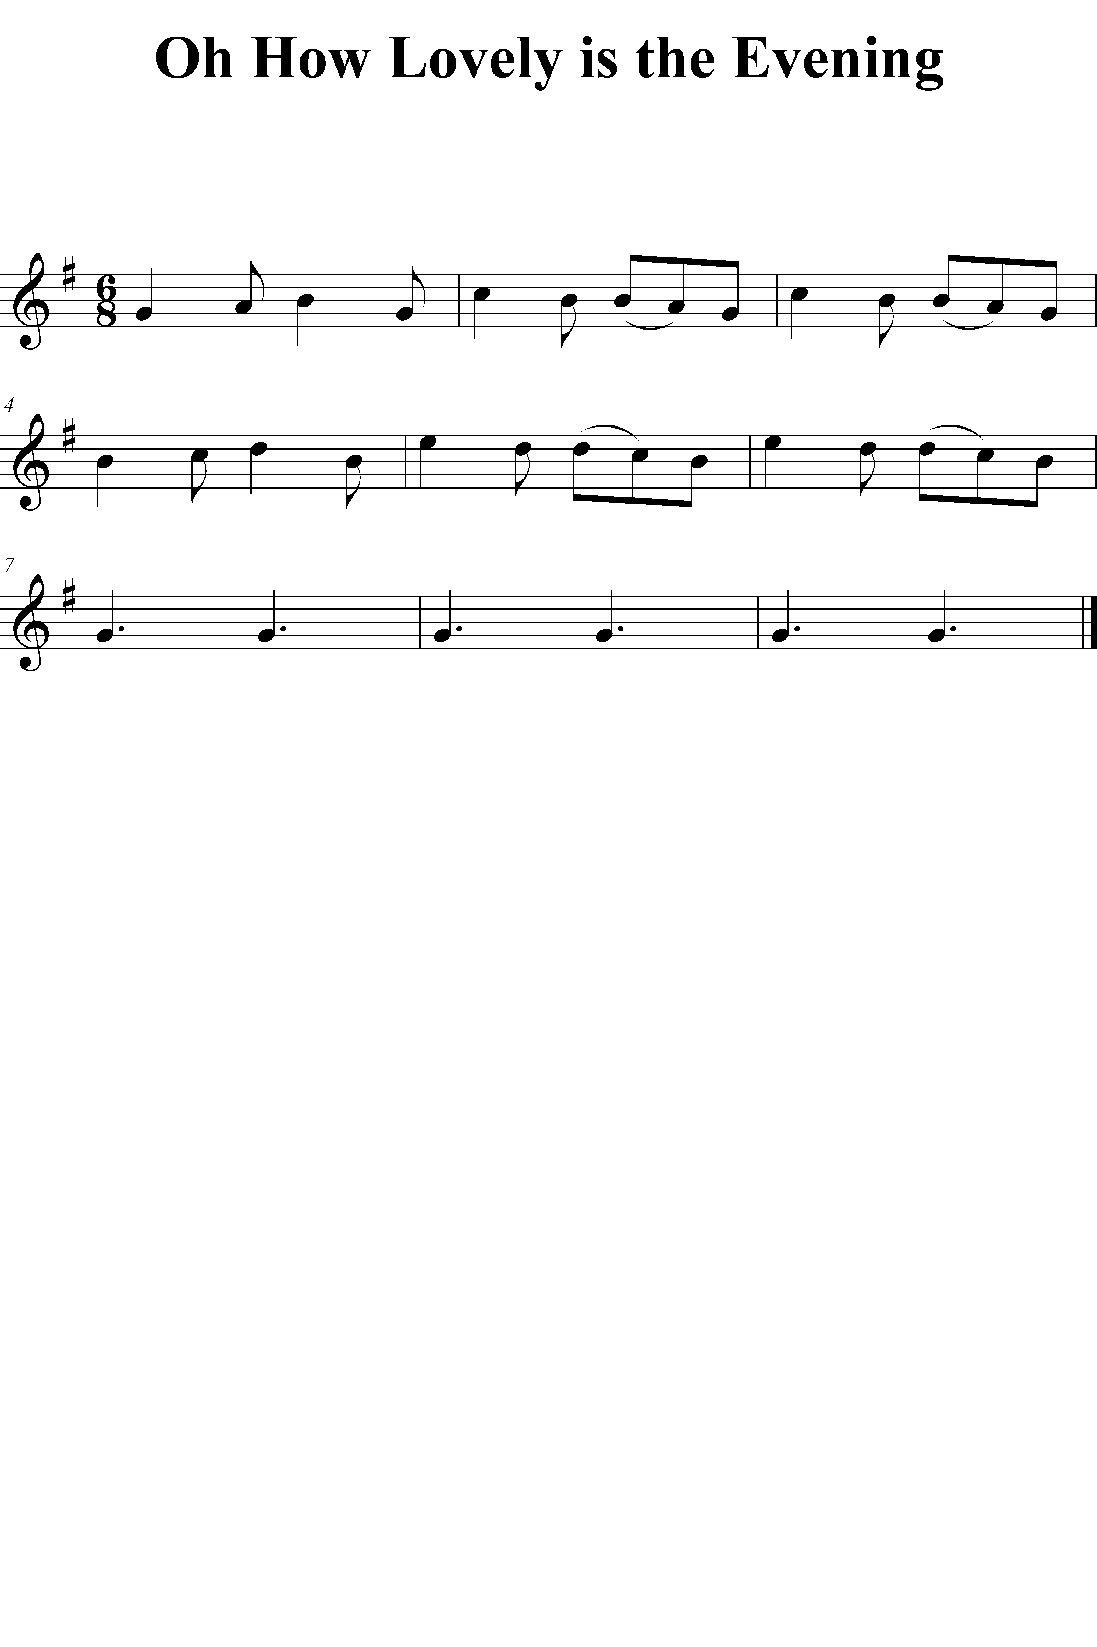

Lesson 14

Objective | Activity
LSA  Partial Synthesis— Duple/Triple– Divisions | - Listen to pairs of series of Duple and Triple patterns containing Divisions embedded in context of Macro- and Micro-beats. Identify the meter of each series.
Learn “Minor Mary Had a Little Lamb” | - Establish Major and sing “Mary Had a Little Lamb”  - Establish parallel Minor and sing minor version
Tone Development | - Low Note Slurs  - Octave Slurs  - Check mouthpiece pitch
Articulation | - Practice legato/staccato articulation with division patterns in duple, triple
Technique:  Perform “Mary Had a Little Lamb” in Major and Harmonic Minor | - Establish C-Do  - Model phrases and perform “Mary Had a Little Lamb” in upper register  - Establish A-La  - Model phrases and perform “Minor Mary Had a Little Lamb”
Practice identifying tonalities | - Perform two familiar tunes  - Identify tonality of each tune
Technique:  Play patterns in F-Do, D-La | - Establish F-Do  - Sing pattern with solfege syllable  - Play pattern  - Repeat with next pattern  - Repeat for D-La
Performance Activity | - Root melody of “Fais Do Do”
Follow up on LSA from Lesson 13 | - Listen to pairs of series of four patterns in Major and Minor tonalities with subdominant patterns sung with a neutral syllable. Identify the tonalities as Major or Harmonic Minor. Record correct identifications.
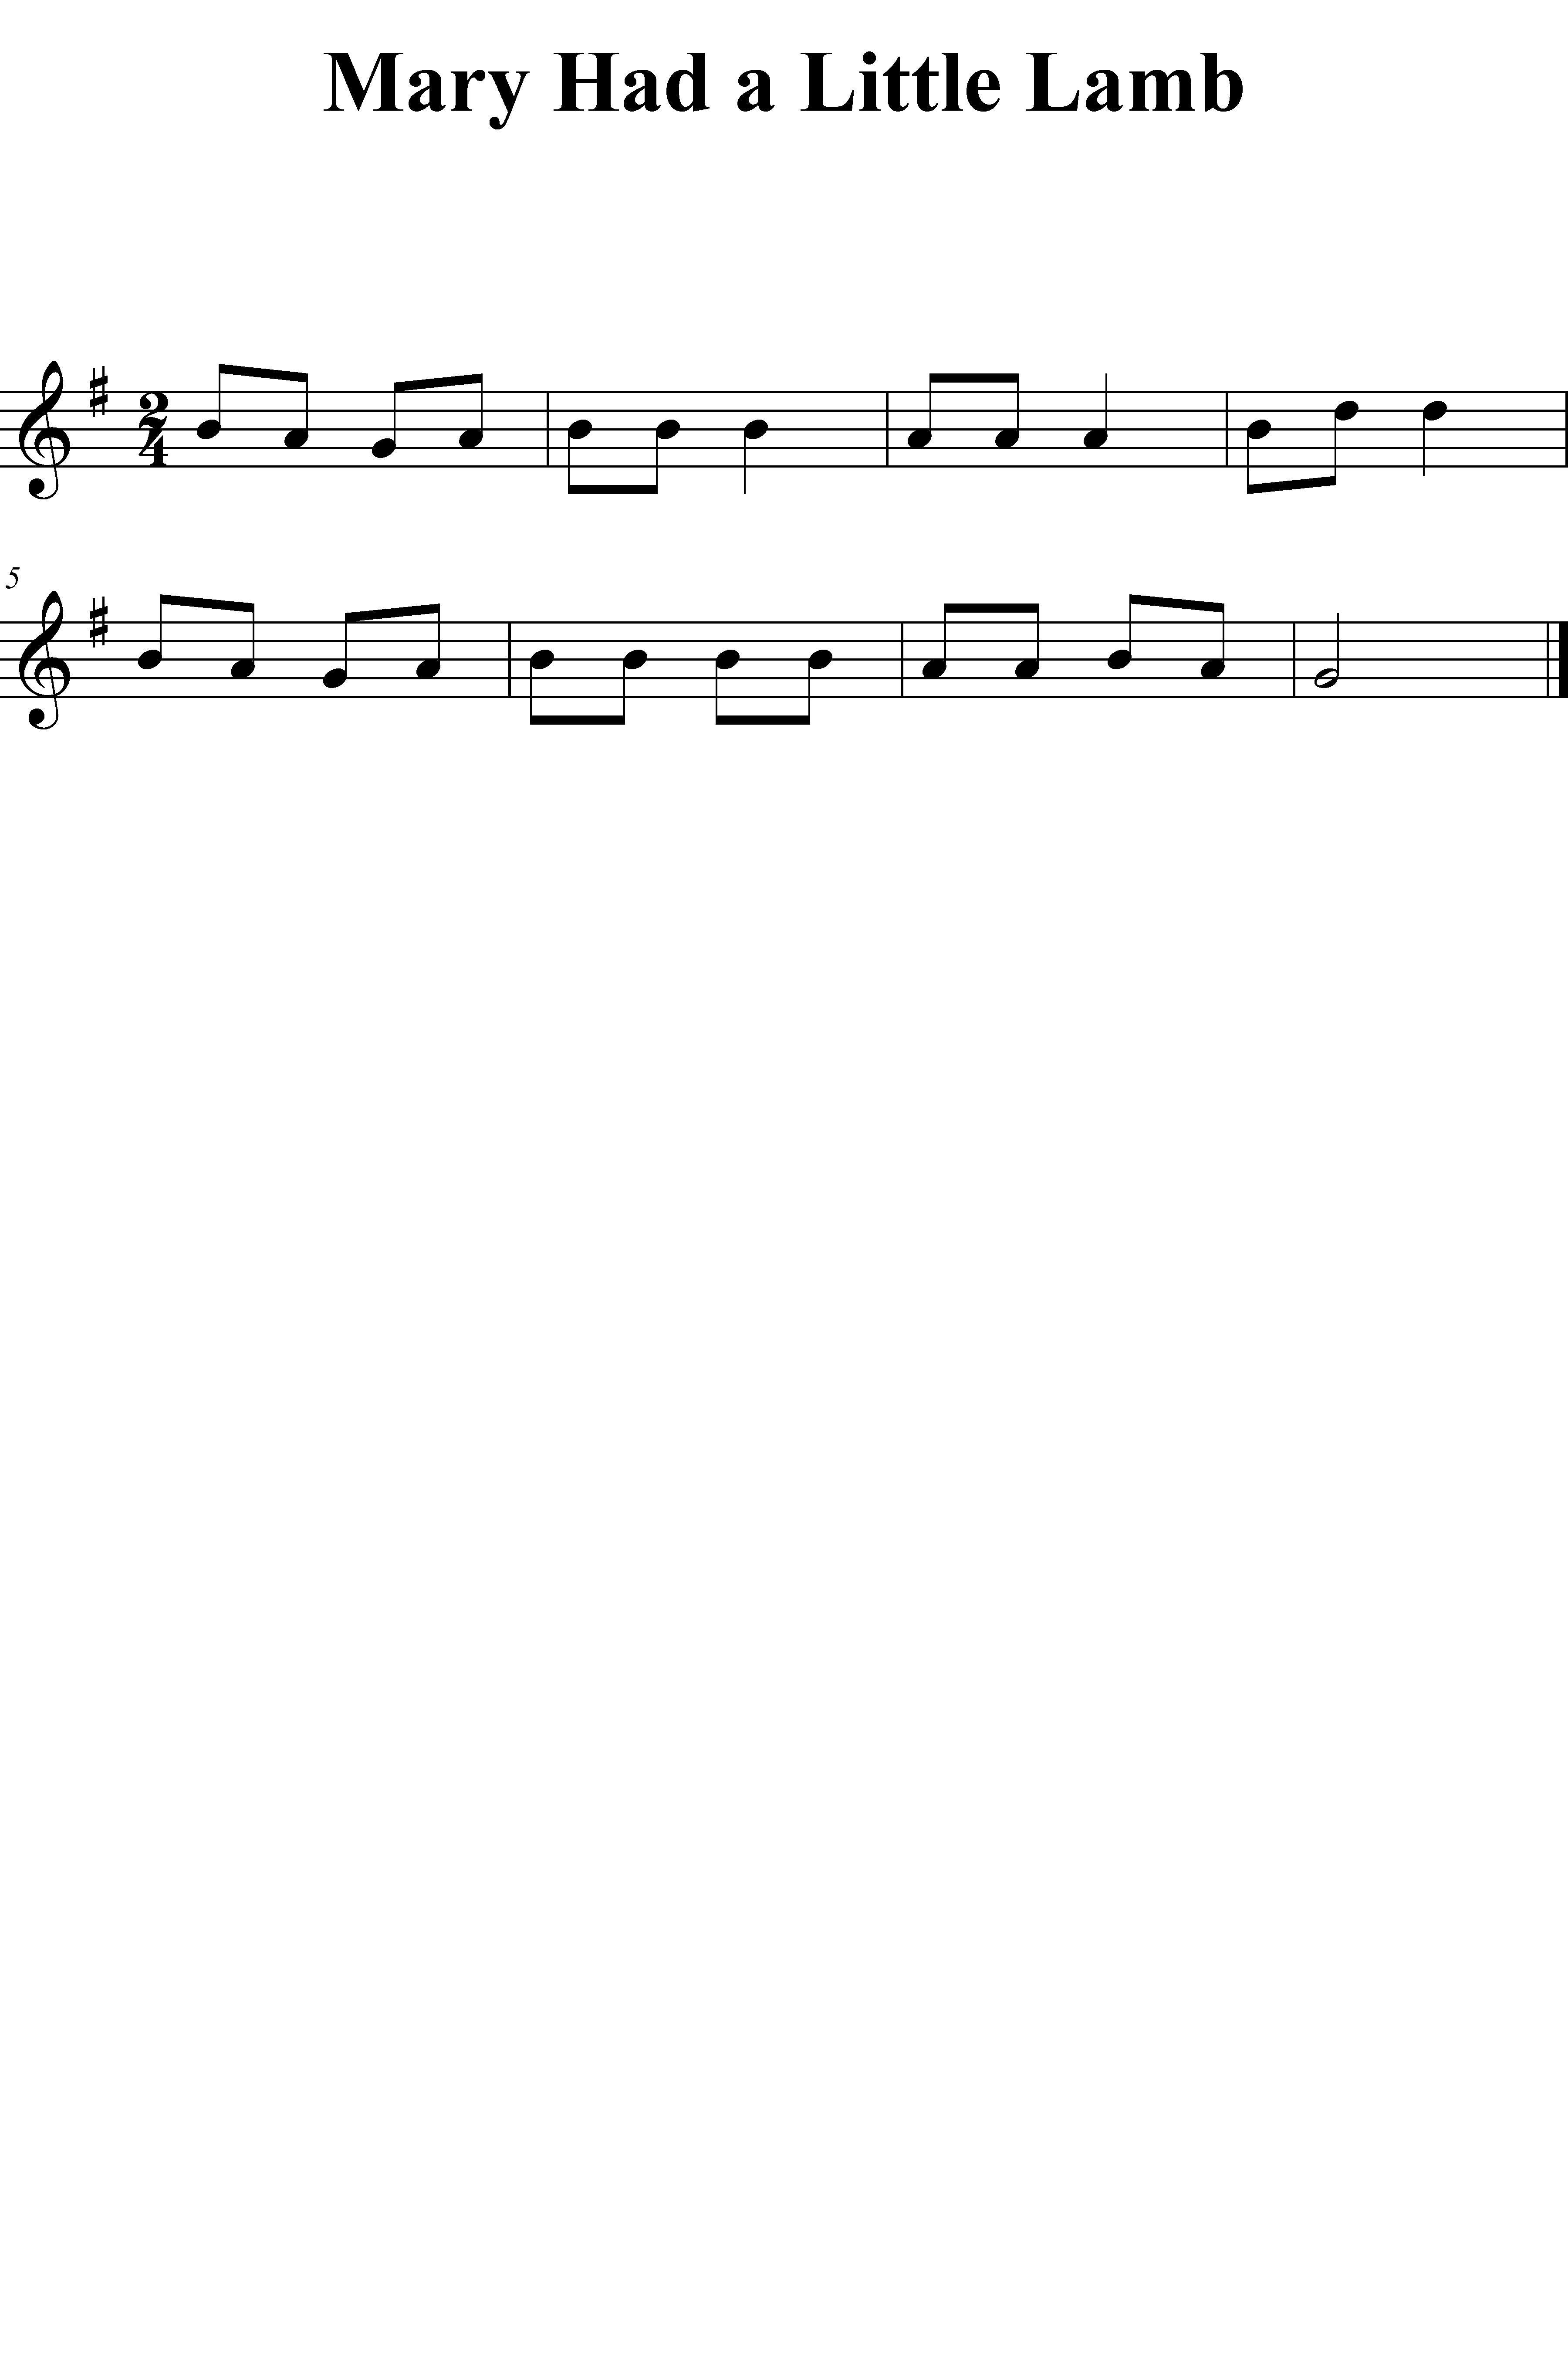
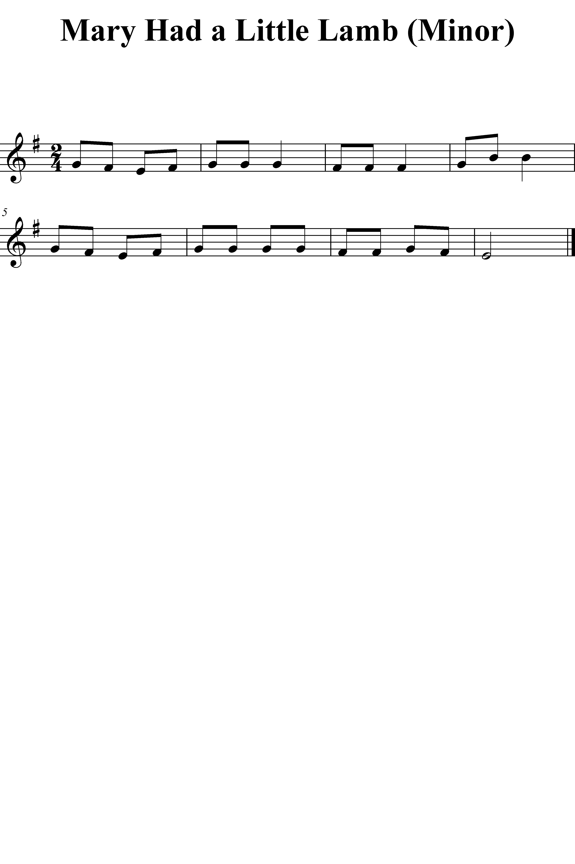

Lesson 15

Objective | Activity
LSA  Symbolic Association– Reading— Major/Minor– Tonic/Dominant | - Orient to staff and ‘Do’ Signature  - Echo-sing select Major– Tonic/Dominant patterns using solfege, then present notation form of patterns, sing patterns. E-Do, D-Do, B-Do, G-Do  - Echo-sing select Minor– Tonic/Dominant patterns using solfege, then present notation form of patterns, sing patterns. F-La, D-La, B-La, G-La
- Learn “Frere Jacques”
Tone Development | - Low Note Slurs: So\C-Do Fa\Ti Do/Mi\Do  - Octave Slurs
Articulation | - Practice legato/staccato articulation with division patterns in duple, triple
Technique:  Perform “Frere Jaques” across break | - Establish G-Do  - Mi/Fa/So So\Fa\Mi  - Model phrases and perform in G-Do  - Repeat in F-Do
Practice identifying meters | - Perform two familiar tunes  - Identify meters of each tune
Technique:  Pitch B0 | - Establish B-Do  - Teach pattern So\Mi\B0-Do  - Teach pattern So\Mi\B1-Do  - Teach pattern So\Fa\Re, demonstrating use of roller key in right hand fourth finger  - Model phrases and perform “Frere Jaques” in B-Do low range and upper range
Performance Activity: | - Harmonize “Coventry Carol”  - Perform “Row, Row, Row Your Boat” as round
Technique:  Play patterns in C-Do, A-La | - Establish C-Do  - Sing pattern with solfege syllable  - Play pattern  - Repeat with next pattern  - Repeat for A-La
Follow up on LSA from Lesson 14 | - Listen to pairs of series of Duple and Triple patterns containing Divisions embedded in context of Macro- and Micro-beats. Identify the meter of each series. Record successful identifications.
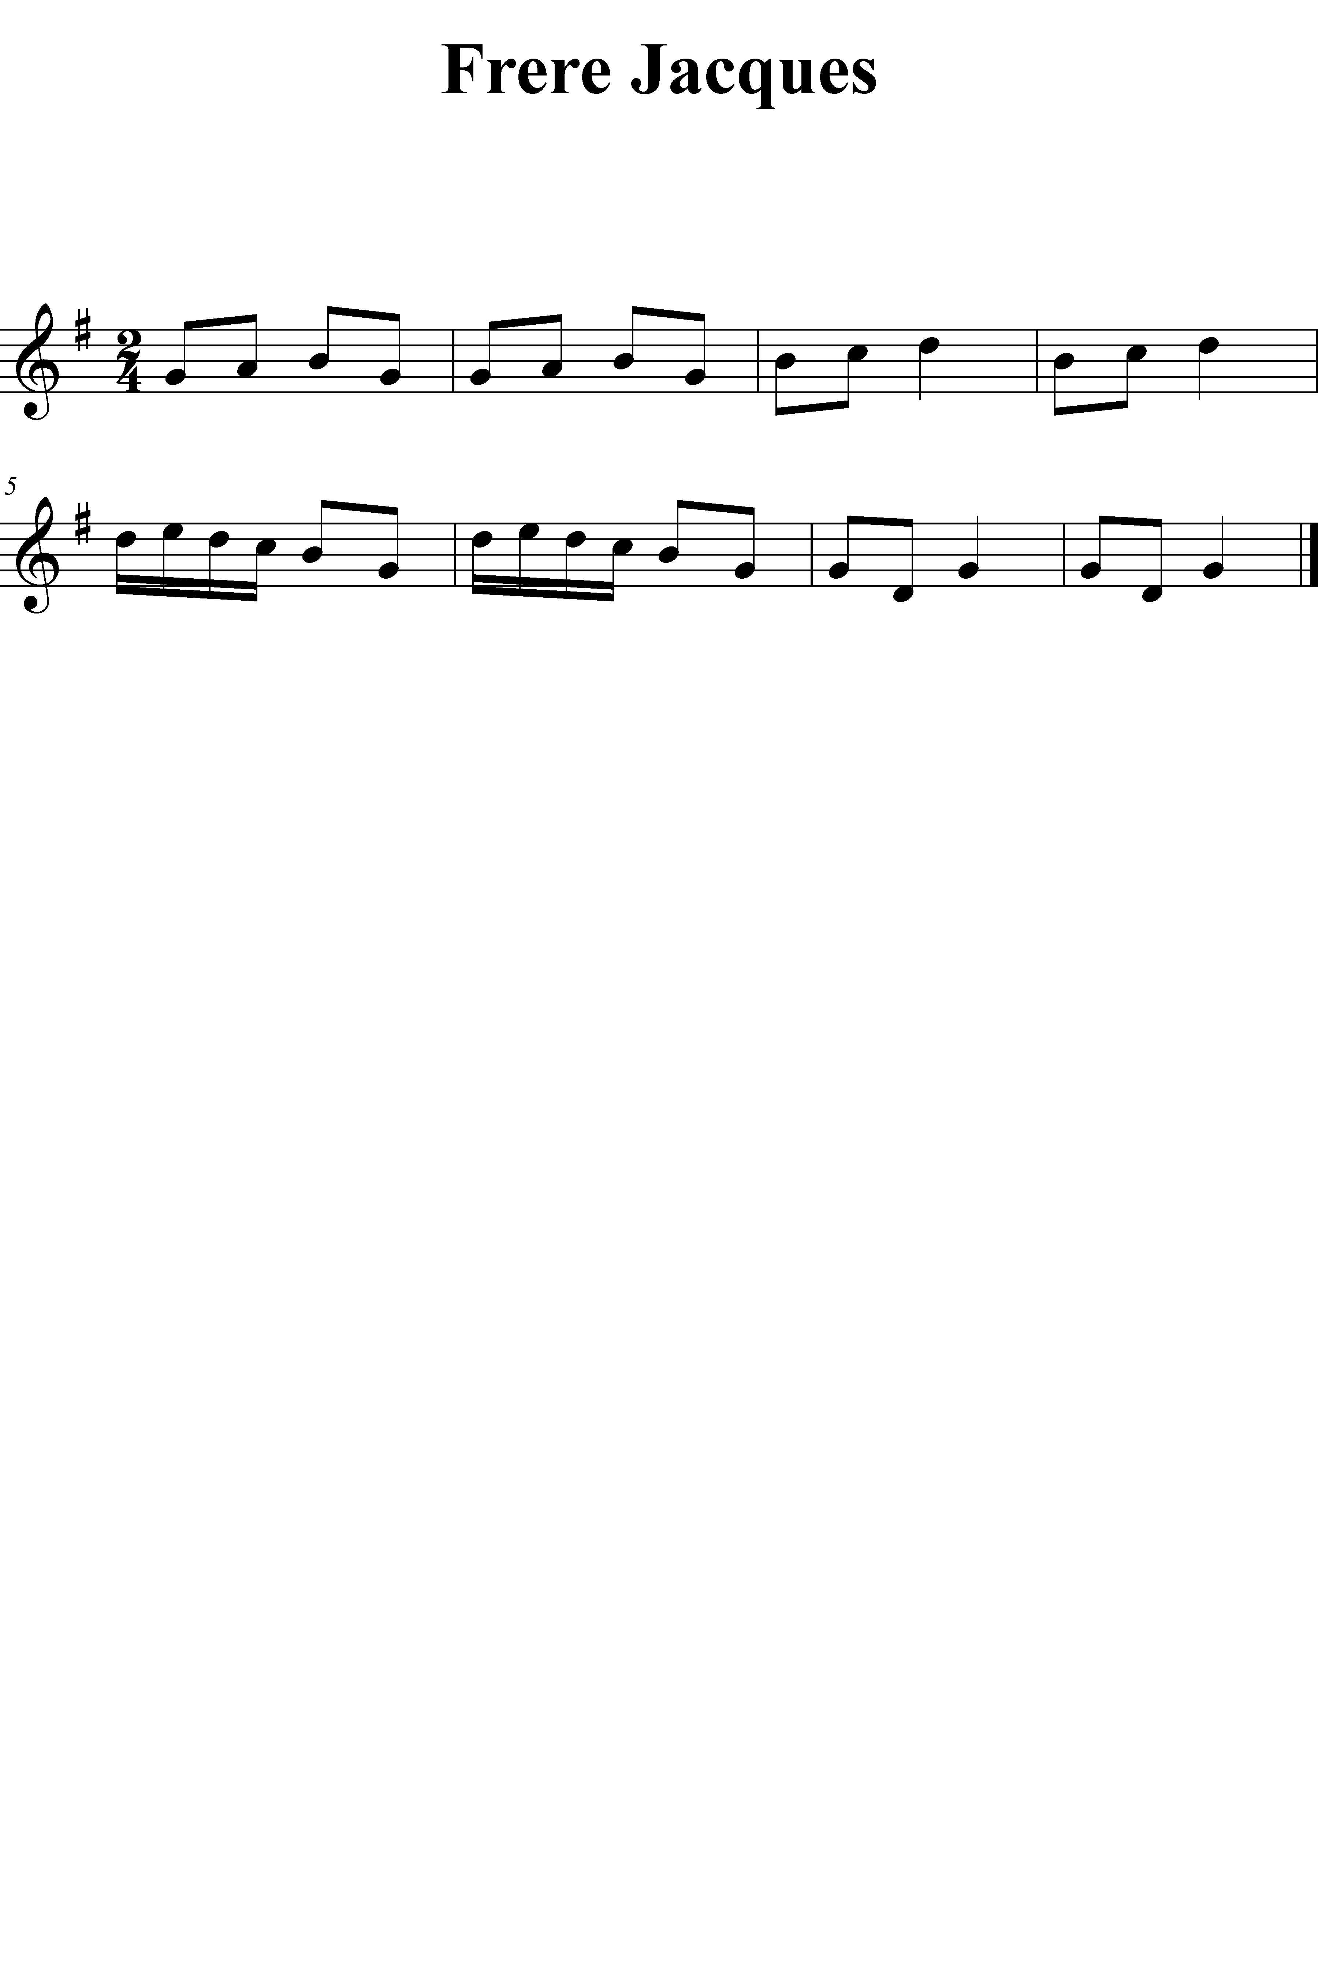

Lesson 16

Objective | Activity
LSA  Symbolic Association– Reading— Duple/Triple– Macro-beat/Micro-beat | - Orient to measure signature.  - Echo-chant select Duple– Macro-beat/Micro-beat patterns using rhythm syllables, then present notation form of patterns, chant patterns. Present in 2/4, 2/2, 4/4, 4/8  - Echo-chant select Triple– Macro-beat/Micro-beat patterns using rhythm syllables, then present notation form of patterns, chant patterns. Present in 6/8, 6/4, 3/8, 3/4
- Learn “Hatikvah”
Tone Development:  Oral Cavity control | - Low Note Slurs  - Octave Key Slurs  - Sustain upper octave without aid of octave key:  - Finger pitch with octave key; release octave key but sustain pitch at upper octave; slur down to lower octave by adjusting oral cavity
Technique:  Perform “Hatikvah” in E-La | - Establish E-La  - Model and perform “Hatikvah”
Articulation:  Mixed slurs and staccato | - Practice articulating on E-La to rhythm pattern [Du–Du-De]  - Chant Du-ut-Tu-Tu for articulation pattern  - Model articulation pattern on Micro-beat patterns of “Hatikvah”  - Perform in E-La
Technique:  Perform “Hatikvah” in G-La (new key) | - Establish G-La  - Mi\Do\G-La Mi\Re\Ti\Si  - Model and perform “Hatikvah” in G-La
Performance Activity:  Transpose select tunes to new keys  Vary articulation (legato, staccato, slurred, mixed)  Vary dynamics (loud–soft) | - Select from the following:  - “Major Duple” and “Major Triple” to D, B-Do  - “Minor Duple” and “Minor Triple” to G-La  - “Snake Dance” to A, G-La  - “Good Night, Ladies” to C, D, B-Do  - “Coventry Carol” to G-La  - “Row, Row, Row Your Boat” G, F, D, B-Do  - “America” G, F, D, B-Do  - “Joshua” A, G-La  - “Bingo” C, D, B-Do  - “Fais Do Do” D, B-Do  - “Oh How Lovely is the Evening” G, F, C, B-Do  - “Mary Had a Little Lamb” G, F, D, B-Do, E, D, G-La  - “Frere Jacques” C, D-Do  - “Hatikvah” D, A-La
Technique:  Play patterns in D-Do | - Establish D-Do  - Sing pattern with solfege syllable  - Play pattern  - Repeat with next pattern
Follow up LSA from lesson 15 | - Establish tonality  - Sing from notation several Major/Minor– Tonic & Dominant patterns, record successful readings.
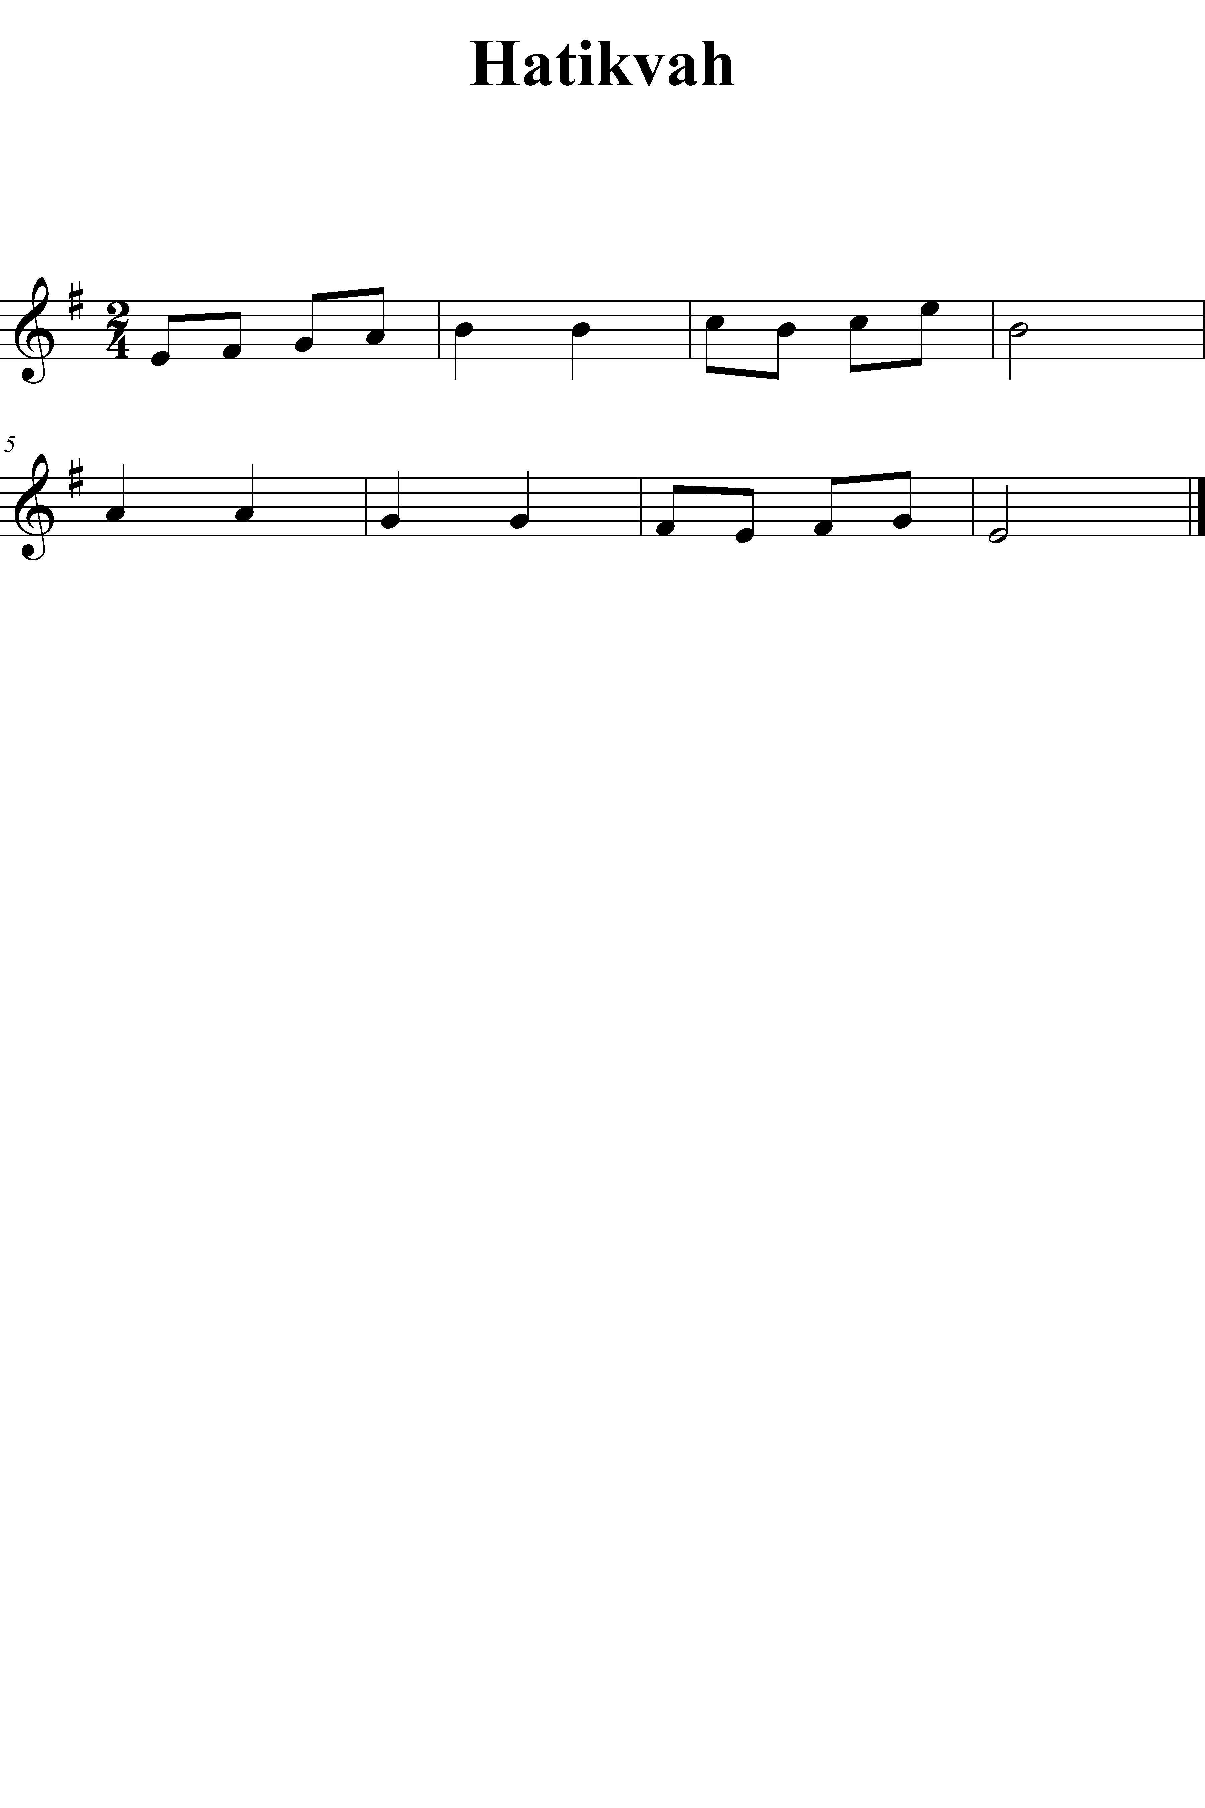

Lesson 17

Objective | Activity
LSA  Symbolic Association– Reading— Major/Minor– Subdominant | - Echo-sing Major– Subdominant patterns embedded in context of Tonic & Dominant, read notation and sing. E-Do, C-Do, A-Do, F-Do  - Echo-sing Minor– Subdominant patterns embedded in context of Tonic & Dominant, read notation and sing. E-La, C-La, B-La, G-La
- Learn “Angels We Have Heard On High”
Tone Development | - Low Note Slurs:  - La\Fa So\Mi Fa\Re Mi\B0-Do  - Octave key flicks:  - According to rhythm pattern [Du—Ta Du— Ta] slur from lower octave on Macro-beat to upper octave on division and back.
Articulation:  Mixed slurs and staccato | - Chant Tu-Tu-Tu-ut and apply to Micro-beat patterns of “Hatikvah” and other tunes with such patterns
Technique:  Pitches D3 (LSK1) | - Establish F-Do  - Do/Mi/So Do/Fa/La So/La\So  - Model “Angels We Have Heard On High”, perform in upper range  - Perform “Frere Jacques”  - Establish B-Do  - Mi\Do Do/Mi  - Perform “Major Duple” or “Major Triple” in high range  - Establish D-Do  - Do\So/Do  - Perform “Row, Row, Row Your Boat”
Technique:  Read patterns in G-Do, E-La | - Establish G-Do  - Echo-sing pattern with solfege syllable from notation, fingering pattern  - Play pattern  - Repeat with next pattern  - Repeat for E-La
Performance Activity | - Root Melody of “Hatikvah”
Follow Up on LSA from lesson 16 | - Demonstrate ability to read select familiar patterns:  - Establish tempo and perform familiar patterns from notation in duple and triple, recording successfully performed patterns

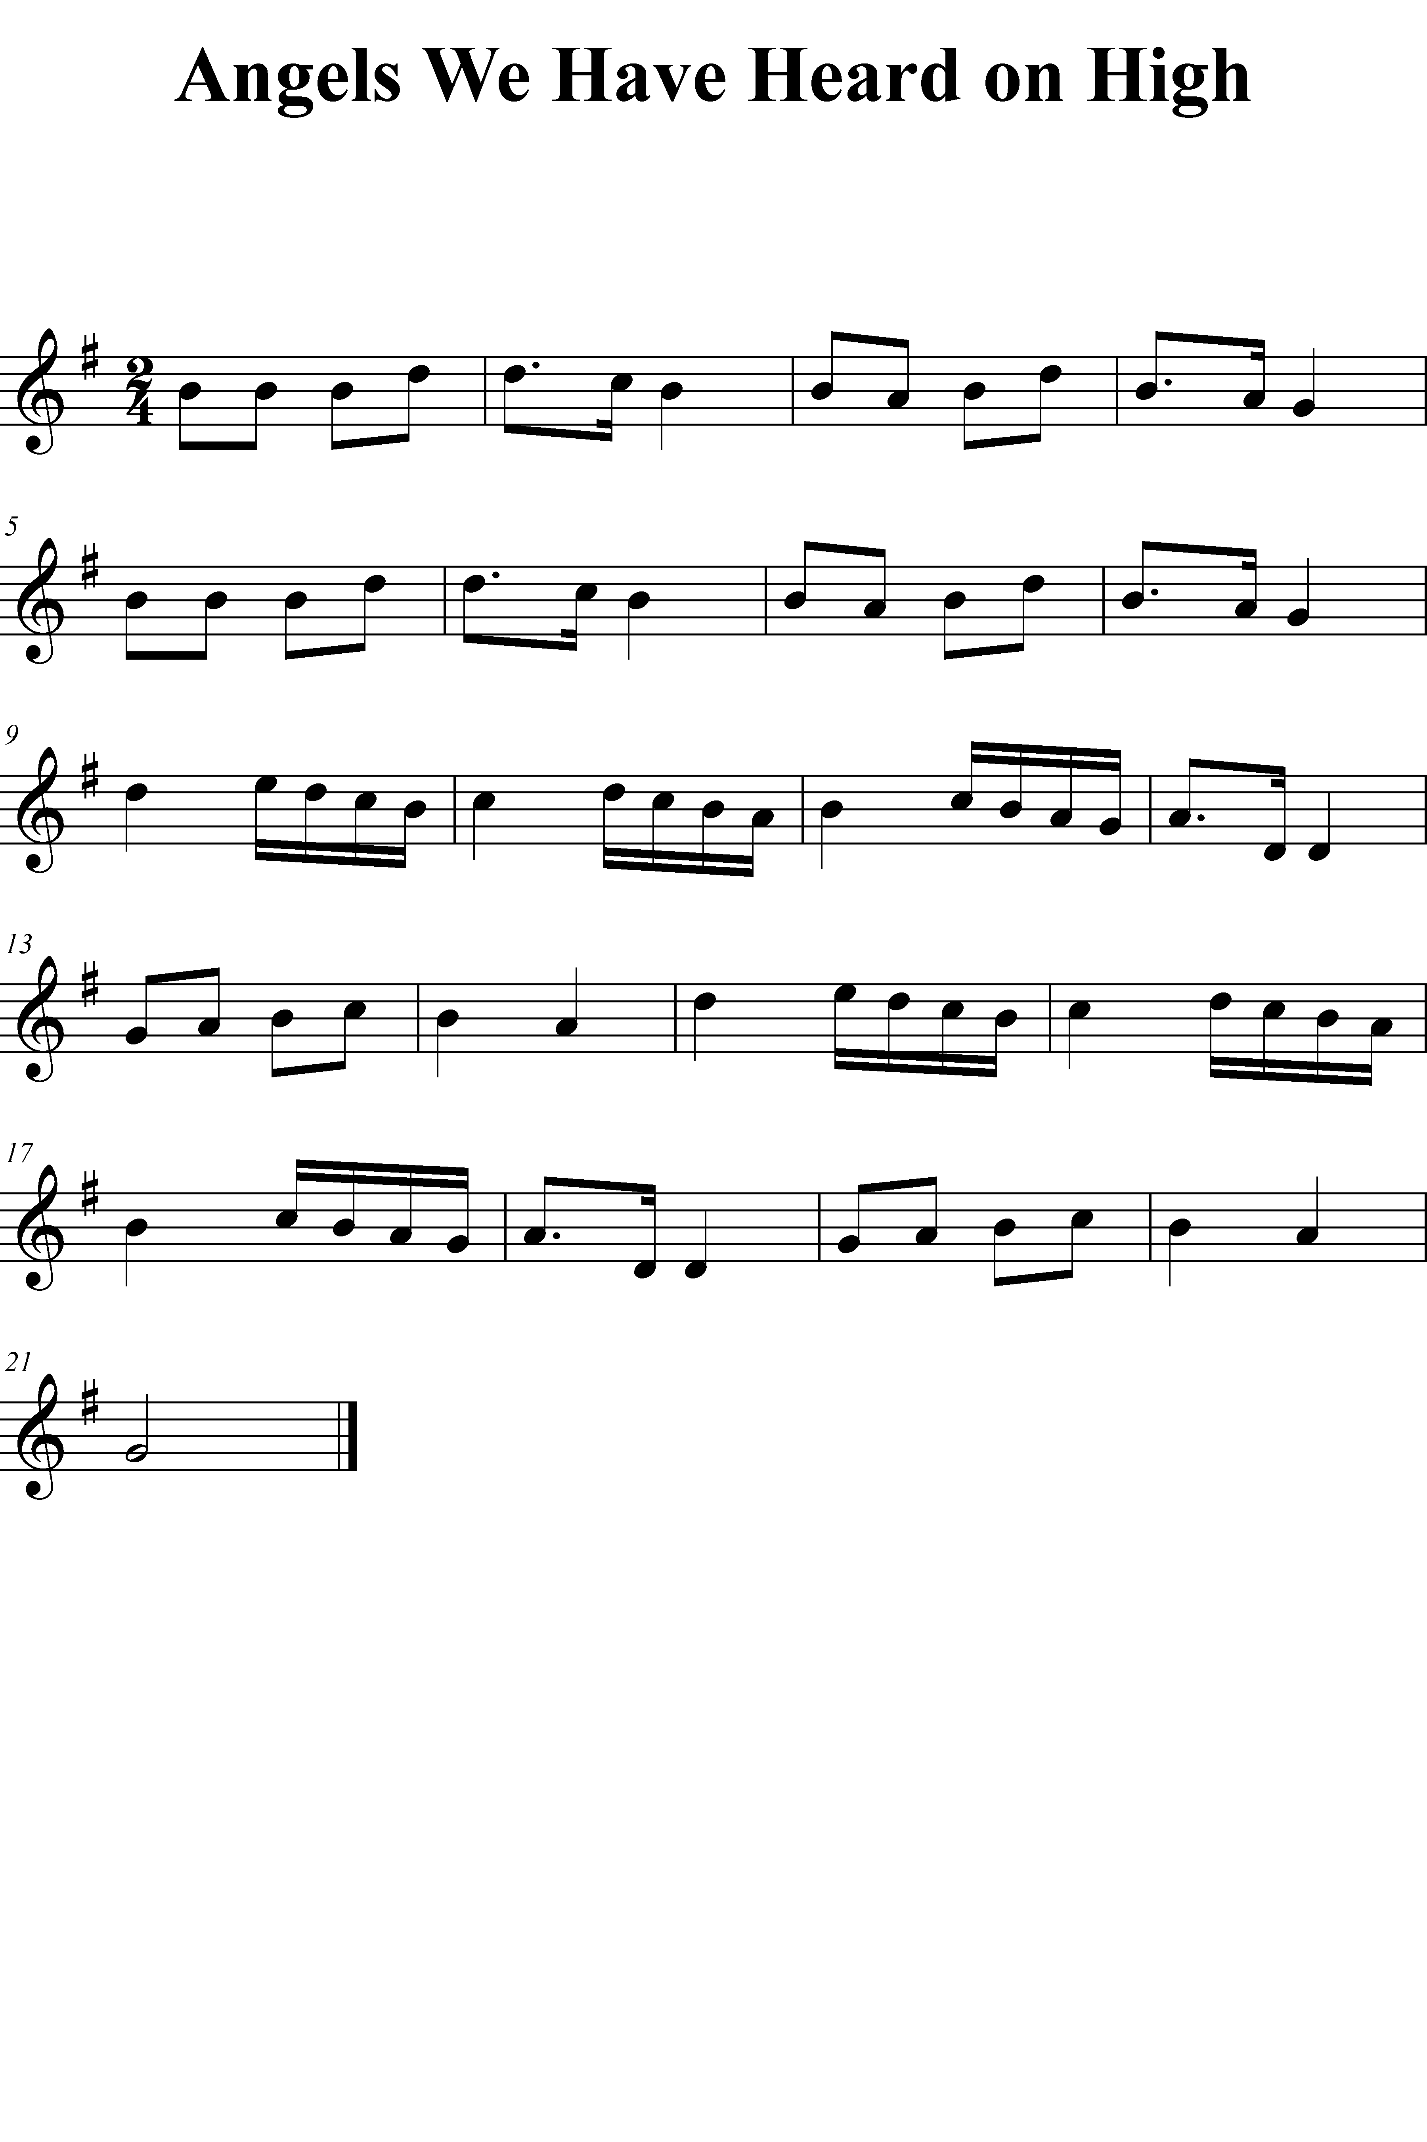

Lesson 18

Objective | Activity
LSA  Symbolic Association– Writing— Duple/Triple– Macro-beats & Micro-beats | - Establish duple meter  - Show notation for familiar pattern and echo-chant  - Write notation; use a variety of duple meters  - Repeat for next pattern  - Establish triple meter and repeat for familiar triple patterns; use variety of triple meters
Learn “Greensleeves” | - Sing “Greensleeves” with special attention to modulation
Tone Development | - Low Note Slurs  - Octave Flicks  - Overtone Exercise (Sustaining octave without octave key)
Articulation: | - Practice legato articulation on two macro-beats, two macro-beats of micro-beats, two macro-beats of divisions, and two macro-beats in duple and triple  - Repeat with staccato articulation
Technique:  Perform “Greensleeves” | - Establish E-La  - Mi/Fi\Mi La\So/La in upper range  - Model first phrases in E-La and perform  - Establish D-Do  - Model phrases from D-Do in second half  - Reestablish E-La  - Si\Fi/Si  - Model remainder of phrases from second half  - Reestablish D-Do  - Model complete second half  - Perform “Greensleeves” in E-La in upper range  - Perform in low range
Technique:  Read patterns in F-Do, D-La | - Establish F-Do  - Echo-sing pattern with solfege syllable from notation, fingering pattern  - Play pattern  - Repeat with next pattern  - Repeat for D-La
Performance Activity | - Root melody of “Oh, How Lovely is the Evening”
Follow up on LSA from lesson 17 | - Establish tonality  - Sing from notation several Major and Minor– Tonic, Dominant and Subdominant patterns; record successful readings.
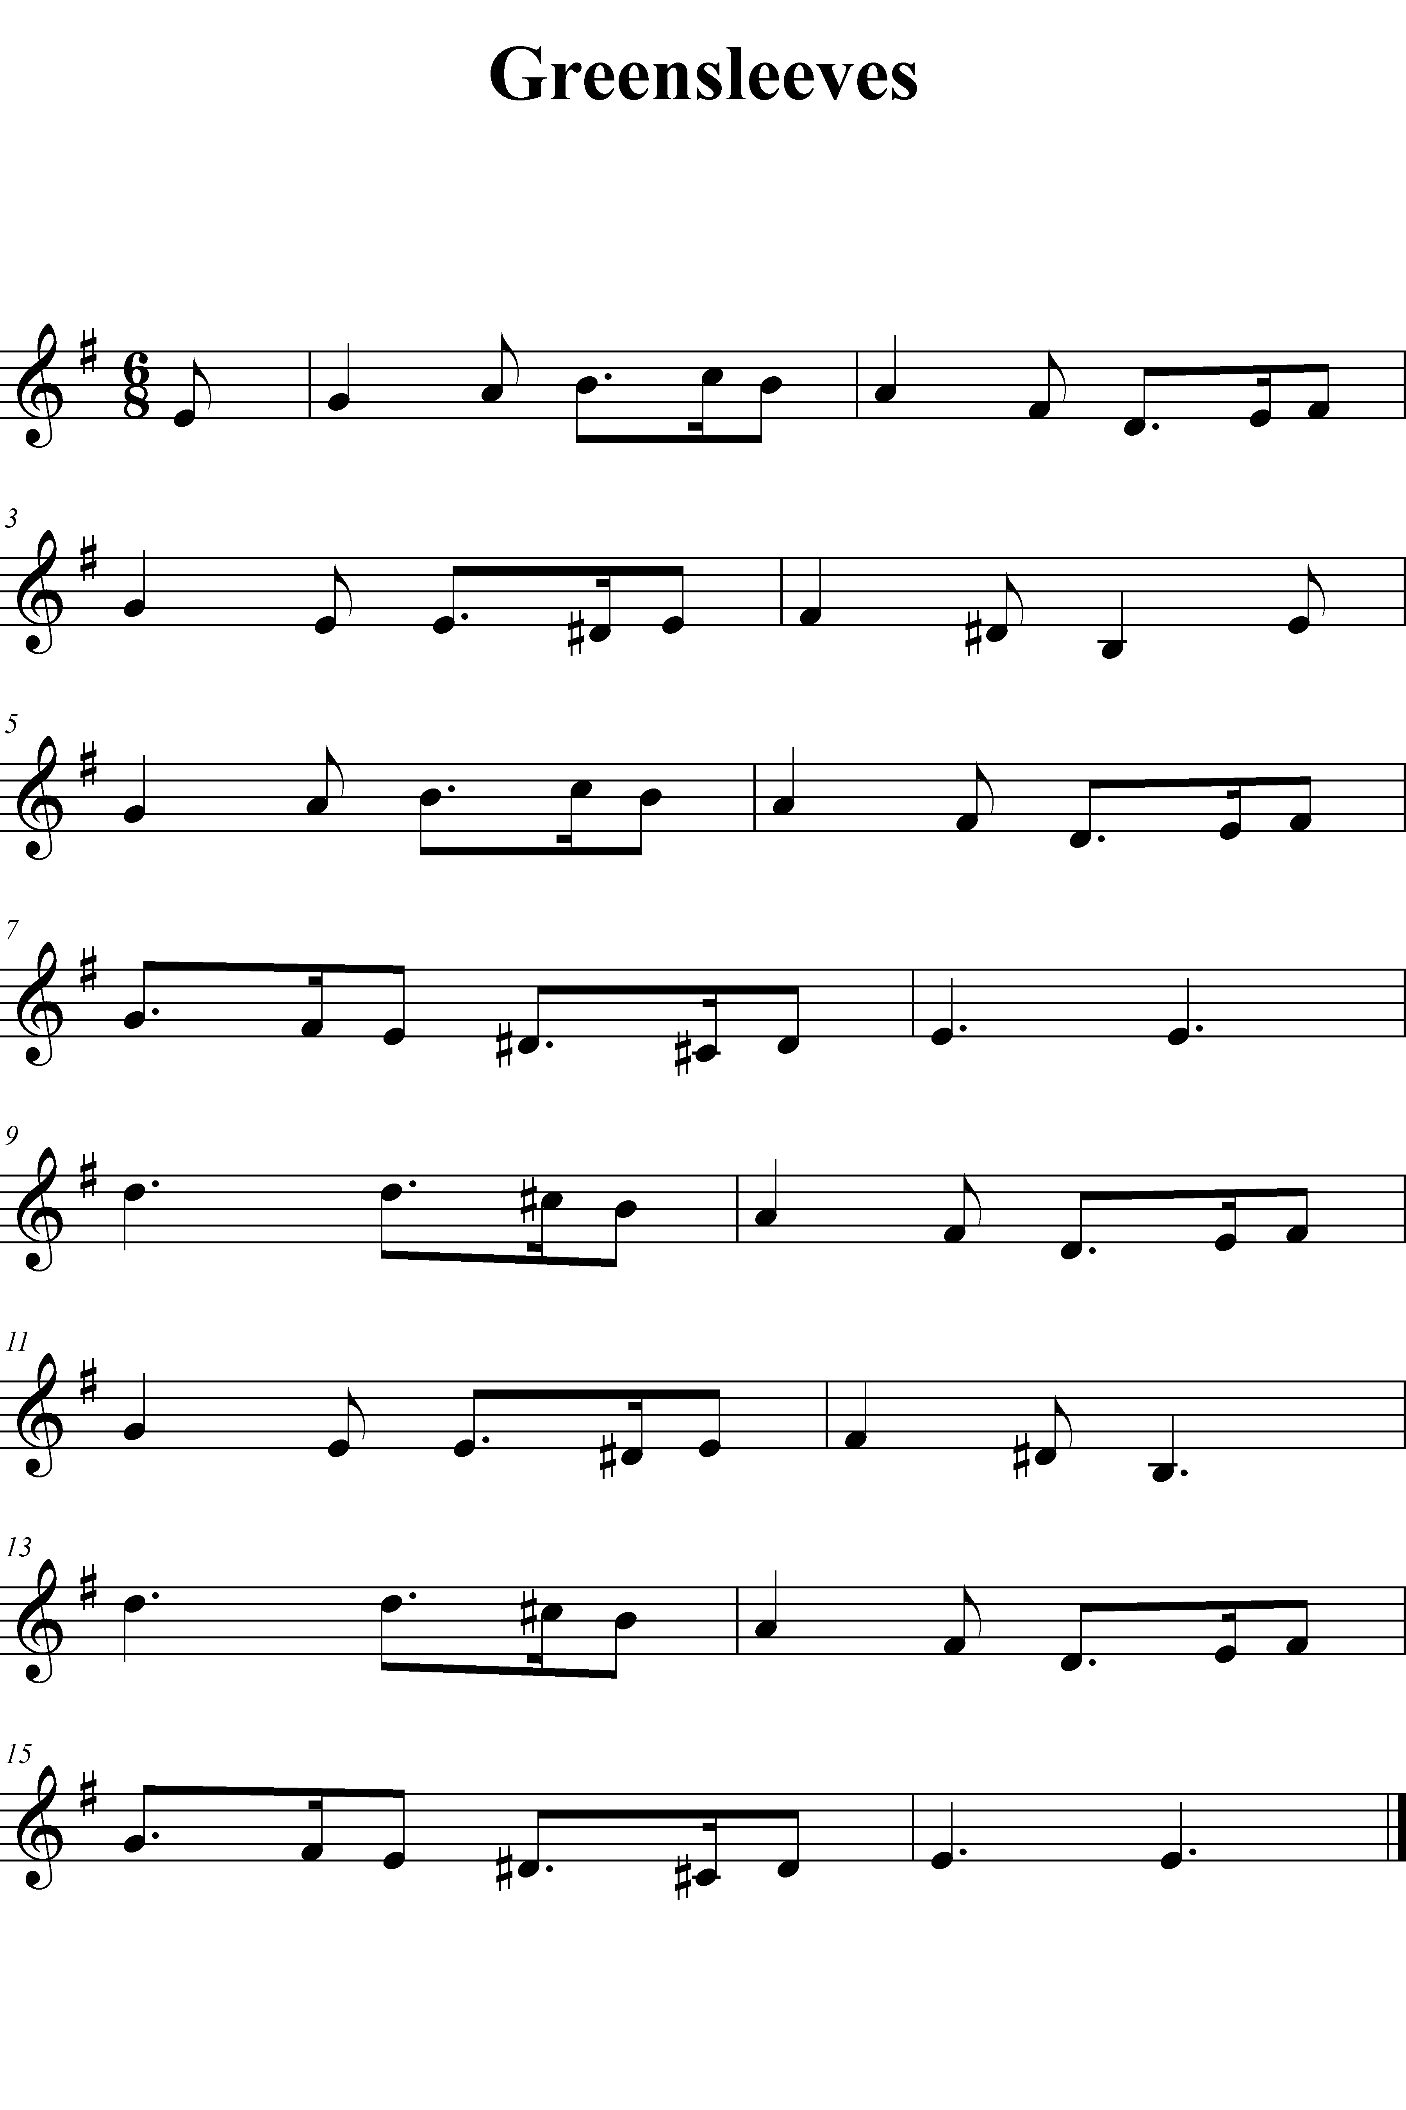

Lesson 19

Objective | Activity
LSA  Symbolic Association– Writing— Major/Minor– Tonic & Dominant | - Establish major tonality  - Show notation for familiar pattern and echo-sing  - Write notation  - Repeat for next pattern  - Establish minor tonality and repeat for familiar triple patterns
- Learn “Sweet Betsy from Pike”
Tone Development | - Low Note Slurs  - Octave Flicks  - Overtone Exercise  - Model piano–mezzo-piano–mezzo-forte–forte  - Perform, then model reverse order and perform
Articulation | - Practice legato articulation on two macro-beats, two macro-beats of micro-beats, two macro-beats of divisions, and two macro-beats in duple and triple  - Repeat with staccato articulation
Technique:  Perform “Sweet Betsy from Pike” | - Establish D-Do  - Model phrases and perform in D-Do  - Establish B-Do  - Model phrases and perform in B-Do, lower and upper register
Technique:  Play patterns in B-Do | - Establish B-Do  - Sing pattern with solfege syllable  - Play pattern  - Repeat with next pattern
Performance activity | - Accompaniment pattern for “Major Duple”/”Major Triple”
Follow up on LSA from Lesson 18 | - Establish meter  - Echo-chant duple and triple patterns and write in variety of meters, record successfully written patterns
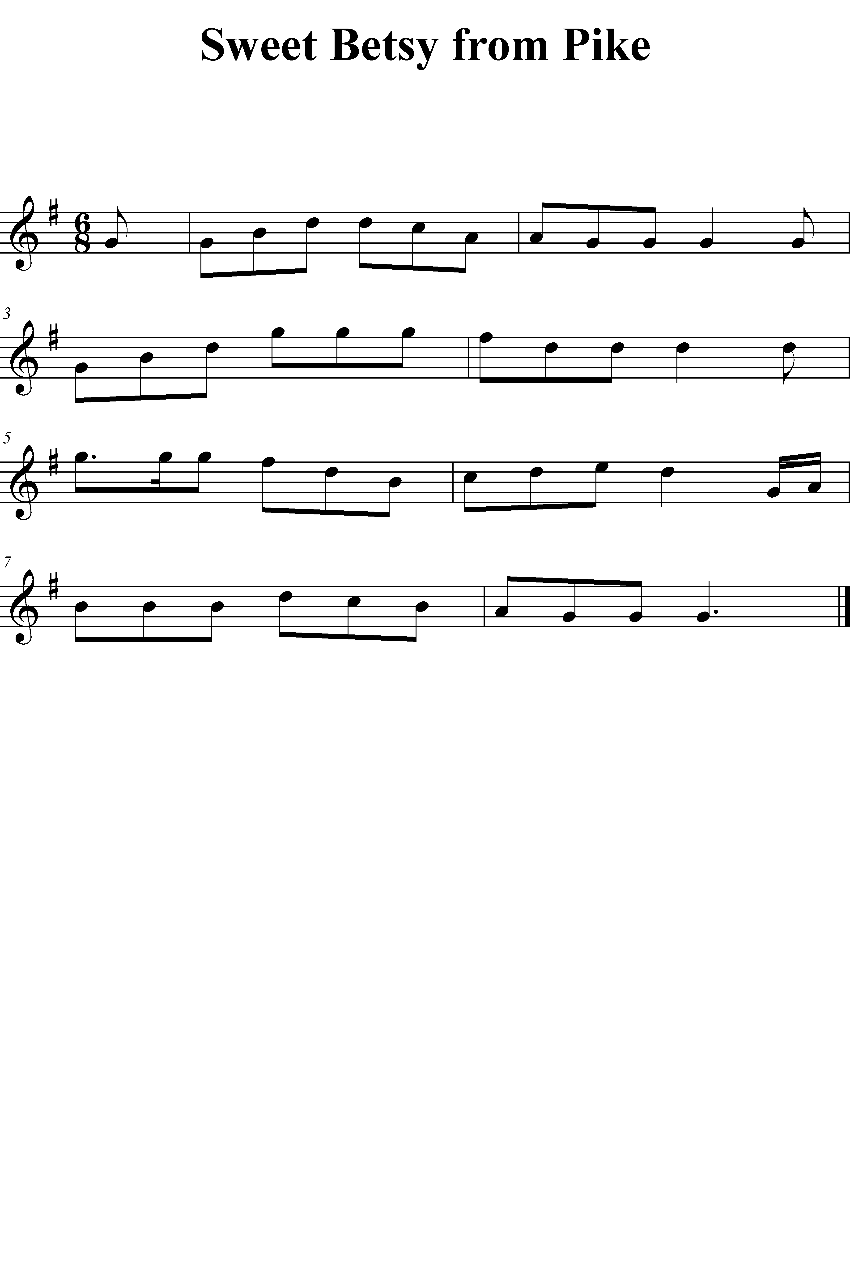

Lesson 20

Objective | Activity
LSA  Symbolic Association– Reading— Duple/Triple– Divisions | - Echo-chant select Duple– Division patterns using rhythm syllables, then present notation form of patterns, chant patterns. Present in 2/4, 2/2, 4/4, 4/8  - Echo-chant select Triple– Division patterns using rhythm syllables, then present notation form of patterns, chant patterns. Present in 6/8, 6/4, 3/8, 3/4
- Learn “Song of the Volga Boatmen”
Tone Development | - Low Note Slurs So\Ti C-Do/Mi\Do  - Octave Key Flicks– Begin in upper register, flick down  - Overtone Exercise
Articulation | - Model accented notes  - Practice legato articulation on two macro-beats, two macro-beats of micro-beats, two macro-beats of divisions, and two macro-beats in duple and triple, exaggerating accent on all macro-beats  - Repeat with staccato articulation
Technique:  Perform “Volga Boatmen” | - Establish B-La  - Do\B0-La Re\La  - Model phrases, perform in B0-La  - Establish A-La and perform  - Establish E-La and perform in upper register
Technique:  Play patterns in G-La | - Establish G-La  - Sing pattern with solfege syllable  - Play pattern  - Repeat with next pattern
Performance Activity | - Harmonize “Joshua”
Follow up on LSA from lesson 19 | - Establish tonalities  - Echo-chant Major and Minor patterns and write in variety of keyalities, record successfully written patterns


Lesson 21

Objective | Activity
LSA  Symbolic Association– Writing— Major/Minor– Subdominant | - Establish major tonality  - Show notation for familiar pattern and echo-sing  - Write notation  - Repeat for next pattern  - Establish minor tonality and repeat for familiar triple patterns
Learn “Ode to Joy” | - Listen to recording of Symphony No. 9 Theme (Beethoven)  - Sing “Ode to Joy”
Tone Development | - Low Note Slur G-Do\Fa Ti\Mi  - Octave Flicks  - Overtone  - Check mouthpiece pitch
Articulation | - Establish tempo and meter  - Legato articulate micro-beats with accent on micro-beat  - Repeat with staccato
Technique:  Perform “Ode to Joy” | - Establish G-Do  - Model phrases and perform in upper register  - Establish F-Do  - Model phrases and perform in low register  - Establish B-Do  - Model phrases and perform
Technique:  Read patterns in C-Do, A-La | - Establish C-Do  - Echo-sing pattern with solfege syllable from notation, fingering pattern  - Play pattern  - Repeat with next pattern  - Repeat for A-La
Performance Activity | - Accompaniment to “Good Night, Ladies”
Follow up on LSA from Lesson 20 | - Demonstrate ability to read select familiar patterns:  - Establish tempo and perform familiar Division patterns from notation in duple and triple, recording successfully performed patterns
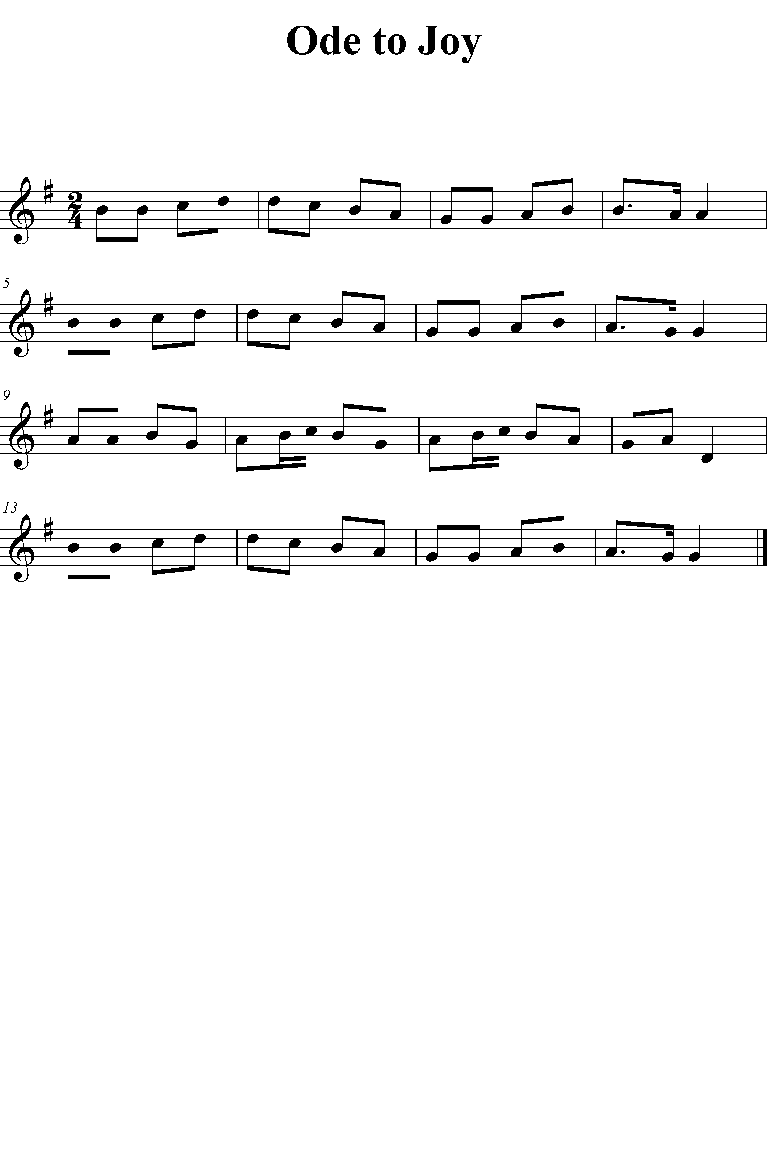

Lesson 22

Objective | Activity
LSA  Symbolic Association– Writing— Duple/Triple– Divisions | - Establish duple meter  - Show notation for familiar Division pattern and echo-chant  - Write notation; use a variety of duple meters  - Repeat for next pattern  - Establish triple meter and repeat for familiar triple patterns; use variety of triple meters
Learn Theme from ”L’arlesienne Suite No. 1" | - Listen to recording of “L’arlesienne Suite No. 1"  - Sing Theme
Tone Development | - Introduce mouthpiece flexibility exercise  - Establish Concert A  - Do\Ti/Do  - Perform on mouthpiece  - Low Note Slurs  - Octave Key Flicks from above  - Overtone exercise
Articulation:  Coordination | - Establish tonality, tempo and meter  - Learn melodic pattern Do/Re/Mi/Fa/So-So [Du-De-Du-De Du Du] and So\Fa\Mi\Re\Do in C, F, B, G, D-Do  - Practice legato articulation, then staccato
Technique:  Pitch A1, 2 (RSK 1) compare to (bis) | - Establish B-La  - Do\La Ti\Si La\Mi/La  - Perform “Minor Triple” in B-La  - Model phrases, perform Theme from “L’arlessienne Suite No. 1" in B-La  - Establish A-La  - Model and perform
Technique:  Play patterns in B-La | - Establish B-La  - Sing pattern with solfege syllable  - Play pattern  - Repeat with next pattern
Performance Activity | - Accompany “Coventry Carol”
Follow Up on LSA from lesson 21 | - Establish tonalities  - Echo-chant Major/Minor– Tonic/Dominant/Subdominant patterns and write in variety of meters, record successfully written patterns
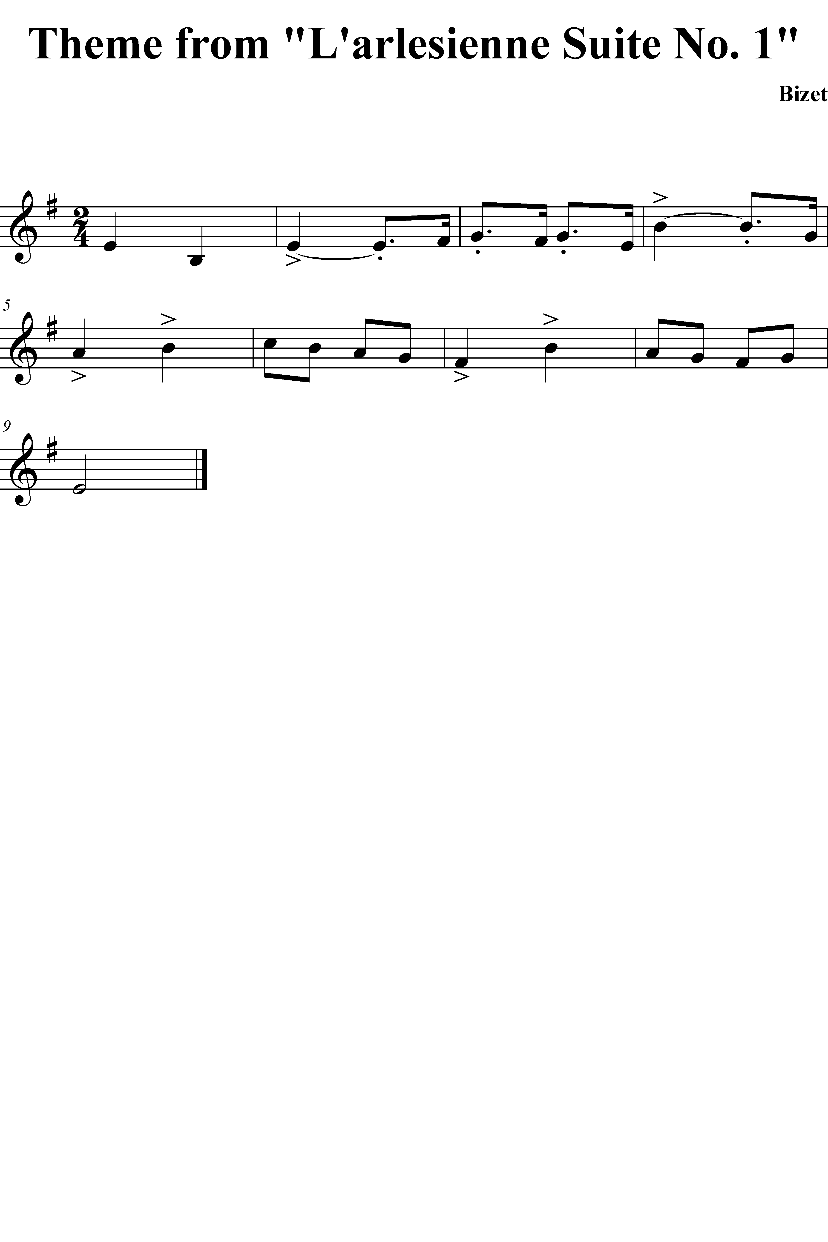

Lesson 23

Objective | Activity
LSA  Composite Synthesis– Reading— Major/Minor– Tonic/Dominant | - Present notation for pairs of series of four familiar Major/Minor– Tonic/Dominant patterns in unfamiliar order  - Identify tonality  - Establish tonality and sing series of patterns
- Learn “Man on the Flying Trapeze”
Tone Development | - Mouthpiece flexibility exercise  - Low Note Slur  - Octave Flicks  - Overtone exercise
Articulation | - Establish tonality, tempo and meter  - Learn melodic pattern La/Ti/Do/Re/Mi Mi [Du-De-Du-De Du Du] and Mi\Re\Do\Ti\La in A, D, G, E, B-La  - Practice legato articulation, then staccato
Technique:  Perform “Man on the Flying Trapeze”  Pitch E3 (LSK 1,2) | - Establish B-Do  - La/Fa Do/Fa  - Model and perform “Man on the Flying Trapeze”
Technique:  Read patterns in D-Do, B-La | - Establish D-Do  - Echo-sing pattern with solfege syllable from notation, fingering pattern  - Play pattern  - Repeat with next pattern  - Repeat for B-La
Performance Activity | - Root melody of “Greensleeves”
Follow up on LSA from lesson 22 | - Establish meters  - Echo-chant Duple/Triple– Division patterns and write with a variety of meter signatures, record successfully written patterns.

Lesson 24

Objective | Activity
LSA  Composite Synthesis– Reading— Duple/Triple– Macro-beat & Micro-beat | - Present notation for pairs of series of four familiar Duple/Triple– Macro-beat/Micro-beat patterns in unfamiliar order  - Identify meter  - Establish meter and chant series of patterns
- Learn “We Three Kings”
Tone Development | - Mouthpiece flexibility exercise  - Low Note Slur  - Octave Flicks  - Overtone exercise
Articulation | - Establish tonality, tempo and meter  - Learn melodic pattern Do/Re/Mi Fa/So/La So-So So [Du-Da-Di Du-Da-Di Du-Di Du] and So\La\So Fa\Mi\Re Do-Do Do in C, F, B, G, D-Do  - Practice legato articulation, then staccato
Technique:  Perform “We Three Kings” | - Establish E-La  - Model and perform first phrases  - Establish G-Do  - Ti/Re  - Model and perform second half phrases  - Reestablish E-La  - Perform entire tune  - Establish G-La  - Perform entire tune
Technique:  Read patterns in B-Do, G-La | - Establish B-Do  - Echo-sing pattern with solfege syllable from notation, fingering pattern  - Play pattern  - Repeat with next pattern  - Repeat for G-La
Performance Activity | - Perform “Frere Jacques” as round
Follow up for LSA from Lesson 23 | - Present notation for pairs of series of four familiar Major/Minor– Tonic/Dominant patterns in unfamiliar order  - Identify tonality  - Establish tonality and sing series of patterns  - Record successfully read series’

Lesson 25

Objective | Activity
LSA  Composite Synthesis– Writing— Major/Minor– Tonic & Dominant | - Specify appropriate Do signature  - Echo-sing series of four Major/Minor– Tonic/Dominant patterns  - Write series of patterns
- Learn Minuet in G Major (Bach)
Tone Development | - Low Note Slur  - Octave Flicks  - Overtone exercise  - Pitch bend exercise:  - Establish D-Do  - D3-Do\Ti/Do  - Perform Do\Ti/Do without change of fingering by adjusting oral cavity
Articulation | - Establish tonality, tempo and meter  - Learn melodic pattern La/Ti/Do Re/Mi/Fa Mi-Mi Mi [Du-Da-Di Du-Da-Di Du-Di Du] and Mi/Fa\Mi Re\Do\Ti La-La La in A, D, G, E, B-La  - Practice legato articulation, then staccato
Technique:  Perform Minuet | - Establish G-Do  - Model and perform A sections  - Model and perform B section first phrase  - Establish D-Do  - Model and perform B section second phrase  - Reestablish G-Do and perform B section  - Perform Minuet  - Establish D-Do and perform
Technique:  Pitches E3 (RSK 3) F3 (LSK 3) | - Establish C-Do  - Mi\C3-Do\So Do/Mi  - Fa\C3-Do\La Do/Fa  - Model “Good Night, Ladies” in C-Do  - Establish F-Do  - Model Minuet and perform in F-Do
Melodic Reading | - Perform from memory “Major Duple” in G Major, then read in G Major, 2/4 Meter  - Perform in F Major, then read in F Major, 4/4 Meter  - Perform “Good Night, Ladies” in C Major, then read in 4/4; in D Major, then read in 2/4
Performance Activity | - Root melody of “We Three Kings”
Follow up on LSA from lesson 24 | - Present notation for pairs of series of four familiar Duple/Triple– Macro-beat/Micro-beat patterns in unfamiliar order  - Identify meter  - Establish meter and chant series of patterns  - Record successfully performed series’

Lesson 26

Objective | Activity
LSA  Composite Synthesis– Reading— Duple/Triple– Divisions | - Present notation for pairs of series of four familiar Duple/Triple– Divisions patterns in unfamiliar order  - Identify meter  - Establish meter and chant series of patterns
- Learn “Erie Canal”
Tone Production | - Low Note Slur Fa\Si/B0-La  - Octave Flicks  - Overtone exercise  - Pitch bend exercise in B Mi\Re/Mi Fa\Mi/Fa Mi
Articulation | - Establish tonality, tempo and meter  - Learn melodic pattern Do\Ti\La So/La/Ti Do-Do Do [Du-Da-Di Du-Da-Di Du-Di Du] in C, F, B, G, D-Do, all ranges  - Practice legato articulation, then staccato
Technique:  Perform “Erie Canal” | - Establish G-La  - Model and perform A section  - Establish B-Do  - Model and perform B section  - Reestablish G-La  - Model and perform final A section  - Perform entire tune in upper range  - Perform entire tune in lower range  - Establish D-La and perform
Melodic Reading | - Perform “Snake Dance” in A Minor, then read in A Minor, 2/4 Meter  - Perform in D Minor, then read in D Minor, 2/2 Meter  - Perform “Minor Duple” in E Minor, then read in E Minor, 4/4; in D Minor, then read in 4/8
Performance Activity | - Accompaniment to “Bingo”
Follow up on LSA from lesson 25 | - Specify appropriate Do signature  - Echo-sing series of four Major/Minor– Tonic/Dominant patterns  - Write series of patterns  - Record successfully written series’

Lesson 27

Objective | Activity
LSA  Composite Synthesis– Reading— Major/Minor– Subdominant | - Present notation for pairs of series of four familiar Major/Minor – Tonic/Dominant/Subdominant patterns in unfamiliar order  - Identify tonality  - Establish tonality and sing series of patterns
- Learn “She’ll Be Comin’ Round the Mountain”
Tone Production | - Low Note Slur G-La\Do  - Octave Flicks  - Overtone exercise  - Pitch bend exercise in B Mi\Re/Mi Fa\Mi/Fa Mi
Articulation | - Establish tonality, tempo and meter  - Learn melodic pattern Do\Ti\La So/La/Ti Do-Do Do [Du-De-Ta Du-De-Ta Du-De Du] in C, F, B, G, D-Do, all ranges  - Practice legato articulation, then staccato
Technique:  Perform “She’ll Be Comin’ Round the Mountain” | - Establish D-Do  - Model and perform  - Establish F-Do  - Model and perform
Performance Activity | - Accompaniment to “Mary Had a Little Lamb” in Major and Harmonic Minor
Melodic Reading | - Perform “America” in C-Do, then read in 6/8; perform in F-Do, then read in F-Do, 6/4  - Perform “Oh How Lovely is the Evening” in D-Do, then read in 6/8; perform in B-Do, then read in 3/8
Follow up on LSA from lesson 26 | - Present notation for pairs of series of four familiar Duple/Triple– Divisions patterns in unfamiliar order  - Identify meter  - Establish meter and chant series of patterns  - Record successfully performed series’

Lesson 28

Objective | Activity
LSA  Composite Synthesis– Writing— Duple/Triple– Macro-beat & Micro-beat | - Echo-sing series of four Duple/Triple– Macro-beat/Micro-beat patterns  - Identify meter  - Specify appropriate measure signature  - Write series of patterns
- Learn “When Johnny Comes Marching Home”
Tone Development | - Low Note Slur La\B-Do  - Octave Flicks  - Overtone exercise  - Pitch bend exercise in B Mi\Re/Mi Fa\Mi/Fa Mi
Articulation | - Establish tonality, tempo and meter  - Learn melodic pattern Do\Ti\La So/La/Ti Do-Do Do [Du-De-Ta Du-De-Ta Du-De Du] in C, F, B, G, D-Do, all ranges  - Practice legato articulation, then staccato
Technique:  Perform “When Johnny Comes Marching Home” | - Establish E-La, model and perform  - Establish G-La, model and perform
Melodic Reading | - Perform “Joshua” in D-La, read in 3/8, then read in G-La, 3/4  - Perform “Fais Do Do” in E-La in 6/4, then A-La in 6/8
Performance Activity | - Harmonize “Angels We Have Heard on High”
Follow up on LSA from Lesson 27 | - Present notation for pairs of series of four familiar Major/Minor – Tonic/Dominant/Subdominant patterns in unfamiliar order  - Identify tonality  - Establish tonality and sing series of patterns  - Record successfully performed series’

Lesson 29

Objective | Activity
LSA  Composite Synthesis– Writing— Major/Minor– Subdominant | - Specify appropriate Do signature  - Echo-sing series of four Major/Minor– Tonic/Dominant/Subdominant patterns  - Write series of patterns
- Learn “Down in the Valley”
Tone Production | - Low Note Slurs  - Octave Flicks  - Overtone exercise:  - Establish B-Do  - Perform So\B0-Do So\\B0-Do  - Finger So\\Do while sustaining So, then adjust oral cavity to allow B0 to sound  - Pitch bend exercise
Articulation | - Establish D-Do  - Practice legato articulation on two macro-beats, two macro-beats of micro-beats, two macro-beats of divisions, and two macro-beats in duple and triple on D3
Technique:  Perform “Down in the Valley” | - Establish F-Do, model and perform  - Establish D-Do, model and perform
Melodic Writing | - Read and sing “Bingo”, then write in two keys and two meters  - Read and sing “Frere Jacques”, then write in two other keys and two other meters
Performance Activity | - Root melody to “When Johnny Comes Marching Home”
Follow up on LSA from lesson 28 | - Echo-sing series of four Duple/Triple– Macro-beat/Micro-beat patterns  - Identify meter  - Specify appropriate measure signature  - Write series of patterns  - Record successfully written series’

Lesson 30

Objective | Activity
LSA  Composite Synthesis– Writing— Duple/Triple– Divisions | - Echo-sing series of four Duple/Triple– Macro-beat/Micro-beat/Division patterns  - Identify meter  - Specify appropriate measure signature  - Write series of patterns
- Learn “Scarborough Fair”
Tone Production | - Low Note Slurs  - Octave Flicks  - Overtone exercises: octave and twelfth  - Pitch bend exercise
Articulation | - Establish B-Do  - Practice legato articulation on two macro-beats, two macro-beats of micro-beats, two macro-beats of divisions, and two macro-beats in duple and triple on Mi (LSK 1), Fa and Mi
Technique:  Perform “Scarborough Fair” | - Establish A-Re, model and perform  - Establish C-Re, model and perform
Melodic Writing | - Read and sing “Hatikvah”, then write in two keys and two meters  - Read and sing “Mary Had a Little Lamb”, then write in two other keys, major and minor and two other meters
Performance Activity | - Harmonize “Ode to Joy”
Follow up on LSA from lesson 29 | - Specify appropriate Do signature  - Echo-sing series of four Major/Minor– Tonic/Dominant/Subdominant patterns  - Write series of patterns  - Record successfully written series’

Lesson 31

Objective | Activity
LSA  Aural/Oral— Major/Minor– all functions | - Echo-Sing series of Major– Tonic/ Dominant/ Subdominant/ Cadential/ Multiple/ Modulatory/ Chromatic/ Expanded  - Echo-Sing series of Harmonic Minor– Tonic/ Dominant/ Subdominant/ Cadential/ Multiple/ Modulatory/ Chromatic/ Expanded
- Learn “When the Saints Go Marching In”
Tone Production | - Low Note Slurs  - Octave Flicks  - Overtone exercises: octave and twelfth  - Pitch bend exercise
Articulation | - Establish C-Do  - Practice legato articulation on two macro-beats, two macro-beats of micro-beats, two macro-beats of divisions, and two macro-beats in duple and triple on C3-Do, Re and Mi
Technique:  Perform “When the Saints Go Marching In” | - Establish G-Do, model and perform  - Establish F-Do, model and perform
Melodic Writing | - Read and sing “Sweet Betsy from Pike”, then write in two keys and two meters  - Read and sing “Greensleeves”, then write in two other keys, major and minor and two other meters
Performance Activity | - Accompaniment to “Sweet Betsy from Pike”
Follow up on LSA from lesson 30 | - Echo-sing series of four Duple/Triple– Macro-beat/Micro-beat/Division patterns  - Identify meter  - Specify appropriate measure signature  - Write series of patterns  - Record successfully written series

Lesson 32

Objective | Activity
LSA  Aural/Oral— Duple/Triple– Divisions/Elongations | - Echo-chant series of Duple– Divisions/Elongations  - Echo-chant series of Triple– Divisions/Elongations
- Learn “Russian Sailor’s Dance”
Tone Production | - Low Note Slurs  - Octave Flicks  - Overtone exercises: octave and twelfth  - Pitch bend exercise
Articulation | - Establish B-Do  - Practice legato articulation on two macro-beats, two macro-beats of micro-beats, two macro-beats of divisions, and two macro-beats in duple and triple on B2-Do, Re, Mi, Fa and So
Technique:  Perform “Russian Sailor’s Dance” | - Establish C-Do, model and perform  - Establish B-Do, model and perform
Melodic Writing | - Read and sing “We Three Kings”, then write in two keys and two meters  - Read and sing “Man on the Flying Trapeze”, then write in two other keys, major and minor and two other meters
Performance Activity | - Accompaniment to “Man on the Flying Trapeze”
Follow up on LSA from lesson 31 | - Echo-Sing series of Major– Tonic/ Dominant/ Subdominant/ Cadential/ Multiple/ Modulatory/ Chromatic/ Expanded  - Echo-Sing series of Harmonic Minor– Tonic/ Dominant/ Subdominant/ Cadential/ Multiple/ Modulatory/ Chromatic/ Expanded  - Record successfully performed patterns

Appendix B: Tonal and Rhythm patterns
Tonal patterns have been normalized so the C is always tonic. Rhythm patterns are normalized so the eighth note is always a micro-beat. Patterns have been grouped according to difficulty. The first four patterns are from the Easy or Moderate category, the second set from Moderate, and the third and fourth set from Moderate to Difficult.
Chapter I: Introduction 1
Edwin Gordon and his Contributions to Music Education 3
Methodology 7
Limitations 7
Other Sight-Before-Sound Approaches 8
Chapter II: Music Learning Theory—an overview 10
Audiation 10
Learning Sequences 15
Learning Sequence Activities 41
Progression in Learning Sequence Activities 41
Coordinating Learning Sequence Activities and Classroom/Performance Activities 44
Chapter III: Literature Review 45
Music Learning Theory-related Literature 45
Selected Saxophone Methods 50
Chapter IV: Technical saxophone concepts 59
Tone Production 59
Articulation 61
Technique 62
Chapter V: Objectives 66
Comprehensive Objectives 66
Sequential Objectives 68
Summary and Conclusion 75
Selected Bibliography 76
Appendix A: An outline of lesson plans for a Music Learning Theory-based, beginning saxophone method 79
Realization of Sequential Objectives into Lesson Plans 81
Appendix b: Tonal and Rhythm patterns 177

Table 1: Methods by Ensemble/Individual Instruction and Traditional/Music Learning Theory Paradigms 3
Table 2: Types of Audiation 8
Table 3: Skills Learning Sequence 11
Table 4: Objective Tonalities 22
Table 5: Functions of Other Objective Tonalities 24
Table 6: Tonal Content Learning Sequence 26
Table 7: Rhythmic Functions 29
Table 8: Rhythmic Content Learning Sequence 33
Table 9: Sequence and Context for Introducing Pitches and Fingerings 54
Table 10: Sequential Objectives for Tonal Content 59
Table 11: Sequential Objectives for Rhythmic Content 61
Table 12: Sequential Objectives for Tone Development 63
Table 13: Sequential Objectives for Articulation 63
Table 14: Sequential Objectives for Technical Development 64

Figure 1: Rhythm Syllables in Various Meters 30

Gordon, Edwin E. Learning Sequences in Music: Skill, Content, and Patterns. Chicago: GIA Publications, 1997, p. 3.
Gordon, Edwin E. Learning Sequences in Music: Skill, Content, and Patterns. Chicago: GIA Publications, 1988, p. 7.
Colwell, Richard and Frank Abrahams, “Edwin Gordon’s Contribution: An Appraisal.” The Quarterly Journal of Music Teaching and Learning, 2:1-2 spring-summer 1991, p. 19.
Colwell and Abrahams, pp. 19-37.
Shuler, Scott C. “A Critical Examination of the Contributions of Edwin Gordon’s Music Learning Theory to the Music Education Profession.” The Quarterly, vol. 2:1-2, pp. 47-48.
Music babble is analogous to the babble stage in speech, in which the individual audiates and sings or chants, but is unaware of how the singing or chanting corresponds to the singing or chanting of others. Commonly, children emerge from music babble within the first three years of life. In some cases, however, an individual with average or high aptitude may not have emerged from this stage of development, even into adulthood. See Gordon (1997), p. 47.
See Literature Review for summary of Creider, “Music Learning Theory and the Suzuki Method.”
Gordon (1997), p. 4.
Ibid.
Ibid. p. 13.
Ibid. p. 21.
Ibid. p. 22.
For a full discussion of Skills Learning Sequence, see Gordon (1997), pp.86-136.
Gordon (1997), p. 94.
Gordon compares several tonal verbal association systems and justifies the use of a ‘La’-based minor in Gordon (1997), pp. 56-69.
A brief description of Gordon’s system is given in the section on Rhythm Content Learning Sequence.
See Rhythm Content Learning Sequence for an explanation of Gordon’s categorization of meters.
Ibid. p. 131.
For a full discussion of Content Learning Sequences, see Gordon (1997), pp. 137-160 (Tonal), pp. 161-202 (Rhythmic).
Ibid. p. 139
Ibid. p. 160.
Ibid. pp. 78-83.
Ibid. pp. 196-197.
Ibid. p. 202.
Gordon, Edwin E. “Toward the Development of a Taxonomy of Tonal Patterns and Rhythm Patterns: Evidence of Difficulty Level and Growth Rate.” Experimental Research in the Psychology of Music, 9 (1974), pp. 39-232.
Gordon (1997), pp. 258-264.
Ibid. p. 28
Ibid. p. 25
Creider, pp. 262-263.
Rousseau, Eugene. The Eugene Rousseau Saxophone Methods, vol. 1. Neil A. Kjos Music Co.: San Diego, 1977, p. 3.
For a complete taxonomy of tonal and rhythm patterns, see Gordon, Learning Sequences in Music: Skill, Content, and Patterns. Chicago: GIA Publications, 1988, pp.92-110, 156-166.

