Telco Customer Churn
Exploratory Data Analysis — Findings Summary
Dataset: 7,043 customers (telco_processed.csv + customer_ids.csv). No missing values, no duplicate customer IDs.
Overall Churn Rate: 26.5%
1,869 of 7,043 customers churned

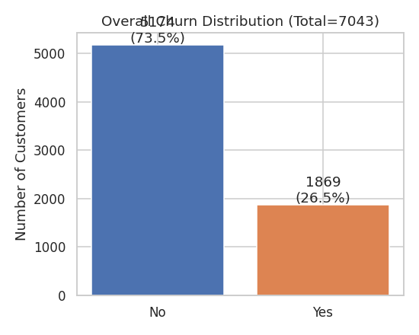
Figure 1. Overall churn distribution across all 7,043 customers.

Key Findings

1. Contract type is the strongest driver of churn.
Month-to-month customers churn at 42.7%, vs. 11.3% for one-year contracts and just 2.8% for two-year contracts. Converting month-to-month customers onto longer terms is likely the single highest-leverage retention lever available.
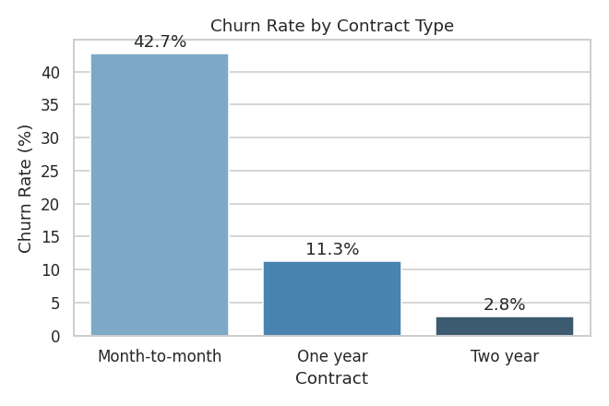
Figure 2. Churn rate by contract type.

2. Churn is concentrated in the first year of tenure.
Customers with 0–12 months tenure churn at 47.4%, falling steadily to 6.6% for customers with 61–72 months tenure. Median tenure of churned customers is 10 months vs. 38 months for retained customers — the first year is the critical retention window.
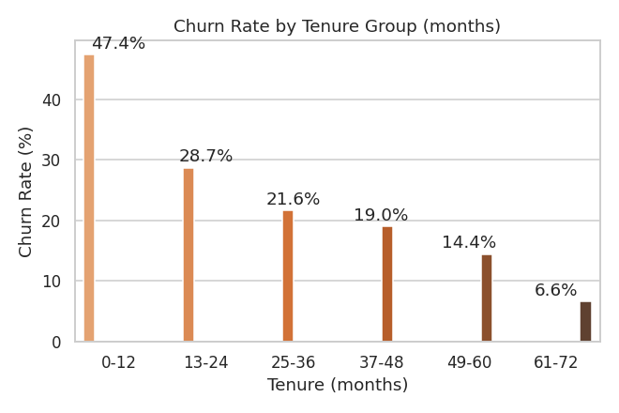
Figure 3. Churn rate by tenure group (months).

3. Fiber optic internet and higher bills correlate strongly with churn.
Fiber optic customers churn at 41.9% vs. 19.0% for DSL and 7.4% for customers with no internet service. Churned customers pay $74.44/month on average vs. $61.27 for retained customers. The riskiest combination is month-to-month + fiber optic, which churns at 54.6% — over half.
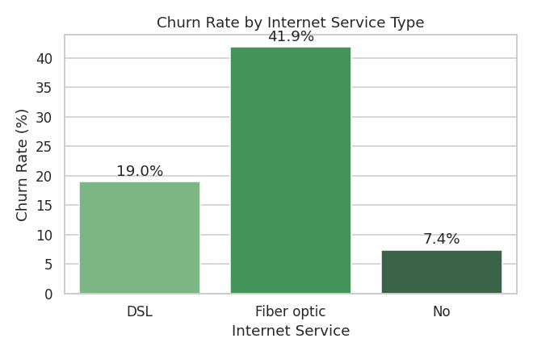
Figure 4. Churn rate by internet service type.

4. Non-automatic payment methods flag high churn risk.
Electronic check users churn at 45.3% — roughly 3x the rate of customers on automatic bank transfer (16.7%) or credit card (15.2%) payment, and well above mailed check (19.1%).
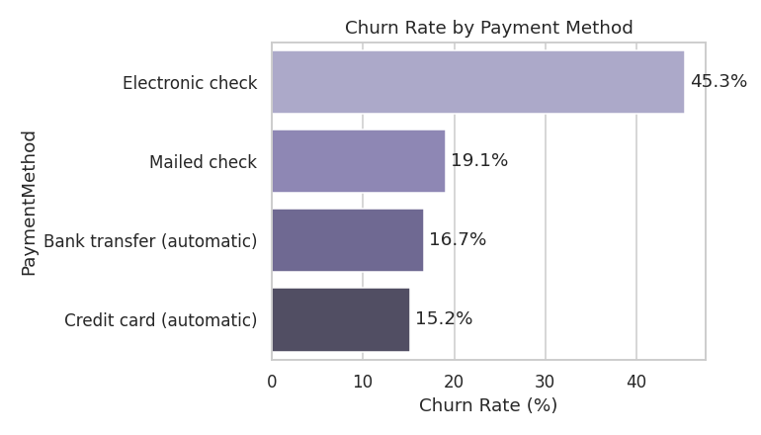
Figure 5. Churn rate by payment method.

5. Missing support services (not entertainment add-ons) predict churn.
Customers without OnlineSecurity or TechSupport churn at ~42%, compared to ~15% for those who have these services — a much larger gap than for StreamingTV/StreamingMovies, where churn sits around 30–34% regardless of the add-on. This suggests proactive support/security bundling is a more effective retention tool than entertainment upsells.
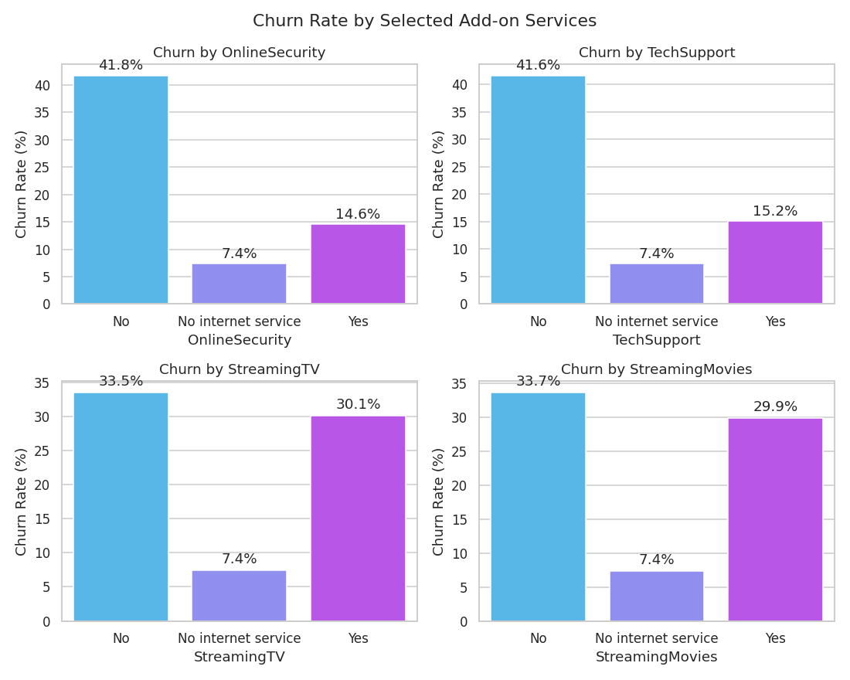
Figure 6. Churn rate by selected add-on services.

6. Household/family ties reduce churn.
Senior citizens churn nearly twice as often as non-seniors (41.7% vs. 23.6%). Customers without a partner (33.0% vs. 19.7%) or without dependents (31.3% vs. 15.5%) also churn more — single and senior customers with fewer household ties to the service are a segment worth targeted retention offers.
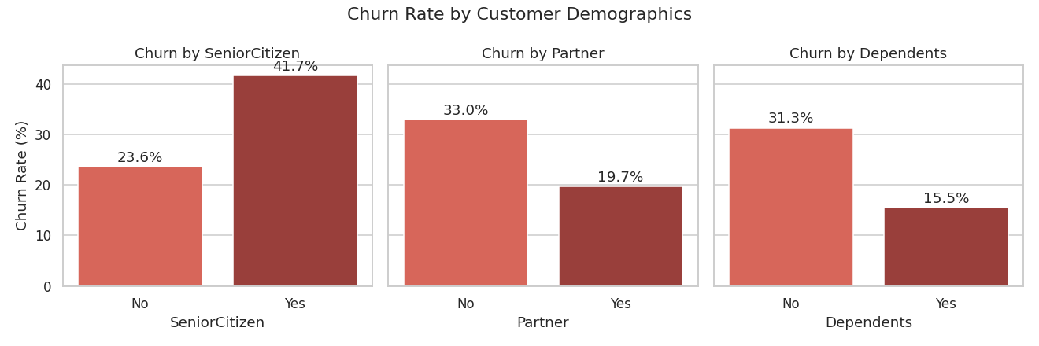
Figure 7. Churn rate by customer demographics.

Combined View: Contract × Internet Service
The highest-risk segment is unambiguous — month-to-month + fiber optic customers churn at 54.6%, more than half. Two-year contract customers churn below 8% regardless of internet type. Contract length is the dominant lever, with fiber optic amplifying risk within any given contract term.
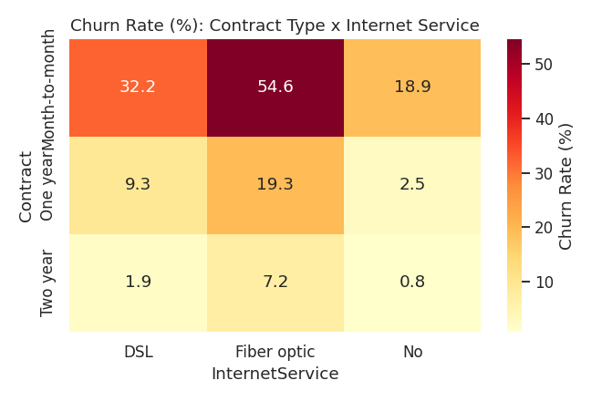
Figure 8. Churn rate (%) — Contract Type × Internet Service.

Recommended Focus Areas for Downstream Reporting (Power BI)
- Segment customers by Contract × Tenure × InternetService as the primary churn-risk cube (see the heatmap above).
- Flag electronic check + month-to-month customers as a high-priority outreach list.
- Track a “first 12 months” cohort view given how disproportionately churn concentrates there.

Note on customerID
customerID was correctly dropped from telco_processed.csv before analysis, since it's a unique identifier with no genuine predictive relationship to churn — including it in a model risks noise or spurious leakage (e.g., if IDs were assigned in a way that happens to correlate with signup date).
It has been re-added in telco_with_ids.csv for reporting/BI purposes only — to allow row-level traceability and joins to other customer systems (CRM, billing, support tickets) in Power BI. It is not used in any aggregation, chart, or analysis in this notebook.
Action for anyone building a predictive model on this data: drop customerID again before training. It should only ever be used as an identifier/join key, never as a model feature.

