INTERNSHIP PROJECT REPORT
RENEWABLE ENERGY
GENERATION & WEATHER
PATTERN ANALYTICS
Using Python, Exploratory Data Analysis and Machine Learning
DATA QUALITY | VISUAL INSIGHTS | PREDICTIVE MODELLING

STUDENT NAME | Aarya Saxena
ROLL NUMBER | 24202803
COURSE | Bachelor of Science (B.Sc.)
COLLEGE | Government P.G. College, Dholpur
UNIVERSITY | Maharaja Surajmal Brij University
INTERNSHIP PROGRAM | IBM SkillsBuild Data Analytics with AI Academic Internship

Prepared for academic learning and mentor review
DATA NOTE
The included dataset is synthetic and created for analytical demonstration. It is not official monitoring data or measured output from real solar plants.

PROJECT CERTIFICATE (MENTOR TEMPLATE)
This page is provided as a certificate template for the assigned mentor or authorized college representative to review and complete. It does not represent a certificate already issued.
This is to certify that Aarya Saxena, Roll Number 24202803, a student of Bachelor of Science (B.Sc.) at Government P.G. College, Dholpur, affiliated with Maharaja Surajmal Brij University, has prepared the project entitled “Renewable Energy Generation & Weather Pattern Analytics Using Python” as an academic project for the Data Analytics with AI internship learning activity.
The report demonstrates a structured workflow involving data understanding, quality checks, exploratory analysis, visualisation, and a supervised machine-learning example using a synthetic educational dataset. The work should be evaluated on the basis of the submitted files, the student’s understanding, and the mentor’s review.
MENTOR REVIEW NOTE
Please confirm the work, update any institutional wording required by the program, and sign only after the report and notebook have been reviewed.

Mentor / Supervisor Name: _________________________________________
Signature: ______________________________ Date: __________________
Department / Institution Seal (if applicable):
____________________________________________________________________

STUDENT DECLARATION
I, Aarya Saxena (Roll Number 24202803), student of Bachelor of Science at Government P.G. College, Dholpur, affiliated with Maharaja Surajmal Brij University, declare that this project report titled “Renewable Energy Generation & Weather Pattern Analytics Using Python” has been assembled for learning and academic submission purposes.
I understand that analytical findings in this report are produced from a synthetic dataset created for demonstration. The data are not represented as official government statistics, real plant records, or an independently collected survey. Model outputs therefore demonstrate workflow and method, not validated real-world forecasting performance.
I have included the technologies, assumptions, preprocessing decisions, evaluation method and limitations to make the work transparent and reproducible. Any final submission will be reviewed against the requirements of the internship program and the mentor’s guidance.
Student Name: Aarya Saxena
Roll Number: 24202803
Signature: _________________________________________
Date: ______________________________________________
ACADEMIC INTEGRITY
Before submission, the student should run the notebook, understand the code and charts, and be able to explain the findings in their own words.

ACKNOWLEDGEMENT
I express my sincere gratitude to my college, Government P.G. College, Dholpur, and Maharaja Surajmal Brij University for providing an academic environment in which I can explore data analysis and its practical applications.
I am thankful to the internship program team, mentors and learning resources associated with the IBM SkillsBuild Data Analytics with AI Academic Internship for encouraging structured problem solving, computational thinking and data-based interpretation. Their learning framework helps connect classroom knowledge with analytical practice.
I also acknowledge the open-source Python ecosystem, especially the developers and maintainers of pandas, NumPy, Matplotlib, Seaborn and scikit-learn. These tools make data preparation, exploratory visualisation and baseline predictive modelling accessible to students.
Finally, I acknowledge that this project uses an artificial dataset generated for educational demonstration. This choice ensures that the complete workflow is self-contained and reproducible while avoiding any claim that the results represent actual solar installation performance.
PROJECT PHILOSOPHY
Useful analytics combines clean data, transparent assumptions, interpretable visuals, careful evaluation and honest communication of uncertainty.

ABSTRACT
Renewable energy systems produce valuable operational data that can be analysed to understand generation patterns, explore weather relationships and support maintenance planning. This project presents a complete beginner-to-intermediate data analytics workflow focused on daily solar generation at four illustrative sites. The work was developed using Python and core libraries for data handling, visualisation and machine learning.
The synthetic dataset includes 4,384 daily records across 2022–2024, with 15 fields covering date, site, installed capacity, solar resource, weather indicators, panel-cleanliness index, availability, outages, demand and generated energy. The workflow assesses data types, missingness, duplicates and plausible values before creating calendar features and comparing site and seasonal patterns.
Across the demonstration dataset, average daily generation is 72.09 MWh and the average solar-resource indicator is 5.14 kWh/m²/day. A time-based holdout evaluation trains models on observations before 2024-05-01 and tests on later records. Linear Regression achieves an R² of 0.967; Random Forest achieves an R² of 0.983 on the synthetic holdout. These values show how an analytical pipeline can be evaluated but are not evidence of accuracy on measured plants.
The project concludes with practical steps for replacing synthetic data with validated observations, tracking capacity-normalised output, maintaining monitoring quality and performing time-aware evaluation. The report emphasises that correlation and feature importance are descriptive, not causal.
KEYWORDS
Renewable energy; solar generation; Python; data cleaning; exploratory data analysis; time-based holdout; regression; synthetic data; reproducibility.

TABLE OF CONTENTS
• Project preliminaries
– Project Certificate (Mentor Template)
– Student Declaration
– Acknowledgement
– Abstract
• List of Figures, Tables and Abbreviations
• Executive Summary
• Chapter 1 — Introduction and Study Context
– Problem Statement, Aim and Objectives
• Background: Solar Generation and Data Analytics
• Study Scenario and Dataset Design
• Dataset Dictionary
• Methodology and Analytical Workflow
• Data Quality and Preparation
• Descriptive Results and KPIs
• Seasonal and Site-Level Patterns
• Weather Relationships and Correlation
• Predictive Modelling Design
• Model Results and Evaluation
• Feature Importance and Interpretation
• Discussion and Analytical Insights
• Recommendations and Practical Application
• Academic, Environmental and Social Relevance
• Limitations, Ethics and Risk Controls
• Conclusion and Future Work
• References
• Appendix A — Reproducibility Guide and Sample Rows
• Appendix B — Submission Checklist
READING GUIDE
The report is arranged from context and data design through analysis, predictive modelling, interpretation and reproducibility. Numerical findings should always be read alongside the synthetic-data disclaimer.

LIST OF FIGURES, TABLES AND ABBREVIATIONS

List of Figures
- Figure 1. Monthly average solar generation by site.
- Figure 2. Cumulative generation by site.
- Figure 3. Seasonal average daily generation.
- Figure 4. Correlation matrix of weather, plant and generation variables.
- Figure 5. Solar resource and daily generation relationship.
- Figure 6. Actual versus predicted generation on the later-period holdout.
- Figure 7. Top predictive features in the Random Forest demonstration.

List of Tables
- Table 1. Dataset field dictionary.
- Table 2. Core descriptive indicators.
- Table 3. Site-level summary statistics.
- Table 4. Predictive-model evaluation metrics.
- Table 5. Risk controls and mitigation actions.
- Table 6. Example dataset rows.

Abbreviations
Term | Meaning
AI | Artificial Intelligence
CSV | Comma-Separated Values
EDA | Exploratory Data Analysis
MAE | Mean Absolute Error
MW | Megawatt
MWh | Megawatt-hour
RMSE | Root Mean Squared Error
R² | Coefficient of determination
SDG | Sustainable Development Goal

EXECUTIVE SUMMARY
This project converts a synthetic but reproducible solar-generation dataset into an end-to-end analytics exercise. It illustrates the way a science student can move from data-quality checks to visual evidence, statistical summaries, a predictive baseline and careful recommendations.
RECORDS  4,384  Across 4 illustrative sites | PERIOD  2022–2024  Daily observations
MEAN GENERATION  72.09 MWh/day  Across all site-days | BEST HOLDOUT R²  0.983  Random Forest on synthetic data
Main observations
- The dataset has 4,384 complete daily records and 15 variables; it is synthetic and intended only for demonstration.
- Jodhpur Sun Array has the largest cumulative total (107,129 MWh), largely reflecting the illustrative capacity assigned to that site.
- The constructed seasonal pattern peaks during the Summer category (92.1 MWh/day average) and is lowest during Monsoon (59.4 MWh/day average).
- The Random Forest model records a holdout MAE of 2.31 MWh and R² of 0.983; results are specific to the synthetic data-generation process.
EXECUTIVE TAKEAWAY
A well-structured analytics project is not just a high model score. It must document the data source, assumptions, validation, evaluation design, limits and reproducibility steps.

CHAPTER 1 — INTRODUCTION AND STUDY CONTEXT

1.1 Introduction
Renewable electricity, including solar photovoltaic power, is an important area for applied science, energy engineering and data-informed planning. Solar generation varies through the year and from day to day because of solar resource, cloud cover, temperature, plant capacity, maintenance and availability. A structured data workflow helps turn these observations into information that can be inspected and communicated.
Data analytics combines data preparation, descriptive statistics, visualisation and model evaluation. A typical analysis starts by asking where records came from, whether their fields are usable, and what uncertainty they contain. It then explores distributions and relationships before attempting a model. This sequence reduces the chance of using a model to obscure basic data-quality problems.

1.2 Why this topic was selected
The renewable-energy topic is suitable for a B.Sc. project because it connects environmental conditions, measurement, quantitative reasoning and computational methods. It also gives a concrete use case for Python data tools without requiring specialised hardware or access to private utility data. A synthetic dataset is used here to make every file self-contained and runnable.

1.3 Project orientation
- Use transparent, reproducible code rather than manual spreadsheet-only analysis.
- Present findings through readable charts and correctly labelled tables.
- Compare simple and ensemble regression methods using a time-based holdout.
- Separate descriptive results from causal claims or real-world operational conclusions.
IMPORTANT CONTEXT
Names such as Dholpur Solar Park and Jodhpur Sun Array are illustrative site labels in the dataset. They do not identify real facilities or imply that the reported values were measured there.

PROBLEM STATEMENT, AIM AND OBJECTIVES

1.4 Problem statement
Daily energy data can contain multiple interacting fields: timestamps, plant attributes, weather observations and operations. Without suitable cleaning and analytical framing, it is easy to confuse capacity effects with efficiency, read correlation as causation or evaluate a model on observations that are not independent of the training period. This project demonstrates a disciplined approach to those issues.

1.5 Aim
PROJECT AIM
To demonstrate an end-to-end, reproducible Python workflow for inspecting synthetic solar-generation data, identifying temporal and site-level patterns, and evaluating a supervised regression model.

1.6 Specific objectives
- Load the CSV file and verify structure, data types, duplicates, missingness and plausible ranges.
- Create calendar features and summarise generation by site, month and season.
- Explore relationships among solar resource, weather indicators, plant availability and output.
- Train Linear Regression and Random Forest models using a time-based split.
- Compare models using MAE, RMSE and R², and visualise prediction behaviour.
- Explain limitations and propose steps for use with measured, quality-controlled data.

1.7 Research questions
- How do average generation and solar resource vary by season in this scenario?
- How do sites differ when viewed by totals and capacity-normalised averages?
- What predictive performance is obtained when later dates are kept out of training?

BACKGROUND: SOLAR GENERATION AND DATA ANALYTICS

2.1 Solar-energy concepts
Solar photovoltaic systems convert sunlight into electrical energy. Daily production is affected by the amount of solar energy reaching the panels, installed capacity, system design, module temperature, shading, soiling, downtime and losses in electrical components. The exact relationship differs by technology, site and measurement convention; a school project should therefore state its units and assumptions clearly.

2.2 Why weather data matters
Solar-resource measures describe the energy available from sunlight. Cloud cover and rainfall can signal conditions associated with reduced resource, while temperature may influence module performance. Humidity, wind and dust can be relevant to environmental context, but their effect is not universal and can be confounded by location, season or other variables. In this project, weather fields are simplified simulation inputs rather than observed meteorological records.

2.3 Role of analytics
- Descriptive analytics summarises what is present in the records.
- Diagnostic exploration investigates relationships and unusual patterns, but does not alone prove cause.
- Predictive analytics estimates a target value under assumptions learned from previous data.
- Operational decision-making requires domain validation, monitoring, and a cost of error analysis.

2.4 Why reproducibility is essential
If another student cannot reconstruct the analysis from the notebook, dataset and dependency list, the output is difficult to verify. Reproducibility requires clear file names, stable random seeds, environment notes, defined train/test periods and plain-language explanations. These practices are included in the submission package.
INTERPRETATION RULE
A high R² on synthetic data indicates that the model learned the synthetic relationships. It does not show that the same model will be accurate on real generation data.

STUDY SCENARIO AND DATASET DESIGN

3.1 Observation design
The CSV contains 4,384 rows, one row per site per calendar day, across four illustrative solar sites from 2022-01-01 to 2024-12-31. Each site contributes 1,096 daily records. The dataset has 15 columns, comprising date, location/site labels, capacity, weather indicators, operational indicators and solar output.

3.2 Synthetic generation approach
Data were generated programmatically using fixed random seed 20261015. Seasonal patterns are specified through month-level modifiers; temperatures, cloud cover, humidity, wind and rainfall receive plausible random variation. Irradiance varies with season and cloud-cover inputs. Daily solar output is derived from installed capacity, the synthetic solar-resource value, a performance factor, panel-cleanliness index and plant availability, with small random variation.

3.3 Site configuration
Illustrative site | District label | Capacity | Daily rows | Status
Dholpur Solar Park | Dholpur | 20 MW | 1,096 | Illustrative
Jaipur Solar Field | Jaipur | 24 MW | 1,096 | Illustrative
Jodhpur Sun Array | Jodhpur | 30 MW | 1,096 | Illustrative
Udaipur Solar Station | Udaipur | 18 MW | 1,096 | Illustrative

3.4 Design considerations
A balanced number of site-days makes site comparisons straightforward, but the data are not samples from a real population. The values are internally structured for demonstration rather than statistically calibrated to specific plants. Any real study would document the source system, sensor calibration, aggregation interval, data licensing and known periods of curtailment or missing telemetry.
DATA PROVENANCE
Dataset file: renewable_energy_weather_dataset.csv. Provenance: generated locally for this student project; no external operational dataset was used.

DATASET DICTIONARY
Table 1 explains each field and its intended use. The values are synthetic and should be treated as a teaching dataset rather than a source of official measurements.
Field | Unit / type | Description
date | Date | Daily timestamp; used to derive year, month, day-of-year and season.
site | Category | Illustrative solar installation label.
district | Category | Illustrative district label.
installed_capacity_mw | MW | Installed capacity scenario assigned to each site.
temperature_c | °C | Synthetic daily temperature indicator.
solar_irradiance_kwh_m2_day | kWh/m²/day | Synthetic daily solar-resource indicator.
cloud_cover_pct | % | Synthetic cloud-cover percentage.
humidity_pct | % | Synthetic relative-humidity indicator.
wind_speed_m_s | m/s | Synthetic wind-speed value.
rainfall_mm | mm | Synthetic daily rainfall amount.
panel_cleanliness_index | Index | Relative panel cleanliness between 0 and 1.
outage_hours | Hours | Synthetic downtime within a day.
plant_availability_pct | % | Synthetic percentage availability.
grid_demand_mwh | MWh | Illustrative demand indicator, not measured demand.
solar_generation_mwh | MWh/day | Primary target variable for descriptive analysis and regression.

Derived fields (year, month, day_of_year and season) are created inside the notebook rather than stored in the CSV. This reduces duplication and makes the feature-engineering steps auditable.

METHODOLOGY AND ANALYTICAL WORKFLOW

4.1 Process sequence
01 LOAD  Read the CSV and parse dates. | 02 AUDIT  Check types, nulls, duplicates and ranges.
03 PREPARE  Engineer calendar fields and define target/features. | 04 EXPLORE  Summarise generation by site, season and month.
05 VISUALISE  Create trend, relationship and correlation plots. | 06 MODEL  Fit baseline regression and Random Forest.
07 EVALUATE  Hold out later dates and compute MAE, RMSE and R². | 08 COMMUNICATE  Explain the results and synthetic-data limitations.

4.2 Tools used
Tool | Role in the workflow
Python 3 | Main programming environment.
pandas | CSV ingestion, filtering, grouping and summaries.
NumPy | Numerical operations and reproducible synthetic-data support.
Matplotlib / Seaborn | Visualisation of trends, distributions and relationships.
scikit-learn | Pipelines, preprocessing, regression models and evaluation metrics.
Jupyter Notebook | Readable, executable narrative combining code, tables and plots.
Microsoft Word / DOCX | Formatted report for review and submission.

4.3 Reproducibility choices
A fixed random seed is used in dataset creation and model configuration. The notebook reads the included CSV rather than generating new values at execution time. Preprocessing operations are packaged into model pipelines, which helps apply the same transformations to the training and evaluation records.

DATA QUALITY AND PREPARATION

5.1 Structural validation
The notebook loads dates with error coercion, prints the dataset dimensions and time span, inspects the first rows, and displays a data-quality table containing data type, missing-value count, missing percentage and unique-value count. It also counts exact duplicate rows and tests key plausible-value conditions before continuing.

5.2 Quality checks applied
- Date values must parse successfully.
- Generation must be non-negative.
- Site labels must be present.
- Outage duration is inspected for values exceeding the number of hours in a day.
- Missing values and duplicate rows are reported rather than hidden.

5.3 Feature engineering
The notebook creates year, month, day-of-year and a four-category seasonal field. These features help summarise repeated annual patterns. The month and day-of-year variables also provide the models with a compact representation of the calendar. More advanced work could compare cyclic encodings such as sine/cosine transformations for day-of-year.

5.4 Data preparation in modelling
Numeric features pass through a median imputer; site and district categories pass through most-frequent imputation and one-hot encoding. Those steps are defined inside a scikit-learn ColumnTransformer and Pipeline, keeping preprocessing consistent between training and evaluation. The supplied dataset has no intentional missing values, but pipeline logic demonstrates how missingness could be handled.
QUALITY PRINCIPLE
A tidy table is not necessarily a valid dataset. Real energy data would also require checks for sensor outages, clock changes, curtailment, unit mismatches, maintenance periods and physically implausible measurements.

DESCRIPTIVE RESULTS AND KPIs
Table 2 summarises the main quantitative indicators calculated from all site-days. Since the values are synthetic, these figures are included to make the analysis reproducible, not to describe actual production in Rajasthan.
Indicator | Value | Interpretation
Observation count | 4,384 | Daily records in the CSV
Observation period | 2022-01-01 to 2024-12-31 | Three complete calendar years
Mean daily generation | 72.09 MWh | Mean across all recorded site-days
Median daily generation | 68.35 MWh | Median is lower than mean in this scenario
Total generation (sum) | 316,053 MWh | Synthetic summed energy output
Mean solar-resource indicator | 5.14 kWh/m²/day | Synthetic daily solar resource
Mean availability | 99.42% | Illustrative operational availability
Mean cleanliness index | 0.804 | Index scale: 1 indicates cleanest

6.1 Range and variability
Daily generation ranges from 16.61 to 159.85 MWh in the constructed dataset. Variation is expected because the simulated resource, capacity, site, seasonal conditions and operational inputs change over time. A real dataset should be assessed for outliers and seasonal effects before removing any extreme records.

6.2 Correlation with solar resource
The Pearson correlation between the solar-resource indicator and generation is 0.679. This is a positive association in the designed data. Capacity and other inputs affect output as well, so the correlation should not be interpreted as the standalone effect of irradiance or as proof of causality.
REPORTING NOTE
Use consistent units, identify whether values are instantaneous or aggregated, and label every total carefully. “MWh/day” refers to daily energy produced; “MW” refers to capacity.

TEMPORAL PATTERNS: MONTHLY GENERATION
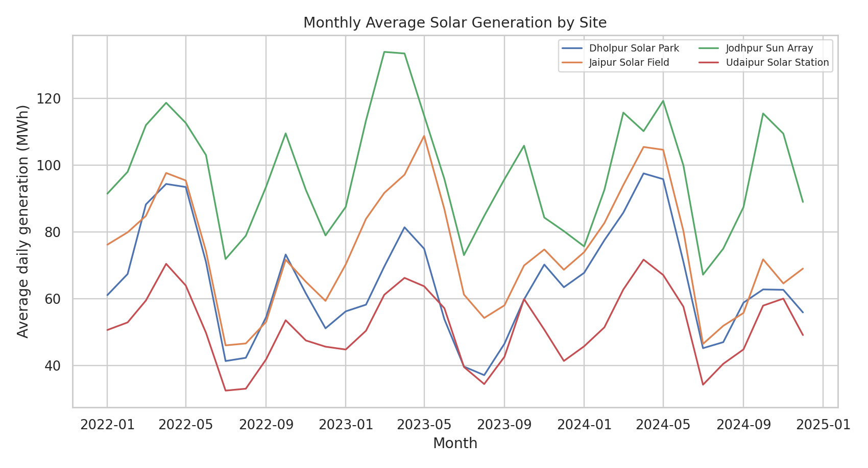
Figure 1. Monthly average daily generation by illustrative site. Source: author analysis of the synthetic dataset.
The line chart shows repeated within-year variation in average daily generation. The constructed solar-resource signal is strongest in spring months, declines during the monsoon months, and recovers during the post-monsoon period. Each site follows a broadly similar annual shape because the data-generation process uses a common seasonal structure.

7.1 What the chart can and cannot tell us
- It makes cyclical patterns and site differences easier to detect than a raw table of thousands of rows.
- It does not establish that real sites in the named districts have the same month-by-month profile.
- Year-to-year variation is deliberately modest in the simulation; real assets can experience changes in weather, degradation, curtailment and maintenance.

7.2 Follow-up analyses
For measured data, use rolling monthly summaries, compare equivalent time windows across years, report confidence intervals when appropriate, and annotate maintenance or curtailment events. A useful next step is to examine output per installed MW and compare it with expected resource levels rather than comparing raw totals only.

SEASONAL GENERATION PATTERNS
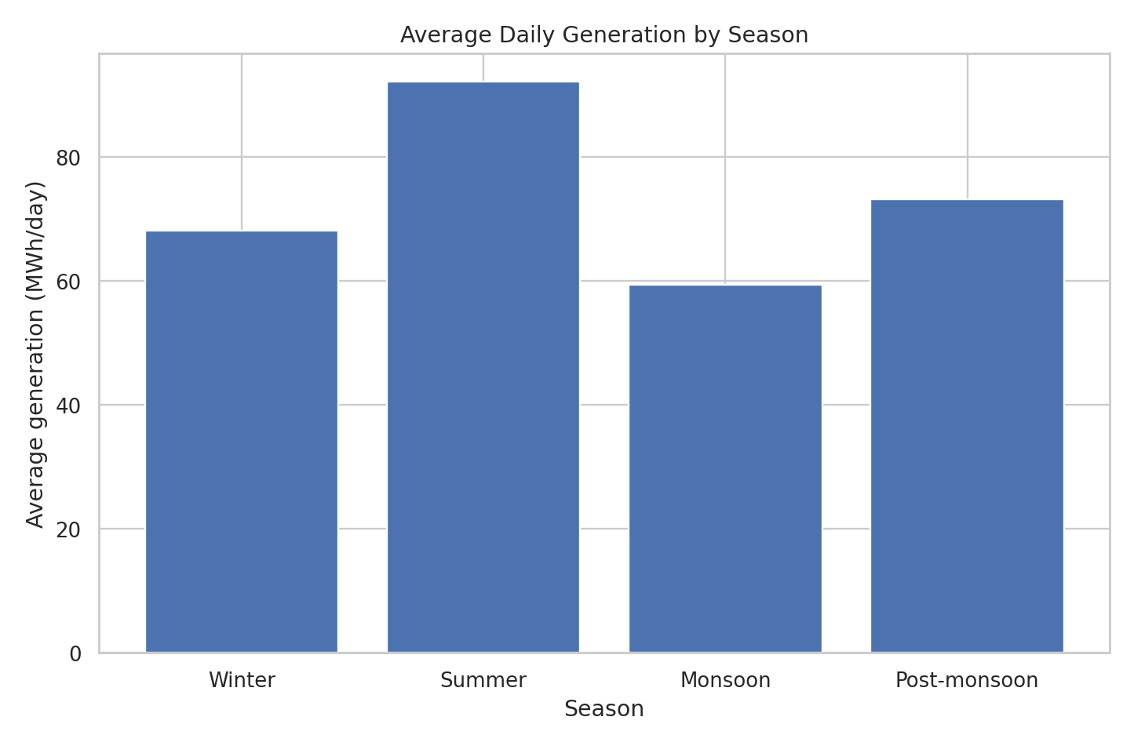
Figure 2. Average daily generation by season. Season groups are defined within the notebook.
Season | Avg generation (MWh/day) | Avg solar resource (kWh/m²/day) | Avg temperature (°C) | Avg cloud (%)
Winter | 68.14 | 4.70 | 18.7 | 19.1
Summer | 92.15 | 6.61 | 33.4 | 15.1
Monsoon | 59.36 | 4.28 | 33.0 | 45.1
Post-monsoon | 73.15 | 5.31 | 26.3 | 16.9

Within this synthetic scenario, the Summer category has the highest mean generation, while Monsoon has the lowest. The table also shows the solar-resource indicator decreasing and mean cloud cover increasing during the monsoon group. These behaviours were intentionally encoded in the generated dataset to support analysis practice.
CAUTION
The season averages are descriptive summaries of the simulated values. Do not quote them as observed climatic norms or use them for energy-yield planning.

SITE-LEVEL COMPARISON
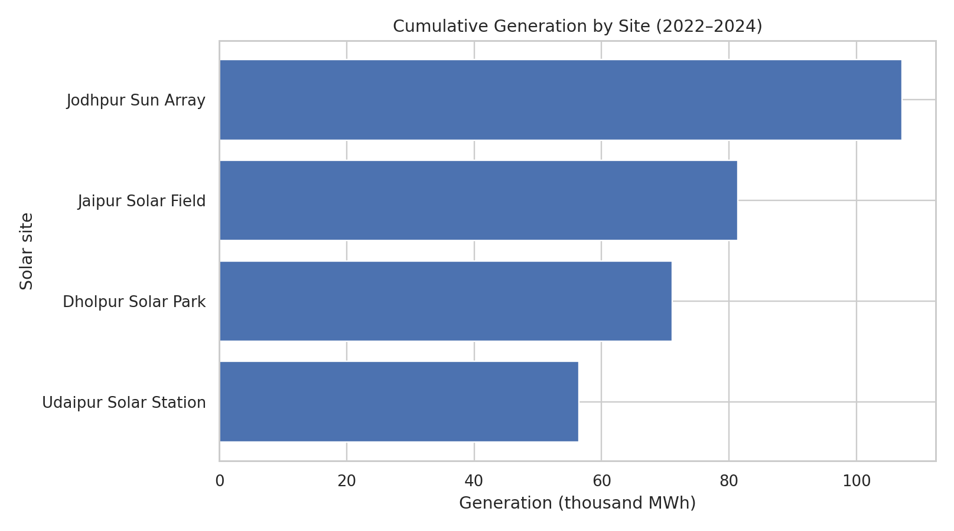
Figure 3. Cumulative generation by illustrative site over 2022–2024.
Site | Capacity (MW) | Total (MWh) | Mean daily (MWh) | Mean solar resource
Dholpur Solar Park | 20 | 71,113 | 64.9 | 5.12
Jaipur Solar Field | 24 | 81,375 | 74.2 | 5.16
Jodhpur Sun Array | 30 | 107,129 | 97.7 | 5.20
Udaipur Solar Station | 18 | 56,435 | 51.5 | 5.08

Jodhpur Sun Array has the largest cumulative total because it is assigned the largest capacity in the simulation (30 MW). This is a useful reminder that larger total production is not synonymous with higher efficiency. A fairer comparison would normalise output by capacity and, for a real project, account for equipment differences, sensor availability, curtailment and the exact reporting period.

9.1 Capacity-normalised performance
A basic capacity-normalised indicator is mean daily generation divided by installed capacity. It can help compare illustrative sites of different sizes, but it is not a standard performance ratio and does not replace calculations based on measured irradiation, module temperature, system losses and other engineering factors.

WEATHER RELATIONSHIPS AND CORRELATION
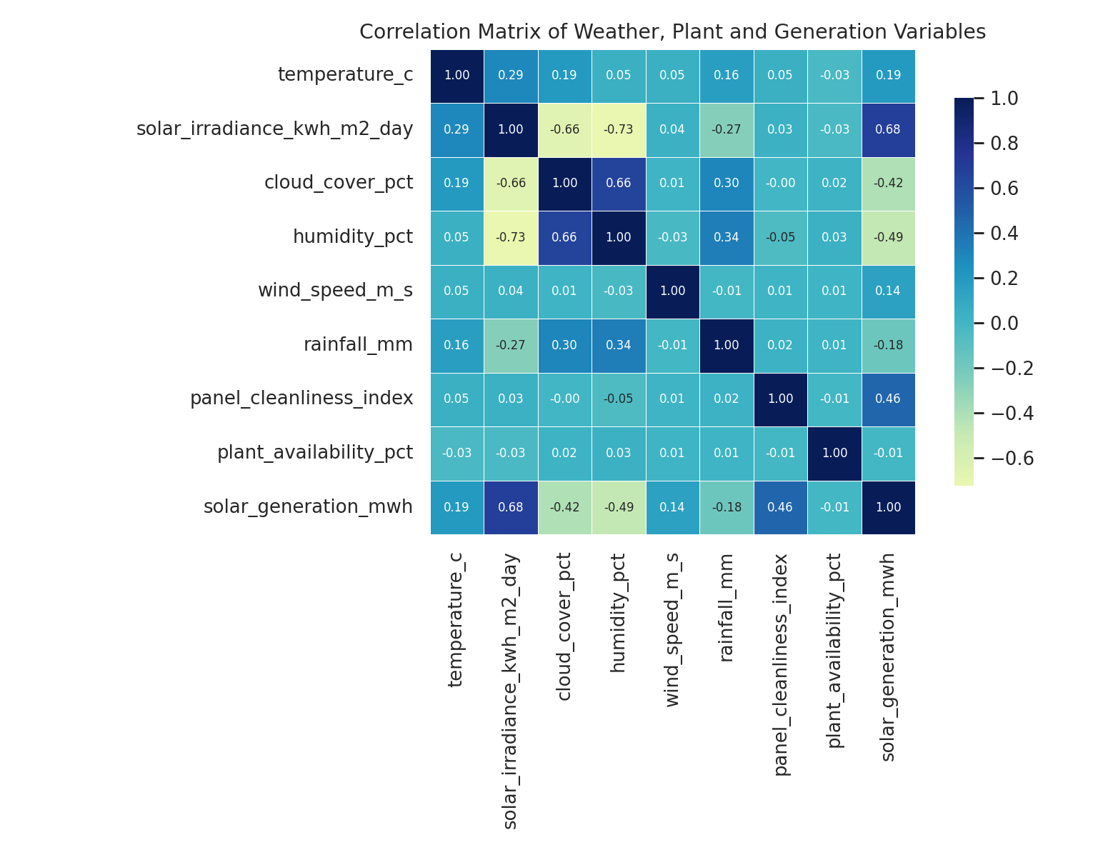
Figure 4. Correlation matrix for selected weather, operational and generation variables.
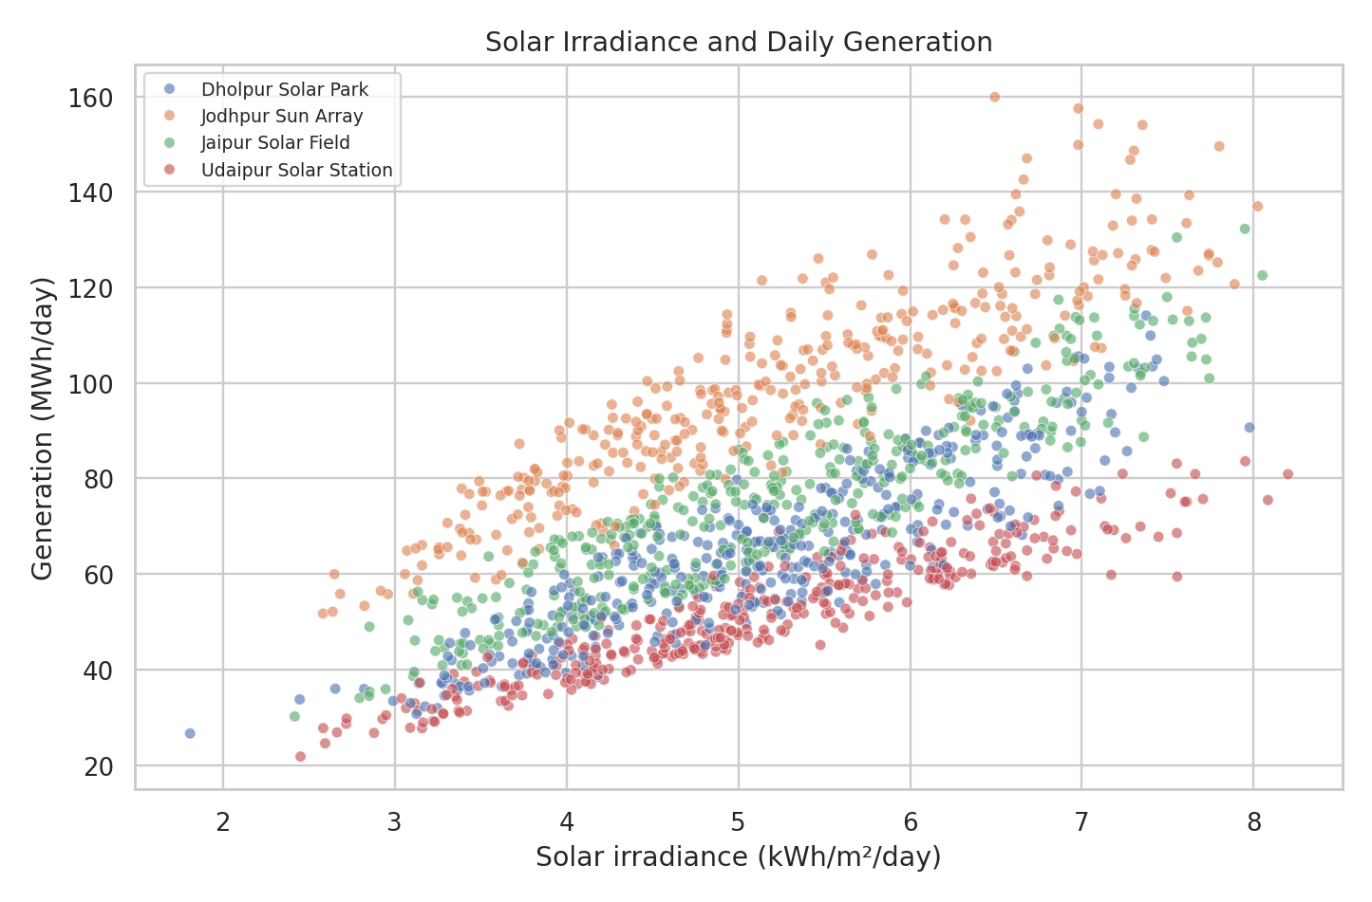
Figure 5. Solar-resource indicator and daily generation, sampled for readability.
The matrix summarises pairwise linear associations, while the scatter plot shows the relationship between solar resource and generation. Clusters may reflect differences in installed capacity rather than conversion efficiency.
STATISTICAL CAUTION
Correlation is not causation. Seasonal patterns, outliers and differences between sites can affect correlations; engineering conclusions require domain review.

PREDICTIVE MODELLING DESIGN

10.1 Target and predictor variables
The target variable is `solar_generation_mwh`. Predictors include categorical site and district labels, installed capacity, weather variables, cleanliness, outages, availability and calendar features. These inputs are assumed to be available for an illustrative daily estimate. A real forecast would need a clearly defined prediction time and only variables available at that time.

10.2 Time-based holdout
The training subset contains 3,404 records dated before 2024-05-01; the later evaluation subset contains 980 records dated from that day onward. The holdout reflects a forward-in-time question better than randomly mixing all dates, though it remains a single split on simulated data.

10.3 Candidate models
Model | Concept | Reason for inclusion
Linear Regression | Fits a linear relationship between transformed predictors and the target. | Interpretable baseline and fast to train.
Random Forest Regressor | Combines many decision trees fitted on resampled data/features. | Can capture nonlinear patterns and interactions.

10.4 Preprocessing pipeline
Numeric features use median imputation and categorical labels use most-frequent imputation followed by one-hot encoding. These steps are embedded in a ColumnTransformer and model Pipeline, ensuring that the transformations are fitted on training data and then applied to the evaluation data in the same sequence.
MODEL BOUNDARY
The model is a demonstration of the workflow. It is not an operational recommendation, a maintenance-control tool or a validated forecast service.

MODEL RESULTS AND EVALUATION
Table 4 presents error metrics on the later-period test subset. Lower MAE and RMSE indicate smaller prediction errors; R² closer to 1 indicates that predictions track variation in the target relative to a mean-only baseline.
Model | MAE (MWh) | RMSE (MWh) | R²
Linear Regression | 3.097 | 4.374 | 0.9672
Random Forest | 2.313 | 3.163 | 0.9828

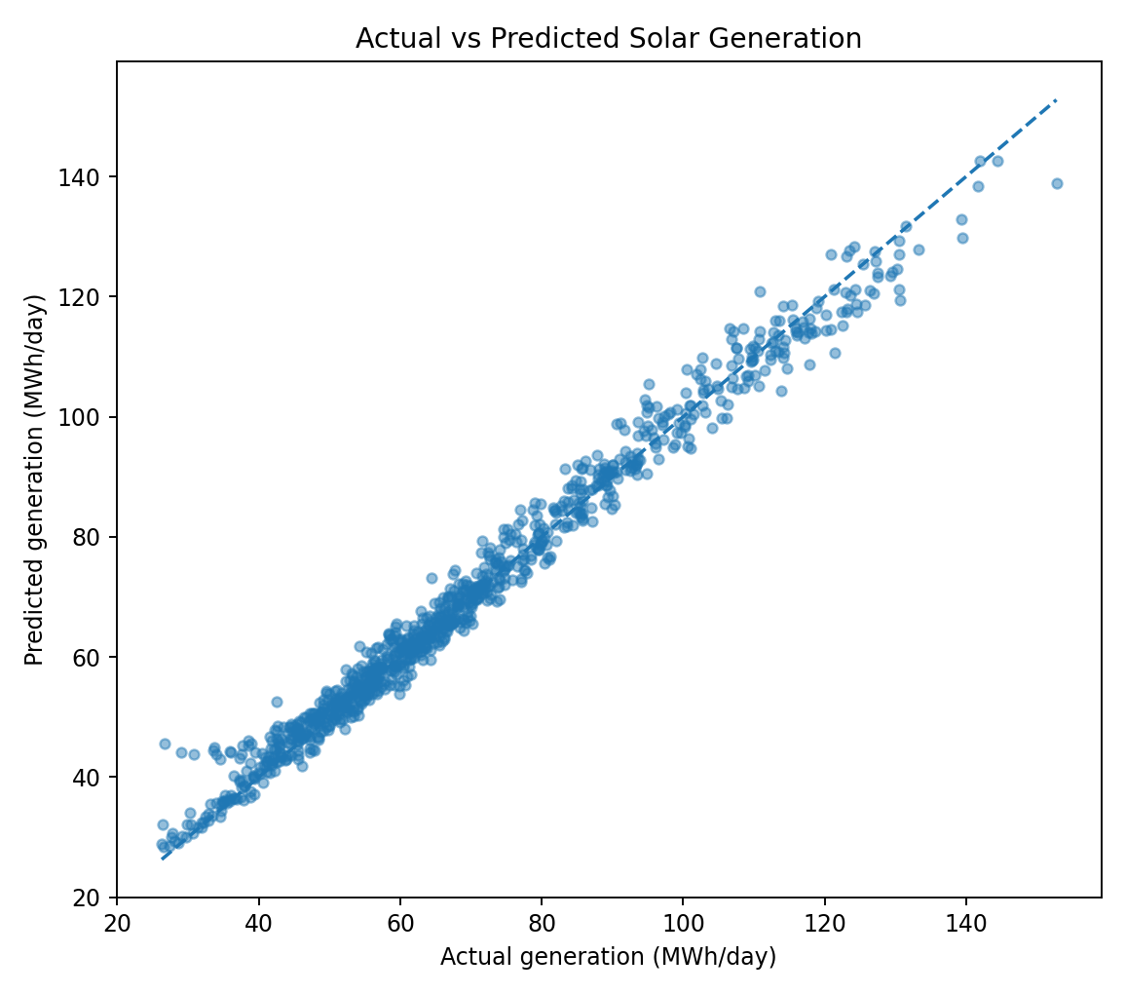
Figure 6. Actual versus Random Forest predicted generation on the later-period holdout.
Random Forest performs better than Linear Regression on this synthetic holdout: its MAE is 2.31 MWh compared with 3.10 MWh for the linear baseline. Its R² is 0.983. The result is consistent with the designed nonlinear generation process, but it must not be interpreted as a real-world accuracy guarantee.

FEATURE IMPORTANCE AND INTERPRETATION
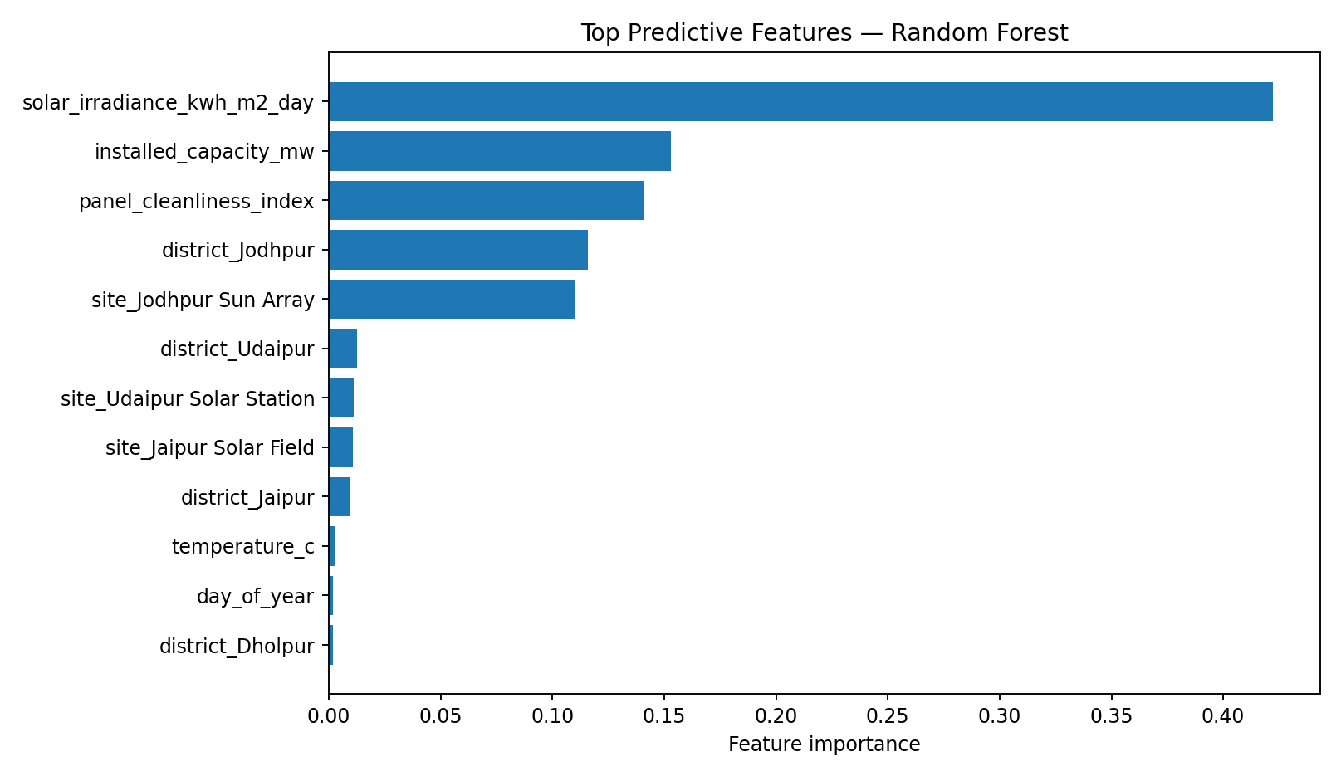
Figure 7. Top predictive features ranked by the Random Forest model in this scenario.
The feature-importance chart summarises how the fitted tree ensemble used transformed variables when reducing prediction error. Variables associated with solar resource, panel cleanliness, installed capacity and site labels are expected to matter because the synthetic generation formula directly or indirectly incorporates them.

11.1 How to read importance
- Importance is relative to the fitted model and this particular dataset; it is not a causal effect size.
- One-hot categories can appear as separate entries, so the importance of a conceptual variable may be spread across multiple columns.
- Correlated inputs can substitute for each other in tree splits, which complicates rankings.
- Permutation importance or SHAP-style methods could provide additional diagnostics but would still require careful interpretation.

11.2 What a real energy analyst should add
Before relying on any feature ranking, compare with engineering expectations, check measurement units, verify the order of data availability, evaluate by site and season, and assess stability across multiple time-based windows.

DISCUSSION AND ANALYTICAL INSIGHTS

12.1 Seasonal behaviour
The largest average daily generation appears in the synthetic Summer group, and the lowest appears in Monsoon. This emerges from the constructed month-level solar-resource pattern and cloud variation. The analysis is therefore successful as a test of the end-to-end workflow: the charts and summaries reflect the designed relationships in the CSV.

12.2 Site differences
Cumulative output is dominated by capacity as well as daily resource and operational factors. Jodhpur Sun Array leads total output because it has the highest assigned capacity. A fair comparison of the real-world performance of solar parks would need a richer normalisation and asset-specific engineering data.

12.3 Model comparison
Random Forest has smaller test-set error than the linear baseline, which is plausible because the generation equation combines interacting inputs and a nonlinear temperature performance term. The results demonstrate why a baseline is useful: a more complex model should earn its place by performing better on a properly reserved evaluation period, not by complexity alone.

12.4 Overall lesson
CORE INSIGHT
The value of the project lies in the reproducible workflow, the explicit data provenance and the careful interpretation of results—not in presenting synthetic model scores as evidence about actual solar assets.

RECOMMENDATIONS AND PRACTICAL APPLICATION

1. Replace synthetic data with measured data
Use approved plant telemetry and validated weather data. Record the source, collection period, units and data-access permissions.

2. Improve data quality controls
Build checks for missing timestamps, duplicates, negative energy, out-of-range sensors, outages and inconsistent units.

3. Compare fair performance metrics
Report daily yield per installed MW, uptime, and engineering-normalised performance alongside cumulative energy.

4. Use time-aware model evaluation
Use rolling-origin evaluation across several windows; compare predictions with simple seasonal or persistence baselines.

5. Monitor by site and season
Track error, bias and data availability by site, month, season and operating condition, not just one global score.

6. Connect analysis to operational context
Annotate panel cleaning, maintenance, curtailment, inverter changes and sensor recalibration before drawing conclusions.

7. Communicate uncertainty
Provide error metrics, data coverage and limitations with each forecast; do not display single-point estimates without context.
IMPLEMENTATION PRIORITY
The first step for a genuine deployment is data governance and quality assurance. Model tuning should come later, once the target and measurement process are trusted.

ACADEMIC, ENVIRONMENTAL AND SOCIAL RELEVANCE

13.1 Relevance to B.Sc. learning
The project combines quantitative reasoning, environmental context, basic statistics, programming and evidence-based communication. It gives practice in translating a real-world question into variables, checking the data before analysis, selecting suitable visual forms and evaluating a model beyond a single training score.

13.2 Relevance to energy transition discussions
Reliable renewable generation and transparent performance monitoring are relevant to wider conversations about clean electricity and energy-system planning. International public resources such as IRENA and the United Nations Sustainable Development Goal 7 describe the broad context of renewable energy and access to affordable, reliable, sustainable and modern energy. This project does not estimate emissions savings or energy-system impacts; it only demonstrates an analytics workflow.

13.3 Responsible use of analytics
- Document how data were obtained or generated and what they can legitimately support.
- Avoid unsupported statements about real communities or infrastructure based on simulated records.
- Consider who may be affected by a prediction and who is responsible for verifying it.
- Keep human and engineering review involved before using a model in an operational setting.

13.4 Transferable skills
Skill | Demonstrated through
Data literacy | Understanding fields, units, date ranges and data provenance.
Quantitative reasoning | Group summaries, correlations, error metrics and capacity-normalised comparison.
Computational practice | Python, notebook structure, pipelines and reproducible outputs.
Communication | Charts, captions, report structure, caveats and recommendations.

LIMITATIONS, ETHICS AND RISK CONTROLS

14.1 Limitations
- The dataset is synthetic and uses an intentionally simplified data-generation mechanism.
- Site and district names are illustrative labels, not validated facility identities.
- The model is evaluated on a later period of the same synthetic process; real-world distribution shifts are not represented.
- The predictors do not include every real-world factor such as curtailment, equipment specifications, shading, dust storms or inverter behaviour.
- Feature importance does not provide causal evidence, and the model is not a deployable forecast service.

14.2 Ethics and transparency
The project avoids using personal data. The main ethical risk is misrepresenting generated values as real measurements. This is addressed by labelling the dataset synthetic in the report, notebook and README, and by avoiding environmental-impact claims that are not calculated from appropriate evidence.

14.3 Risk-control table
Risk | Why it matters | Control
Synthetic results mistaken as real | Can mislead readers or evaluators. | Repeat the provenance disclaimer on all deliverables.
Data leakage | May inflate model performance. | Use a time-based holdout and preprocessing pipelines.
Unfair site comparison | Raw totals reflect capacity. | Show capacity and discuss normalisation.
Overclaiming correlation | Association can be confounded. | Use cautious language and avoid causal claims.
Reproducibility failure | Analysis cannot be checked. | Include CSV, notebook, requirements and README together.

SAFE USE STATEMENT
Do not use the results for energy procurement, grid operations, financial decisions or public reporting unless the work is rebuilt and validated with appropriate measured data.

CONCLUSION AND FUTURE WORK

15.1 Conclusion
This project presents a reproducible pipeline for analysing daily solar-generation data using Python. It covers CSV loading, data-quality checks, feature engineering, descriptive summaries, visualisations, site and seasonal comparisons, correlation analysis, regression modelling and a time-based evaluation. The files are organised to make the work easy to inspect and rerun.
The demonstration dataset contains 4,384 observations from four illustrative sites over 2022–2024. It records an average daily generation of 72.09 MWh. Random Forest obtains an R² of 0.983 on the held-out synthetic period, outperforming the linear baseline under the selected metrics. This result reflects the simulated relationships and is not a claim about actual solar plants.
The key conclusion is methodological: reliable analytics requires explicit data provenance, clear units, reproducible steps, sensible baselines, an evaluation design aligned with the intended use and transparent limitations. Visuals and metrics are useful only when the evidence behind them is understood.

15.2 Future work
- Acquire authorised, measured generation and weather data with documented sources.
- Use rolling-origin evaluation, site-wise validation and error intervals.
- Explore cyclic calendar encoding, gradient boosting and persistence baselines.
- Add measured irradiance, inverter output, curtailment and maintenance events when available.
- Develop a compact dashboard for monthly yield, data-quality flags and forecast-error monitoring.
- Compare output per MW and appropriate engineering performance indicators with expert review.
FINAL MESSAGE
A strong academic analytics submission makes its evidence inspectable. The notebook, report, dependency file, README and CSV should be kept together, and the student should understand the analytical decisions before submission.

REFERENCES AND LEARNING RESOURCES
The following resources provide background and technical documentation for the methods and tools used. The dataset itself was generated locally for this project; it was not downloaded from these sources.
[1] pandas development team. “pandas documentation.” https://pandas.pydata.org/docs/ (accessed 15 October 2026).
[2] NumPy Developers. “NumPy documentation.” https://numpy.org/doc/ (accessed 15 October 2026).
[3] Matplotlib Development Team. “Matplotlib documentation.” https://matplotlib.org/stable/ (accessed 15 October 2026).
[4] Waskom, M. L. “seaborn: statistical data visualization.” https://seaborn.pydata.org/ (accessed 15 October 2026).
[5] scikit-learn developers. “scikit-learn User Guide.” https://scikit-learn.org/stable/user_guide.html (accessed 15 October 2026).
[6] International Renewable Energy Agency (IRENA). “Solar energy.” https://www.irena.org/Energy-Transition/Technology/Solar-energy (accessed 15 October 2026).
[7] United Nations. “Sustainable Development Goal 7: Affordable and Clean Energy.” https://sdgs.un.org/goals/goal7 (accessed 15 October 2026).
[8] Jupyter Project. “Jupyter Notebook documentation.” https://docs.jupyter.org/ (accessed 15 October 2026).

Citation and data note
Technical documentation is cited for software behaviour and tools; contextual references provide general background only. No reported value in the dataset is sourced from IRENA or the United Nations. All project-specific numeric results arise from the synthetic CSV included with the submission.

APPENDIX A — REPRODUCIBILITY GUIDE AND SAMPLE ROWS

A.1 Folder contents
File | Purpose
AaryaSaxena_Renewable_Energy_Analytics.ipynb | Executable analysis notebook.
renewable_energy_weather_dataset.csv | Synthetic dataset used by the notebook.
requirements.txt | Python dependencies.
README.md | Overview and run instructions.
AaryaSaxena_ProjectReport.docx | Formatted report.

A.2 Run the notebook
- Extract all project files into one folder.
- Install Python 3.10+ and the packages listed in requirements.txt.
- Open the notebook in Jupyter and confirm the CSV is in the same folder.
- Run all cells from top to bottom and inspect tables, plots, warnings and model metrics.
- If you change data, re-run the checks and rebuild all result tables and charts.

A.3 Sample records
Date | Site | Capacity (MW) | Solar resource | Temp (°C) | Generation (MWh)
2022-01-01 | Dholpur Solar Park | 20 | 4.612 | 17.9 | 56.474
2022-01-02 | Dholpur Solar Park | 20 | 4.835 | 15.6 | 61.144
2022-01-03 | Dholpur Solar Park | 20 | 4.480 | 20.8 | 56.823
2022-01-04 | Dholpur Solar Park | 20 | 4.813 | 22.6 | 63.389
2022-01-05 | Dholpur Solar Park | 20 | 4.008 | 17.2 | 50.357
2022-01-06 | Dholpur Solar Park | 20 | 4.729 | 20.4 | 60.253
2022-01-07 | Dholpur Solar Park | 20 | 4.095 | 16.7 | 52.790

Only a small sample is reproduced in this appendix. The full 4,384-row file is supplied separately as a CSV to keep the report readable and the analytical workflow practical.

APPENDIX B — FINAL SUBMISSION CHECKLIST

B.1 Required project files
Required field in internship form | File to select | Check
Code File | AaryaSaxena_Renewable_Energy_Analytics.ipynb | ☐ Opens and runs
Requirements File | requirements.txt | ☐ Dependencies listed
Project Report | AaryaSaxena_ProjectReport.docx | ☐ Student details checked
README File | README.md | ☐ Setup guide included
GitHub Repository | Repository URL after creation | ☐ URL opens publicly if required

B.2 Before final upload
- Confirm that the roll number is 24202803 and the course is B.Sc.
- Confirm college and university wording with the official institution record.
- Have the mentor complete the certificate template only after review.
- Keep the notebook and CSV together so relative file paths work.
- Run the notebook from a fresh kernel and inspect all charts and metrics.
- Ensure the synthetic-data disclaimer remains visible in the report, notebook and README.
- Create the GitHub repository under the correct account and verify the actual URL before entering it in the form.
SUBMISSION RESPONSIBILITY
This package supports project preparation but does not guarantee a grade, approval or praise. Review the material and be prepared to explain the code, plots, results and limitations.

— End of Report —

