Week 4 Task
Designing an NLP Pipeline for Named Entity Recognition (NER)
Pipeline Design and Implementation Strategy Report
Internship: Data Analytics Specialist (Language Processing)
Platform: YuvaInternship
Prepared by: Nikhil saxena
Date: October 2026

Table of Contents
Executive Summary
1. Introduction and Objective
2. Key Components of an Effective NER Pipeline
3. Conceptual Framework
4. System Architecture and Pipeline Flowchart
5. Data Pre-processing Techniques
6. Public Datasets and Pre-trained Models
7. NER Model Selection
8. Post-processing and Correction Techniques
9. Challenges and Mitigation Strategies
10. Error Handling and Accuracy-Boosting Strategies
11. Evaluation and Result Validation
12. Rationale of Each Component and Contribution to System Performance
13. Implementation Strategy, Deployment and Monitoring
14. Worked Example
15. Conclusion
Appendix A: Reference Code
References

Executive Summary
Named Entity Recognition (NER) is the NLP task of locating spans of text that refer to real-world entities, such as people, organizations, locations, dates and monetary values, and assigning each span a category. This report designs and documents an end-to-end NER pipeline that takes raw text, prepares it, identifies named entities with a suitable model, corrects the output and validates the results.
The proposed system has eight stages: data ingestion, cleaning and normalization, tokenization and sentence splitting, feature and context preparation, NER model, tag decoding, post-processing and validation. It is organized into a three-phase conceptual framework (pre-processing, model training or selection, result validation) with a feedback loop driven by error analysis. For model selection the report recommends starting from a pre-trained transformer tagger (for example a BERT-family model fine-tuned on CoNLL-2003 or OntoNotes) with a fast spaCy or CRF baseline for comparison, and fine-tuning on in-domain data when available.
Special attention is given to the challenges that make NER difficult: contextual ambiguity (for example Apple the company versus apple the fruit), polysemy, nested and overlapping entities, rare and unseen entities, noisy or badly cased text, domain shift and inconsistent annotations. For each challenge a specific mitigation strategy is described. The report also covers rule-based and statistical post-processing corrections, error-handling and accuracy-boosting strategies, evaluation using entity-level precision, recall and F1, the use of public datasets and pre-trained models, and a phased implementation and monitoring plan, with diagrams and code to support the design.

1. Introduction and Objective

1.1 What is Named Entity Recognition?
NER is a sequence labelling task: given a sentence, the system must decide for each token whether it is part of a named entity and, if so, of which type. For example, in the sentence "Sundar Pichai said Google will open a new office in Bengaluru on 15 March 2027", a NER system should identify Sundar Pichai as a person, Google as an organization, Bengaluru as a location and 15 March 2027 as a date. NER is a foundational step for information extraction, search, question answering, knowledge-graph construction, document classification, compliance monitoring and customer-analytics applications.

1.2 Objective of this Report
The objective is to design and document an end-to-end NLP pipeline tailored for NER. The report conceptualizes a system architecture that processes raw text data, identifies named entities and categorizes them accurately, and focuses on strategies for effective data pre-processing, model selection and post-processing, while addressing common challenges such as contextual ambiguity and polysemy in natural language.

1.3 Scope and Entity Types
The design targets English text and a configurable label set. Typical label sets are listed below; a project selects the one that suits its use case and may add custom types (for example PRODUCT, INVOICE_NUMBER, DRUG).
Label scheme | Entity types | Typical use
CoNLL-2003 | PER, ORG, LOC, MISC | Benchmarking and general news text
OntoNotes 5.0 | 18 types including PERSON, ORG, GPE, DATE, MONEY, PERCENT, PRODUCT, EVENT | General-purpose, richer applications
Custom domain schema | Domain-specific (e.g., DRUG, DISEASE, CONTRACT_PARTY, ACCOUNT) | Healthcare, legal, finance, e-commerce
Table 1: Common NER label schemes

2. Key Components of an Effective NER Pipeline
Before presenting the architecture, the key components necessary to set up an effective NER pipeline are reviewed. Each component is later discussed in detail with its rationale.
Component | Purpose | Typical tools
Data acquisition and annotation | Provide text and gold-standard entity labels for training and testing | Public datasets, Label Studio, Prodigy, Doccano
Pre-processing | Clean, normalize, tokenize and align text with labels | spaCy, NLTK, regex, Hugging Face tokenizers
Representation / features | Convert tokens into numerical form carrying context | Word and subword embeddings, contextual embeddings, POS, casing, gazetteers
NER model | Predict a tag for every token | CRF, BiLSTM-CRF, BERT, RoBERTa, spaCy, Flair
Decoding | Convert tag sequences into entity spans | BIO/BIOES decoding, CRF Viterbi
Post-processing | Fix systematic errors and standardize output | Rules, regex, gazetteers, entity linking
Evaluation and validation | Measure quality and find errors | seqeval, confusion matrix, human review
Deployment and monitoring | Serve model reliably and detect drift | REST API, batch jobs, logging, dashboards
Table 2: Key components of an NER pipeline

3. Conceptual Framework
The conceptual framework in Figure 1 organizes the work into three phases: data pre-processing, model training (or selection) and result validation. The phases are connected by a feedback loop: findings from validation (error analysis) improve data and models in the next iteration.
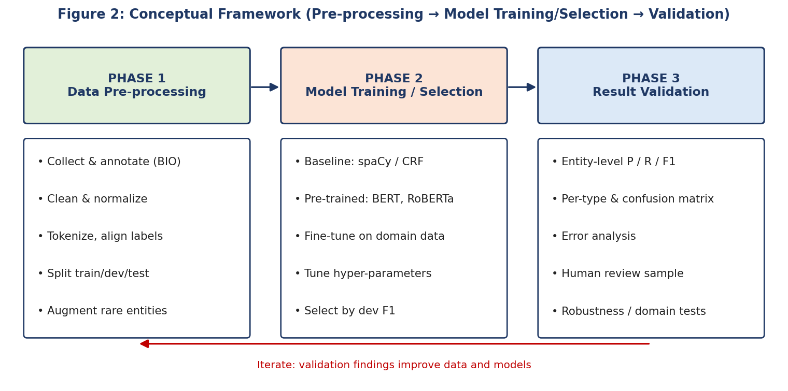
Figure 1: Conceptual framework with three phases and an iterative feedback loop

3.1 Phase 1: Data Pre-processing
This phase produces clean, consistently tokenized, correctly labelled data. It includes collecting text, annotating entities (or loading an annotated dataset), cleaning and normalizing text, tokenizing, aligning labels with tokens or sub-word pieces, splitting data into training, development and test sets, and augmenting data for rare entity types.

3.2 Phase 2: Model Training or Selection
This phase chooses and builds the recognizer. It starts with simple baselines (spaCy statistical model or a CRF), evaluates pre-trained transformer taggers, fine-tunes the most promising model on in-domain data, tunes hyper-parameters on the development set and selects the final model by development F1 and practical constraints such as speed and memory.

3.3 Phase 3: Result Validation
This phase checks whether the system is good enough and why it fails when it is not. It uses entity-level precision, recall and F1 on a held-out test set, per-type scores and a confusion matrix, structured error analysis, human review of a sample and robustness tests on other domains or noisy text.

4. System Architecture and Pipeline Flowchart
Figure 2 shows the proposed system architecture. Data flows left to right on the top row and then continues on the bottom row. The red line shows the feedback loop from validation back to model and data improvement.
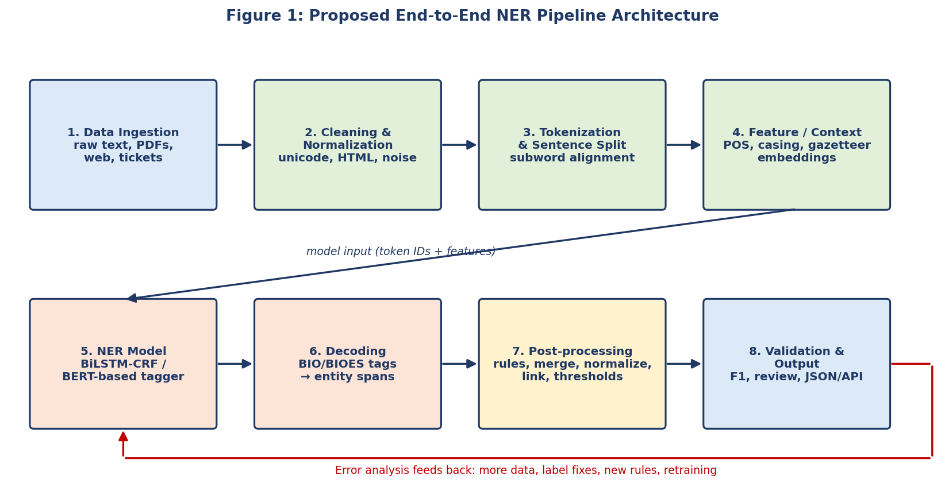
Figure 2: Proposed end-to-end NER pipeline architecture

4.1 Step-by-Step Description of the Pipeline
- Data ingestion. Collect raw text from files, PDFs, web pages, emails or databases and convert it into plain text with source metadata (document ID, date, source).
- Cleaning and normalization. Fix encoding, remove HTML tags and boilerplate, normalize whitespace, quotes and Unicode forms while preserving capitalization, punctuation and digits that carry entity information.
- Tokenization and sentence segmentation. Split text into sentences and tokens. For transformer models, use the model's own sub-word tokenizer and align word-level labels to sub-word pieces.
- Feature and context preparation. Prepare model inputs: token IDs and attention masks for transformers; optionally add POS tags, casing and shape features, character embeddings and gazetteer flags for feature-based or BiLSTM models.
- NER model. Predict a BIO (or BIOES) tag for each token using a CRF, BiLSTM-CRF or fine-tuned transformer token-classification model.
- Decoding. Convert tag sequences into entity spans with character offsets, resolve inconsistent tag sequences (for example an I- tag with no preceding B-) and, for sub-words, take the prediction of the first piece of each word.
- Post-processing. Apply confidence thresholds, merge or split spans, apply rules and gazetteers, normalize surface forms (for example "U.S." and "United States") and link entities to canonical IDs.
- Validation and output. Measure quality, route uncertain cases to human review, and output entities in a structured format (JSON with text, label, start, end, confidence). Error analysis feeds the next iteration.

4.2 Interfaces Between Stages
Stage | Input | Output
Ingestion | Files, URLs, databases | Plain text + metadata
Cleaning | Plain text | Normalized text
Tokenization | Normalized text | Sentences, tokens, offsets
Feature preparation | Tokens | Token IDs, masks, features
NER model | Model inputs | Tag probabilities / tags per token
Decoding | Tags + offsets | Entity spans with labels
Post-processing | Raw entity spans | Corrected, normalized, linked entities
Validation / output | Final entities, gold labels | Metrics, error report, JSON
Table 3: Inputs and outputs for each pipeline stage

5. Data Pre-processing Techniques
Pre-processing for NER differs from pre-processing for tasks such as topic modeling. Because the signal for entities lies in capitalization, punctuation, digits and word shape, aggressive cleaning can destroy the information the model needs.

5.1 What to Do and What to Avoid
Technique | Recommended for NER? | Reason
Lower-casing | Avoid (or use cased model) | Capitalization is a strong cue for proper nouns; lower-casing makes "Apple" and "apple" identical.
Stop-word removal | Avoid | Words such as "of" and "the" occur inside entity names ("Bank of America") and provide context.
Stemming / lemmatization | Avoid for model input | Changes surface forms and breaks span offsets. May be used later for normalization or linking.
Punctuation removal | Avoid | Punctuation appears in entities ("U.S.", "AT&T", "Dr.") and marks sentence boundaries.
Unicode and whitespace normalization | Yes | Reduces noise without removing information.
HTML / boilerplate removal | Yes | Removes non-text noise.
Sentence segmentation | Yes | Models are trained on sentence-level input.
Tokenization | Yes (consistent with model) | Needed for sequence labelling; must match the model's tokenizer.
Number and date handling | Keep as is | Numbers are part of MONEY, DATE, PERCENT entities.
Table 4: Suitability of common pre-processing techniques for NER

5.2 Tokenization and Sub-word Alignment
Transformer models split words into sub-word pieces (for example, a rare name may be split into several word pieces). Because labels are annotated at word level, they must be aligned with the pieces: the first piece receives the word's label and the remaining pieces are either ignored in the loss (label -100) or given the matching I- label. At prediction time, the tag of the first piece is used for the word. Failing to align labels correctly is one of the most common implementation errors and causes a sharp drop in accuracy.

5.3 Annotation Scheme
Scheme | Description | Comment
IO | I-TYPE for entity tokens, O otherwise | Simple but cannot separate adjacent entities of the same type.
BIO (IOB2) | B-TYPE begins an entity, I-TYPE continues, O outside | Most widely used; separates adjacent entities.
BIOES | Adds E-TYPE (end) and S-TYPE (single token) | Gives the model explicit boundary information and often slightly improves accuracy.
Table 5: Tagging schemes

5.4 Data Splitting, Quality and Augmentation
- Split by document, not by sentence, to prevent leakage of near-identical sentences between training and test sets. Use a development set for tuning and keep the test set untouched until the final evaluation.
- Check annotation quality: measure inter-annotator agreement (for example Cohen's kappa on a sample), write clear annotation guidelines and resolve disagreements.
- Handle class imbalance: most tokens are labelled O. Use class weights, sampling of sentences that contain entities, or focal loss if rare types perform poorly.
- Augment data for rare types with techniques such as entity replacement (swap an entity with another of the same type from a gazetteer), mention-level replacement, back-translation and controlled synthetic sentences. Review augmented data to avoid unnatural examples.
- Add noisy-text variants (random casing changes, typos, missing punctuation) if the system will process social-media or OCR text.

6. Public Datasets and Pre-trained Models
Public datasets and pre-trained models greatly reduce the cost of building an NER system. They can be used for training, fine-tuning, benchmarking and bootstrapping annotation.

6.1 Public Datasets
Dataset | Description | How it is used in the pipeline
CoNLL-2003 (English) | News text with PER, ORG, LOC, MISC; roughly 14,000 training sentences | Standard benchmark; fine-tuning and comparison with published results
OntoNotes 5.0 | Multi-genre text with 18 entity types (licence required) | Richer label set; training a general-purpose model
WNUT-17 | Social-media text focused on emerging and rare entities | Testing robustness to noisy text and unseen entities
WikiANN (PAN-X) | Automatically annotated Wikipedia data in many languages | Multilingual training and weak supervision
Domain datasets (for example BC5CDR for chemicals/diseases, MIT Restaurant, FIN) | Domain-specific entities | Domain adaptation and evaluation
Table 6: Public NER datasets and their use

6.2 Pre-trained Models
Model / library | Type | Notes
spaCy (en_core_web_sm / md / lg / trf) | Statistical CNN or transformer pipelines | Fast, easy to deploy; OntoNotes-style labels; good baseline and production option.
Hugging Face BERT/RoBERTa NER checkpoints (for example dslim/bert-base-NER) | Transformer token classifiers | High accuracy; can be used directly or fine-tuned.
Flair NER | Contextual string embeddings + BiLSTM-CRF | Strong accuracy on CoNLL-2003; heavier.
Stanza | Neural pipeline from Stanford NLP | Multilingual support.
Base encoders (BERT, RoBERTa, DeBERTa, domain models such as BioBERT, FinBERT, Legal-BERT) | Pre-trained language models without NER head | Starting point for fine-tuning on custom labels.
Table 7: Pre-trained models and libraries

6.3 Recommended Way of Using Them
- Evaluate out of the box. Run a pre-trained model zero-shot on a sample of your own data to measure the starting accuracy and see which entity types are missed.
- Use directly. If the label schema matches and accuracy is acceptable, deploy with post-processing rules.
- Fine-tune. If the domain or labels differ, fine-tune a pre-trained encoder on a few hundred to a few thousand in-domain annotated sentences. Transfer learning typically needs far less labelled data than training from scratch.
- Bootstrap annotation. Use the pre-trained model's predictions as pre-annotations, then correct them manually. This can greatly speed up annotation.
- Check licences. Check dataset and model licences (for example OntoNotes access terms) before commercial use.

7. NER Model Selection

7.1 Candidate Approaches
Approach | Strengths | Weaknesses | Best suited for
Rule-based / gazetteer | Transparent; no training data; precise for fixed patterns (emails, IDs, dates) | Brittle; poor recall on new entities; manual upkeep | Structured patterns, closed lists
CRF with hand-crafted features | Fast; works with small data; interpretable features | Needs feature engineering; limited context understanding | Small datasets, low-resource settings
BiLSTM-CRF | Learns features automatically; captures sequence context | Needs more data; static embeddings struggle with polysemy unless contextual embeddings are added | Medium datasets, moderate compute
Transformer (BERT / RoBERTa) token classifier | Contextual embeddings handle ambiguity and polysemy; best accuracy; transfer learning | Heavier compute; sub-word alignment; max input length | Most production systems with GPU or optimized CPU
spaCy pipeline | Fast, simple API, easy deployment | Slightly lower accuracy than top transformers (the transformer pipeline closes the gap) | Quick baselines and CPU-based production
Large language model prompting | Zero or few-shot; flexible labels | Costly; non-deterministic; span offsets and consistency need checking | Prototyping, rare labels, annotation assistance
Table 8: Comparison of NER approaches

7.2 Evidence from Published Benchmarks
Figure 3 plots results reported in the original papers for several well-known neural NER models on the CoNLL-2003 English test set. These are published figures, not experiments run for this report; they illustrate the consistent gains from contextual representations.
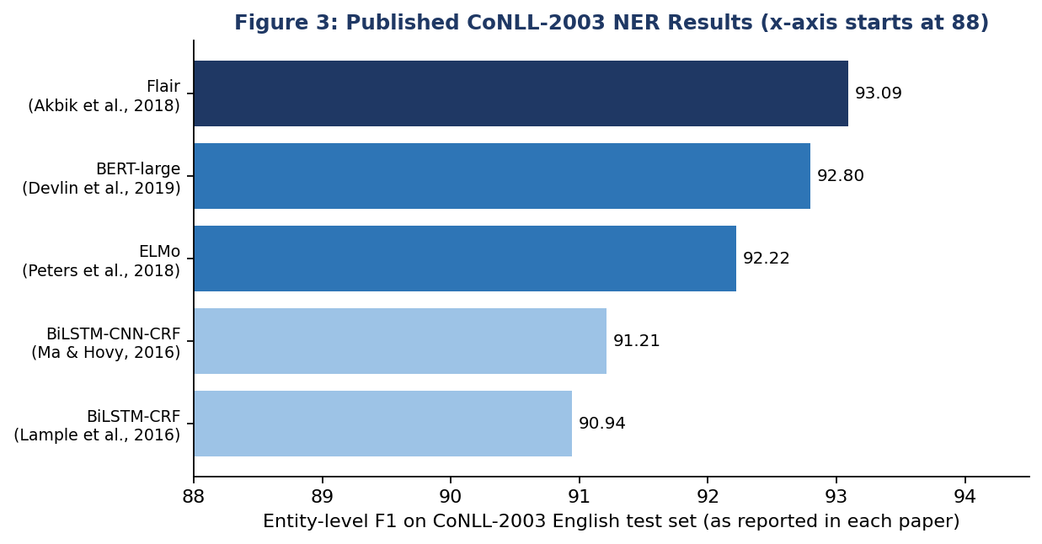
Figure 3: Published CoNLL-2003 test F1 scores (Lample et al., 2016; Ma & Hovy, 2016; Peters et al., 2018; Devlin et al., 2019; Akbik et al., 2018)
Interpretation: moving from static-embedding BiLSTM-CRF models to models with contextual embeddings (ELMo, BERT, Flair) improves F1 by roughly 1 to 2 points on this benchmark. Because contextual models represent the same word differently depending on its sentence, they directly address the ambiguity and polysemy problems that dominate NER errors.

7.3 Recommended Model Strategy
- Baselines. Build two quick baselines: a spaCy pipeline (or CRF) and a rule-based extractor for pattern entities.
- Primary model. Select a pre-trained transformer encoder appropriate to the domain (RoBERTa or BERT for general text; BioBERT, FinBERT or similar for specialized text) and fine-tune with a token-classification head.
- Selection criteria. Choose by development-set entity-level F1, with latency and memory limits as tie-breakers. If speed is critical, use a distilled model (DistilBERT) or a spaCy pipeline.
- Ensembling. Optionally combine models (for example transformer + rules, or majority vote over several models) to raise precision on critical entity types.

7.4 Suggested Fine-tuning Configuration
Setting | Typical starting value and reasoning
Base model | roberta-base or bert-base-cased (cased models preserve capitalization)
Learning rate | 2e-5 to 5e-5 with linear warm-up and decay
Epochs | 3 to 5, with early stopping on development F1
Batch size | 16 to 32 (reduce for long sequences or limited memory)
Max sequence length | 128 to 256 sub-word tokens; split longer documents into overlapping windows
Loss | Cross-entropy over tokens (ignore -100); class weights if rare types underperform
Random seeds | Run at least 3 seeds and report mean and standard deviation
Table 9: Suggested fine-tuning configuration (starting values to be tuned on the development set)

8. Post-processing and Correction Techniques
Even strong models make systematic mistakes. Post-processing uses rules, domain knowledge and document-level context to correct them cheaply, without retraining. Figure 4 shows the proposed workflow.
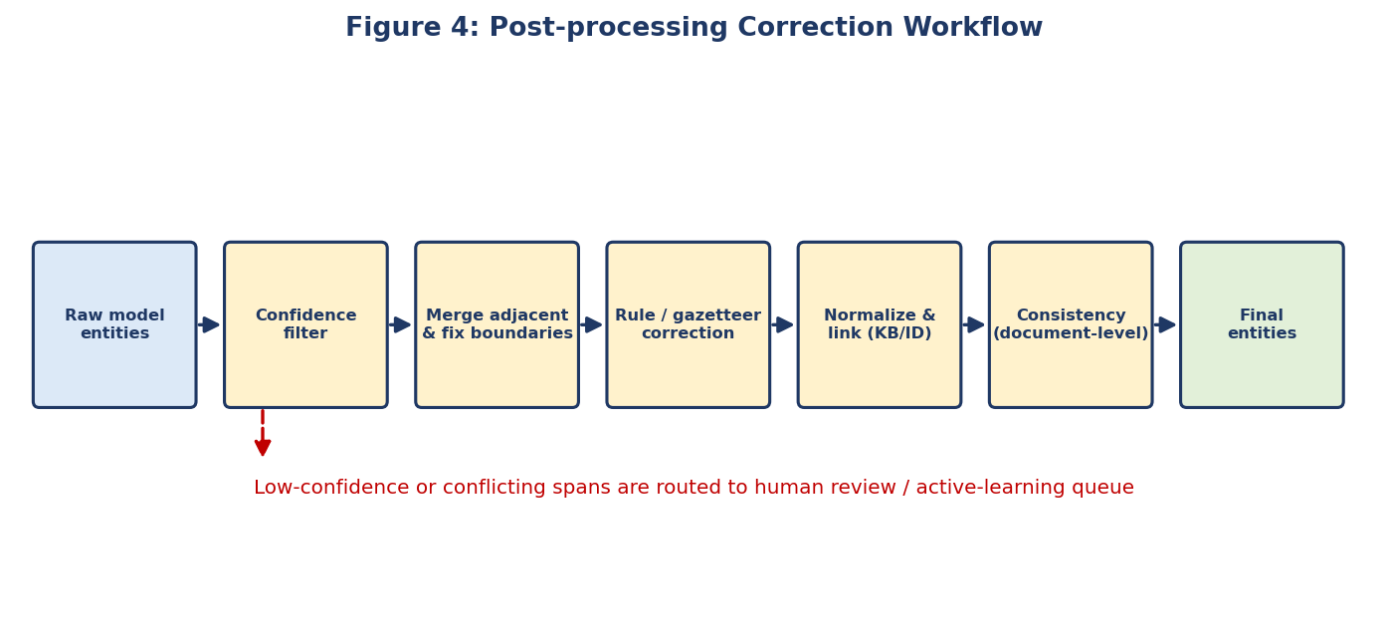
Figure 4: Post-processing correction workflow
Technique | What it does | Example
Tag-sequence repair | Fix invalid sequences such as I-ORG with no B-ORG, or a type change inside one entity | I-PER after O becomes B-PER
Confidence thresholding | Discard or flag low-probability entities | Drop an entity with confidence below 0.5, or send it to review
Span merging and boundary fixing | Merge adjacent same-type spans; strip trailing punctuation or titles | "Mr." removed from the person span; "New" + "York" merged
Rule and regex correction | Apply deterministic patterns for well-structured entities | Emails, phone numbers, PAN/GST-like IDs, ISO dates, currency amounts
Gazetteer / dictionary lookup | Correct or add entities from curated lists | Known company names, product catalogue, city lists
Document-level consistency | If a name is tagged ORG in most mentions, apply the majority label to the rest | "Apple" tagged ORG in 9 of 10 mentions in a tech article
Normalization | Map surface variants to a canonical form | "U.S.", "USA", "United States" → United States
Entity linking | Link mentions to knowledge-base IDs using context | "Jordan" linked to the country or the person based on context
Type-specific business rules | Remove impossible combinations | A DATE span that contains no digits or month name is rejected
Human-in-the-loop review | Route uncertain or conflicting cases to reviewers | Corrections returned as new training data
Table 10: Post-processing techniques

9. Challenges and Mitigation Strategies
This section discusses the potential challenges in entity recognition and the strategies to mitigate the resulting errors.
Challenge | Why it happens | Mitigation strategy
Contextual ambiguity | Same string can be different types: Washington (person, city, state, organization), Apple (company or fruit), Amazon (company, river) | Use contextual transformer embeddings; keep full-sentence context; add document-level consistency rules; use entity linking with context; provide larger windows around the mention.
Polysemy | Common words used as names ("Will", "Bill", "Orange", "Mercury") | Case-aware models; POS features; training data rich in both usages; gazetteer combined with context checks.
Nested and overlapping entities | "Bank of America Tower" contains an ORG inside a FACILITY | Use span-based or layered models, or two-pass tagging; or define a flat annotation policy and document it.
Rare and unseen entities (out of vocabulary) | New companies, products and names not in training data | Sub-word tokens and character features; pre-trained language models; data augmentation by entity replacement; periodic retraining and gazetteer updates.
Noisy, informal or badly cased text | Social media, OCR, transcripts, all-lowercase text | Train on noisy variants; use truecasing models; use WNUT-style data; avoid depending only on capitalization.
Domain shift | Model trained on news performs worse on legal, medical or financial text | Fine-tune on in-domain data; use domain-specific encoders; evaluate on a domain test set before deployment.
Boundary errors | Partial matches such as "New York" vs. "New York Times" | BIOES scheme; CRF layer; boundary-fixing rules; use of partial-match metrics in error analysis.
Annotation inconsistency | Different annotators label the same pattern differently | Clear guidelines; agreement measurement; adjudication; remove or fix conflicting examples.
Class imbalance | Most tokens are O; some types are rare | Class weights, oversampling of entity-bearing sentences, augmentation, per-type monitoring.
Long documents | Input length limits of transformers | Sliding windows with overlap; merge predictions; prefer predictions with more context.
Multilingual and code-mixed text | Different scripts and mixed languages (for example Hinglish) | Multilingual encoders (mBERT, XLM-R); transliteration handling; language-specific gazetteers.
Privacy and bias | Names and personal data in text; unequal performance across groups | Mask or restrict sensitive data; evaluate performance across name groups and regions; audit regularly.
Table 11: Challenges in NER and mitigation strategies

10. Error Handling and Accuracy-Boosting Strategies

10.1 Error Handling in the Pipeline
- Input validation: reject or flag empty text, unsupported encodings, extremely long or binary input, and log the reason.
- Graceful degradation: if the primary model fails or times out, fall back to the baseline model or rule-based extractor and mark the output accordingly.
- Confidence-based routing: low-confidence entities go to a review queue instead of being silently accepted.
- Defensive decoding: repair invalid tag sequences and verify that character offsets map back to the original text.
- Logging and traceability: store model version, input hash, entities and confidence for audit and debugging.
- Batching and timeouts: process large inputs in batches with retries to avoid whole-job failure.

10.2 Strategies to Boost Accuracy
Strategy | How it improves recognition
Transfer learning with domain-adapted encoders | Starts from rich language knowledge; domain pre-training (for example BioBERT) improves handling of specialist vocabulary.
More and better data | Active learning selects the most uncertain sentences for annotation, giving more improvement per labelled example than random sampling.
Data augmentation | Entity replacement and noise injection improve recall on rare entities and robustness to noisy text.
CRF layer on top of the encoder | Enforces valid tag transitions and improves span boundaries.
Ensembling | Majority voting or averaging over several models or seeds reduces variance and random mistakes.
Rules and gazetteers | Raise precision for patterned and closed-list entities; fix recurring errors cheaply.
Context windows | Provide neighbouring sentences for long or ambiguous mentions.
Hyper-parameter tuning | Systematic search of learning rate, batch size and epochs on the development set.
Error-driven iteration | Categorize errors, fix the largest category first (data, rule or model), re-evaluate.
Continuous learning | Feed human-corrected predictions back into training data and retrain on a schedule.
Table 12: Accuracy-boosting strategies

11. Evaluation and Result Validation

11.1 Metrics
NER is evaluated at entity level: a predicted entity counts as correct only if both its boundaries and its type exactly match the gold annotation (strict matching, as used by the CoNLL evaluation and the seqeval library).
Metric | Definition | Use
Precision | Correct predicted entities / all predicted entities | How trustworthy the extracted entities are
Recall | Correct predicted entities / all gold entities | How many real entities are found
F1 | Harmonic mean of precision and recall | Primary single-number metric
Micro vs. macro averaging | Micro pools all entities; macro averages over types | Micro reflects overall performance; macro shows weakness on rare types
Partial-match / relaxed F1 | Counts overlapping spans with the correct type | Helps diagnose boundary errors
Per-type scores and confusion matrix | Scores and confusions for each entity type | Find types that are mixed up (for example ORG vs. LOC)
Latency and throughput | Time per document, documents per second | Production readiness
Table 13: Evaluation metrics

11.2 Validation Procedure
- Hold-out test. Use a held-out test set that is never used for tuning; report mean and standard deviation over multiple seeds.
- Per-type analysis. Report per-type precision, recall and F1, not only the overall score.
- Error taxonomy. Categorize errors: missed entity (false negative), spurious entity (false positive), wrong type, wrong boundary. Count each category and review samples.
- Robustness testing. Test on out-of-domain and noisy text to estimate real-world robustness.
- Human review. Have reviewers check a random sample of output (including entities the model accepted with high confidence) to estimate real precision.
- Acceptance criteria. Define acceptance thresholds in advance, for example overall F1 of at least 0.85 on the in-domain test set and at least 0.80 for every critical entity type (targets to be agreed with stakeholders, not results).

12. Rationale of Each Component and Contribution to System Performance
Component | Rationale (why it is included) | Contribution to overall performance
Cleaning and normalization | Noise and encoding problems break tokenization and confuse the model | Removes avoidable errors; improves consistency of input
Preserving case and punctuation | They carry strong entity signals | Higher recall and precision for proper nouns and abbreviations
Tokenization with label alignment | Models need tokens, labels annotate words | Prevents label noise that would reduce training quality
Feature / context preparation | Context decides entity type | Enables disambiguation of polysemous words
Pre-trained transformer model | Contextual representations and transfer learning | Largest single gain in accuracy, especially with little labelled data
CRF / valid-sequence decoding | Tags depend on neighbouring tags | Cleaner boundaries, fewer invalid spans
Post-processing rules and gazetteers | Fix systematic and pattern errors without retraining | Raises precision and fixes known errors quickly
Normalization and linking | Entity mentions vary in surface form | Makes output usable for analytics and knowledge graphs
Validation and error analysis | Measure and understand failures | Directs effort to the most valuable improvements
Monitoring and feedback loop | Language and data change over time | Maintains accuracy after deployment
Table 14: Rationale and contribution of each pipeline component

13. Implementation Strategy, Deployment and Monitoring

13.1 Phased Implementation Plan
Phase | Activities | Output | Indicative effort
1. Setup | Define entities, schema and acceptance criteria; collect sample data; set up environment and repository | Annotation guidelines, sample corpus | 4-5 hours
2. Data | Annotate or load datasets; clean; tokenize; split; align labels | Train / dev / test data | 6-8 hours
3. Baselines | Run spaCy and rule-based baselines; measure F1 | Baseline report | 4-5 hours
4. Modeling | Fine-tune transformer; tune hyper-parameters; compare | Selected model | 8-10 hours
5. Post-processing | Implement rules, gazetteers, normalization | Post-processing module | 3-4 hours
6. Validation | Evaluate; error analysis; human review | Evaluation report | 3-4 hours
7. Deployment | Package as API or batch job; logging; documentation | Deployed pipeline | 2-3 hours
Table 15: Phased plan (indicative effort within a 30-35 hour assignment)

13.2 Technology Stack
- Language and libraries: Python, spaCy, Hugging Face Transformers and Datasets, PyTorch, seqeval, scikit-learn.
- Annotation: Label Studio, Doccano or Prodigy.
- Experiment tracking: MLflow or Weights and Biases; Git for version control.
- Serving: FastAPI or Flask REST service, containerized with Docker; batch processing for large archives.
- Monitoring: logs of entity counts and confidence distributions, periodic evaluation on a fresh labelled sample.

13.3 Deployment and Monitoring
- Version every model and dataset; keep the ability to roll back.
- Monitor for drift: sudden changes in entity-type frequency or in average confidence can signal new vocabulary or a data-source change.
- Collect user corrections and review-queue decisions as new training data; retrain on a schedule.
- Protect privacy: mask or restrict personal data, control access to logs and apply retention limits.

14. Worked Example
The following example shows how one sentence passes through the pipeline: "Sundar Pichai said Google will open a new office in Bengaluru on 15 March 2027."
Token | BIO tag | Entity | Comment
Sundar | B-PER | PERSON | Start of a person name
Pichai | I-PER | PERSON | Continuation of the same name
said | O | - | Not an entity
Google | B-ORG | ORG | Company (context: acts and opens an office)
will open a new office in | O | - | Context words, kept for disambiguation
Bengaluru | B-LOC | GPE / LOC | City; may be split into several sub-word pieces. Only the first piece carries the label
15 | B-DATE | DATE | Start of a date
March | I-DATE | DATE | Continuation
2027 | I-DATE | DATE | Continuation; span 15 March 2027
Table 16: Tagged example sentence
Pipeline view: (1) the sentence is cleaned and tokenized; (2) the model assigns BIO tags using the whole sentence as context; (3) decoding produces four spans; (4) post-processing normalizes the date to the ISO form 2027-03-15 and links Google and Bengaluru to knowledge-base entries; (5) the result is returned as structured JSON with confidences. Ambiguity example: in "Apple released a new phone" the context word "released" and the position at sentence start help the contextual model choose ORG, while in "She ate an apple" the lower-case form and context favour no entity at all.
{ "entities": [
{"text": "Sundar Pichai", "label": "PERSON", "start": 0, "end": 13, "conf": 0.99},
{"text": "Google", "label": "ORG", "start": 19, "end": 25, "conf": 0.98},
{"text": "Bengaluru", "label": "GPE", "start": 52, "end": 61, "conf": 0.97},
{"text": "15 March 2027", "label": "DATE", "start": 65, "end": 78, "conf": 0.96,
"normalized": "2027-03-15"} ] }
Illustrative output format (values shown for illustration only)

15. Conclusion
This report designed a complete NER pipeline, from raw text to validated, structured entities. The design combines careful pre-processing that preserves the cues entities depend on, a pre-trained transformer tagger fine-tuned on in-domain data with simpler baselines for comparison, post-processing rules that correct systematic errors, and a validation process built on entity-level metrics, error analysis and human review. Contextual ambiguity, polysemy, rare entities, noisy text and domain shift are addressed with specific mitigation strategies at the data, model and post-processing levels. The three-phase framework with a feedback loop makes the system improvable over time rather than fixed at deployment. Following the phased implementation plan, an organization can move from a quick baseline to a reliable, monitored NER service while keeping quality measurable and errors explainable.

Appendix A: Reference Code
The snippets below illustrate the main steps. They are examples to be adapted and run in a Python environment with the listed libraries.

A.1 Quick baseline with a pre-trained pipeline
# Hugging Face pre-trained NER model
from transformers import pipeline
ner = pipeline('token-classification',
model='dslim/bert-base-NER',
aggregation_strategy='simple')
print(ner('Sundar Pichai said Google will open an office in Bengaluru.'))

# spaCy baseline
import spacy
nlp = spacy.load('en_core_web_sm')
print([(e.text, e.label_) for e in nlp('Google opened an office in Bengaluru.').ents])

A.2 Aligning word-level labels to sub-word tokens
def align_labels(examples, tokenizer, label2id):
enc = tokenizer(examples['tokens'], truncation=True,
is_split_into_words=True)
all_labels = []
for i, labels in enumerate(examples['ner_tags']):
word_ids = enc.word_ids(batch_index=i)
prev, out = None, []
for w in word_ids:
if w is None: out.append(-100) # special tokens
elif w != prev: out.append(labels[w]) # first piece
else: out.append(-100) # other pieces
prev = w
all_labels.append(out)
enc['labels'] = all_labels
return enc

A.3 Simple post-processing
import re
def postprocess(entities, text, min_conf=0.5):
out = []
for e in entities:
if e['conf'] < min_conf: # confidence filter
continue
e['text'] = e['text'].strip(' .,;:') # boundary fix
if e['label'] == 'DATE' and not re.search(r'\d|jan|feb|mar|apr|may|jun|jul|aug|sep|oct|nov|dec', e['text'], re.I):
continue # business rule
out.append(e)
return out

A.4 Entity-level evaluation
from seqeval.metrics import classification_report, f1_score
# y_true, y_pred: lists of tag lists, e.g. [['B-PER','I-PER','O'], ...]
print(classification_report(y_true, y_pred))
print('Entity-level F1:', f1_score(y_true, y_pred))

References
- Tjong Kim Sang, E. F., & De Meulder, F. (2003). Introduction to the CoNLL-2003 Shared Task: Language-Independent Named Entity Recognition. CoNLL.
- Lample, G. et al. (2016). Neural Architectures for Named Entity Recognition. NAACL.
- Ma, X., & Hovy, E. (2016). End-to-end Sequence Labeling via Bi-directional LSTM-CNNs-CRF. ACL.
- Peters, M. E. et al. (2018). Deep Contextualized Word Representations (ELMo). NAACL.
- Akbik, A., Blythe, D., & Vollgraf, R. (2018). Contextual String Embeddings for Sequence Labeling. COLING.
- Devlin, J. et al. (2019). BERT: Pre-training of Deep Bidirectional Transformers for Language Understanding. NAACL.
- Liu, Y. et al. (2019). RoBERTa: A Robustly Optimized BERT Pretraining Approach. arXiv:1907.11692.
- Weischedel, R. et al. (2013). OntoNotes Release 5.0. Linguistic Data Consortium.
- Derczynski, L. et al. (2017). Results of the WNUT2017 Shared Task on Novel and Emerging Entity Recognition. W-NUT.
- Pan, X. et al. (2017). Cross-lingual Name Tagging and Linking for 282 Languages. ACL.
- Lee, J. et al. (2020). BioBERT: a pre-trained biomedical language representation model. Bioinformatics.
- Honnibal, M., & Montani, I. spaCy: Industrial-strength Natural Language Processing in Python.
- Nakayama, H. seqeval: A Python framework for sequence labeling evaluation.

