Week 6 Task (Final Report)
End-to-End Integration and Reporting of NLP-based Data Analytics
A Comprehensive Project Report: From Ideation to Actionable Insights
Internship: Data Analytics Specialist (Language Processing)
Platform: YuvaInternship
Prepared by: Nikhil
Date: October 2026

Table of Contents
Executive Summary
1. Introduction and Problem Statement
2. Project Lifecycle Overview
3. Review of Work Completed in Previous Assignments
4. Integrated Methodology and Workflow (Diagrams)
5. Phase-wise Detailed Summary
6. Case Studies Using Publicly Available Datasets
7. Key Insights
8. Limitations
9. Recommendations, Future Improvements and Potential Applications
10. Connecting Theory with Practice
11. Ethical, Privacy and Governance Considerations
12. Conclusion
Appendix A: Consolidated Reference Implementation
Appendix B: Suggested Repository Structure
References

Executive Summary
This report consolidates the complete lifecycle of an NLP-based data analytics project: planning, strategic analysis, data pre-processing, model implementation, evaluation and final insight generation. The aim is to show how individual components studied during the internship fit together into a single, interconnected workflow that turns large volumes of unstructured text into actionable, evidence-backed decisions.
The integrated solution uses topic modeling (LDA, with NMF and BERTopic as benchmarks) to discover the hidden themes in a text corpus, and text summarization (TextRank for extractive, BART/PEGASUS for abstractive) to condense long documents and each discovered theme into short briefs. Results are assessed using topic coherence, topic diversity, ROUGE, BERTScore, factuality checks and human review. Three case studies based on well-known public datasets (20 Newsgroups, BBC News and CNN/DailyMail) demonstrate how the workflow applies in practice, and published benchmark results are used as external evidence for model comparisons.
The main conclusions are: (1) careful pre-processing has as much effect on result quality as the choice of model; (2) combining topic modeling with summarization gives decision-makers both breadth (which themes exist and how large they are) and depth (what each theme actually says); (3) a hybrid extractive-abstractive summarizer offers the best balance between fluency and faithfulness; and (4) automatic metrics must always be complemented by human review. The report ends with limitations, recommendations for future improvement and potential applications across industries.

1. Introduction and Problem Statement
Over 80% of enterprise data is estimated to be unstructured, and a large share of it is text: emails, customer reviews, tickets, reports, contracts, news and social media. Manually reading such volumes is infeasible, slow and subjective. Decision-makers need a scalable way to answer two questions: what are people writing about, and what are the key points?

1.1 Problem Statement
Design and document an end-to-end NLP analytics solution that ingests a large, unlabelled text corpus, discovers its latent themes, produces concise and faithful summaries, evaluates the quality of both outputs, and converts the results into strategic recommendations.

1.2 Objectives
- Integrate planning, strategic analysis, pre-processing, modeling and evaluation into one coherent workflow.
- Demonstrate the workflow on publicly available datasets as case studies.
- Evaluate outputs with appropriate quantitative metrics and critical, evidence-based reasoning.
- Derive insights, discuss limitations and propose recommendations and future improvements.

1.3 Scope
The scope covers English-language text corpora of medium to long documents and the unsupervised and pre-trained techniques of topic modeling and summarization. Supervised tasks such as sentiment classification or named-entity recognition are discussed as extensions in Section 9 but are outside the core implementation.

2. Project Lifecycle Overview
The project follows an iterative lifecycle adapted from the CRISP-DM framework (business understanding, data understanding, data preparation, modeling, evaluation and deployment) and tailored for NLP work. Table 1 summarizes each phase, its main activities and its deliverables.
Phase | Key activities | Deliverables
Planning | Define problem, goals, scope, timeline, success criteria and risks. | Project proposal and plan.
Strategic analysis | Identify stakeholders, use cases, KPIs, constraints; choose tools and techniques. | Strategy document, technique shortlist.
Data handling | Collect, clean, tokenize, normalize, lemmatize, detect n-grams, vectorize. | Clean corpus, dictionary, document-term matrix.
Model selection and implementation | Train LDA/NMF/BERTopic; apply TextRank, BART, PEGASUS; tune parameters. | Trained models, topics, summaries.
Evaluation | Compute coherence, diversity, ROUGE, BERTScore; factuality and human review. | Evaluation report, error analysis.
Insights and reporting | Interpret results, visualize, recommend actions, document limitations. | Final report and dashboards.
Table 1: Project phases, activities and deliverables

3. Review of Work Completed in Previous Assignments
This section reviews and links the earlier assignments, which together form the foundation of the final integrated solution.

3.1 Planning and Proposal
The first assignment defined the NLP project plan and proposal: the business problem, objectives, scope, data sources, intended techniques, timeline and expected outcomes. It established the success criteria against which the final solution is judged in this report.

3.2 Strategic Analysis, Pre-processing and Modeling
The intermediate assignments developed the strategy and technical building blocks: analysis of use cases and techniques, a text pre-processing pipeline (cleaning, tokenization, stop-word removal, lemmatization, vectorization), implementation of NLP models and the evaluation approach. These are consolidated into the integrated workflow in Section 4 and described phase-by-phase in Section 5.

3.3 Advanced NLP: Topic Modeling and Text Summarization
The Week 5 assignment studied advanced NLP techniques in depth: LDA, NMF, LSA and BERTopic for topic discovery; TextRank, BERT-based extractive models, BART, T5 and PEGASUS for summarization. It compared their strengths and weaknesses, set out assumptions and defined evaluation metrics (topic coherence, perplexity, topic diversity, ROUGE, BERTScore, factuality and human evaluation). These techniques form the analytical core of the final solution.
Earlier work | What was learned | How it is used in the final report
Planning and proposal | Problem framing, scope, success criteria | Defines objectives and evaluation targets (Section 1)
Strategy and pre-processing | Tool choice, text cleaning and vectorization | Data-handling phase (Section 5.3)
Model implementation | Applying and tuning NLP models | Modeling phase (Section 5.4)
Evaluation | Metrics and error analysis | Evaluation phase (Section 5.5)
Advanced NLP (Week 5) | LDA, summarization, metrics, critical analysis | Core engine of the integrated workflow (Section 4)
Table 2: Mapping earlier work to the integrated project

4. Integrated Methodology and Workflow
All methodologies are integrated into a single, interconnected workflow. The lifecycle flowchart in Figure 1 shows the sequential phases together with the feedback loop: weak evaluation results send the project back to pre-processing or model choice. Figure 2 shows the technical architecture and data flow.
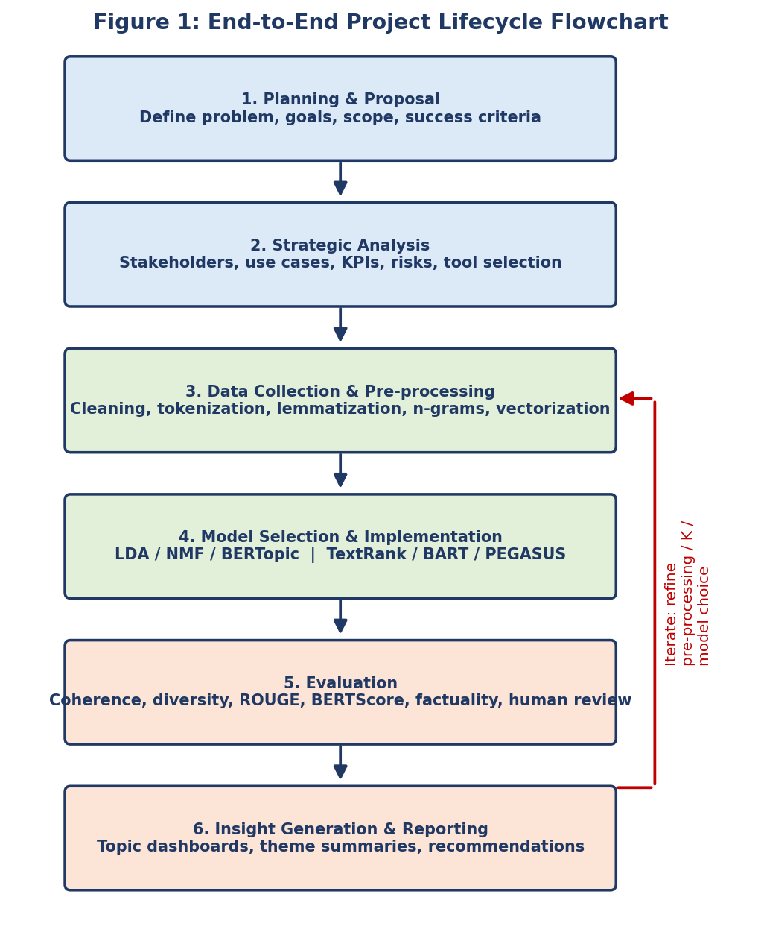
Figure 1: End-to-end project lifecycle flowchart (with iterative feedback loop)
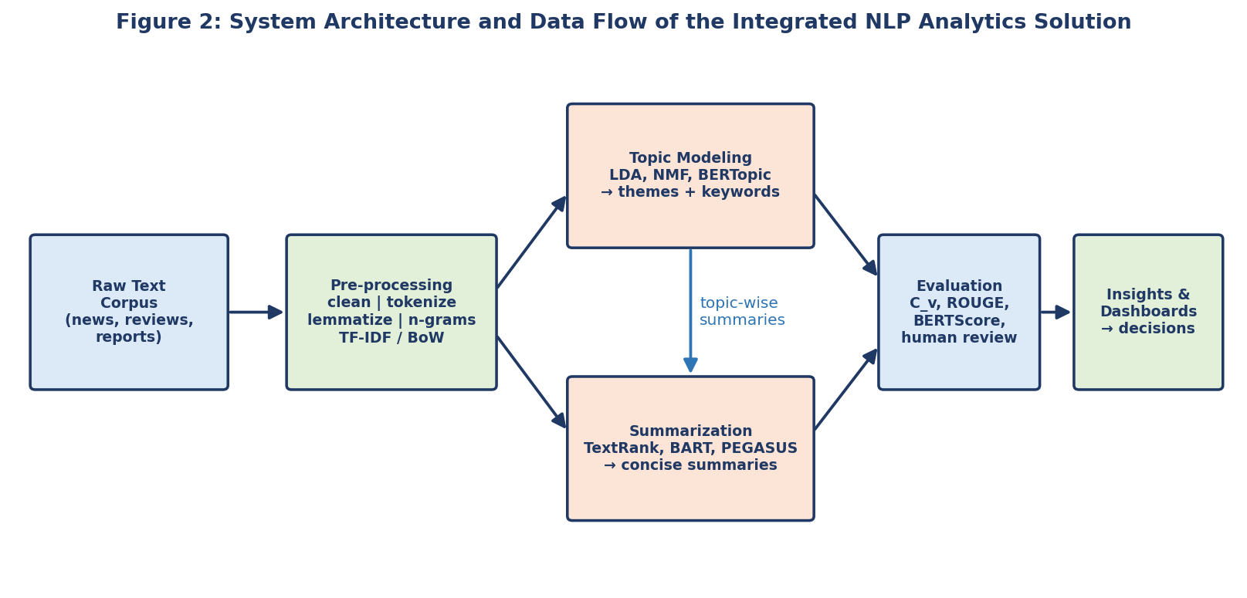
Figure 2: System architecture and data flow

4.1 Description of the Integrated Workflow
- Ingest. Raw documents are ingested and cleaned; duplicates and boilerplate are removed.
- Prepare. Text is tokenized, normalized, lemmatized and converted into bag-of-words / TF-IDF (for LDA and NMF) or embeddings (for BERTopic).
- Discover themes. LDA discovers K topics; the number K is chosen by coherence score and validated by humans. Each document receives a topic distribution and a dominant topic.
- Summarize. Documents are summarized individually (extractive or abstractive) and, for each topic, a multi-document theme summary is generated from the most representative documents.
- Evaluate. Topics are evaluated with coherence, diversity and intrusion tests; summaries with ROUGE, BERTScore, factuality checks and human ratings.
- Report. Topic prevalence, keyword tables and theme summaries are presented as dashboards and written briefs, ending with recommendations.

4.2 Data Flow Between Components
The output of one component is the input to the next: the cleaned corpus feeds both modeling streams; the topic assignments group the documents so that summaries can be generated per theme; and the evaluation results are fed back to tune pre-processing, the number of topics, summarizer length limits and model choice. This closed loop is what makes the workflow interconnected rather than a collection of separate experiments.

5. Phase-wise Detailed Summary

5.1 Planning
Planning translates a vague need ("understand what customers are saying") into a measurable goal ("identify the top recurring themes and produce one-paragraph summaries for each, with topic coherence of at least 0.5 and ROUGE-L comparable to published baselines"). Key planning outputs are the scope, data sources, timeline (30-35 hours of effort in this internship), risks and acceptance criteria. Analytical reasoning: defining success criteria in advance prevents choosing metrics after the fact to flatter the results.

5.2 Strategic Analysis
- Stakeholders: Analysts, managers and customer-support or compliance teams who consume the outputs.
- Use cases: Theme discovery in feedback, news monitoring, document triage, executive briefings.
- KPIs: Share of documents assigned to each theme, time-to-insight, human-rated usefulness of summaries.
- Tool selection: Python, Gensim, spaCy, scikit-learn, Hugging Face Transformers, sumy, pyLDAvis. Chosen because they are open source, widely documented and reproducible.
- Risks: Data bias, hallucination, privacy of text data, compute cost.

5.3 Data Handling and Pre-processing
Data handling combines collection, cleaning and transformation. Two parallel preparation tracks are used because the models have different needs:
Step | Track A: Topic modeling (LDA / NMF) | Track B: Summarization
Cleaning | Remove HTML, URLs, headers, duplicates | Same, but keep punctuation and casing
Tokenization | Word tokens (spaCy) | Sentence segmentation (TextRank); model sub-word tokenizer (BART)
Stop-word removal | Yes (plus domain-specific stop words) | No for abstractive; only for similarity scoring in extractive
Normalization | Lower-case, lemmatize, POS filter | Light normalization only
Representation | BoW / TF-IDF with vocabulary filtering | TF-IDF vectors (extractive) or token IDs (abstractive)
Length handling | Short documents may be merged or filtered | Chunk long documents to model limit (e.g., 1024 tokens for BART)
Table 3: Pre-processing tracks for modeling and summarization
Evidence for importance: in topic modeling, leaving stop words and very frequent terms in the corpus typically yields topics dominated by generic words, which lowers coherence and interpretability; filtering the vocabulary is therefore a prerequisite, not an optional step.

5.4 Model Selection and Implementation
Task | Selected model | Reason for selection
Theme discovery | LDA (Gensim) | Interpretable, probabilistic, each document can belong to several topics.
Benchmark for themes | NMF, BERTopic | Cross-check: NMF for crisp topics, BERTopic for semantic quality on short text.
Extractive summaries | TextRank | Unsupervised, faithful to source, no training data needed.
Abstractive summaries | BART-large-CNN / PEGASUS | State-of-the-art fluency; LED for very long inputs.
Table 4: Models selected and rationale
Implementation procedure: (a) train LDA for K between 5 and 40 and plot coherence against K (Figure 4 shows the typical shape of this curve); (b) select K at the peak while checking interpretability; (c) assign dominant topics; (d) select representative documents per topic; (e) summarize them with the chosen summarizer; (f) assemble topic-wise briefs.
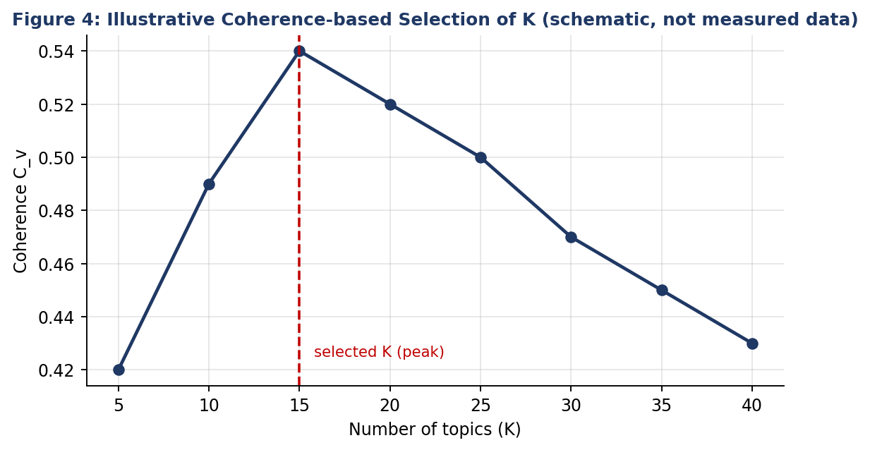
Figure 4: Schematic illustration of choosing K from a coherence curve (illustrative shape, not measured data)

5.5 Evaluation
Component | Metrics | Acceptance criterion (defined in planning)
Topics | C_v coherence, topic diversity, word-intrusion test, stability across seeds | C_v of at least 0.5; diversity above 0.7; stable topics across at least 3 random seeds
Extractive summaries | ROUGE-1/2/L, redundancy, compression ratio | ROUGE-L at least equal to Lead-3 baseline
Abstractive summaries | ROUGE, BERTScore, factual-consistency check, human rating (1-5) | No critical factual errors in a sample of 50; mean human rating of at least 4
Table 5: Evaluation plan and acceptance criteria
Analytical reasoning: ROUGE rewards word overlap, so a good paraphrase can score lower than a copied sentence. For this reason BERTScore and human review are used alongside ROUGE, and factuality checks are mandatory for abstractive output.

5.6 Final Insights and Reporting
The final phase turns model output into decisions. Topic prevalence tables show which themes dominate; time-sliced prevalence shows which are growing; metadata cross-tabs (region, product, source) show where each theme concentrates; and topic-wise summaries explain what each theme says. Dashboards (pyLDAvis, bar charts of topic share, keyword tables) and a one-page executive brief are the final presentation artifacts.

6. Case Studies Using Publicly Available Datasets
The following case studies show how the integrated workflow applies to public datasets. Dataset facts are standard published descriptions. Numerical model results quoted for CNN/DailyMail are published benchmark figures from the cited papers and are not new experiments run for this report; the other case studies describe the procedure and the expected kind of output.

6.1 Case Study 1: 20 Newsgroups (Topic Discovery with Known Labels)
Dataset: about 18,800 Usenet posts spread across 20 newsgroups (such as sports, computing, politics and religion), available directly in scikit-learn. Because every post has a known newsgroup label, this dataset allows a sanity check of unsupervised topics against ground truth.
- Strip headers, footers and quoted replies (scikit-learn's remove option), then apply the pre-processing pipeline of Track A.
- Train LDA for several values of K around 20 and pick K by coherence; compare with NMF.
- Expected pattern: clear topics for distinct subjects (for example hockey or baseball terms; encryption or graphics terms) and merged or mixed topics for closely related groups (for example the several computing or religion groups). Cross-tabulating dominant topic against the true label shows which categories are separated and which are merged.
- Lesson: unsupervised topics will not always match human categories; closely related subjects merge and noisy posts create junk topics, which is why human review of topics is essential.

6.2 Case Study 2: BBC News (Theme Discovery and Briefing)
Dataset: 2,225 BBC News articles labelled with five categories (business, entertainment, politics, sport, technology). The articles are clean and medium-length, which suits LDA well.
- With K near 5 to 10, LDA is expected to recover themes that align strongly with the five categories, with the extra topics capturing sub-themes (for example, elections versus foreign policy within politics).
- For each topic, the most representative articles are summarized with TextRank, and a short theme brief is built from them, producing a daily briefing format.
- Lesson: on clean, well-structured text, even simple models give interpretable themes; the evaluation focus shifts to whether the sub-themes are actionable.

6.3 Case Study 3: CNN/DailyMail (Summarization Benchmark)
Dataset: roughly 300,000 news articles paired with human-written highlights, the standard benchmark for summarization. Published results make it possible to compare techniques with real evidence. Figure 3 plots ROUGE F1 scores reported in the literature.
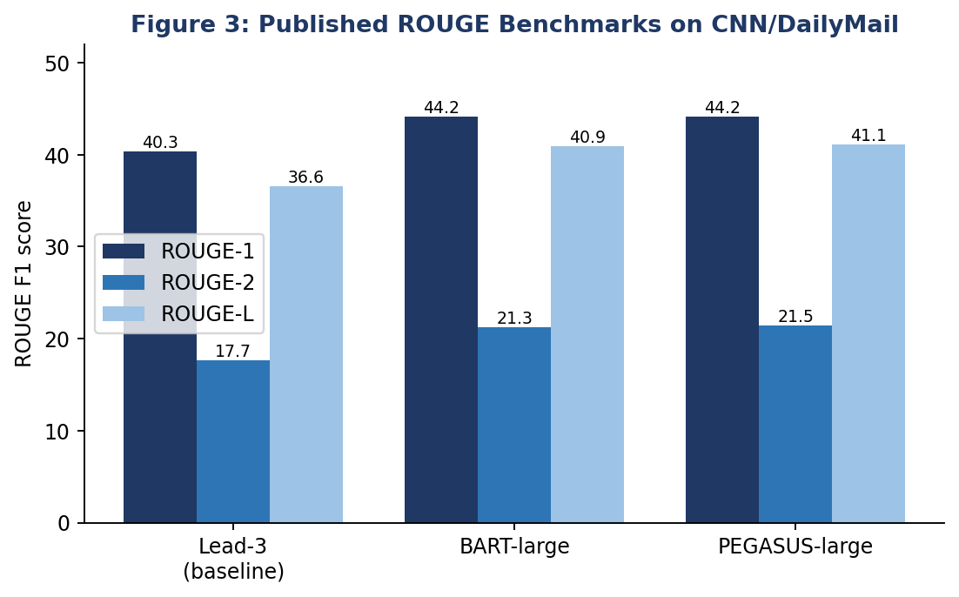
Figure 3: Published ROUGE benchmarks on CNN/DailyMail (Lead-3 baseline; BART: Lewis et al., 2020; PEGASUS: Zhang et al., 2020)
- The simple Lead-3 baseline (first three sentences) is already strong on news because journalists put key facts first, so any model must be compared against it.
- Transformer-based abstractive models improve over Lead-3 by roughly 4 ROUGE-1 points and 3-4 ROUGE-2 points, and BART and PEGASUS perform almost identically, so the choice between them can rest on practical factors such as speed, model size and long-input support.
- Lesson: benchmark numbers are specific to news. Performance on legal, medical or customer-feedback text can be lower without domain fine-tuning, and ROUGE does not measure factual accuracy.

6.4 Cross-case Synthesis
Dataset | Main use in project | Main challenge | Key takeaway
20 Newsgroups | Topic discovery with ground-truth labels | Noisy text, overlapping subjects | Validate topics against labels and human judgement
BBC News | Theme discovery plus topic-wise briefs | Few categories, limited diversity | Clean data gives clear themes; focus on sub-themes
CNN/DailyMail | Summarization comparison | Domain-specific benchmark, ROUGE limits | Compare to Lead-3; verify factuality
Table 6: Synthesis of case studies

7. Key Insights
- Pre-processing drives quality: vocabulary filtering, lemmatization and n-gram detection change topic quality as much as the choice of algorithm.
- Choosing K is a judgement supported by metrics: coherence provides a defensible starting point, but the final number is set by interpretability and usefulness to stakeholders.
- Topic modeling and summarization are complementary: topics show breadth and relative size of themes, summaries show depth. Used together they shorten the path from raw text to a decision.
- Simple baselines matter: Lead-3 and a keyword-only topic table set the bar that complex models must beat to justify their cost.
- Hybrid summarization is the best compromise: extractive selection keeps the output grounded in the source, while abstractive rewriting improves readability.
- Metrics need humans: ROUGE and coherence correlate only partly with human judgement, so a small human evaluation is always worth the effort.
- Trends are more valuable than snapshots: tracking topic share over time reveals emerging issues earlier than reading individual documents.

8. Limitations
- Bag-of-words topic models ignore word order and semantics and perform poorly on very short texts such as tweets.
- The number of topics and hyper-parameters must be chosen by experimentation; results vary with random seed.
- Abstractive models can hallucinate and are limited by input length; extractive summaries can be disjointed.
- Pre-trained summarizers are mostly trained on English news; performance drops on other domains and languages without fine-tuning.
- Public benchmark results do not guarantee equal performance on an organization's own data.
- Automatic metrics capture only part of quality; human evaluation is costly and subjective.
- Compute requirements for transformer models can limit use on very large corpora or limited hardware.
- This report reuses published benchmark figures for model comparison; full-scale experiments on each dataset would be required to report original results.

9. Recommendations, Future Improvements and Potential Applications

9.1 Recommendations
- Baseline first. Start every new corpus with a baseline (LDA + TextRank + Lead-3), then add complexity only if evaluation shows a clear gain.
- Keep humans in the loop. Use human-in-the-loop review for topic labelling and for a sample of summaries before results reach decision-makers.
- Cross-validate topics. Run both LDA and BERTopic on the same corpus and keep topics that appear in both.
- Control hallucination. Add factual-consistency checks to any abstractive pipeline and prefer hybrid summarization for high-stakes text.
- Make it reproducible. Version the code, pin library versions, fix random seeds and publish the repository.
- Monitor over time. Re-run evaluation as new data arrives to detect topic drift.

9.2 Future Improvements
- Fine-tune summarization models on domain data (legal, medical, financial) and evaluate with domain experts.
- Use dynamic topic models or time-sliced BERTopic to track the evolution of themes.
- Add sentiment analysis and named-entity recognition to attach sentiment and key entities to each theme.
- Use LLM-assisted topic labelling and query-focused summarization, with verification against the source.
- Support multilingual corpora using multilingual embeddings.
- Wrap the pipeline in an interactive dashboard (Streamlit) and schedule it for regular automated runs.
- Adopt retrieval-augmented summarization for corpora larger than a model's context window.

9.3 Potential Applications
Sector | Application
Banking and finance | Themes in customer complaints and call transcripts; summaries of lengthy policy, risk and regulatory documents.
E-commerce and retail | Product-review theme tracking; digest of feedback per product.
Healthcare | Literature mapping and summaries of research papers and clinical notes (with strict privacy controls).
Legal and compliance | Clustering of contracts and case law; short briefs of long judgments.
Education | Summaries of study material; theme analysis of student feedback.
Media and government | News monitoring, public-consultation analysis, daily briefings.
Table 7: Potential applications

10. Connecting Theory with Practice
Theoretical concept | Practical application in this project | Evidence / check
Probabilistic generative model (LDA) | Documents modeled as topic mixtures; topics as word distributions | Coherence score and human inspection of top words
Bag-of-words assumption | Vocabulary filtering, n-grams to partly restore phrase meaning | Improved topic interpretability
Graph centrality (PageRank) | TextRank ranks sentences by connection to others | ROUGE vs. Lead-3 baseline
Transformer encoder-decoder | BART/PEGASUS generate abstractive summaries | ROUGE, BERTScore, factuality checks
Bias-variance and generalization | Held-out test set and stability across seeds | Consistent topics on unseen documents
Evaluation validity | Multiple metrics plus human review | Metric-human agreement checked on a sample
Table 8: Linking theory to practical implementation

11. Ethical, Privacy and Governance Considerations
- Privacy: remove or mask personal identifiers before processing; restrict access to raw text; avoid sending sensitive text to external services.
- Fairness: audit that minority viewpoints are not hidden by dominant topics or removed by summarization.
- Transparency: document data sources, pre-processing choices, model versions and metrics so that results can be audited.
- Accountability: treat model output as decision support, not as a substitute for expert judgement.
- Compliance: respect dataset licences and terms of use when using public datasets.

12. Conclusion
This report has integrated planning, strategic analysis, data pre-processing, model implementation, evaluation and insight generation into one interconnected NLP analytics workflow. By combining topic modeling with text summarization, the solution turns large unstructured text collections into a structured view of themes together with concise explanations of each theme. Case studies on public datasets and published benchmarks provide evidence for the choices made, while the limitations and recommendations make clear where care is needed. The central lesson is that dependable NLP analytics comes from the whole system: careful data preparation, appropriately chosen models, honest multi-metric evaluation, human oversight and clear communication of insights. With the future improvements proposed, the workflow can be extended into a robust, reusable analytics solution for real-world decision-making.

Appendix A: Consolidated Reference Implementation
The following compact script shows how the components are connected in one pipeline (illustrative; adapt paths and parameters to the dataset).
# 1. Load data (20 Newsgroups example)
from sklearn.datasets import fetch_20newsgroups
data = fetch_20newsgroups(subset='all',
remove=('headers','footers','quotes'))
docs = [d for d in data.data if len(d.split()) > 50]

# 2. Pre-process
import spacy
from gensim import corpora
from gensim.models import LdaModel, CoherenceModel, Phrases
nlp = spacy.load('en_core_web_sm', disable=['parser','ner'])
def prep(t):
return [w.lemma_.lower() for w in nlp(t)
if w.is_alpha and not w.is_stop and w.pos_ in ('NOUN','ADJ','VERB')]
tokens = [prep(d) for d in docs]
tokens = [Phrases(tokens, min_count=5)[t] for t in tokens]

# 3. Topic modeling
dic = corpora.Dictionary(tokens)
dic.filter_extremes(no_below=5, no_above=0.5)
bow = [dic.doc2bow(t) for t in tokens]
lda = LdaModel(bow, num_topics=20, id2word=dic,
alpha='auto', passes=10, random_state=42)
cv = CoherenceModel(model=lda, texts=tokens, dictionary=dic,
coherence='c_v').get_coherence()

# 4. Dominant topic per document
dom = [max(lda.get_document_topics(b), key=lambda x: x[1])[0] for b in bow]

# 5. Summarize most representative document per topic
from transformers import pipeline
summ = pipeline('summarization', model='facebook/bart-large-cnn')
for k in range(20):
idx = [i for i, t in enumerate(dom) if t == k][:1]
for i in idx:
print(k, summ(docs[i][:3000], max_length=120,
min_length=40)[0]['summary_text'])

Appendix B: Suggested Repository Structure
nlp-analytics-project/
|-- README.md # overview, how to run
|-- requirements.txt # pinned library versions
|-- data/ # links or small samples (no private data)
|-- notebooks/
| |-- 01_preprocessing.ipynb
| |-- 02_topic_modeling.ipynb
| |-- 03_summarization.ipynb
| |-- 04_evaluation.ipynb
|-- src/ # reusable functions
|-- figures/ # flowcharts, charts
|-- report/ # final .docx report

References
- Blei, D. M., Ng, A. Y., & Jordan, M. I. (2003). Latent Dirichlet Allocation. Journal of Machine Learning Research, 3, 993-1022.
- Mihalcea, R., & Tarau, P. (2004). TextRank: Bringing Order into Text. EMNLP.
- Lewis, M. et al. (2020). BART: Denoising Sequence-to-Sequence Pre-training for Natural Language Generation, Translation, and Comprehension. ACL.
- Zhang, J. et al. (2020). PEGASUS: Pre-training with Extracted Gap-sentences for Abstractive Summarization. ICML.
- Grootendorst, M. (2022). BERTopic: Neural Topic Modeling with a Class-based TF-IDF Procedure. arXiv:2203.05794.
- Roder, M., Both, A., & Hinneburg, A. (2015). Exploring the Space of Topic Coherence Measures. WSDM.
- Chang, J. et al. (2009). Reading Tea Leaves: How Humans Interpret Topic Models. NeurIPS.
- Lin, C.-Y. (2004). ROUGE: A Package for Automatic Evaluation of Summaries. ACL Workshop.
- Zhang, T. et al. (2020). BERTScore: Evaluating Text Generation with BERT. ICLR.
- Hermann, K. M. et al. (2015). Teaching Machines to Read and Comprehend (CNN/DailyMail dataset). NeurIPS.
- Greene, D., & Cunningham, P. (2006). Practical Solutions to the Problem of Diagonal Dominance in Kernel Document Clustering (BBC dataset). ICML.
- Lang, K. (1995). NewsWeeder: Learning to Filter Netnews (20 Newsgroups). ICML.
- Shearer, C. (2000). The CRISP-DM Model: The New Blueprint for Data Mining. Journal of Data Warehousing.
- Rehurek, R., & Sojka, P. (2010). Software Framework for Topic Modelling with Large Corpora (Gensim). LREC Workshop.

