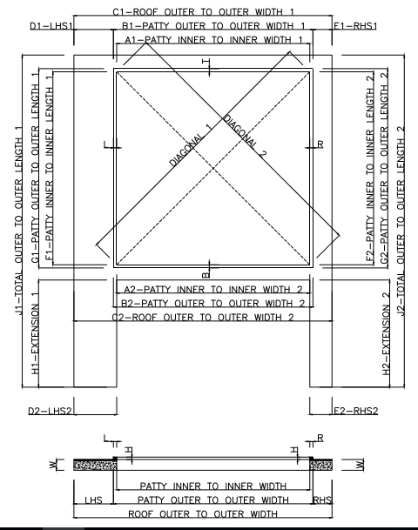

A1 |  | A2
B1 |  | B2
C1 |  | C2
D1 |  | D2
E1 |  | E2
F1 |  | F2
G1 |  | G2
H1 |  | H2
J1 |  | J2
DIAGONAL 1 |  | DIAGONAL 2
W |  | H
L |  | R
T |  | B

CLIENT NAME - ………………………………………………
SITE LOCATION - ………………………………………………

Point to be observed –
- Top beam surface should be smooth (granite/marble) for proper movement of roof.
- The concrete patty and the beam should be a single structure so to avoid any joints. If any joints then it should be properly sealed to make them leak proof.
- There should be a slope of 50 mm along the length to avoid water stagnancy.
- Check the electrical point connection on site and mark the location as per the site.
- Consider all the dimension in MM.

