数据入库到临时表到目标表

１、综资数据

综资数据ftp到主机10.184.141.67上去取。用户名：ftpuser1 密码：Boco_123
ftp主机上的文件如下：
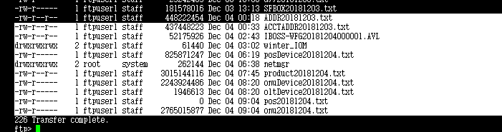
Kettle取文件下来后本地存放路径97主机：/app/kettle/ftpFiles/res ，取文件使用kettle：getResFile.kjb
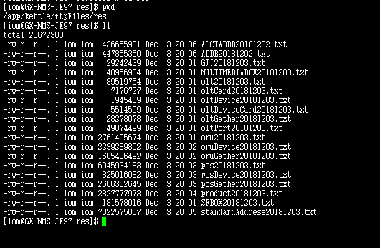

下载综资数据文件，每晚8点开始执行，定时任务部署在97主机上：/app/kettle/shell
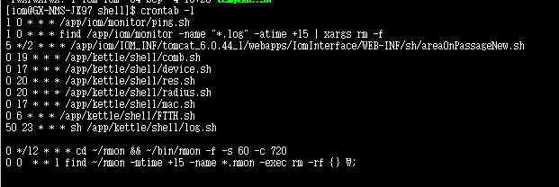

综资数据采用kettle入库到临时表（资源数据入库流程入库kettle名称：file2table.kjb,入库日志保存位置：/app/kettle/kettleLogs） tail -300f file2table_20181213.log
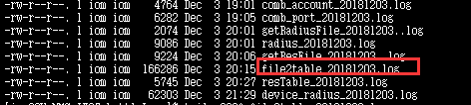

temp_pos/temp_olt/temp_onu/temp_product/temp_olt_device/temp_onu_device

综资数据入库到目标表存过：PKG_RES_ZZFTPRK

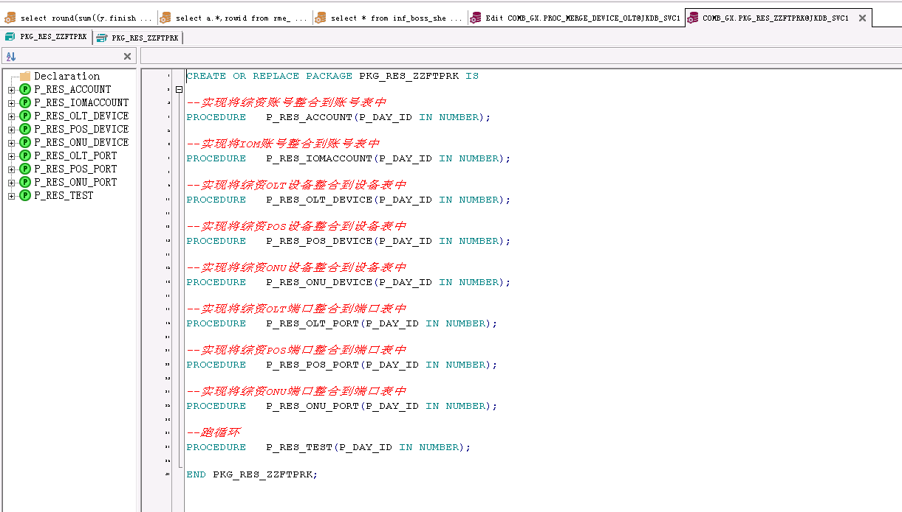

数据从临时表通过存过写入目标表：

一、将综资账号整合到账号表中：从TEMP_PRODUCT表写入结果表CODE_ACCOUNT ：P_RES_ACCOUNT

二、 将IOM账号整合到资源账号中，满足查询条件插入CODE_ACCOUNT ：P_RES_IOMACCOUNT
SELECT * FROM GX_OSS.PM_LOID_EQUIPMENT A WHERE NOT EXISTS(SELECT 1 FROM CODE_ACCOUNT B WHERE A.ACC_NBR = B.ACCOUNT)

三、将综资OLT设备整合到设备表中：临时表TEMP_OLT_DEVICE写入设备表 RME_EQP ：P_RES_OLT_DEVICE

四、将综资POS设备整合到设备表中： 临时表TEMP_POS_DEVICE写入设备表 RME_EQP ： P_RES_POS_DEVICE

五、将综资ONU设备整合到设备表中：TEMP_ONU_DEVICE 写入设备表 RME_EQP ： P_RES_ONU_DEVICE

六、将综资OLT端口整合到端口表中：TEMP_OLT写入设备表 RME_EQP ： P_RES_OLT_PORT

七、将综资POS端口整合到端口表中：TEMP_POS写入RME_PORT： P_RES_POS_PORT

八、将综资ONU端口整合到端口表中：TEMP_ONU写入RME_PORT： P_RES_ONU_PORT

２、采集平台PON资源四类数据
采集平台PON资源4类数据入库（从统一采集平台获取原始文件的kettle：getDeviceFile，入库不是用kettle,入库到临时表由蒙友泽写的的程序完成
入库日志路径：/app/iom/IOM_INF/apache-tomcat-timer-28080/bin/logs/OSSTimerTools ）-》这个tomcat被扫描到漏洞，已经停用，使用下面的tomcat
97主机更新为这个：/app/iom/IOM_INF/apache-tomcat-8.0.53/bin/logs/OSSTimerTools

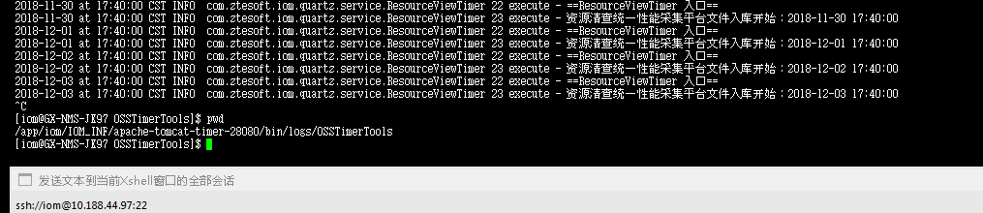
采集平台PON资源4类数据，文件来源：网管
ftp主机：10.184.141.67 用户名：tmpusr 密码：Bmkdt@66
取文件路径：/ftpuser1/Boco_123/
文件名示例：/huawei/NN-U2000-2-P/CM-PON-OLT-1A-V1.0.0-20180610120119.xml.zip
本地保存路径：/app/kettle/ftpFiles/pon
入库的临时表：
temp_device_onu/temp_device_olt/emp_device_port/temp_device_vlan_info

使用存过更新入数据表：device_olt、DEVICE_ONU、DEVICE_PORT、DEVICE_VLAN_INFO
SELECT * FROM dba_jobs a WHERE a.WHAT LIKE 'PROC_MERGE_DEVICE%';

PROC_MERGE_DEVICE_OLT PROC_MERGE_DEVICE_ONU PROC_MERGE_DEVICE_PORT PROC_MERGE_DEVICE_VLAN

数据从临时表到目标表：

一、temp_device_olt的数据更新到device_olt
SELECT
t.RM_UID as RM_UID
, t.NATIVE_NAME as NATIVE_NAME
, t.DEVICE_MODE as DEVICE_MODE
, t.SOFT_VERSION as SOFT_VERSION
, t.TOPO_LOC as TOPO_LOC
, t.IP_ADDRESS as IP_ADDRESS
, t.STATUS as STATUS
, p.REGION_NAME as REGION_NAME
, p.MFR_NAME as MFR_NAME
FROM TEMP_DEVICE_OLT t
left join pon_file_path p on t.region_name= p.region_code and t.mfr_name = p.mfr_no

查询存过日志：
select * from ins_up_log a where a.deal_type like 'device_olt_forall_%' order by a.create_date desc;

二、temp_device_onu的数据更新到device_onu
SELECT
t.RM_UID as RM_UID
, t.NATIVE_NAME as NATIVE_NAME
, t.OLTRM_UID as OLTRM_UID
, t.OLT_PORTRM_UID as OLT_PORTRM_UID
, t.DEV_IP as DEV_IP
, t.ONU_CLASS as ONU_CLASS
, t.ONU_TYPE as ONU_TYPE
, t.ONU as ONU
, t.SOFT_VERSION as SOFT_VERSION
, t.ONU_NO as ONU_NO
, t.ONU_SN as ONU_SN
, t.AUTH_TYPE as AUTH_TYPE
, t.AUTH_VALUE as AUTH_VALUE
, t.FTTX as FTTX
, t.ADMIN_STATE as ADMIN_STATE
, t.OPER_STATE as OPER_STATE
, t.LAST_OFF_TIME as LAST_OFF_TIME
, t.ONU_RTT as ONU_RTT
, t.VENDOR as VENDOR
, t.DOWN_BW as DOWN_BW
, p.REGION_NAME as REGION_NAME
, p.MFR_NAME as MFR_NAME
FROM TEMP_DEVICE_ONU t
left join pon_file_path p on t.region_name= p.region_code and t.mfr_name = p.mfr_no

查询存过日志： select * from ins_up_log a where a.deal_type like 'device_onu_forall_%' order by a.create_date desc;

三、temp_device_port的数据更新到device_port
SELECT
t.RM_UID as RM_UID
, t.NERM_UID as NERM_UID
, t.CARDRM_UID as CARDRM_UID
, t.HOLDERRM_UID as HOLDERRM_UID
, t.NATIVE_NAME as NATIVE_NAME
, t.PORT_NO as PORT_NO
, t.ADMIN_STATE as ADMIN_STATE
, t.OPER_STATE as OPER_STATE
, t.PHYSICAL_TYPE as PHYSICAL_TYPE
, t.PORT_TYPE as PORT_TYPE
, t.PORT_SUPPORT_SERVICE as PORT_SUPPORT_SERVICE
, t.PORT_RATE as PORT_RATE
, t.DIRECTION as DIRECTION
, t.ROLE as ROLE
, t.IS_UPLINK_PORT_T as IS_UPLINK_PORT_T
, p.REGION_NAME as REGION_NAME
, p.MFR_NAME as MFR_NAME
FROM TEMP_DEVICE_PORT t
left join pon_file_path p on t.region_name= p.region_code and t.mfr_name = p.mfr_no

查询存过日志：
select * from ins_up_log a where a.deal_type like 'device_port_forall_%' order by a.create_date desc;

四、temp_device_vlan_info的数据更新到device_vlan_info
SELECT
v.RM_UID as RM_UID
, v.OLT_NERMUID as OLT_NERMUID
, v.OLT_PORT_RMUID as OLT_PORT_RMUID
, v.ONU_NO as ONU_NO
, v.ONUNE_RMUID as ONUNE_RMUID
, v.ONU_PORT_RMUID as ONU_PORT_RMUID
, v.SVLAN as SVLAN
, v.CVLAN as CVLAN
, v.USER_VLAN as USER_VLAN
, olt.ip_address as olt_ip
, pon.native_name as PON_NO
, port.native_name as onu_port
, p.REGION_NAME as REGION_NAME
, p.MFR_NAME as MFR_NAME
FROM TEMP_DEVICE_VLAN_INFO v
left join device_olt olt on v.olt_nermuid = olt.rm_uid
left join device_port pon on pon.rm_uid = v.olt_port_rmuid and pon.nerm_uid = v.olt_nermuid
left join device_port port on v.onu_port_rmuid = port.rm_uid and port.nerm_uid = v.onune_rmuid
left join pon_file_path p on v.region_name= p.region_code and v.mfr_name = p.mfr_no

查询存过日志：
select * from ins_up_log a where a.deal_type like 'device_vlan_info_forall_%' order by a.create_date desc;
SELECT * FROM dba_jobs a WHERE a.WHAT LIKE 'PROC_MERGE_DEVICE%';

3、MAC数据入库到临时表
MAC数据入库使用kettle：getMacFile
Mac数据文件来源：mac ftp主机：10.184.233.78
用户名：taiyueftp 密码：Taiyueftp123$
取文件路径：/BAISE/ZTE/20180510/***_10.188.39.24.txt
本地保存路径：/app/kettle/ftpFiles/mac
入库的临时表：mac转发临时表（mac转发数据入库表）temp_mac
/app/iom/IOM_INF/apache-tomcat-8.0.53/bin/logs/OSSTimerTools
使用存过PROC_MERGE_DEVICE_MAC写入mac转发数据表 device_mac

temp_mac的数据更新到device_mac
SELECT
t.olt_Ip as olt_Ip
,f.region_name as city
,f.mfr_name as mfr
,regexp_replace(t.mac,'[[:punct:]]','') as mac
,t.svlan as svlan
,t.pon_Id as pon_Id
,t.onu_Id as onu_Id
from temp_mac t,mac_file_path f
where t.city=f.region_code and t.mfr = f.mfr_no and t.olt_ip is not null
and t.pon_id is not null and t.pon_id not like '%undefined%'

4、radius话单数据入库
RADIUS话单采用kettle入库（入库kettle名称：radius.kjb）
文件来源：radius ，取文件使用kettle：getRadiusFile
ftp主机：10.184.233.78 用户名：radius 密码：radius123#
取文件路径：radius_net_list20180528000001.AVL （ftp后即可看到avl文件）
本地保存路径：/app/kettle/ftpFiles/radius
radius临时表（radius数据入库表）：temp_radius

radius话单数据入库radius数据表：device_radius表（kettle：device_radius.ktr）

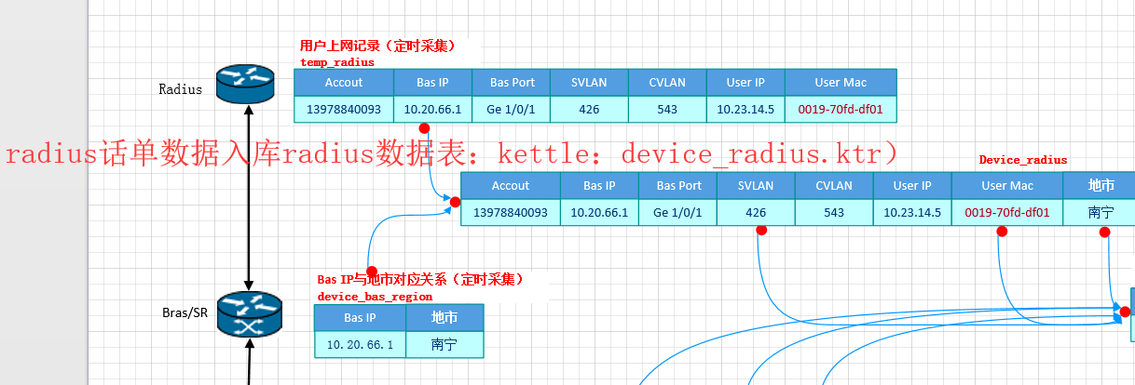
device_bas_region 这表的数据由网管提供，一般该表的数据是固定的，如有增加，由网管增加

数据整合：
Radius数据和MAC数据整合到device_radius_mac表(存过：proc_merge_device_r_m)

device_radius和device_mac匹配
匹配结果入表：device_radius_mac
select m.olt_ip as olt_ip,
m.pon_id as pon_id,
m.svlan as svlan,
m.region_name as region_name,
m.onu_id as onu_id,
m.mac as mac,
r.account as account,
r.cvlan as cvlan
from device_radius r,device_mac m
where r.svlan = m.svlan and r.region_name = m.region_name and r.user_mac = m.mac
and m.olt_ip is not null

将PON资源四类数据与device_radius_mac表的数据整合到code_account表（存过：PROC_MERGE_DEVICE_C_A）
匹配后更新code_account数据
select r.account as account,r.olt_ip as olt_ip,v.pon_no,v.onu_no as onu_no,v.ONU_PORT,6024 as res_type_id
from device_vlan_info v
inner join device_radius_mac r
on v.olt_ip = r.olt_ip and v.pon_no = r.pon_id
and v.onu_no = r.onu_id

