**日常维护常用的业务问题核查脚本**

**--终端出库失败单量**

select count(distinct i.order_id) 终端出库失败单量,to_char(i.create_date, 'dd-hh24') 时间

from inf_log partition(p201901) i

where i.create_date >

TO_DATE('2019-01-23 07:00:00', 'yyyy-mm-dd hh24:mi:ss')

and i.create_date <

to_date('2019-01-23 12:59:59', 'YYYY-MM-DD HH24:MI:SS')

and i.inf_type = '1012'

and i.result='1'

group by to_char(i.create_date, 'dd-hh24');

**--终端出库单量**

select count(distinct i.order_id) 终端出库单量,to_char(i.create_date, 'dd-hh24') 时间

from inf_log partition(p201901) i

where i.create_date >

TO_DATE('2019-01-23 07:00:00', 'yyyy-mm-dd hh24:mi:ss')

and i.create_date <

to_date('2019-01-23 12:59:59', 'YYYY-MM-DD HH24:MI:SS')

and i.inf_type = '1012'

group by to_char(i.create_date, 'dd-hh24');

**--解挂异常单量**

select count(distinct i.order_id) 解挂异常单量,to_char(i.create_date, 'dd-hh24') 时间

from inf_log partition(p201901) i

where i.create_date >

TO_DATE('2019-01-23 07:00:00', 'yyyy-mm-dd hh24:mi:ss')

and i.create_date <

to_date('2019-01-23 12:59:59', 'YYYY-MM-DD HH24:MI:SS')

and i.inf_type = '101'

and i.result='1'

group by to_char(i.create_date, 'dd-hh24');

**--挂起异常卡单**

select count(distinct i.order_id) 挂起异常卡单,to_char(i.create_date, 'dd-hh24') 时间

from inf_log partition(p201901) i

where i.create_date >

TO_DATE('2019-01-23 07:00:00', 'yyyy-mm-dd hh24:mi:ss')

and i.create_date <

to_date('2019-01-23 12:59:59', 'YYYY-MM-DD HH24:MI:SS')

and i.inf_type = '100'

and i.result='1'

group by to_char(i.create_date, 'dd-hh24');

**--经纬度异常卡单量**

SELECT to_char(oid) AS order_id, to_char(wid) AS work_order_id

FROM (SELECT a.id AS oid, b.id AS wid

FROM om_order a

LEFT JOIN wo_work_order b ON a.id = b.base_order_id

LEFT JOIN WO_AUTO_WORK_ORDER c ON c.id = b.id

LEFT JOIN om_service_order d ON d.id = a.id

WHERE a.service_id IN (220196, 220197, 220198)

AND a.ORDER_STATE NOT IN ('10F', '10C', '10G', '10R', '10A')

AND b.WORK_ORDER_STATE = '10E'

AND b.tache_define_id = 100044

-- AND A.AREA_ID=1100

AND c.RETURN_CONTENT LIKE '%经度%'

--AND b.state_date > sysdate - 1 / 48

) om

WHERE rownum <= 2

AND NOT EXISTS

(SELECT 1 FROM wd_exec_order_log we WHERE we.om_order_id = om.oid);

update om_service_order a set a.longitude =

(select oso.res_longitude from om_so_order_rela

oso where oso.service_order_id=a.id)

where a.id

in(select a.id

from om_order a

left join wo_work_order b on a.id = b.base_order_id

left join WO_AUTO_WORK_ORDER c on c.id = b.id

left join om_service_order d on d.id = a.id

where

a.service_id in (220196, 220197, 220198)

and a.ORDER_STATE NOT IN ('10F', '10C', '10G', '10R', '10A')

and b.WORK_ORDER_STATE = '10E'

and b.tache_define_id = 100044

and c.RETURN_CONTENT LIKE '%经度%');

SELECT to_char(oid) AS order_id, to_char(wid) AS work_order_id

FROM (SELECT a.id AS oid, b.id AS wid

FROM om_order a

LEFT JOIN wo_work_order b ON a.id = b.base_order_id

LEFT JOIN WO_AUTO_WORK_ORDER c ON c.id = b.id

LEFT JOIN om_service_order d ON d.id = a.id

WHERE a.service_id IN (220196, 220197, 220198)

AND a.ORDER_STATE NOT IN ('10F', '10C', '10G', '10R', '10A')

AND b.WORK_ORDER_STATE = '10E'

AND b.tache_define_id = 100044

-- AND A.AREA_ID=1100

AND c.RETURN_CONTENT LIKE '%纬度%'

--AND b.state_date > sysdate - 1 / 48

) om

WHERE rownum <= 2

AND NOT EXISTS

(SELECT 1 FROM wd_exec_order_log we WHERE we.om_order_id = om.oid);

update om_service_order a set a.latitude =

(select oso.res_latitude from om_so_order_rela

oso where oso.service_order_id=a.id)

where a.id

in(select a.id

from om_order a

left join wo_work_order b on a.id = b.base_order_id

left join WO_AUTO_WORK_ORDER c on c.id = b.id

left join om_service_order d on d.id = a.id

where a.service_id in (220196, 220197, 220198)

and a.ORDER_STATE NOT IN ('10F', '10C', '10G', '10R', '10A')

and b.WORK_ORDER_STATE = '10E'

and b.tache_define_id = 100044

and c.RETURN_CONTENT LIKE '%纬度%');

**--预约改约工单量**

select count(y.fault_order_id) 预约改约工单量,to_char(y.create_date, 'dd-hh24') 时间

from om_order i, fault_order_track y

where i.id = y.fault_order_id

and y.oper_type = 30

and y.create_date >

TO_DATE('2019-01-23 07:00:00', 'yyyy-mm-dd hh24:mi:ss')

and y.create_date <

to_date('2019-01-23 12:59:59', 'YYYY-MM-DD HH24:MI:SS')

group by to_char(y.create_date, 'dd-hh24');

**--装移竣工量**

select count(1) 装移竣工量,to_char(i.finish_date, 'dd-hh24') 时间

from om_order i

where i.order_state = '10F'

and i.service_id in (220196, 220198)

and i.finish_date >

TO_DATE('2019-01-23 07:00:00', 'yyyy-mm-dd hh24:mi:ss')

and i.finish_date <

to_date('2019-01-23 12:59:59', 'YYYY-MM-DD HH24:MI:SS')

group by to_char(i.finish_date, 'dd-hh24');

**--挂起工单量**

select count(distinct i.order_id) 挂起工单量,to_char(i.create_date, 'dd-hh24') 时间

from inf_log partition(p201901) i

where i.create_date >

TO_DATE('2019-01-23 07:00:00', 'yyyy-mm-dd hh24:mi:ss')

and i.create_date <

to_date('2019-01-23 12:59:59', 'YYYY-MM-DD HH24:MI:SS')

and i.inf_type = '100'

group by to_char(i.create_date, 'dd-hh24');

**--解挂工单量**

select count(distinct i.order_id) 解挂工单量,to_char(i.create_date, 'dd-hh24') 时间

from inf_log partition(p201901) i

where i.create_date >

TO_DATE('2019-01-23 07:00:00', 'yyyy-mm-dd hh24:mi:ss')

and i.create_date <

to_date('2019-01-23 12:59:59', 'YYYY-MM-DD HH24:MI:SS')

and i.inf_type = '101'

group by to_char(i.create_date, 'dd-hh24');

**--改端口遇到转圈的时候，资源改端口相关日志**

select (i.call_end_date-i.call_sta_date)*60*60*24,i.* from inf_res_log i

where i.create_date >= to_date('2018-07-19 07:10:00','YYYY-MM-DD HH24:MI:SS')

and i.create_date <= to_date('2018-07-19 09:30:00','YYYY-MM-DD HH24:MI:SS')

and (i.call_end_date-i.call_sta_date)*60*60*24>20

**--投诉工单操作日志**

select e.optype,count(*) as 总请求数,

sum(case when e.usetime>10 then 1 else 0 end) as 超10秒请求数,

round(sum(case when e.usetime>10 then 1 else 0 end)*100/count(*),2) as 超10秒比例

from eoms_inf_log e where to_char(e.create_date,'yyyymmdd' )=20180908

group by e.optype;

**--查询eoms投诉工单接口回单慢**

select * from eoms_inf_log i where i.optype='gx_op104';

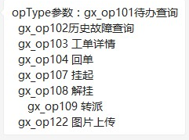

**--预占工单预警耗时查询**

select TRUNC((i.res_finish_date - i.msg_send_date) * 24 * 60 * 60,0) 耗时,

y.acc_nbr 宽带账号,

i.order_id 定单Id,

i.res_finish_date ,

i.msg_send_date

from inf_tache_date i, om_service_order y

where i.res_finish_date >

to_date('2018-07-23 11:15:00', 'YYYY-MM-DD HH24:MI:SS')

and i.res_finish_date <

to_date('2018-07-23 11:30:00', 'YYYY-MM-DD HH24:MI:SS')

and i.order_id = y.id

and (i.res_finish_date - i.msg_send_date) * 24 * 60 * 60 < 100

order by (i.res_finish_date - i.msg_send_date) * 24 * 60 * 60 desc;

**--查询已经入库成功的工单（即在om_order表里面有数据，但是在wo_work_order表没有数据的工单）**

select i.id, i.order_code, i.order_title, i.order_state

from om_order i

where i.id not in (select oo.id

from om_order oo, wo_work_order wwo

where oo.id = wwo.base_order_id)

and i.service_id in

(220196, 220197, 220198, 220273, 220335, 220334, 220253, 220213)

and i.order_state not in ('10F', '10C', '10A');

**--查询指令是成功状态，但是子工单和工单没有更改为10F状态，以至于卡单的：**

select i.yd_id

from wo_order_info i, wo_ne_order wno, ne_execute_cmdinfo_history nec

where i.order_id = wno.order_id

and wno.ne_order_id = nec.ne_order_id

and i.state_code = '10N'

and wno.state_code in ('10F', '10A', '10I')

and nec.state = '10F'

and i.receive_date >

to_date('2017-08-21 00:00:59', 'YYYY-MM-DD HH24:MI:SS')

and i.receive_date < sysdate - 1 / 144

**--统计地市材料使用量：**

select sum(cailiao) 皮线光纤使用量,yh 月份,dw 地市 from (select distinct i.order_code order_code,

j.use_num cailiao,

to_char(i.Accept_Date, 'yyyy-mm') yh,

ua.area_name dw

from om_order i,

wo_work_order y,

wo_work_order_material j,

EOMS_RES_MATERIAL k,

uos_area ua

where i.id = y.base_order_id

and y.base_order_id = j.base_order_id

and j.material_id = k.material_id

and ua.area_id = i.area_id

and i.service_id in (220196, 220198)

and j.material_id = 4689

and i.order_state = '10F'

-- and i.area_id = '1100'

and i.accept_date >=

to_date('2017-07-01 00:00:00', 'YYYY-MM-DD HH24:MI:SS')

and i.accept_date <=

to_date('2017-07-31 23:59:59', 'YYYY-MM-DD HH24:MI:SS')

and k.material_name is not null)

group by yh,dw;

**--其他业务流转时长以及异常工单查询脚本，即IT巡检告警；**

select * from service_control_config i where i.state=0;

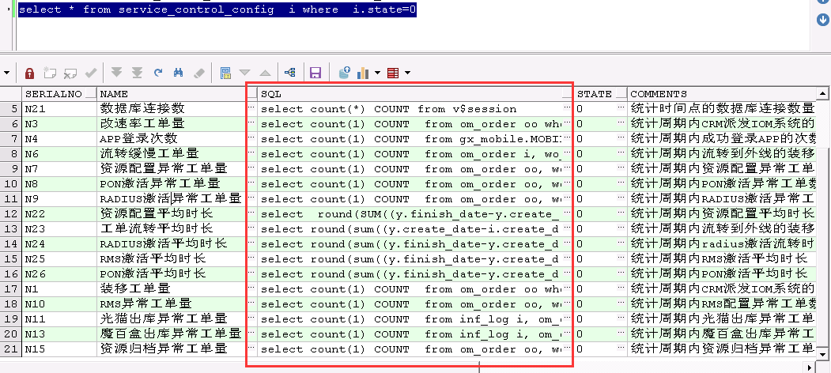

**--统计一月份IOM系统PC端登录数：**

select count(*),substr(WEE,0,2),wde

from (select distinct ss.STAFF_NAME,

ss.logon_date de,

ss.logout_date,

iiil.Area_Id wee,

iiil.area_name wde,

ss.online_state

from (select distinct T.STAFF_ID,

t.STAFF_NAME,

SO.LOG_INFO_ID,

so.logon_date logon_date,

so.logout_date logout_date,

so.online_state online_state,

CASE

WHEN SO.LOG_INFO_ID IS NOT NULL THEN

1

ELSE

0

END AS LOGIN_NUM

from uos_staff t

join uos_job_staff ujs

on ujs.staff_id = t.staff_id

join uos_job uj

on uj.job_id = ujs.job_id

left join staff_online so

on so.staff_id = t.staff_id

where t.state = '1'

and uj.state = '1'

and so.logon_date >=

TO_DATE('2017-11-01 00:00:00', 'YYYY-MM-DD hh24:mi:ss')

and so.logon_date <=

TO_DATE('2017-11-30 23:59:59', 'YYYY-MM-DD hh24:mi:ss')) SS,

uos_job_staff ujss,

uos_job hjb,

uos_org uog,

uos_area iiil

where ss.staff_id = ujss.staff_id

and ujss.state = '1'

and ujss.is_normal = '1'

and ujss.isbasic = '1'

-- and hjb.job_id=875

-- and ss.staff_id=1

and ujss.job_id = hjb.job_id

and iiil.area_id = uog.area_id

and hjb.org_id = uog.org_id) weww

group by substr(WEE,0,2),wde order by substr(WEE,0,2);

**--手机端分组统计登录次数（在gx_mobile用户下执行）：**

select count(a.staff_id),substr(ua.area_id,0,2)

from MOBILE_OPER_REC a,uos_staff us,uos_job_staff ujs,uos_job uj,uos_org uo,uos_area ua

where

us.staff_id=a.staff_id

and us.staff_id=ujs.staff_id

and ujs.job_id=uj.job_id

and uj.org_id=uo.org_id

and uo.area_id=ua.area_id

and ujs.state = '1'

and ujs.is_normal = '1'

and ujs.isbasic = '1'

and

a.in_time

between to_date('2017-11-01 00:00:00', 'yyyy-MM-dd HH24:mi:ss') and

to_date('2017-11-30 23:59:59', 'yyyy-MM-dd HH24:mi:ss') and a.service_id=1

group by substr(ua.area_id,0,2) order by substr(ua.area_id,0,2);