# 无法解挂工具自测报告

## 自测报告：

## 定时任务位置

## **查询SQL**

## **执行器目录**

定时任务位置：

运维管理工具--》解挂失败，与BOSS状态不一致

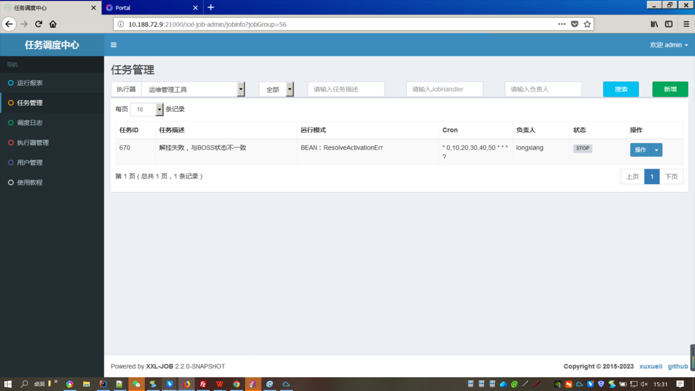

### 执行执行器

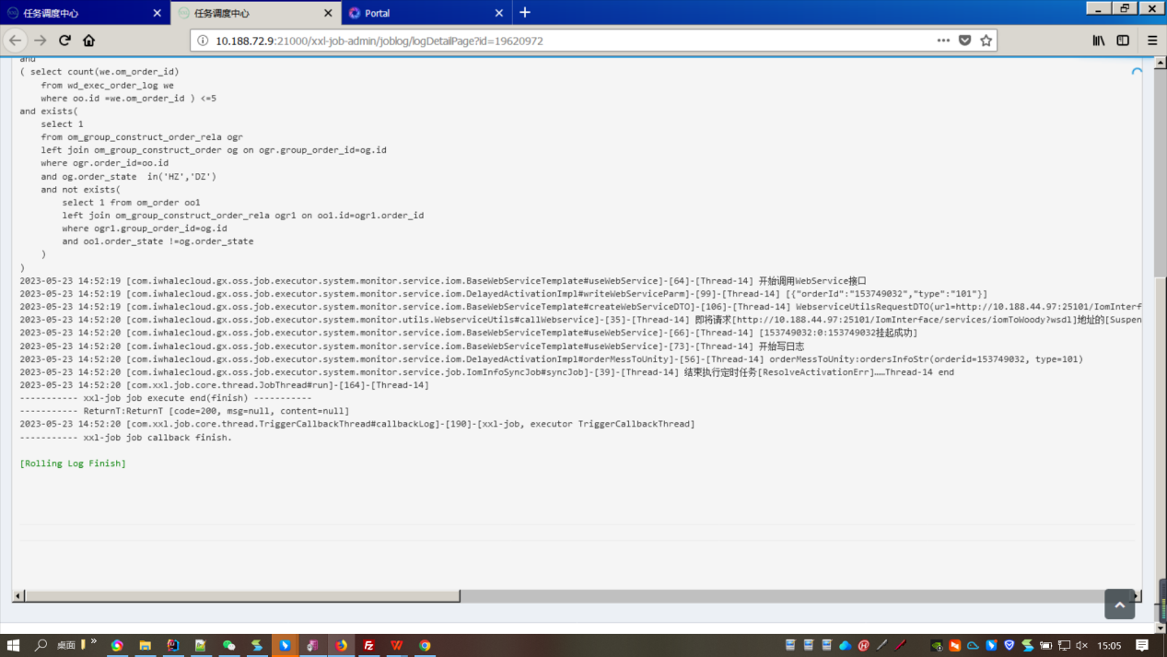

### 结果：

工单2023/5/23 14：51：51解挂失败

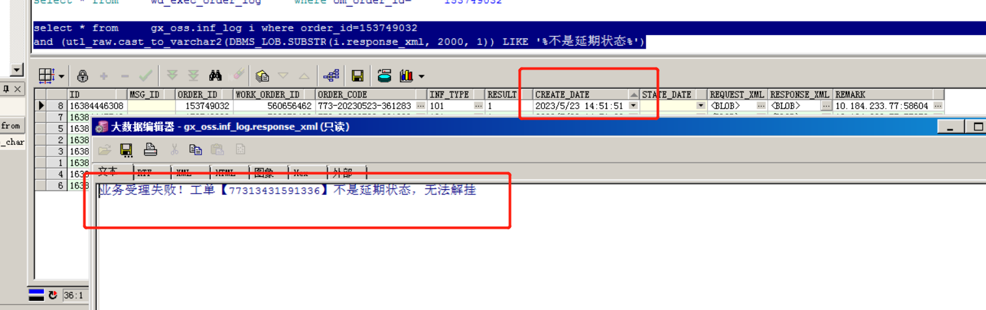

执行后14：52：20秒挂起

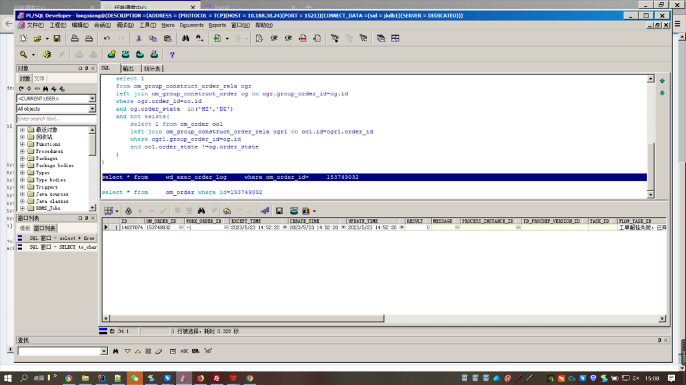

10.188.72.9:5221（xxl-job的ip）进行挂起

2023/5/23 14:52:27 师傅操作解挂成功！



工单状态变为正常执行中

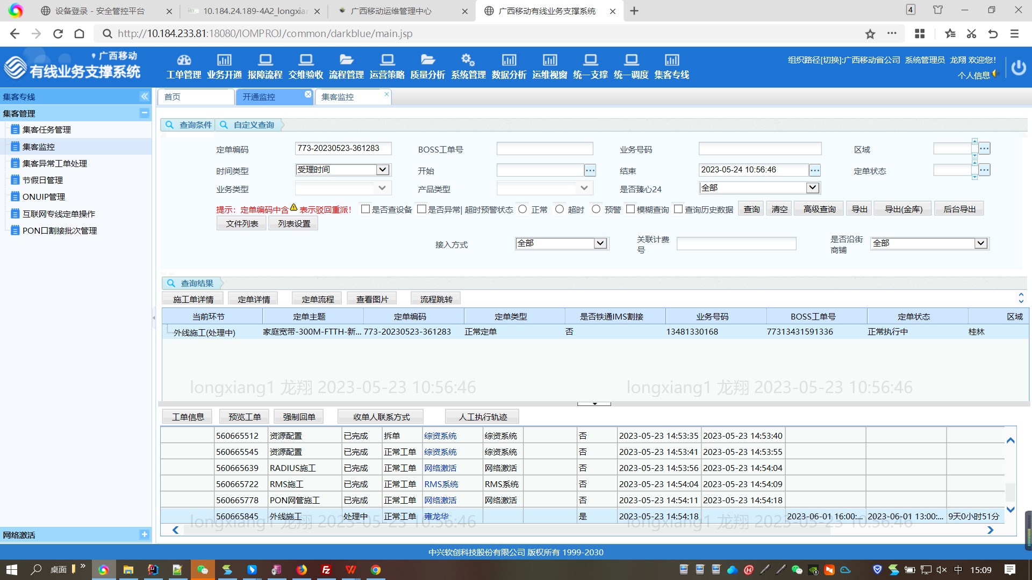

查询SQL:

查询日志表最新的是解挂报错“不是延期状态”并且工单和子订单都是HZc状态的工单

SELECT to_char(oo.id) as orderid ,to_char(kkd.inf_type) as type

FROM om_order oo, (

SELECT i.order_id ,i.inf_type

FROM inf_log i WHERE (utl_raw.cast_to_varchar2(DBMS_LOB.SUBSTR(i.response_xml, 2000, 1)) LIKE '%不是延期状态%')

AND i.create_date > sysdate - 1 /8

AND i.inf_type = '101'

AND i.result = '1'

AND (

SELECT MAX(il.id)

FROM inf_log il

WHERE il.order_id = i.order_id

) = i.id

) kkd

WHERE oo.id = kkd.order_id

and oo.order_state in('HZ','DZ')

and

( select count(we.om_order_id)

from wd_exec_order_log we

where oo.id =we.om_order_id ) <=5

and exists(

select 1

from om_group_construct_order_rela ogr

left join om_group_construct_order og on ogr.group_order_id=og.id

where ogr.order_id=oo.id

and og.order_state in('HZ','DZ')

and not exists(

select 1 from om_order oo1

left join om_group_construct_order_rela ogr1 on oo1.id=ogr1.order_id

where ogr1.group_order_id=og.id

and oo1.order_state !=og.order_state

)

)

### **执行器目录**

**主机IP：10.188.72.9**

**目录：/iom/app/xxl-job/executor/work-order/systemMonitor**

**启动脚本：sh run.sh start prod**

**停止脚本：sh run.sh stop prod**

**日志在Logs文件夹下:info.log文件**