定时任务项目部署：

主机：10.188.44.91

启停：

cd /app/iom/IOM_INF/apache-tomcat-timer-28080/bin

启： ./startup.sh

停： ./shutdown.sh

数据库：

comb_gx/comb_gx

定时任务配置：

目前只配置一个定时任务，串行执行入库操作

*-- 察看配置表*

select a.*,a.rowid from os_public a where a.stype = 'ResourceView' ;

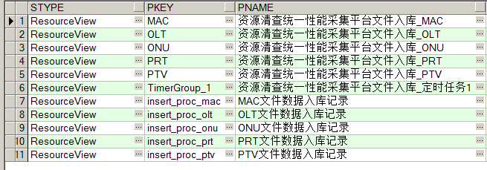

*-- 根据PKEY配置CODEEE以修改定时任务执行序列,以英文逗号分隔*

update os_public a set a.codee = 'OLT,ONU,PRT,PTV,MAC' where a.stype = 'XQZLJKDPG' and a.pkey = 'TimerGroup_1';

入库耗时及数据量

F:\QQFiles\1270086516\Image\C2C\R_8@~XWAMFB4]SP}CG8U420.png

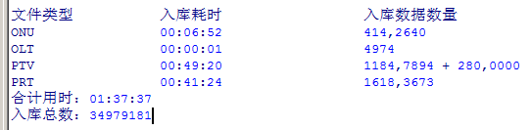

*-- 察看入库进程记录*

select op.PNAME,op.CODEE from os_public op where op.stype = 'ResourceView'

and (op.pkey = 'insert_proc_onu' or op.pkey = 'insert_proc_prt' or op.pkey = 'insert_proc_olt' or op.pkey = 'insert_proc_ptv' or op.pkey = 'insert_proc_mac' )

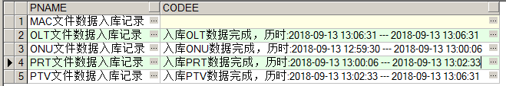

*-- 统计入库数据*

select count(1) from temp_device_olt;

select count(1) from temp_device_onu;

select count(1) from temp_device_port;

select count(1) from temp_device_vlan_info;

select count(1) from temp_mac;