# 预置条件

1. 更新微服务V1的group模块

# 预期结果

1. 在IP申请回复，IP激活回复时，正确回写到om_order_ip_main_info、om_order_service_ip_info、om_order_service_ipv6_info表中。

# 测试步骤

1. 以boss工单号77130009281014为例，模拟ip申请回复 ipApplyReply

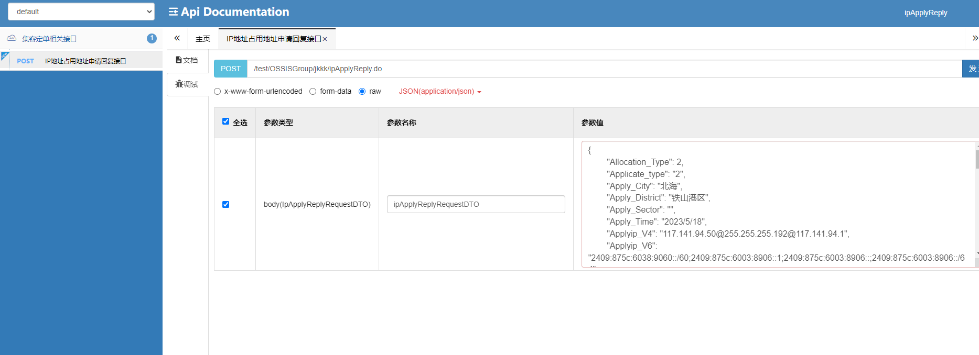

模拟报文

{

"Allocation_Type": 2,

"Applicate_type": "2",

"Apply_City": "北海",

"Apply_District": "铁山港区",

"Apply_Sector": "",

"Apply_Time": "2023/5/18",

"Applyip_V4": "117.141.94.50@255.255.255.192@117.141.94.1",

"Applyip_V6": "2409:875c:6038:9060::/60;2409:875c:6003:8906::1;2409:875c:6003:8906::;2409:875c:6003:8906::/64",

"Business_Id": "互联网专线营销计划（极速光纤）",

"Certificate_Class": "50",

"Certificate_Num": "91450512MA5NXT7X06",

"Contact_Email": "13877989861@139.com",

"Contact_Name": "集团",

"Contact_Tel": "15207708375",

"Customer_Add": "广西北海铁山港区兴港镇川江村委兴港镇太阳纸业(集客)办公楼5楼16机柜",

"Customer_City": "北海",

"Customer_Name": "铁山港区",

"Customer_Prince": "广西",

"Customer_district": "铁山港区",

"Deal_Satus": 200,

"Device_Name": "北海铁山港区兴港镇川江村委兴港镇太阳纸业(集客)-ONU001-HW-MA5626",

"Fail_Code": null,

"Failed_Reason": "",

"Industry_Class": "2",

"Ip_Ordernum": "57714921_559321385",

"Network_Type": 0,

"Order_Subject": "",

"Order_Type": 0,

"PORT_INFO": "lag-224",

"Protocol_Type": "3",

"Reassign_Unit": "",

"Special_City": "北海",

"Special_Code": "97110408974",

"Special_District": "铁山港区",

"Stl_Type": 0,

"Unit_Class": "2",

"Unit_Level": 9,

"Unit_Nature": 2,

"Use_Aera": 1,

"Use_Type": "1",

"User_Email": "13877989861@139.com",

"User_Mobile": "15777994202",

"User_Name": "莫超芳_北海集客支撑中心订单员（政企直销）",

"V4_needCount": "1",

"V6_Pre": 1,

"V6_needCount": "1",

"domain_ipv4": "add-117.141.94.0/26",

"domain_ipv6": "add-117.141.94.0/26",

"iesOrVprn": "ies 10",

"ndpoolname": "",

"vbui": "",

"vpn_ipv4": "lag-224-117.141.94.0/26",

"vpn_ipv6": "lag-224-117.141.94.0/26"

}

如下图所示，调用成功

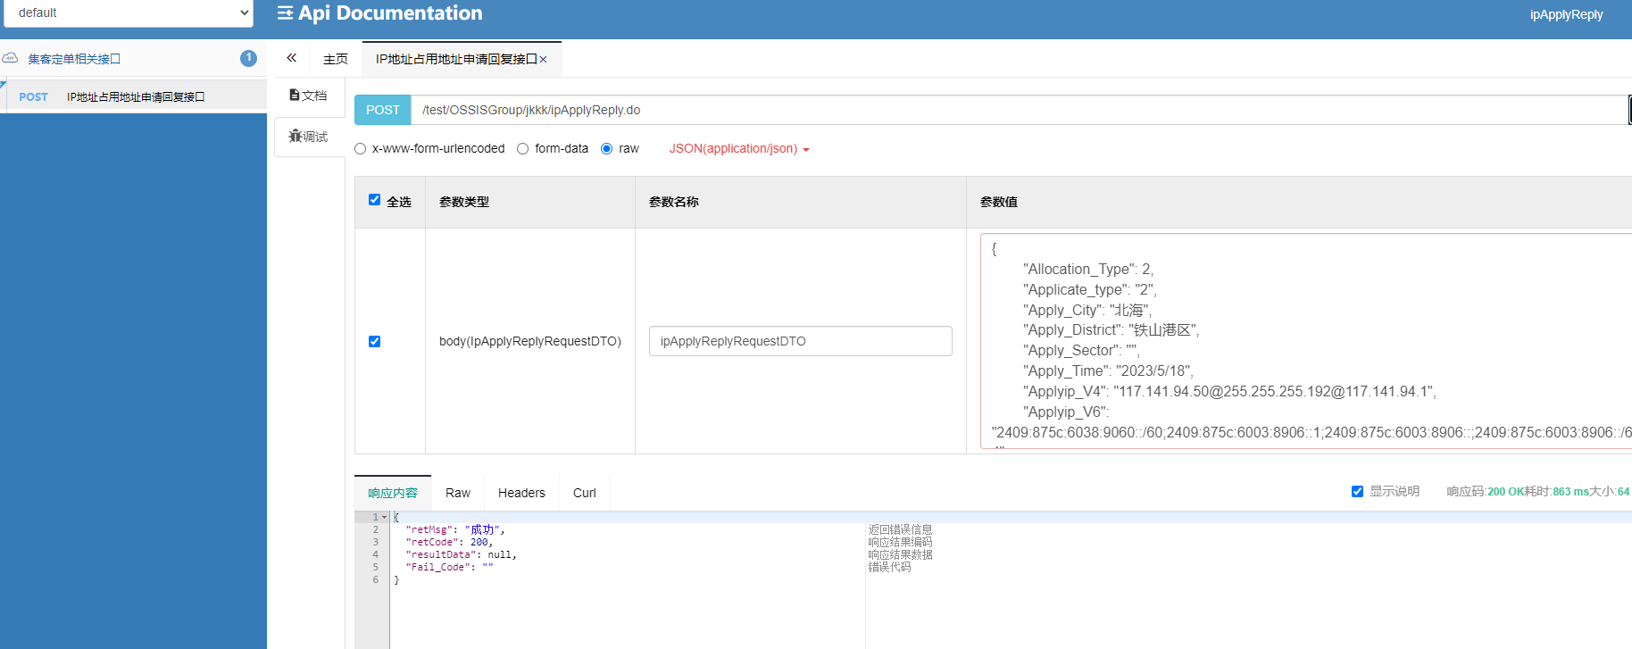

数据正常入库到ip_apply_reply_info

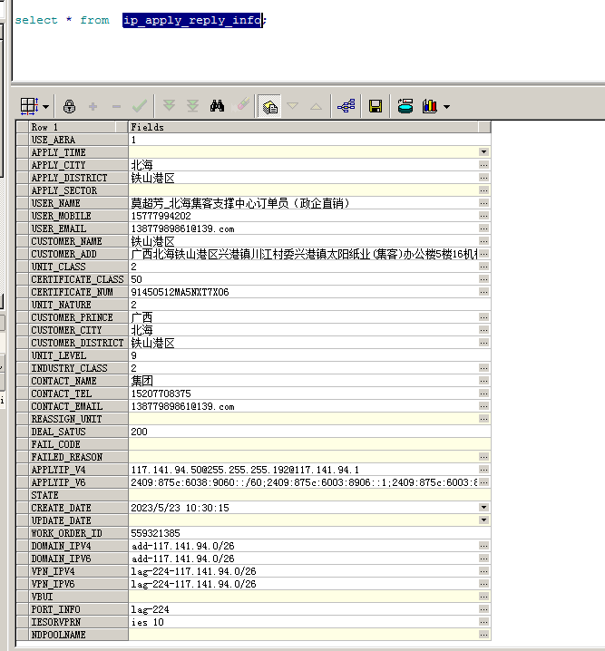

回写到select * from om_order_ip_main_info f where f.order_id = 57714921;

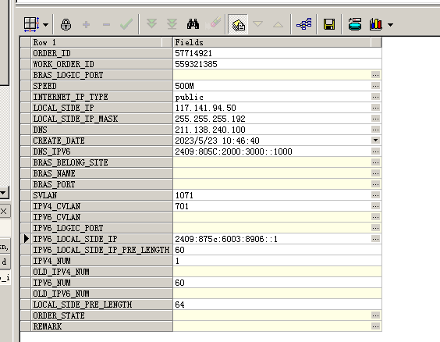

select * from om_order_service_ip_info f where f.order_id = 57714921;

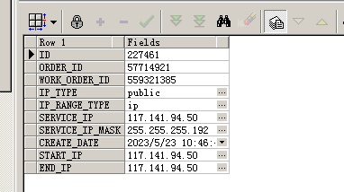

select * from om_order_service_ipv6_info f where f.order_id = 57714921;

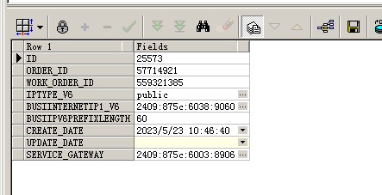

1. 然后再模拟回调激活回复接口

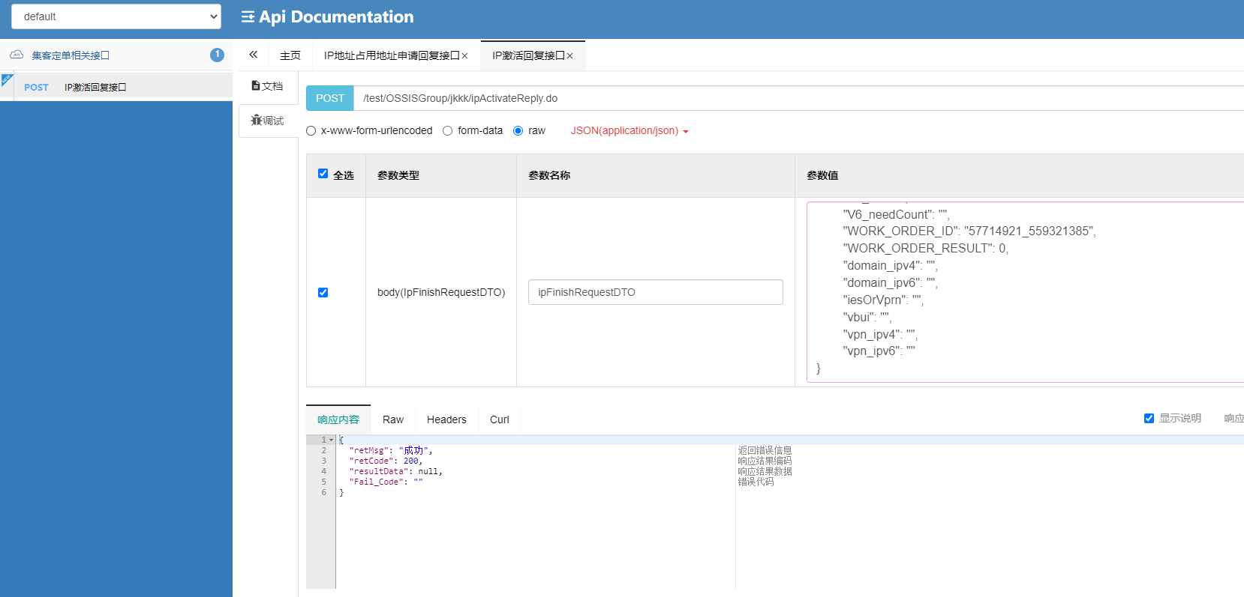

模拟报文

{

"AREA_CODE": "防城港",

"BAND_WIDTH": "2M",

"BRAS_IP": "221.180.120.8",

"BRAS_NAME": "防城港市防城区商务局里火口岸(专线)-ONU001-ZX-F804",

"CONVER_NAME": "",

"CONVER_UPLINK": "",

"CVLAN": 700,

"Fail_CODE": "",

"IPV4": "218.204.54.125@255.255.255.192@218.204.54.65",

"IPV6": "2409:875c:6610:60::/60;2409:875c:6601:6::1;2409:875c:6601:6::/64",

"OLT_NAME": "防城港防城区滩散基站-OLT001-ZX-C300",

"OLT_UPLINK": "",

"ORDER_TYPE": "",

"PORT_DESCRIBE": "",

"PORT_INFO": "",

"Protocol_Type": "",

"RESERVE_1": "",

"RESERVE_2": "",

"RE_REST_MSG": "",

"SERVICE_TYPE": "",

"SPECIAL_CODE": "",

"SUB_INTERFACE": "lag-13:1001.700",

"SVLAN": 0,

"SYS_FROM": "",

"Special_District": "",

"V4_needCount": "",

"V6_Pre": 0,

"V6_needCount": "",

"WORK_ORDER_ID": "57714921_559321385",

"WORK_ORDER_RESULT": 0,

"domain_ipv4": "",

"domain_ipv6": "",

"iesOrVprn": "",

"vbui": "",

"vpn_ipv4": "",

"vpn_ipv6": ""

}

成功之后，会更新

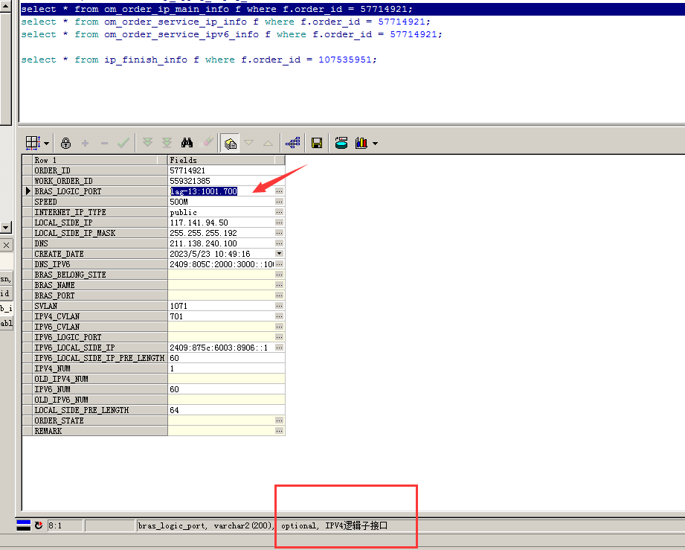

1. 回写之后效果展示

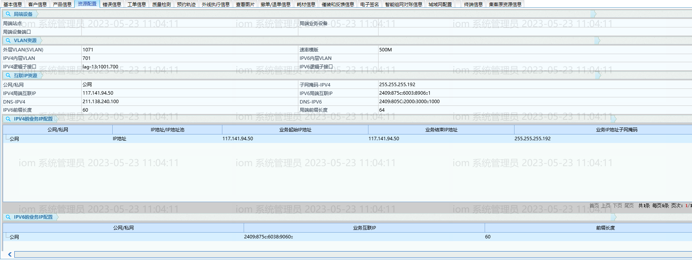

# 测试结果

测试通过

# 逻辑说明

## 局端设备

局端站点 om_order_ip_main_info.BRAS_BELONG_SITE 来源inf_res_output.cmnet_site

--资源给的为空

局端业务设备 om_order_ip_main_info.BRAS_NAME 来源inf_res_output.cmnet_srma

--资源给的为空

局端设备端口 om_order_ip_main_info.BRAS_PORT 来源inf_res_output.cmnet_sr_port

--资源给的为空

## VLAN资源

外层VLAN(SVLAN) om_order_ip_main_info.svlan 来源inf_res_output.svlan

IPV4内层VLAN om_order_ip_main_info.ipv4_cvlan 来源inf_res_output.cvlan

IPV4逻辑子接口 om_order_ip_main_info.BRAS_LOGIC_PORT

来源：select f.sub_interface from ip_finish_info f where f.order_id = ?;--ip激活回复的时候

速率模版 om_order_ip_main_info.speed

来源：SELECT a.character_value FROM om_indep_prod_order_attr a

where a.service_order_id = #{orderId} and a.character_id = 72092 and rownum = 1

IPV6内层VLAN om_order_ip_main_info.IPV6_CVLAN 来源：无

IPV6逻辑子接口 om_order_ip_main_info.IPV6_LOGIC_PORT 来源：无

## 互联IP资源

公网/私网 om_order_ip_main_info.INTERNET_IP_TYPE

来源：select decode(f.network_type, 0, 'public', 'private') from ip_apply_reply_info f where f.order_id = ?

IPV4局端互联IP om_order_ip_main_info.LOCAL_SIDE_IP

来源 ip_apply_reply_info.applyip_v4字段解析得来

如 117.141.94.50@255.255.255.192@117.141.94.1 取117.141.94.1

DNS-IPV4 om_order_ip_main_info.DNS

来源：写死211.138.240.100

IPV6前缀长度 om_order_ip_main_info.IPV6_LOCAL_SIDE_IP_PRE_LENGTH

来源 ip_apply_reply_info.applyip_v6字段解析得来

如值2409:875c:6038:9060::/60;2409:875c:6003:8906::1;2409:875c:6003:8906::;2409:875c:6003:8906::/64

取第一个;之前的IP里的长度，2409:875c:6038:9060::/60，即60

子网掩码-IPV4 om_order_ip_main_info.LOCAL_SIDE_IP_MASK

来源 ip_apply_reply_info.applyip_v4字段解析得来

如 117.141.94.50@255.255.255.192@117.141.94.1 取255.255.255.192

IPV6局端互联IP om_order_ip_main_info.IPV6_LOCAL_SIDE_IP

来源 ip_apply_reply_info.applyip_v6字段解析得来

如值2409:875c:6038:9060::/60;2409:875c:6003:8906::1;2409:875c:6003:8906::;2409:875c:6003:8906::/64

取第二个;之前的IP--2409:875c:6003:8906::1

DNS-IPV6 om_order_ip_main_info.DNS_IPV6

来源：写死2409:805C:2000:3000::1000

局端前缀长度 om_order_ip_main_info.LOCAL_SIDE_PRE_LENGTH

来源 ip_apply_reply_info.applyip_v6字段解析得来

如值2409:875c:6038:9060::/60;2409:875c:6003:8906::1;2409:875c:6003:8906::;2409:875c:6003:8906::/64

取第三个;之后的IP里的长度，2409:875c:6003:8906::/64，即64

## IPV4的业务配置

公网/私网 om_order_service_ip_info.ip_type

来源：来源：select decode(f.network_type, 0, 'public', 'private') from ip_apply_reply_info f where f.order_id = ?

IP地址/IP地址池 om_order_service_ip_info.ip_range_type

来源 ip_apply_reply_info.applyip_v4字段解析得来

如 117.141.94.50@255.255.255.192@117.141.94.1 是单个IP，所以值为ip

如 117.141.94.50_59@255.255.255.192@117.141.94.1 是IP段，所以值为ipRange

业务起始IP地址 om_order_service_ip_info.start_ip

来源 ip_apply_reply_info.applyip_v4字段解析得来

如 117.141.94.50@255.255.255.192@117.141.94.1 是单个IP，所以值为117.141.94.50

如 117.141.94.50_59@255.255.255.192@117.141.94.1 是IP段，所以值为117.141.94.50

业务结束IP地址 om_order_service_ip_info.end_ip

来源 ip_apply_reply_info.applyip_v4字段解析得来

如 117.141.94.50@255.255.255.192@117.141.94.1 是单个IP，所以值为117.141.94.50

如 117.141.94.50_59@255.255.255.192@117.141.94.1 是IP段，所以值为117.141.94.59

业务IP地址子网掩码 om_order_service_ip_info.service_ip_mask

来源 ip_apply_reply_info.applyip_v4字段解析得来

如 117.141.94.50@255.255.255.192@117.141.94.1 是单个IP，所以值为255.255.255.192

## IPV6的业务配置

公网/私网 om_order_service_ipv6_info.iptype_v6

来源：select decode(f.network_type, 0, 'public', 'private') from ip_apply_reply_info f where f.order_id = ?

业务互联IP om_order_service_ipv6_info.BUSIINTERNETIP1_V6

来源 ip_apply_reply_info.applyip_v6字段解析得来

如值2409:875c:6038:9060::/60;2409:875c:6003:8906::1;2409:875c:6003:8906::;2409:875c:6003:8906::/64

取第一个;之前的IP，2409:875c:6038:9060::

前缀长度 om_order_service_ipv6_info.BUSIIPV6PREFIXLENGTH

来源 ip_apply_reply_info.applyip_v6字段解析得来

如值2409:875c:6038:9060::/60;2409:875c:6003:8906::1;2409:875c:6003:8906::;2409:875c:6003:8906::/64

取第一个;之前的IP里的长度，2409:875c:6038:9060::/60，即60