
SET has a deck with 81 cards. Each card has four features, which vary as follows:
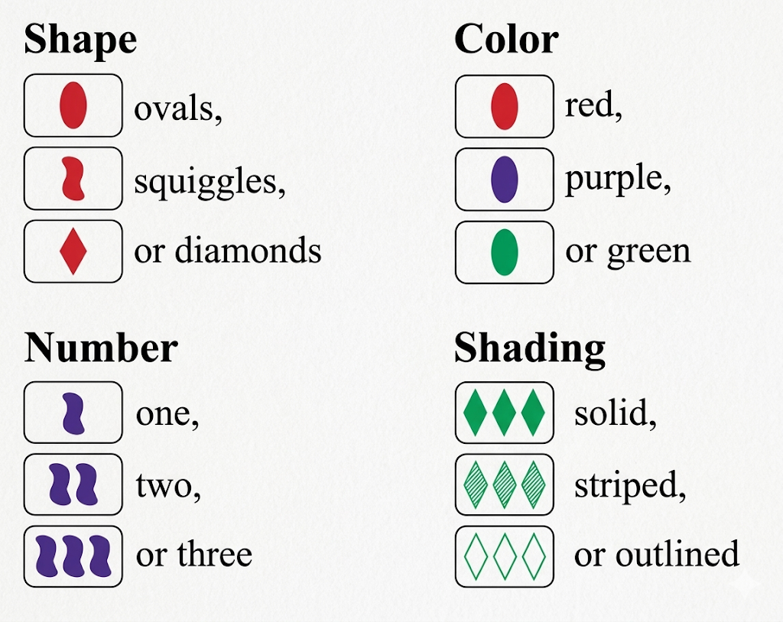
A SET consists of 3 cards in which each of the cards’ features, looked at one-by-one, are the same on each card, or are different on each card. If 2 cards are the same in any feature and 1 card is different in that feature, then it is not a SET.
Given any two cards, there exists a unique third card that forms a SET with the first two.
Examples:

All three cards have the same shape, the same color, the same number of symbols, and they all have different shading.

All three cards have different shapes, different colors, and different numbers of symbols, and they all have the same shading.
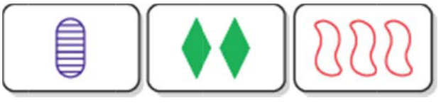
All three cards have different shapes, different colors, different numbers of symbols, and different shadings.
SET Quilt Instructions:
1. Make space for a 9x9 grid. You don’t need all the gridlines, but it helps to have lines (shown in yellow in Figure 1) for the largest 3x3 grid, separating the 9 smaller 3x3 grids.
2. Choose one card at random and place it in one of the corners (Figure 1).
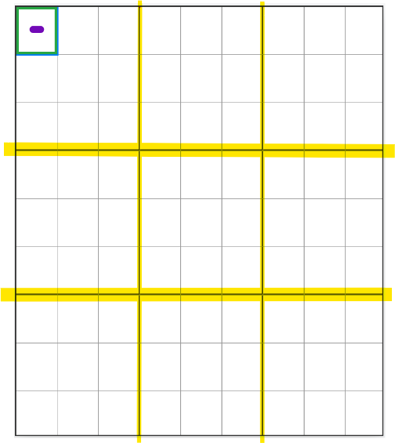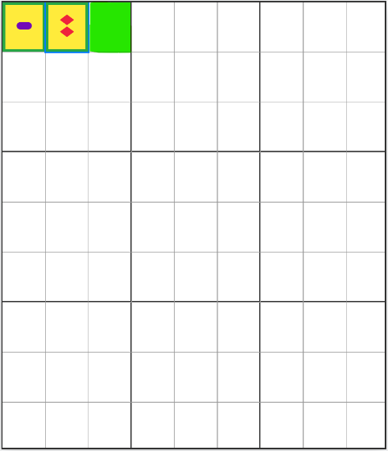
Figure 1. Setup and 1st card Figure 2. Next card and 1st SET
3. Choose a second card at random and place it adjacent to the first card (Figure 2).
4. Complete the row by finding the unique card that forms a SET with the first two (Figure 2).
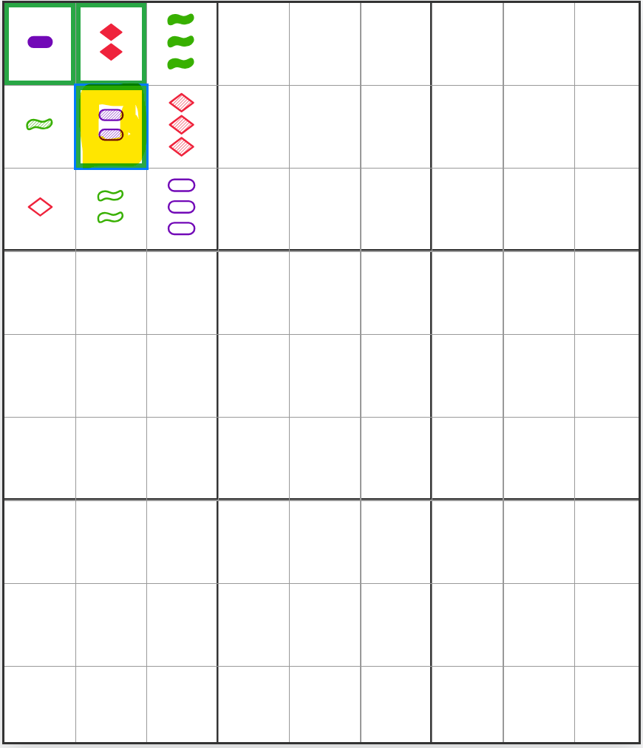 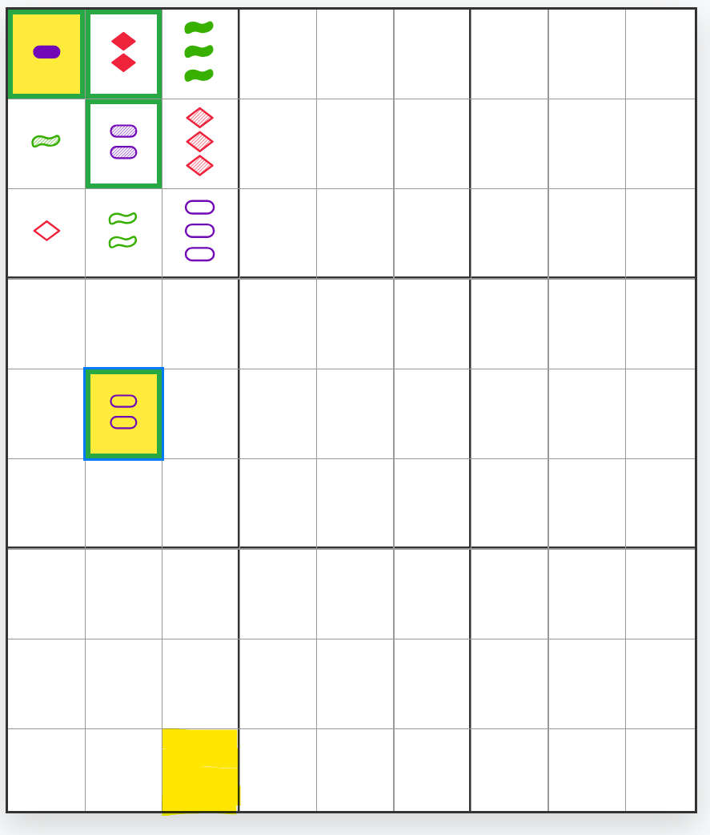Figure 3. First complete subgrid. Figure 4. Example of a 3D Set
5. Choose a card at random to place in the middle of the same 3x3 subgrid. Place the 5 remaining cards in the subgrid so that each row, column, and diagonal is a SET (Figure 3).
6. Randomly choose another card to place in the middle of the 3x3 subgrid below the first. Visualize these 3 subgrids in this column as being layers of a cube. Find and place the remaining 8+9 cards in this column. Figure 4 highlights three locations in yellow that form a SET. Visualize this set as a diagonal line going from a corner at the top of a cube to the opposite corner at the bottom of the cube.
7. The completed column is shown in Figure 5.
8. Placing any remaining card in any remaining position uniquely determines all remaining cards. (The easiest position is to place this last card in the very middle of the 9x9 grid.)
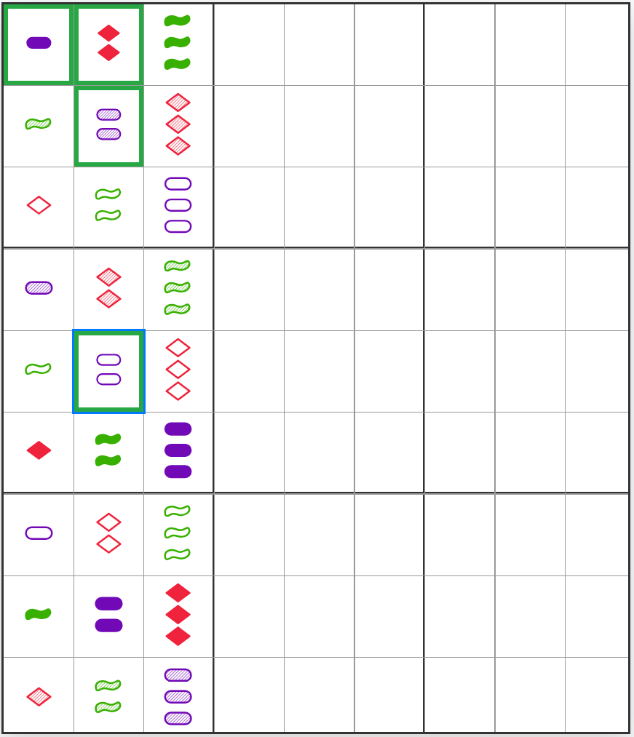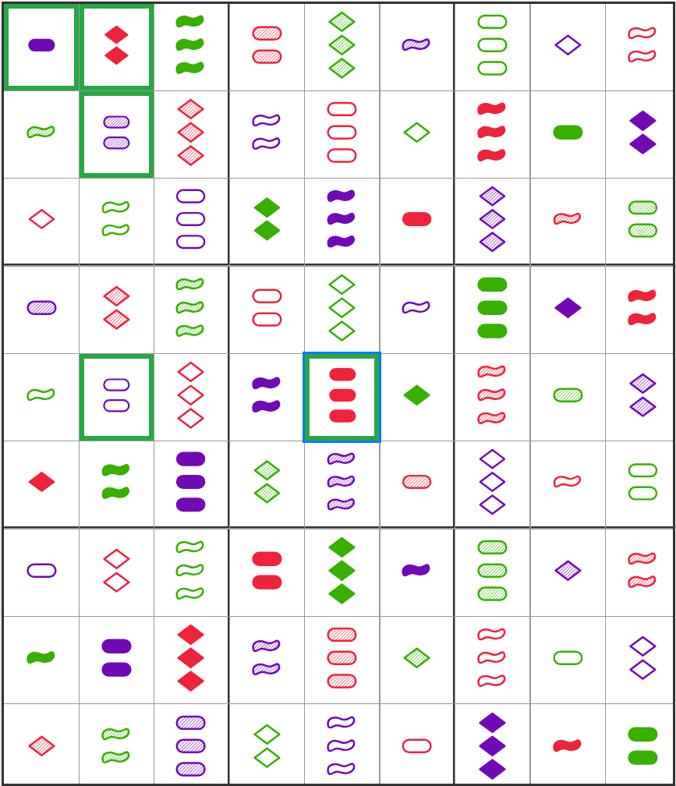
Figure 4. First completed 3x3x3 cube. Figure 5. The completed 9x9 grid.
Challenge Questions:
- What is the correct/best order to describe the conditions of a card?
- Within a single 3x3 subgrid, how many distinct SETs are there?
- How many total SETs are there within a standard 81-card deck?
- How many distinct SET quilts are there?
- Encode each card as a 4-tuple $(number,color, shading,shape)$ where each coordinate is from the set $\{0,1,2\}$. Given cards $X=(x_{1}, x_{2}, x_{3}, x_{4})$ and $Y=(y_{1},y_{2},y_{3},y_{4})$, prove that the third card in the SET is given by $-\left(X+Y\right) (mod 3)$, where all operations are taken component-wise.
- Suppose there are four possibilities in the four categories (or five categories with three possibilities each). What would the dimensions of the quilt be?
Original Activity: Brian Conrey and Brianna Donaldson, “How to Make a SET Quilt”, MathCircular, August 2024.
Resources: Online Demo and Source Code by Tom Mahoney, Emporia State University, tmahoney@emporia.edu

