Q1. Make a schema first and then insert 6 documents. • Roll_no=[1,2,3,4,5,] • Name=["Ram","Alex","John","Bob","Mukesh",”Danny”] • Age=[20,19,40,55,30,28] • Salary=[546.7,333.4,666.7,678.4,245.6,546.3] • City=["A","B","C","D","E",”F”] • Phone_no=[123,456,122,444,567,892].
Ans:- {
roll_no: Number,
name: String,
age: Number,
salary: Number,
city: String,
phone_no: Number
}
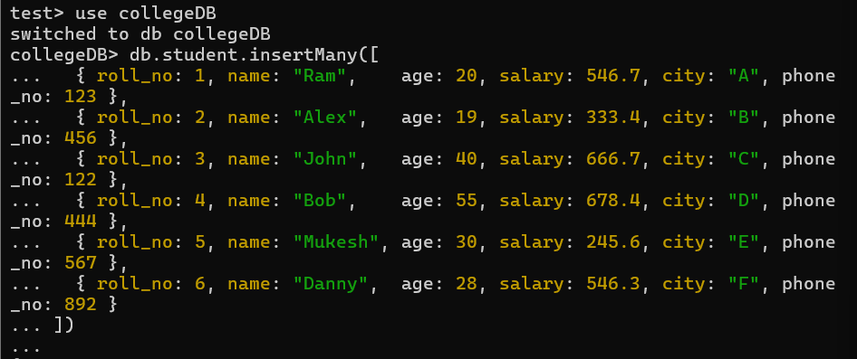

Q2. Write a query to update the name of RAM to SAM.
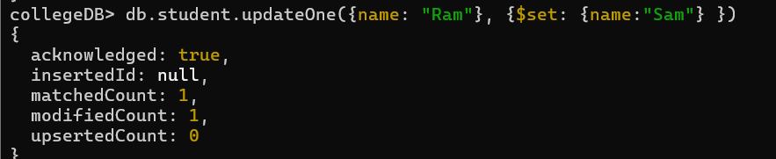

Q3. Write a query to display only the cities present in that collection.
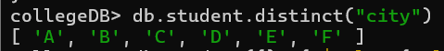

Q4. Write a query to update the salary by 10%.

Q5. Write a query to display all the documents in ascending and descending order of age.

Q6. Write a query to display all the documents with City → A,B,C
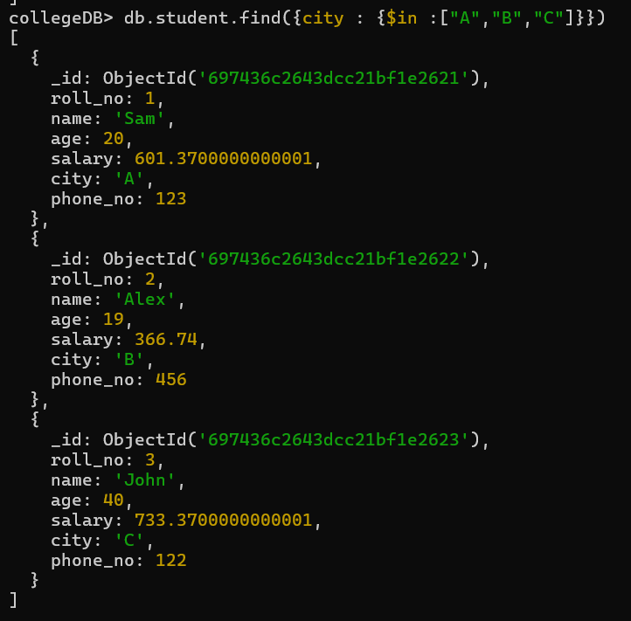

Q7. Write a query to display only two documents from the entire collection.
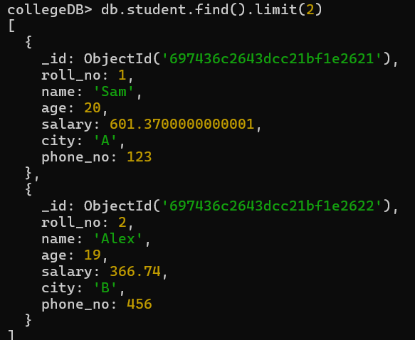

Q8. Write a query to delete a document with ROLL_NO:5.
Q9. Write a query to display all the documents with AGE greater than 20.
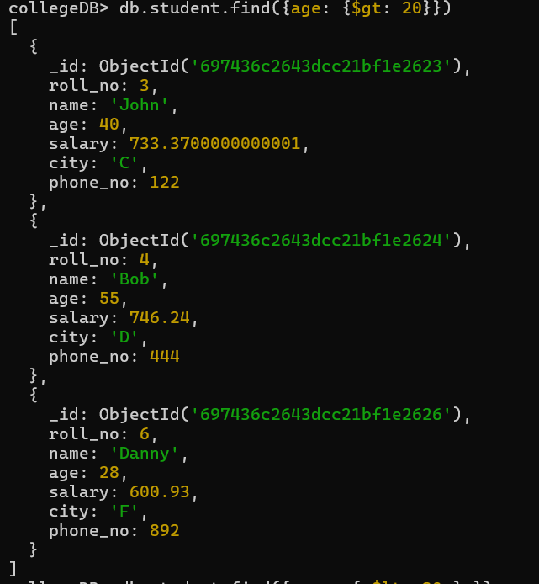

Q10. Write a query to display all the documents with AGE less than 20
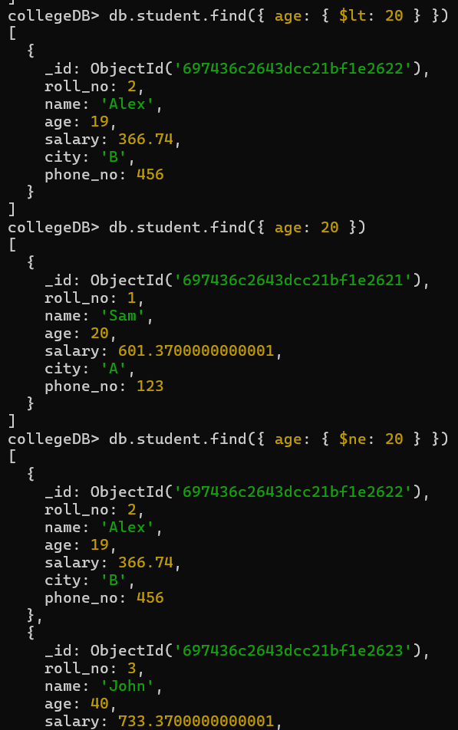

Q11. Write a query to display all the documents with AGE equals to 20.
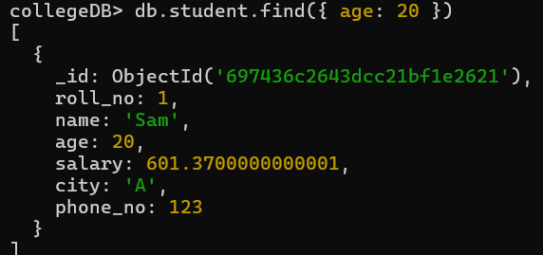
Q12. Write a query to display all the documents with AGE not equals to 20.
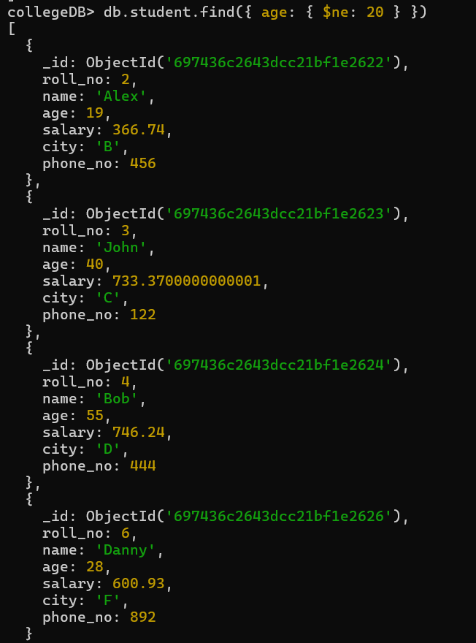

Q13. Write a query to display all the documents where AGE is greater than equals to 30.
