Assignment – Studio3T
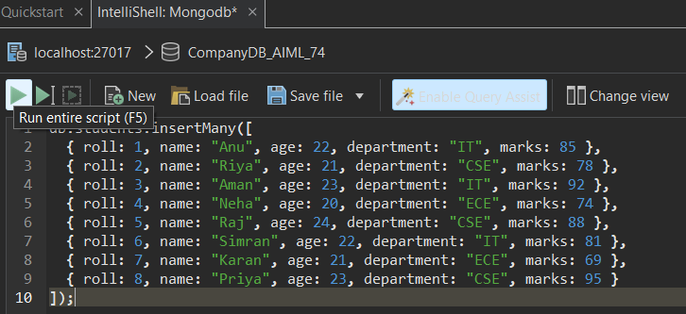
Q1. Display all documents.
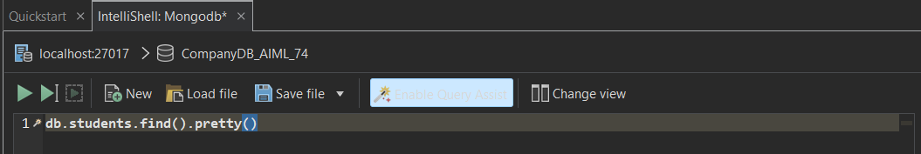
Q2. Find students from IT department.
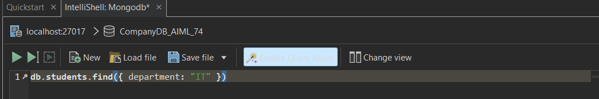
Q3. Find students with marks > 80.
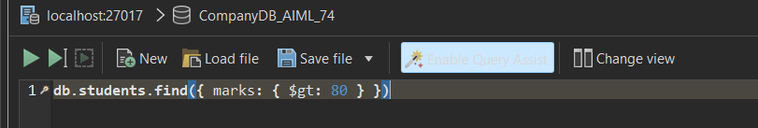
Q4. Insert one new student.
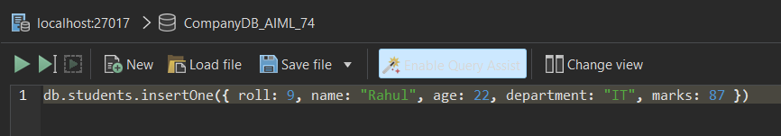
Q5. Update marks of Anu to 90.
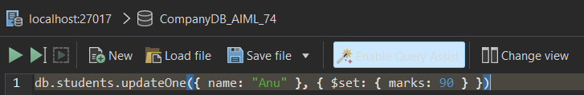
Q6. Add a new field "status: Pass" for all students .
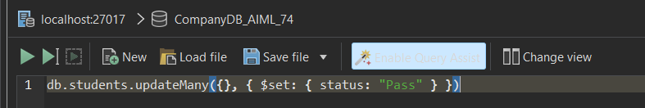
Q7. Delete all students with marks < 70.
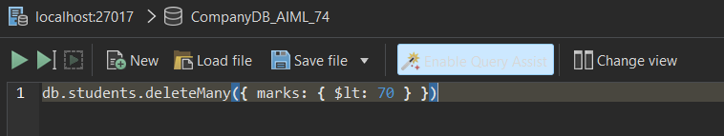
Q8. Count students in CSE department.
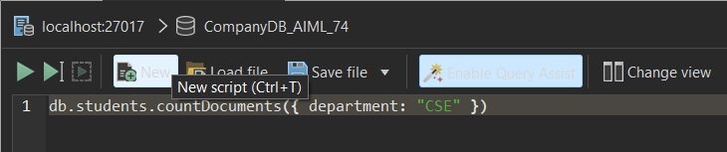
Q9. Find total students in each department.
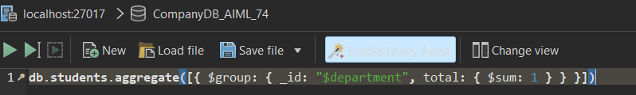
Q10. Find highest marks.
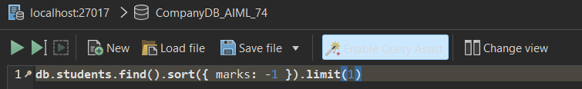
Q11. Find the second highest marks .
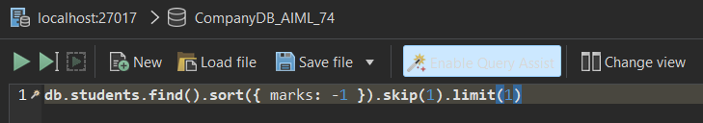
Q12. Find students whose name starts with 'A' and marks > 80.
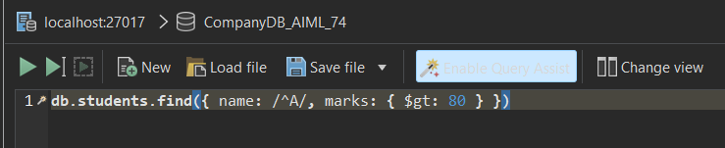
Q13. Display department-wise average marks, only for departments where avg > 80.
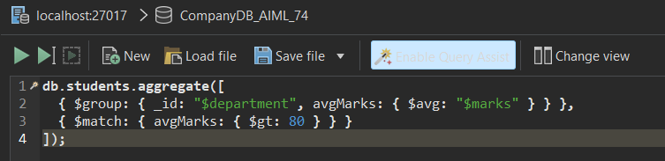
Q14. Find students with marks between 75 and 90, sorted by marks ascending.
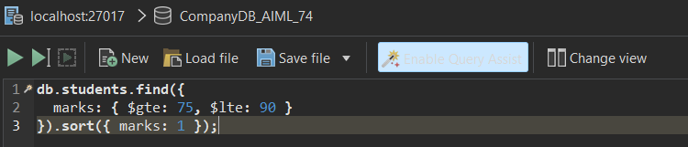
Q15. Add grade field based on marks
