Saxon Taylor, 21

📞0404 227 570 | saxoontaylor@gmail.com | South Brisbane, QLD

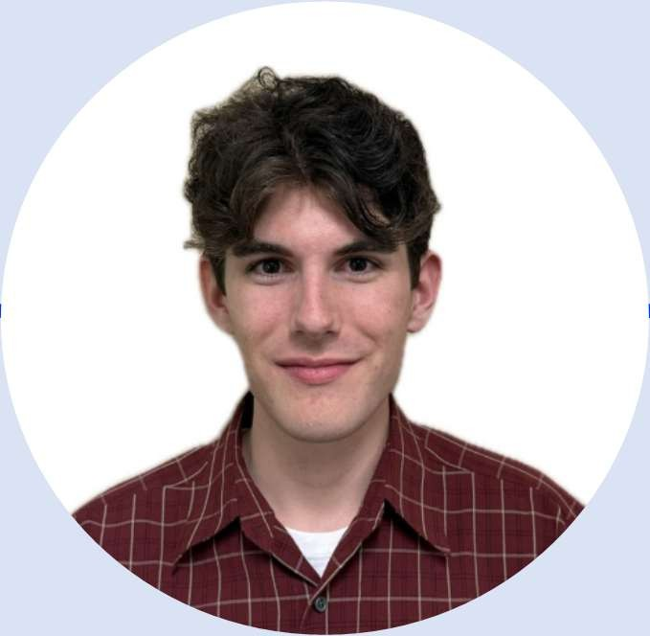

Education
Corinda High School (2021)
Bachelor of Biomedical Science
Griffith University, QLD — 2022–2024
- Covered subjects including Microbiology, Immunology, Biochemistry, and Clinical Pathology
- Practical lab exposure: pipetting, gel electrophoresis, PCR, spectrophotometry, aseptic technique
- Comfortable with basic data handling using Excel and GraphPad
Ongoing – Bachelor of Science
Work Experience
Various part-time/casual jobs while at university:
- Spuds and plums – Upper Mt Gravatt: Delivery & Packaging Assistant
- Butterfields – Royal Brisbane Women’s Hospital: Retail assistant
- Woolworths – Rochedale: Stock & Inventory Assistant

Objective
Biomedical Science graduate seeking a suitable position to commence my future career in Brisbane. I bring reliability, attention to detail, and hands-on experience with basic lab techniques from university. I'm a quick learner, used to working in fast-paced environments, and ready to contribute immediately, always punctual and on time.

Skills
- Lab Techniques: Pipetting, solution prep, PCR, gel electrophoresis, sample handling
- Software: Excel, GraphPad (basic use)
- Work Ethic: Reliable, punctual, focused on quality and process
- Communication: Comfortable speaking with staff, customers, and healthcare professionals
- Learning: Fast to adapt to new systems, environments, and protocols

Reference:
- Belinda Lamy (Butterfields store owner): 0481051086

