Assignment 2: From ER diagrams to tables

- Transform the following ER diagram into a relational schema diagram
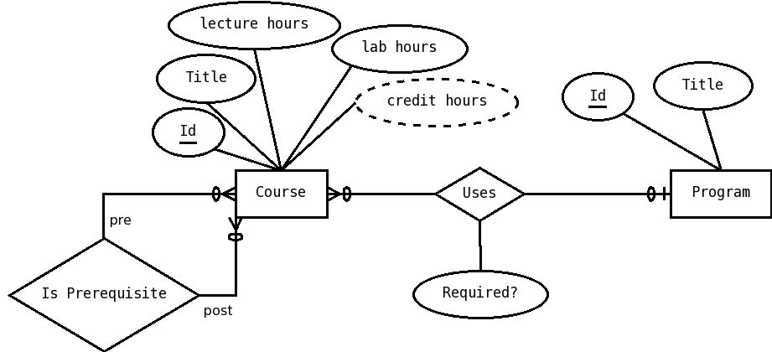

- Transform the following ER diagram into a relational schema diagram

