Firebase: Tutorial

Firebase is a mobile and web application development platform that provides a range of tools and services to help developers build high-quality applications quickly and easily. It was developed by Google and offers a range of features that are designed to help developers build, grow, and monetize their apps.

Firebase includes features like authentication, real-time database, cloud messaging, cloud storage, and hosting, among others. These features help developers to focus on building the app's core functionality, while Firebase handles the backend infrastructure.

Firebase is known for its ease of use, scalability, and flexibility. It allows developers to build apps for iOS, Android, and the web, and it provides a simple, easy-to-use interface that doesn't require a lot of technical knowledge to get started.

In summary, Firebase is a comprehensive platform that provides developers with the tools and services they need to build, run, and grow their apps with ease.

We primarily use firebase for easing our backend works, even a layman can code a good and firm backend.

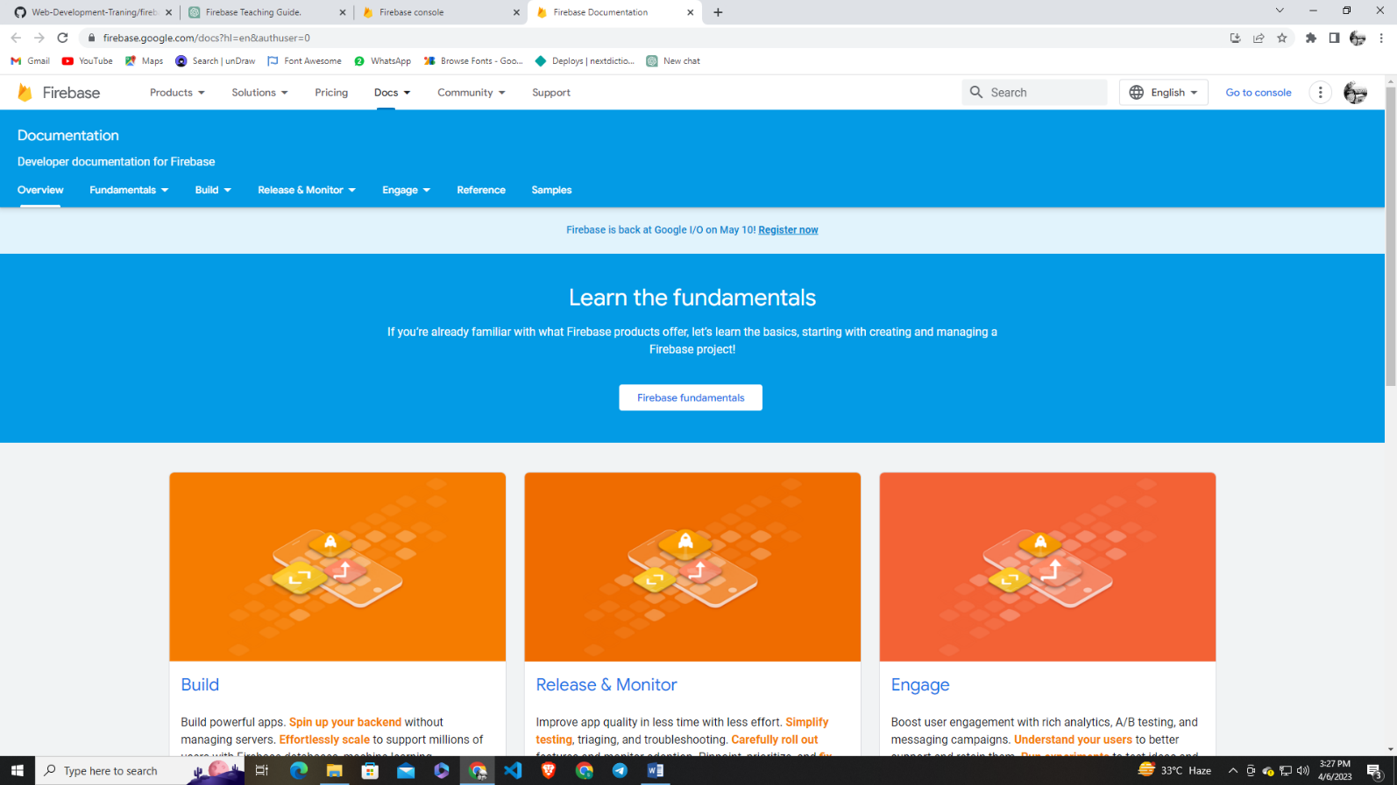There are 5 most important things we’ll use firebase for:

1. Authentication
2. Realtime database
3. Cloud Storage
4. Cloud messaging
5. Free Hosting