Working with Entity Class:

@SecondaryTable example

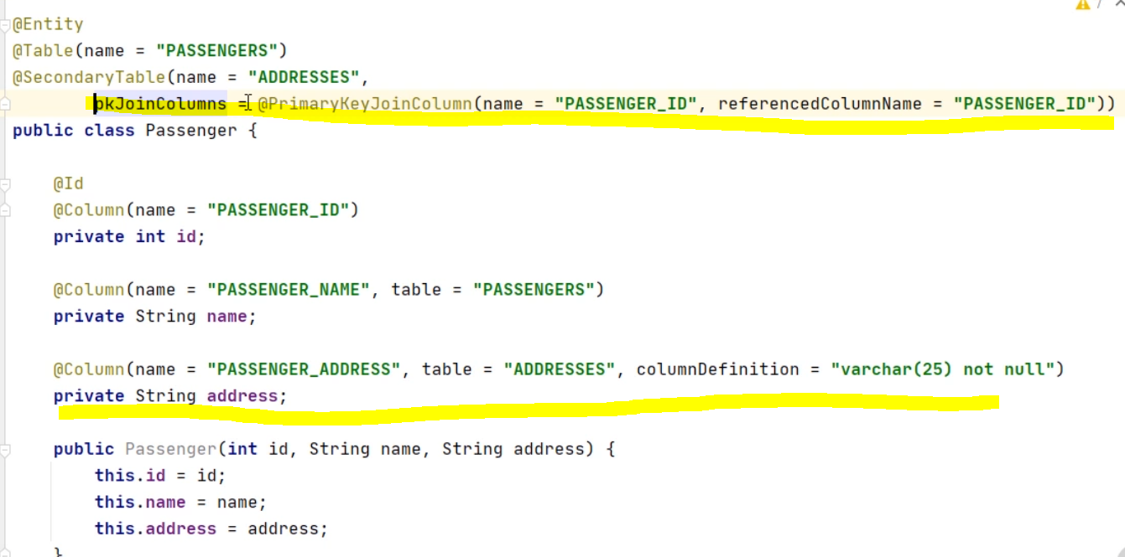

Above example creates two tables (PASSENGERS & ADDRESSES table) in database.

@SecondartTables example

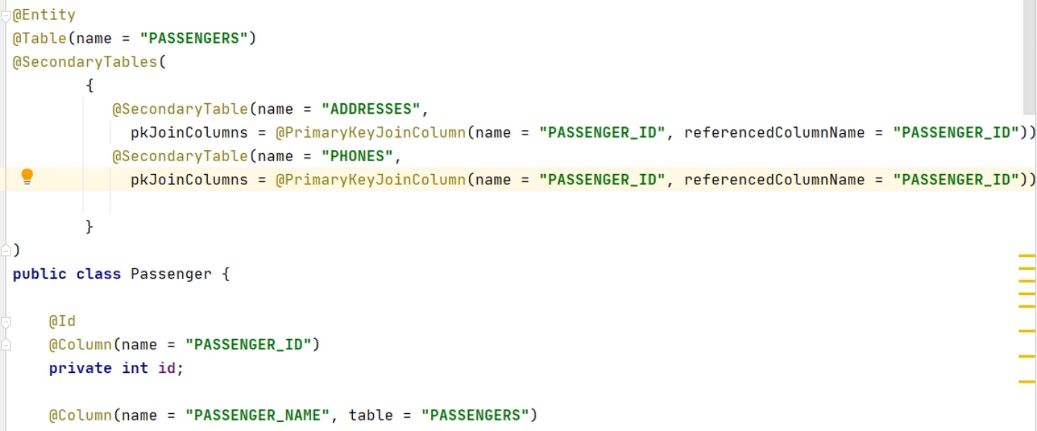

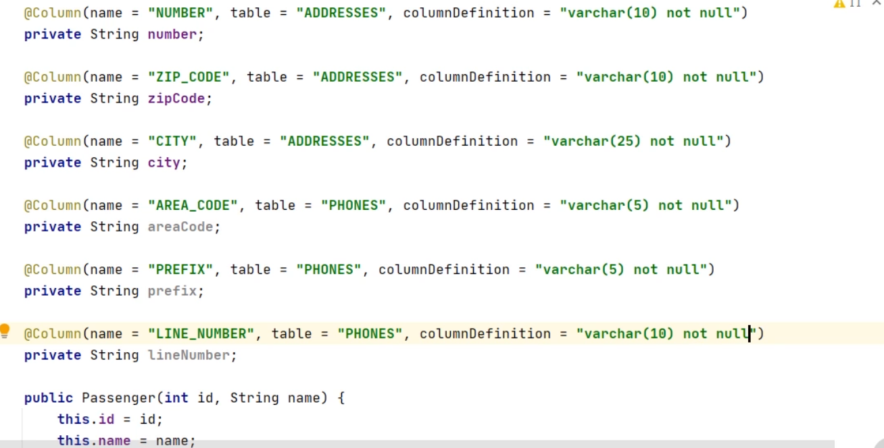

Above example creates three tables (PASSENGERS, ADDRESSES & PHONES table) in database.

Entity Access Types:

The Entity Access Type is the method by which Persistent Run-Time access the persistent state of the entity

There are two access types –

Filed access – through the instance variables

Property access – through the getter & setter methods of variables. It is used

By default, the access type is determined by the position of annotations. Example –

Field Based access

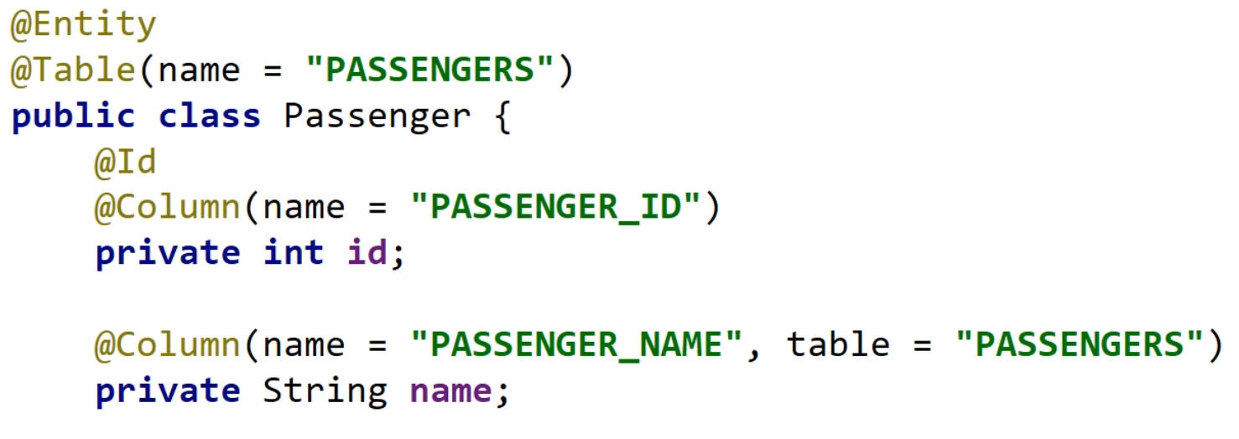

Property Based access

