Scopes in Spring –

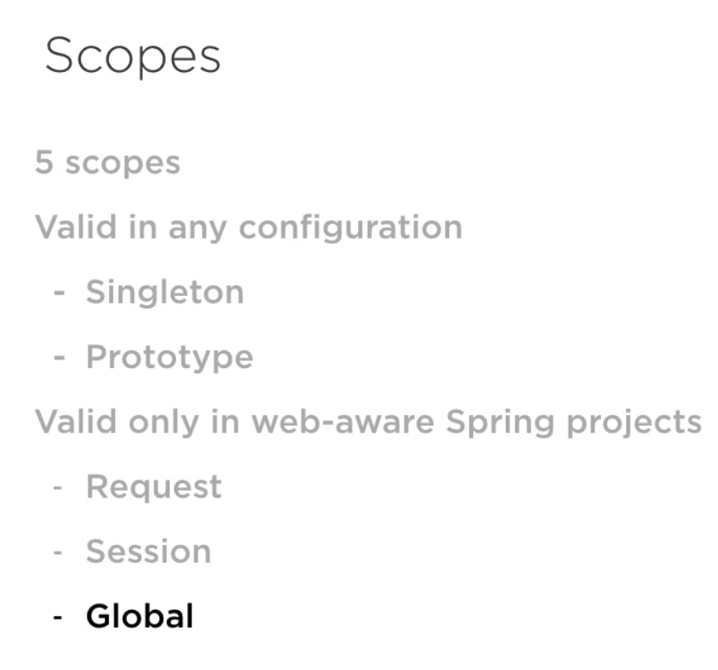

Singleton – this design pattern restricts the instantiation of a class to just one object. It is the default scope in spring. To define the scope of a @Bean, @Scope (…context.annotation.Scope) is used.

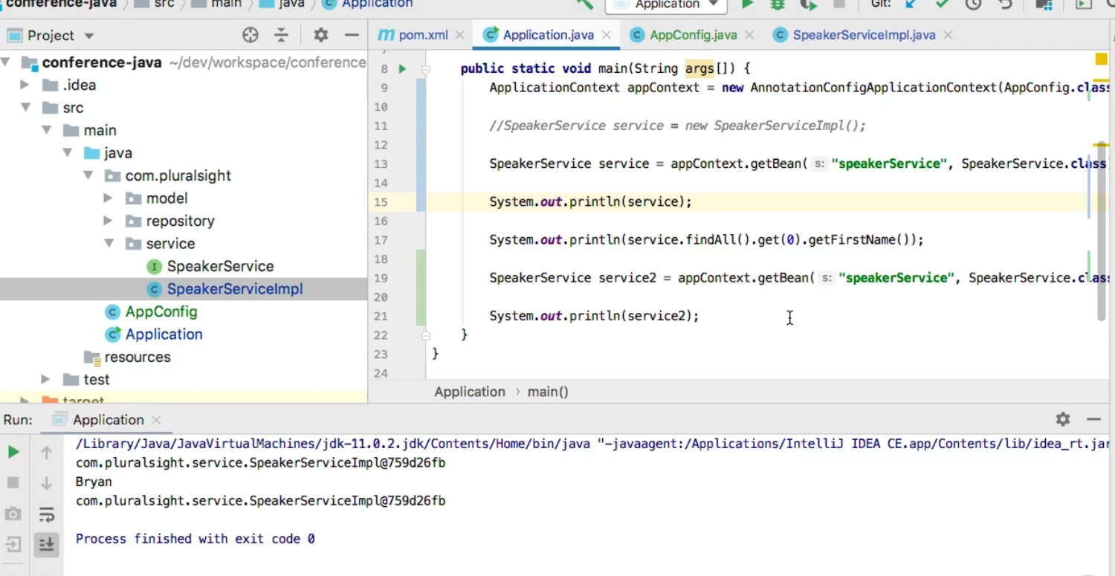

Every time the bean is called it returns the same object since it is a ***singleton.***

Prototype – this design pattern guarantees a unique instance per request. It is opposite of a singleton

@Autowire

In order to enable @Autowire we need to add a @ComponentScan to our configuration file, inside component scan annotation we need to mention the package where we want to use @Autowire. Autowiring can be By Name or by Instance Type.

Stereotype Annotations

To remove the ned to @Bean configuration in AppConfig file we need the Stereotype Annotations.

1: @Component 2: @Repository 3: @Service

@Bean does not work in class level, it only works on method level that is why Stereotype Annotations are used which are used in class level.

Annotating an Interface with Stereotype Annotations does not work, it should used only in implementation classes.

Beans can be thought of as just classes, defining a bean can be thought of as replacing the keyword *new.* Bean of Interfaces should not be created.

Spring MVC

MVC Architecture -