**R Player**

RPlayer (android music player) that list the latest song and allow user to purchase or unlock new songs.

Technologies used in RPlayer

* Firebase
* Android Studio
* Kotlin, xml (programming language)

Features of RPlayer

* Light & Dark Theme Feature.
* Gestures for navigate songs (onFling gesture)
* Gesture for pause song(onLongPress)
* Autoplay next song
* Subscription feature
* New song unlock feature
* Share free song feature

Implementation

* Starting page

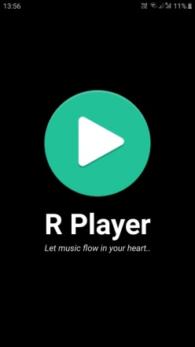

Here we implement animation(fadingtext and dowtouo) with the icon and slogan and make the use of Timer Schedule.

* Welcome page

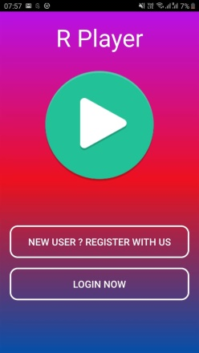

From here user can have option to login or registration , we use (custom design) using xml to make this button.

* Registration page

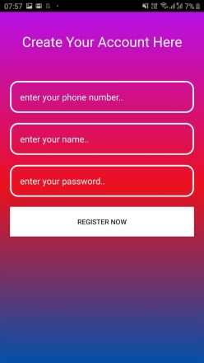

Here user give input like phone,password and their name for registration with us we make the use of firebase to accomplish this , with this error handling is also implemented there for check whether use give input in all field or not.

* Login page

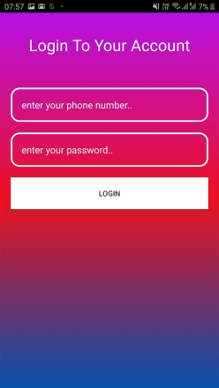

From here user can login into the RPlayer by providing their credentials and error handling for text input field is also implemented there.

* Selection page

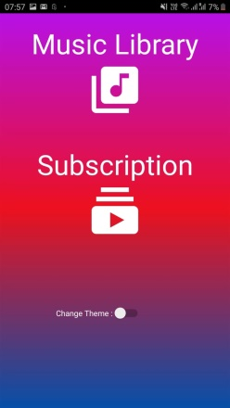 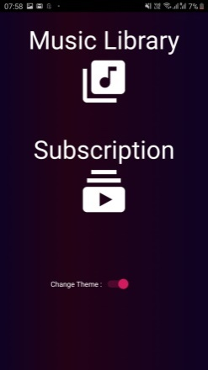

(Light Theme) (Dark Theme)

From here user can open music library and open subscription page for purchase tokens

Here we use material design icon for music library button and subscription.

* Song List Page

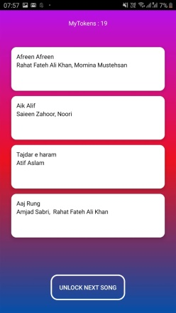 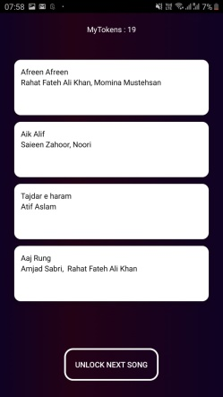

(Light Theme) (Dark Theme)

Here we make the use of Card View to display songs and from here user can select song and play it also user can unlock next song by the use of token feature.

* Subscription page

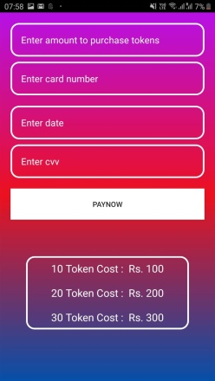 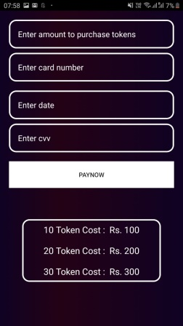

(Light Theme) (Dark Theme)

From here user can purchase token by simply fill the details of card and then after completion of payment tokens will be update by which user can unlock next song.

Here user can purchase the tokens and by default we give 3 tokens to the user .

Here we make the use of firebase to save the default token of user and when user purchase token then we update their total token in firebase database and then it will reflect in music player so from that token now user can unlock next song and after unlock we decrease one token from their total tokens.

* Music Player page

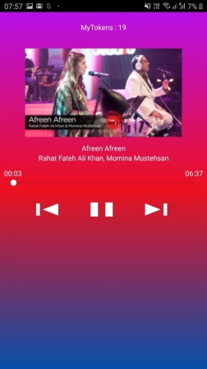 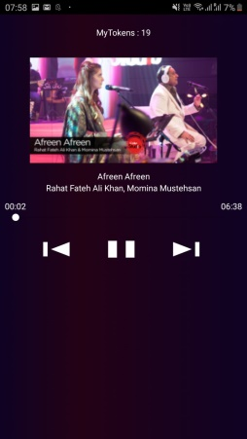

(Light Theme) (Dark Theme)

This is the music player page here user can navigate between song by make the use of Gestures and using button.

Here we use Gesture listeners and gesture detector to detect which gesture is come into account , also we use onfling gesture to check the movement of finger is left or right.

Fading animation and uptodown animation is implemented there on artist name and on cover image and we make the use of glide library there.

User can also navigate by using previous and next button

Make the use of long press gesture to pause button.

* Features that could have been implemented if we had more time
* Search box

A search box will be added to the music list page so that user can easily search their favourite song.

We implement this by collecting the songs url from the web api and apply song filters to display that song.

* Shuffle song

We will add shuffle song feature so that user can shuffle songs and listen random songs.

We will also implement this by collection url data from web api and shuffle it and start first song from shuffled collection.

* How to run apk in emulator
* Open code in android studio and open emulator and then click on run button after gradle build complete it will install in emulator.
* It is not working properly in real device because with the unsecured api the api call is failed and don’t get any response.