**Problem Statement:**

EBazaar is an online shopping portal where the users can purchase items online. They have approached you to create the application. In first phase they have asked you to create the Search module.

**Objective:**

Should develop the components as per the requirement below and showcase it to the trainers.

**Requirement Description:**

**Search Module**

The company deals with sales of three categories of products

1. Mobiles
2. Laptops
3. Watches

These are the sequence of steps the user does to purchase a product,

**Step 1:**  User logs into the web application using the login.jsp. On successful login the page should be redirected to the home page.

**Step 2:**  The home page (index.jsp) should list down the products Mobiles, Laptops and Watches as links.

**Step 3:** The user can select one of the above links and select the product they want to add to the cart.

**Step 4:**  After adding the products to the cart the user can purchase the products in the cart.

**Features:**

* Each product category page should provide an option for the user to navigate to the home page or to the cart page.
* The cart page should display all the products the user has added to his cart.
* The cart page should also provide the option to remove items from the cart..
* The cart page should also provide a feature for purchasing the products, clicking the purchase button should purchase all the products added by the user to the cart.
* The company also wishes to keep in track of the number of visitors visiting the site and to display it to all the users in all pages. The visitor count is incremented by for every new login. Say Jack logs into the application the count should show one. If he logs out and logs in again it should be incremented and displayed as 2.

**Design:**

Design the components as stated below.

* **Login.jsp :** Login Page for the user

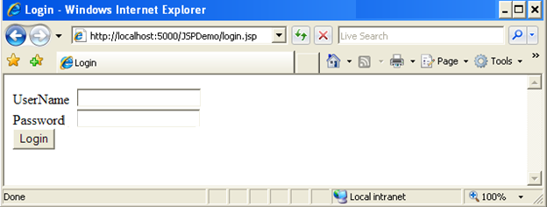

* **Index .jsp** : Displays various categories of products

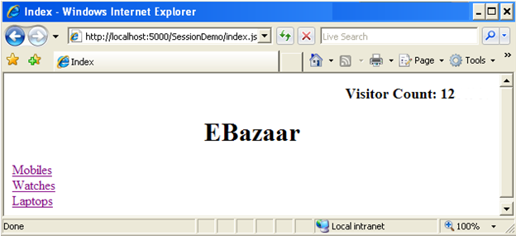

* **Watch.jsp :** Displays the list of watches available for Sale
* **Laptop.jsp :** Displays the list of Laptops available for Sale
* **Mobiles.jsp :** Displays list of mobiles available for Sale

The ***Mobile.jsp*** should display a response similar to the below screen shot,

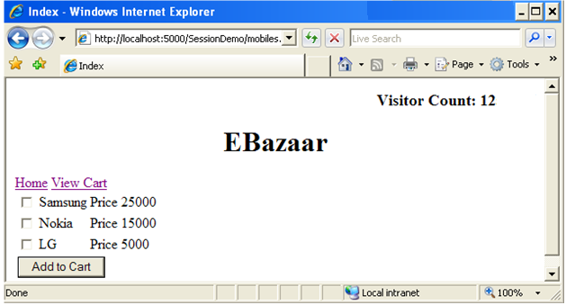

* User selects the appropriate device he needs to purchase using the check box and clicks Add to cart. This will add the selected products to carts page. Each product category page should provide an option for the user to navigate to the home page or to the cart page. A link “**home**” for the index page and “**View Cart**” for the Cart page should be included as per shown in the screen shot above.

**NOTE:**  The ***Laptop.jsp*** and ***Watches.jsp*** should display a response HTML similar to the above screen shot and display some laptops and mobiles models respectively

* **Cart.jsp :** Displays the products which was added by the user in the cart.

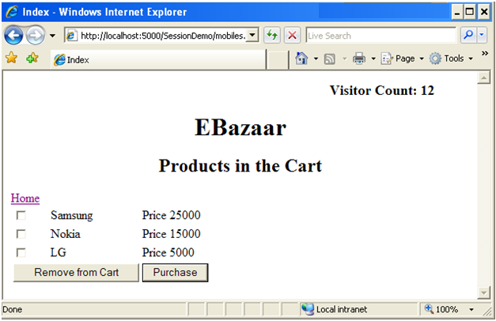

The user can either select products and **remove from the cart** or **purchase** the products.

The user can also drop some products from the page by selecting them and clicking “remove from cart”. This should remove the product from the carts page.

On clicking the purchase button the response should be taken to a purchase successful page as illustrated below,

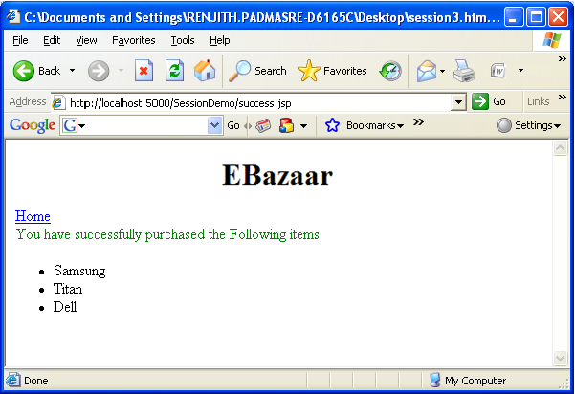

After purchase the products from the cart page should be automatically removed.

**Hint:**

* Use HTTP session management technique to manage the products selected by user. Use Sessions add, remove API’s to complete this case study.
* Store the user count in application context to make it available across the application.
* Use session to check whether the current user visits the index page for the first time in the current session.