1. **Ant and Triangle Problem:**

**Three ants are sitting at the three corners of an equilateral triangle. Each ant starts randomly picks a direction and starts to move along the edge of the triangle. What is the probability that none of the ants collide?**

The probability is that all of three ants are moving in clockward direction or all of them moving in anti clockwise direction.

=0.5*0.5*0.5+0.5*0.5*0.5

=.25  
  
**2. Crossing the Bridge Puzzle**

**Four people need to cross a rickety bridge at night. Unfortunately, they have only one torch and the bridge is too dangerous to cross without one. The bridge is only strong enough to support two people at a time. Not all people take the same time to cross the bridge. Times for each person: 1 min, 2 mins, 7 mins and 10 mins. What is the shortest time needed for all four of them to cross the bridge?**

A and B cross the bridge. A comes back. Time taken 3 minutes. Now B is on the other side.

C and D cross the bridge. B comes back. Time taken 8 + 2 minutes. Now C and D are on the other side.

A and B cross the bridge. Time taken is 2 minutes. All are on the other side.

Total time spent is 3 + 10 + 2 = 15 minutes.

**3. Burning Rope Problem**

**A man has two ropes of varying thickness (Those two ropes are not identical, they aren’t the same density nor the same length nor the same width). Each rope burns in 60 minutes. He actually wants to measure 45 mins. How can he measure 45 mins using only these two ropes.**

**He can’t cut the one rope in half because the ropes are non-homogeneous and he can’t be sure how long it will burn.**

To measure 45 minutes with these two ropes, you should first light both ends of one rope. At the same time, only light one end of the second rope. When the first rope is completely burned up, 30 minutes will have elapsed. At this point, you should then light the other end of the second rope. Because there are 30 minutes left of burn time on this rope, lighting the other end will cut that time in half, leaving you with 15 minutes of burn. Overall, you will have burned through both ropes in 45 minutes.

**4. Heaven’s Gate Probelm**

**You are standing before two doors. One of the path leads to heaven and the other one leads to hell. There are two guardians, one by each door. You know one of them always tells the truth and the other always lies, but you don’t know who is the honest one and who is the liar. You can only ask one question to one of them in order to find the way to heaven. What is the question?**

Ask one of the guard:" what would the other guard say if i ask him which way is the hell?"

And whatever answer he gives that is the way to heaven.

Explanation:

If you end up asking the question to the truthful one, he will tell the true and he knows the other guard is going to lie so he will so the way to heaven.

If you end up asking the question to the liar he will lie what the answer will be and he lies and instead shows the way to heaven.

**5. 10 Coins Puzzle**

**You are blindfolded and 10 coins are place in front of you on table. You are allowed to touch the coins, but can’t tell which way up they are by feel. You are told that there are 5 coins head up, and 5 coins tails up but not which ones are which. How do you make two piles of coins each with the same number of heads up? You can flip the coins any number of times.**

Now, take 5 coins.

There could be 5 combinations:

In these 5 coins, 1 is tail and 4 is head. (other half, 1 head and 4 tail)

In these 5 coins, 2 is tail and 3 is head. (other half, 2 is head and 3 is tail)

In these 5 coins, 3 is tail and 2 is head (other half, 3 is head and 2 is tail)

In these 5 coins, 4 is tail and 1 is head. (other half, 4 is head and 1 is tail)

In these 5 coins, every one is tail. (other half, 5 is head)

We just need to flip one set. (and two piles of coins will havve same number of heads up)

**6. King and Wind Bottles Puzzle**

**A bad king has a cellar of 1000 bottles of delightful and very expensive wine. A neighboring queen plots to kill the bad king and sends a servant to poison the wine. Fortunately (or say unfortunately) the bad king’s guards catch the servant after he has only poisoned one bottle. Alas, the guards don’t know which bottle but know that the poison is so strong that even if diluted 100,000 times it would still kill the king. Furthermore, it takes one month to have an effect. The bad king decides he will get some of the prisoners in his vast dungeons to drink the wine. Being a clever bad king he knows he needs to murder no more than 10 prisoners – believing he can fob off such a low death rate – and will still be able to drink the rest of the wine (999 bottles) at his anniversary party in 5 weeks time. Explain what is in mind of the king, how will he be able to do so ?**

**We have 1000 bottles of wine, one of which is poisoned and somehow we need to test all of the wine bottles using only 10 prisoners as taste testers. However we decide to administer the wine to the prisoners, we need to use the prisoners deaths as a code to trace back to the poisoned wine bottle.**

Since we have only 24 hours to test the wine, we know that there is not enough time nor enough prisoners to test the wine one-by-one. I’m guessing you got to this point and that’s where the confusion set in.

How can we test all of the bottles? Well, we’re going to have to get the prisoners drunk, I can tell you that much! Jk, but seriously we need to systematically distribute the wine to the prisoners so that there are at least a thousand different combinations!

First, let’s line up our 10 prisoners and label them. Also label the wine bottles 0–999 so we can tell them apart.

Next, assign Prisoner B the task of drinking from every other set of two bottles. For example, Prisoner B drinks from bottles 0 and 1, skips 2 and 3. Drinks from 4 and 5, skips 6 and 7, and so forth continuing the pattern.

Have Prisoner C drink from every other set of four bottles: i.e. Prisoner C drinks from bottles 0–3, (skip 4–7), 8–11, (skip 12–15), 16–19, …

Are you seeing the pattern? Keep doubling the number of bottles each prisoner drinks in succession.

Prisoner D drinks from every other set of eight bottles. Prisoner E from every other set of 16. Prisoner F from every other 32. Prisoner G from every other 64. Prisoner H from every other 128. Prisoner I from every other 256. And lastly, Prisoner J from the first 512 bottles.

How will we be able to tell which bottle was the poisonous one? We will look at the pattern of poisoned prisoners encoded in binary. To do so I’ll place a zero above the prisoners who are poisoned, and a one above those who aren’t.

Before we decode the result, we need to flip our prisoners around so that it matches the binary place-value system.

There we go. Now suppose all the prisoners are poisoned? Which bottle of wine was it?

Well it must have been the first bottle, bottle #0, since this is the only bottle that they all drank from.

This is confirmed in our diagram because if they are all poisoned, we place a zero above every prisoner. And 0000000000 in binary is still 0 in decimal.

If we translate 0000000001 into decimal we get 1. Which means bottle # 1 was poisoned. This confirms what we know to be true because Prisoner A was the only prisoner not to drink from bottle # 1 (remember Prisoner A drank from bottles 0, 2, 4, 6…).

**7. Mislabeled Jar Puzzle**

**You have 3 jars that are all mislabeled. One jar contains Apple, another contains Oranges and the third jar contains a mixture of both Apple and Oranges.**

**You are allowed to pick as many fruits as you want from each jar to fix the labels on the jars. What is the minimum number of fruits that you have to pick and from which jars to correctly label them?  
  
Here, important point is all of the jar are mislabeled.** Now, the answer is 1. Suppose, you pick the third jar. The label of it says it contains both apple and oranges. Now, you pick a fruit from it. If it’s apple, label will be changed to apple. Now, jar 1’s label is to be changed to **Oranges** and **jar 2’s Apples and Oranges. (all of the jars are mislabeled)**

1. **Red And Blue Marble jar Puzzle:**

**You have two jars, 50 red marbles and 50 blue marbles. You need to place all the marbles into the jars such that when you blindly pick one marble out of one jar, you maximize the chances that it will be red. When picking, you’ll first randomly pick a jar, and then randomly pick a marble out of that jar. You can arrange the marbles however you like, but each marble must be in a jar.**

The maximum probability will be :

jar A : (1/2)*1 = 1/2 (selecting the jar A = 1/2, red marble from jar A = 1/1)

jar B : (1/2)*(49/99) = 49/198 (selecting the jar B = 1/2, red marble from jar B = 49/99)

Total probability = 1/2+49/198=148/198=74/99 (~3/4)

**9.Gold Bar Problem:**

**You’ve got someone working for you for seven days and a gold bar to pay him. The gold bar is segmented into seven connected pieces. You must give them a piece of gold at the end of every day. What and where are the fewest number of cuts to the bar of gold that will allow you to pay him 1/7th each day?**

gold-bar-300x56

Lets split the chain as,



Day 1: Give A (+1)

Day 2: Get back A, give B (-1, +2)

Day 3: Give A (+1)

Day 4:Get back A and B, give C (-2,-1,+4)

Day 5:Give A (+1)

Day 6:Get back A, give B (-1,+2)

Day 7:Give A (+1)

**10. 100 Doors Puzzle**

**You have 100 doors in a row that are all initially closed. you make 100 passes by the doors starting with the first door every time. the first time through you visit every door and toggle the door (if the door is closed, you open it, if its open, you close it). the second time you only visit every 2nd door (door #2, #4, #6). the third time, every 3rd door (door #3, #6, #9), ec, until you only visit the 100th door. What state are the doors in after the last pass? Which are open which are closed?**

1,4,9,….100

1. **Egg Drop Puzzle:**Now, I know how to solve the problem dynamically.

# 12)5 Pirates and 100 Gold Coins **There are 5 pirates, they must decide how to distribute 100 gold coins among them. The pirates have seniority levels, the senior-most is A, then B, then C, then D, and finally the junior-most is E.**

# **Rules of distribution are:**

# **The most senior pirate proposes a distribution of coins.**

# **All pirates vote on whether to accept the distribution.**

# **If the distribution is accepted, the coins are disbursed and the game ends.**

# **If not, the proposer is thrown and dies, and the next most senior pirate makes a new proposal to begin the system again.**

# **In case of a tie vote the proposer can has the casting vote**

# **Rules every pirates follows.**

# **Every pirate wants to survive**

# **Given survival, each pirate wants to maximize the number of gold coins he receives.**

Answer:

The answer is 98 which is not intuitive.

A uses below facts to get 98.

Consider the situation when A, B and C die, only D and E are left. E knows that he will not get anything (D is senior and will make a distribution of (100, 0). So E would be find with anything greater than 0.

Consider the situation when A and B die, C, D and E are left. D knows that he will not get anything (C will make a distribution of (99, 0, 1)and E will vote in favor of C).

Consider the situation when A dies. B, C, D and E are left. To survive, B only needs to give 1 coin to D. So distribution is (99, 0, 1, 0)

Similarly A knows about point 3, so he just needs to give 1 coin to C and 1 coin to E to get them in favor. So distribution is (98, 0, 1, 0, 1).

The idea is based on the fact that what B will distribute if A dies (B would always want A to die). If A gives more coins to 2 people than B would have given, A wins.

**13)Question: How to make 4 equilateral triangles with 6 identical match sticks?**

Make a tetrahedron.

(pyramid shaped one)

1. **Question : 100 coins are lying flat on a table. 10 of them are heads up and 90 are tails up. How can we split the coins into two piles such that there are same number of heads up in each pile?**

**Answer : Make 2 piles with 10 coins and 90 coins each. Now, flip all the coins in one of the piles.**

Explanation :

Let’s consider a case

Pile 1: 88T, 2H

Pile 2: 2T, 8H

Flipping the coins in Pile 2

Pile 1: 88T, 2H

Pile 2: 2H, 8T

Pile 1(heads) = Pile 2(heads)

**15)The Boy Or Girl Problem:**

**The Boy or Girl problem consists of a bunch of questions in probability which has kept the mathematicians on discussion about its possibilities. But different from them, here is one puzzle for you with no ambiguity.**

**Suppose that I have a friend whose name is Ankur. Ankur has his elder brother who got married 10 years before. But Ankur being a silly guy has the habit of forgetting things; you can say a “Short time memory loss”. This summer he is going to meet his brother after 10 years, and he has planned to purchase some clothes for his brother’s kids as a token of love. Each and every time he faces a problem he comes to me, so this time also, he came to seek help, and I have not left him empty handed. I told him that as far as I can recall, his brother has two offspring’s and one of the boy was born on Tuesday. Now, it’s your turn to help him. What is the probability that Ankur’s brother has two boys? Assume an equal chance of giving birth to either sex and an equal chance to giving birth on any day.**

**Solution:** If you think the answer should be 1/2, you would be wrong. If you knew which child was a boy (say, the younger one), you would be closer to the truth.But since the boy could be either the younger or the older child, the analysis is more subtle. The answer would be 13/27.

There can be four cases, i.e. either his brother has two boys, or one boy(elder) and one girl, one girl(elder) and one boy, or both of them are girls. And there are 7 equally likely possibilities for any one of the children of taking birth on Tuesday for all these four cases. Therefore, the total cases are 7×4- 1(as there is repetition of two boys two times). The possibility for having two boys with both of them taking birth on Tuesday will be 7×2- 1. Therefore, the answer would be 13/27. The things can be made more clear from the image shown below.

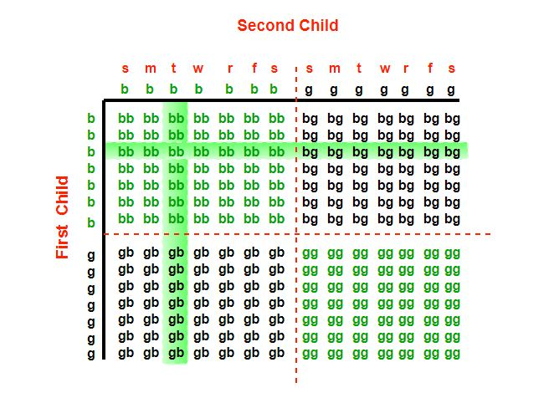

(Now, I find it is suspicious. Because, the girl girl possibility should be left out, too. Is not it? Because, what he recalls, is at least true. Right? )

**Similar Probabilistic Problem:**

Mr. Smith is the father of two. We meet him walking along the street with a young boy whom he proudly introduces as his son. What is the probability that Mr. Smith's other child is also a boy?

Bar-Hillel & Falk use this variant to highlight the importance of considering the underlying assumptions. The intuitive answer is 1/2 and, when making the most natural assumptions, this is correct. However, someone may argue that "…before Mr. Smith identifies the boy as his son, we know only that he is either the father of two boys, BB, or of two girls, GG, or of one of each in either birth order, i.e., BG or GB. Assuming again independence and equiprobability, we begin with a probability of 1/4.

that Smith is the father of two boys. Discovering that he has at least one boy rules out the event GG. Since the remaining three events were equiprobable, we obtain a probability of 1/3 for BB

**16)500 note puzzle:**

**A Lady (L) bought an item of Rs 100 from the Shopkeeper (C). She paid him through a 500 Rs Note. Realizing that he did not have change, the shopkeeper C got change for that note from another shopkeeper (S) and paid Rs 400 to the Lady.**

**After a few days, S realized that the note is fake, And this railed at C and took 500 Rs back from him.**

**So in this whole process how much money did C loose in the end?**

Answer: 500

Explanation:

The total loss must be equal to total profit. Here the loser is C and the gainer is L.

Note: S doesn’t gain anything because he just got his money back.

So, loss of C = gain of L = 100(for product) + 400(cash) = Rs.500

1. **Gold Bar Problem: (modified for 5 days)**

**(again two. I can do that)**

1. **Palindrome date:**

In year 2001 on October 2, 2001, the date in MMDDYYYY format was a palindrome (same forwards as backwards), 10/02/2001 -> “10022001”

One year can have only one palindrome as the year fixes the month and date too, so the year has to be less than 2001 since we already have the palindrome for 10/02. It can’t be any year in 1900 because that would result in a day of 91, same for 1800 down to 1400. it could be a year in 1300 because that would be the 31st day.

So what’s the latest year in 1300 that would make a month?

When you first look at it, 12th month comes to mind as we have to find the latest date, so it seems it would be 1321. But we have to keep in mind that we want the maximum year in 1300 century with a valid date, so lets think about 1390 that will give the date as 09/31, is this a valid date…? No, because September has only 30 days, so last will be the 31st August. Which means the correct date would be 08/31/1380.

1. **God’s Mercy Graduation**

**There is a school on the foothills of Himalayas. This Gurukul admits only 100 students every year and these are entitled to be the best in knowledge, health and spirit. A specialty about this Gurukul is that, despite being a secret well hidden from the muggles (non-sorcerers), it’s a renowned institution and well known amongst sorcerers and priests. The school is famous in these communities for “God’s Mercy Graduation”. It is believed that every year there comes a time, starting in the second week of November, when the skies turn red and there are exactly 100 days left to graduation. It’s an overly tensed time for the students of the institution. All students are preparing for the world’s toughest and the most rigorous examination. God comes one night and puts a seal at the back of the head of some meritorious students and these students are exempted from giving the examination and have to leave the school.**

**Rules:**

**No student has the ability to touch and find out whether they have been marked or not. A student can see the heads of all other students except his own.**

**No student is allowed to communicate by any means (verbal/non-verbal) with another student telling him or giving him hints regarding God’s mark.**

**On the 23rd day (from the night God had visited), some students leave the school as they have been blessed by God and don’t need to give the examination. Find out how many students remain in the institution?**

**Note: Initially there were 100 students only.**

Solution: 77

Explanation:

Since no student is allowed to communicate and is unable to know about himself, it can inferred that irrespective of whether he himself is marked or not, each student can only get to know about all other students who are marked (by looking at the back of all 99 heads except her own).

Example:

Assume only 2 students were marked (answer: 98 how?)

On the first day after God had visited, everyone comes to school and looks at the back of the head of every other student. Let A and B be the children who were marked.

Day 1: A saw 98 unmarked heads and 1 marked head. Still A has no knowledge whether his head was marked or not.

B also saw 98 unmarked heads and 1 marked head on day 1. Still B has no knowledge whether his head was marked or not.

Day 2: A notices that B has still has not left. [98 + A + B = 100]. B notices that A has not left.

So, A sees again on day 2, 98 unmarked heads and one marked head of B, he infers since B has not left, B must have seen 1 marked head on the day 1 (since A knows 98 heads are unmarked and B’s head is marked ). So one head that he doesn’t know about i.e. his own head is being seen by B on day 1 as a marked head.

Therefore, A realizes that along with B, it’s his head that is marked. Same observation can be made from B’s point of view. (Where B realizes that apart from A, his own head is marked). So as a result on day 2 both A and B will leave and 98 students will be left.

Generalization: On nth day, n students realize that apart from n-1 marked heads, their own head is marked and so on nth day, n students leave the school.

1. **Car Tyre Change Problem:**

**A car has 4 tyres and 1 spare tyre. Each tyre can travel a maximum distance of 20000 miles before wearing off. What is the maximum distance the car can travel before you are forced to buy a new tyre? You are allowed to change tyres (using the spare tyre) unlimited number of times.**

**Answer:** 25000

Divide the lifetime of spare tire into 4 equal part i.e., 5000 and swap it at each completion of 5000 miles distance.

Let four tyres be A, B, C and D and spare tyre be S.

5000 KMs: Replace A with S.

10000 KMs: Put A back to its original position and replace B with S

15000 KMs: Put B back to its original position and replace C with S

20000 KMs: Put C back to its original position and replace D with S

1. **Completion Of Task:  
     
   A man is allocated a task. He doubles the task done everyday. If the man completely does the task in 18 days, how many days did it take for the man to complete 25% of the task?**

**Answer:** 16

100% of task = 18 days

As he doubles the task everyday.

**22)Day Of Month Using 2 Dices:**

**How can you represent days of month using two 6 sided dice ?**

You can write one number on each face of the dice from 0 to 9 and you have to represent days from 1 to 31, for example for 1, one dice should show 0 and another should show 1, similarly for 31 one dice should show 3 and another should show 1.

(Now, as you can understand, it need not to be a conventional one)

Dice 1: 0 1 2 3 5 7

Dice 2: 0 1 2 4 6 8

How?

Basically you have to show 11, 22 so 1 and 2 should be present in both dices, similarly to show 01, 09 0 should be present in both dices, now the trick is for showing 9 you can use dice with 6 printed on one of the face.

**23)3 Bulbs and 3 Switches**

**There is a room with a door (closed) and three light bulbs. Outside the room there are three switches, connected to the bulbs. You may manipulate the switches as you wish, but once you open the door you can’t change them. Identify each switch with its bulb.**

**Let the bulbs be X, Y and Z**

**Turn on switch X for 5 to 10 minutes. Turn it off and turn on switch Y. Open the door and touch the light bulb.**

1. if the light is on, it is Y  
   2. if the light is off and hot, it is X  
   3. if the light is off and cold, it is Z
2. **Find the Jar with contaminated pills**

**You have 5 jars of pills. Each pill weighs 10 grams, except for contaminated pills contained in one jar, where each pill weighs 9 grams. Given a scale, how could you tell which jar had the contaminated pills in just one measurement?**

**Solution:**

Take out 1 pill from jar 1, 2 pills from jar 2, 3 pills from jar 3, 4 pills from jar 4 and 5 pills from jar 5. Put all these 15 pills on scale. The correct wight is 150 (15*10). But one of the jars has contaminated pills. So the wight will definitely less than 150. If the wight is 149 then jar 1 has contaminated pills because the there is only one contaminated pill. If the wight is 148 then jar 2, if the wight is 147 then jar 3, if 146 then jar 4, if 145 then jar 5.

# 25)A Man with Medical Condition and 2 Pills

**A man has a medical condition that requires him to take two kinds of pills, call them A and B. The man must take exactly one A pill and exactly one B pill each day, or he will die. The pills are taken by first dissolving them in water.**

**The man has a jar of A pills and a jar of B pills. One day, as he is about to take his pills, he takes out one A pill from the A jar and puts it in a glass of water. Then he accidentally takes out two B pills from the B jar and puts them in the water. Now, he is in the situation of having a glass of water with three dissolved pills, one A pill and two B pills. Unfortunately, the pills are very expensive, so the thought of throwing out the water with the 3 pills and starting over is out of the question. How should the man proceed in order to get the right quantity of A and B while not wasting any pills?**

**Solution:**  
Add one more A pill to the glass and let it dissolve. Take half of the water today and half tomorrow. It works under following assumptions.

The dissolved Pills can be used next day.

The man has to take pills at least for one more day.

**26)1000 Coins and 10 Bags**

**A dealer has 1000 coins and 10 bags. He has to divide the coins over the ten bags, so that he can make any number of coins simply by handing over a few bags. How must divide his money into the ten bags?**

(again, binary representation)  
  
So, 1st bag contains 1 coin.

2nd bag contains 2 coins.

3rd bag contains, 4 coins.

4th bag contains, 8 coins.

10th bag contains, 512 coins.

(However, to make the total count 1000, 10th bag should contain 1000-511 coins=489 coins)

1. **Find The Fastest Three Horse:**

**(I know)  
  
(https://www.google.co.in/search?q=find+the+fastest+three+horses&oq=find+the+fastest+three+horses&aqs=chrome..69i57j0l5.6467j0j7&sourceid=chrome&ie=UTF-8#kpvalbx=1)**

**28)Camel and Banana Puzzle:  
  
A person has 3000 bananas and a camel. The person wants to transport maximum number of bananas to a destination which is 1000 KMs away, using only the camel as a mode of transportation. The camel cannot carry more than 1000 bananas at a time and eats a banana every km it travels. What is the maximum number of bananas that can be transferred to the destination using only camel (no other mode of transportation is allowed).**

**Solution:**

At first look, it seems that the person cannot transfer any banana as the camel can carry at most 1000 bananas and going to eat all bananas when destination is reached.

The trick is to transfer bananas to an intermediate point, then transfer all bananas from the intermediate point to destination. Refer following link for detailed explanation.

**Explanation:** since there are 3000 bananas and the camel can carry at most 1000 bananas, at least five trips are needed to carry away all bananas from the plantation P (3 trips away from the plantation and 2 return trips):

**(two back trips and three front trips)**

P (plantation) ===forth===> A

<===back====

===forth===>

<===back====

===forth===>

**Point A in the above picture cannot be the market.** This is because the camel can never travel more than 500 kilometers into the desert if it should return to the plantation (the camel eats a banana every kilometer it travels!). So point A lies somewhere in the desert between the plantation and the market. From point A to the next point, less than five trips must be used to transport the bananas to that next point. We arrive at the following global solution to the problem (P denotes the plantation, M denotes the market):

**P (plantation) A B c**

**===forth===> ===forth===> ===forth===>**

**<===back==== <===back====**

**===forth===> ===forth===>**

**<===back====**

**===forth===>**

Note that section PA must be in the solution (as explained above), but section AB or section BM might have a length of 0. Let us now look at the costs of each part of the route. One kilometer on section PA costs 5 bananas. One kilometer on section AB costs 3 bananas. One kilometer on section BM costs 1 banana. To save bananas, we should make sure that the length of PA is less than the length of AB and that the length of AB is less than the length of BM. Since PA is greater than 0, we conclude that AB is greater than 0 and that BM is greater than 0.

The camel can carry away at most 2000 bananas from point A. **(Now, why is that?)**

**(Now, we already know, to shift 3000 bananas by 1 km, a camel has to eat 5 bananas. And, to shift 2000 bananas by 1 km, a camel has to eat 3 banana. (same logic).)**

Now, from this logic, we can tell that since, from A to M(Market) a camel needs to eat 3 bananas to move by 1 km, the camel can carry away at most 2000 bananas from intermediate point A.

Now, there is another intermediate point between A and M, B. Since, the camel needs to eat 1 banana to move by 1 km from B to M, it can atmost have 1000 banana at point B.

This means the distance between P and A must be chosen such that exactly 2000 bananas arrive in point A. When PA would be chosen smaller, more than 2000 bananas would arrive in A, but the surplus cannot be transported further. When PA would be chosen larger, we are losing more bananas to the camel than necessary. Now we can calculate the length of PA: 3000-5*PA=2000, so PA=200 kilometers. **Note that this distance is less than 500 kilometers, so the camel can travel back from A to P.**

The situation in point B is similar to that in point A. The camel cannot transport more than 1000 bananas from point B to the market M. Therefore, the distance between A and B must be chosen such that exactly 1000 bananas arrive in point B. Now we can calculate the length of AB: 2000-3*AB=1000, so AB=333 1/3. **Note that this distance is less than 500 kilometers, so the camel can travel back from B to A. (Now, AB can be considered as 333 Since, we are considering at most**

It follows that BM=1000-200-333=467 kilometers. As a result, the camel arrives at the market with 1000-467=533 bananas. **(atmost)**

1. **Number Of Squares In A ChessBoard:  
     
   82+72+…+12**

**29)The number of Rectanges in a chessboard:**

Here is an easy way to count the number of rectangles. There are 9 horizontal lines on the chessboard, and 9 vertical lines. Choose two distinct horizontal lines, and two distinct vertical lines. These determine a unique rectangle. And any rectangle determines a pair of horizontal lines and a pair of vertical lines.

**So the number of rectangles is (9C2)2.** That is 1296.

**30)Strategy For 2 Player Coin Game:**Consider a two player coin game where each player gets turn one by one. There is a row of even number of coins, and a player on his/her turn can pick a coin from any of the two corners of the row. The player that collects coins with more value wins the game. Develop a strategy for the player making the first turn, such he/she never looses the game.

Note that the strategy to pick maximum of two corners may not work. In the following example, first player looses the game when he/she uses strategy to pick maximum of two corners.

**Example:**

18 20 15 30 10 14

First Player picks 18, now row of coins is

20 15 30 10 14

Second player picks 20, now row of coins is

15 30 10 14

First Player picks 15, now row of coins is

30 10 14

Second player picks 30, now row of coins is

10 14

First Player picks 14, now row of coins is

10

Second player picks 10, game over.

The total value collected by second player is more (20 +

30 + 10) compared to first player (18 + 15 + 14).

So the second player win.

**Solution:**

The idea is to count sum of values of all even coins and odd coins, compare the two values. The player that makes the first move can always make sure that the other player is never able to choose an even coin if sum of even coins is higher. Similarly, he/she can make sure that the other player is never able to choose an odd coin if sum of odd coins is higher.

**Example:**

18 20 15 30 10 14

Sum of odd coins = 18 + 15 + 10 = 43

Sum of even coins = 20 + 30 + 14 = 64.

Since the sum of even coins is more, the first player decides to collect all even coins. He first picks 14, now the other player can only pick a coin (10 or 18). Whichever is picked the other player, the first player again gets an opportunity to pick an even coin and block all even coins.

**31)Ratio of Boys and Girls in a Country where people want only boys)**

**In a country in which people only want boys, every family continues to have children until they have a boy. If they have a girl, they have another child. If they have a boy, they stop. What is the proportion of boys to girls in the country?**  
**(Now, every family ccontinues to have children until they have a boy. So, if the first child is boy, the process is stopped. If after a girl child there is a boy, the process stopeed again and so on)**

**NG can be written as sum of following infinite series.**

**NG = 0*p + 1*p*(1-p) + 2*p*p*(1-p) + 3*p*p*p*(1-p) + 4*p*p*p*p*(1-p) +.....**

**Putting p = 1/2 and (1-p) = 1/2 in above formula.**

**NG = 0*(1/2) + 1*(1/2)2 + 2*(1/2)3 + 3*(1/2)4 + 4*(1/2)5 + ...**

**1/2*NG = 0*(1/2)2 + 1*(1/2)3 + 2*(1/2)4 + 3*(1/2)5 + 4*(1/2)6 + ...**

**NG - NG/2 = 1*(1/2)2 + 1*(1/2)3 + 1*(1/2)4 + 1*(1/2)5 + 1*(1/2)6 + ...**

**Using sum formula of infinite geometrical progression with**

**ratio less than 1**

**NG/2 = (1/4)/(1-1/2) = 1/2**

**NG = 1**

So, expected number of girls per family is 1.

Now, every family stops when they get one boy child.

So, the number boys per family is 1.  
  
Hence, the ratio is 50:50

**32)Hourglass Problem:**

**Question: Measure 9 minutes from a 4 minutes hourglass and a 7 minutes hourglass?**

**Answer:**

At 0 minutes: start both hourglasses at the same time. **(the significant side)**

At 4 minutes: 4 minutes hourglass runs out and flip it. 7 minutes hourglass is left with 3 minutes. (the significant side)

At 7 minutes: 4 minutes hourglass is left with 1 minute. 7 minutes hourglass runs out and flip it.

At 8 minutes: 4 minutes hourglass runs out and 7 is filled with 1 minutes in one side and **6 minute in the other side**. Now, just reverse the 7 hour hourglass.

At 9 minutes, the side of the 7 hour hourglass, which was containing sand which can be filled by 1 minutes, will become empty.

**33)Maximize probability of White Ball:  
  
There are two empty bowls in a room. You have 50 white balls and 50 black balls. After you place the balls in the bowls, a random ball will be picked from a random bowl. Distribute the balls (all of them) into the bowls to maximize the chance of picking a white ball.**  
Put 1 white ball in one bowl and 49 white balls in other bowl.

So probability of getting white ball becomes 1/2*1 + 1/2*49/99 which is approximately 3/4.

**34)Maximum Chocolate:  
  
You have 15 Rs with you. You go to a shop and shopkeeper tells you price as 1 Rs per chocolate. He also tells you that you can get a chocolate in return of 3 wrappers. How many maximum chocolates you can eat?**

**Answer: 22**  
Buy and eat **15** chocolates  
Return 15 wrappers and get **5** more chocolates.  
Return 3 wrappers, get **1**chocolate and eat it (keep 2 wrappers)  
Now we have 3 wrappers. Return 3 and get **1**more chocolate.

# **35)**Know Average Salary without Disclosing Individual Salaries)

**Three Employees want to know average of their salaries. They are not allowed to share their individual salaries.**  
**Answer:**

1) X adds a random number to his salary and tells the sum to Y.

2) Y also adds a random number to sum told by X and tells new sum to Z.

3) Z also adds a random number to sum told by Y and tells new sum to X.

4) X subtracts its random number from sum told by Z and tells the new number to Y.

5) Y subtracts its random number from sum told by X and tells the new number to Z.

6) Z subtracts its random number from sum told by Y and **announces the new number. (That is how the actual salary sum is visible to 3)**

The new number is now sum of three salaries and average can be calculated by dividing the sum by 3.

Finally, nobody knows salary of others, but all know average.

**36)Maximum Run In A Cricket:**  
**Question: In a *one day international cricket match*, considering no extras(no wides, no ‘no’ balls, etc.) and no overthrows.**

**What is the maximum number of runs that a batsman can score in an ideal case ?**

**Note:”Here we assume ideal and little practical scenario. We assume that batsman can not run for more than 3 runs in a ball, as otherwise there is no limit, he can run infinite runs(theoretically) in a ball, as far as opposite team does not catch the ball.”**

Answer) 49*(6*5+3)+(6*6)= 1653

**37)The Total Distance Travelled By A Bee:  
  
Two trains are on same track and they are coming toward each other. The speed of first train is 50 KMs/h and the speed of second train is 70 KMs/h. A bee starts flying between the trains when the distance between two trains is 100 KMs. The bee first flies from first train to second train. Once it reaches the second train, it immediately flies back to the second train … and so on until trains collide. Calculate the total distance traveled by the bee. Speed of bee is 40 KMs/h.**

**Solution:**  
Let the first train moves at u km/h

second train moves at v km/h

distance betweem trains be d km

speed of bee is b km/h

time taken by trains to collide = d/(u+v)

distance travelled by bee = b*d/(u+v) = 40 * 100/(50+70) = 33.333

1. **Find the Ages of three Daughters:**

**Alok has three daughters. His friend Shyam wants to know the ages of his daughters. Alok gives him first hint.**

1) The product of their ages is 72.

Shyam says this is not enough information Alok gives him a second hint.

2) The sum of their ages is equal to my house number.

Shyam goes out and look at the house number and tells “I still do not have enough information to determine the ages”.

Alok admits that Shyam can not guess and gives him the third hint

3) The oldest of the girls likes strawbarry ice-cream.

Shyam is able to guess after the third hint. Can you guess what are the ages of three daughters?

**Answer)**

**1) Product of ages is 72**

Below are all possibilities to get 72 from product of three different ages:

1 * 1 * 72 = 72

1 * 2 * 36 = 72

1 * 3 * 24 = 72

1 * 4 * 18 = 72

1 * 6 * 12 = 72

1 * 8 * 9 = 72

2 * 2 * 18 = 72

2 * 3 * 12 = 72

2 * 4 * 9 = 72

2 * 6 * 6 = 72

3 * 3 * 8 = 72

3 * 4 * 6 = 72

2) Sum of the ages is given

1 + 1 + 72 = 74

1 + 2 + 36 = 39

1 + 3 + 24 = 28

1 + 4 + 18 = 23

1 + 6 + 12 = 19

1 + 8 + 9 = 18

2 + 2 + 18 = 22

2 + 3 + 12 = 17

2 + 4 + 9 = 15

2 + 6 + 6 = 14

3 + 3 + 8 = 14

3 + 4 + 6 = 13

All sums are unique except 14. So the age sum must have been 14, otherwise Shyam would have guessed the ages from hint 1 only.

So we have two possible combination to get sum 14

2 + 6 + 6 = 14

3 + 3 + 8 = 14

1. Alok has an oldest girl (not two!!). So the ages must be 3, 3 and 8.
2. **100 Prisoners With Red/Black Hats:**

**100 prisoners in jail are standing in a queue facing in one direction. Each prisoner is wearing a hat of color either black or red. A prisoner can see hats of all prisoners in front of him in the queue, but cannot see his hat and hats of prisoners standing behind him.**

**The jailer is going to ask color of each prisoner’s hat starting from the last prisoner in queue. If a prisoner tells the correct color, then is saved, otherwise executed. How many prisoners can be saved at most if they are allowed to discuss a strategy before the jailer starts asking colors of their hats.**

**Answer:**

At-most 99 prisoners can be saved and the 100th prisoner has 50-50 chances of being executed.

The idea is that every prisoner counts number of red hats in front of him.

(now, suppose, there was a strategy set by prissoners that they will think that number of red hats is even)

100th prisoner says red if the number of red hats is odd in front of him. He may or may not be saved, but he coneys enough information to save 99th prisoner.  
  
How? Because, if 100th prisoner is saved, **all other prisoner knows that the total number of red hats are even, this strategy works. They also know 100th prisoner is wearing a red cap.**And, if the 100th prisoner is executed, all other prisoner knows that **“the total number of red hats are even”** this strategy is not wrong. And, 100th prisoner was actually wearing a black hat.

1. **Poison And Rat:**

**There are 1000 wine bottles. One of the bottles contains poisoned wine. A rat dies after one hour of drinking the poisoned wine. How many minimum rats are needed to figure out which bottle contains poison in hour.**  
  
**Answer) I know.**

**41)Cheesboard And Dominos:**  
  
**There is an 8 by 8 chessboard in which two diagonally opposite corners have been cut off.You are given 31 dominos, and a single domino can cover exactly two squares. Can you use the 31 dominos to cover the entire board?**

**Answer:**  
No

**Explanation:**  
At first it seems that there were 8*8 = 64 squares  
then 2 have been cut off so Squares remaining= 64-2 = 62  
And there are 31 dominos, so they will cover the remaining chessboard coz = 31*2 = 62

**Let’s visualize it:  
  
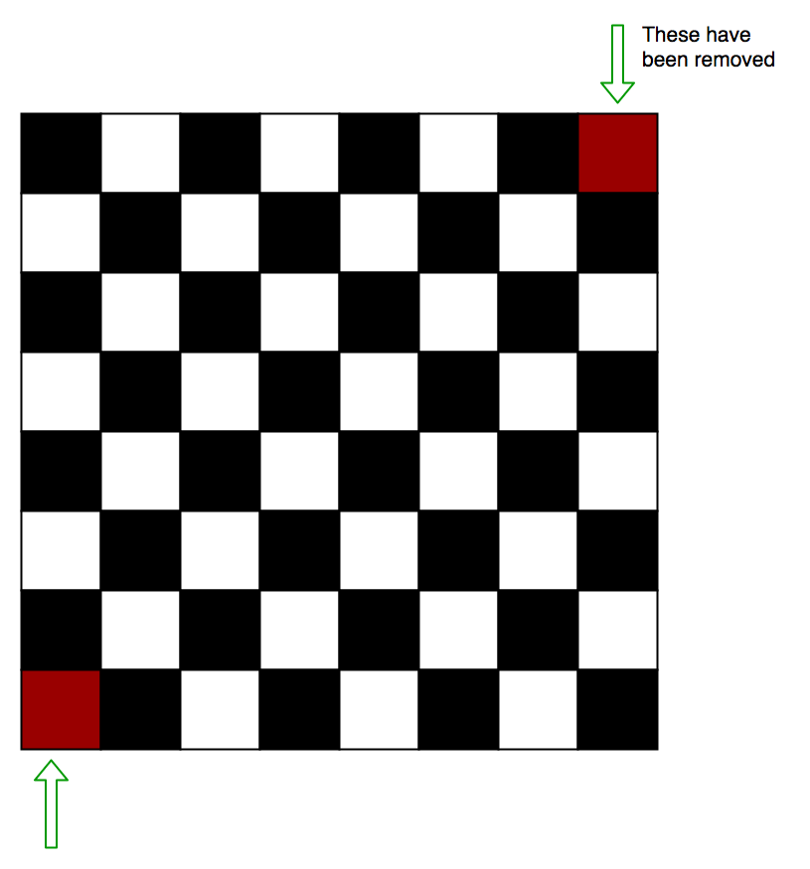**

Each domino we set on the chessboard will always take 1 Black and 1 White square.Therefore, 31 dominos will take 31 white square and 31 black squares exactly. On this chessbord however, we must have 32 black and 30 white squares. Hence it is not possible to do so.

1. **NewsPaper Puzzle:**

**Question: A newspaper made of 16 large sheets of paper folded in half. The newspaper has 64 pages altogether. The first sheet contains pages 1, 2, 63, 64.  
If we pick up a sheet containing page number 45. What are the other pages that this sheet contains?**

now, the first one will be 1,2,63,64  
second one is 3,4,61,62  
nth one from the back is **45,46 (since they come in pair)  
(64-2*n=46)= n is 9**Now, 45,46’s counterpair from the front will be 1+(9*2)=19 and 2+(9*2)=20

**42)Prisoner and Policeman Puzzle:  
  
Policeman decided to punish the Prisoner and asked him to make a statement. The Prisoner should make such a statement so that he would be alive.  
If the statement is held true by Policeman, the Prisoner will be hanged to death and if the statement is held false, the Prisoner will be shot dead.**

**Answer:**The Prisoner said, ‘I will be shot dead’  
If Policeman says the statement is true, the Prisoner will be hanged to death which will make his statement false.  
If Policeman says the statement is false, the Prisoner will be shot dead which will make the statement true.

**43)Guess Color of Hat:**

**There are 20 people standing in a line, one behind the other. Each is made to wear a hat, which can either be white or black. There can be any number of white or black hats between 0 and 20. Each person can see the hat of all the persons ahead of him in the line, but not those of the people standing behind. Each person is required to guess (loudly) the color of his/her own hat. The objective is for the group to get as many correct guesses as possible. The group is allowed to discuss and form a strategy before the exercise. What is the best strategy? What is the maximum number of correct guesses in this strategy?**Answer) the approach which was used for 100 Prisoners With Red/Black Hats can be used here.  
  
**44) Tic Tac Toe Puzzle:**  
**The game of Tic-Tac-Toe is being played between two players and it is in below state after six moves.**

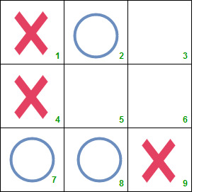  
  
  
**Can you answer following questions?**

**Who will win the game, O or X?**

**Which was the sixth mark and at which position?**

**Assume that both the players are intelligent enough.**

Now, actually the starting point is we need to find about the 6th move.  
  
Probably, it starts with a red cross.  
  
Now, for 6th move we have 3 choices.  
  
2,7,8.  
  
Now, if it starts with a blue circle.   
  
Now, for 6th move, we have 3 choices. 1,4,9

Now, short explanation was:

Explanation:

The 7th mark must be placed in square 5 which is the win situation for both X and O. Hence, the 6th mark must be placed in a line already containing two of the opponents marks. There are two such possibilities – the 6th mark would have been either O in square 7 or X in square 9.

As we know both the players are intelligent enough, the 6th mark could not be O in square 7. Instead, he would have placed O in square 5 and would have won.

Hence, the sixth mark must be X placed in square 9. And the seventh mark will be O. Thus O will win the game.

**But, how do we reach this step: we can represent it as matrix and step by step explain that why the cross mark at 9th is the 6th move. Then predict the next move.**

1. **Find Missing Rows In Excel  
     
   We are given an excel sheet which contains integers from 1 to 50, including both. However, the numbers are in a jumbled form and there is 1 integer missing. You have to write a code to identify the missing integer. Only the logic is required.**

**Solution:**

We know that the sum of all the numbers from 1 to n is (n*(n+1)/2)

Therefore, sum of all the numbers from 1 to 50 is

50*(50+1)/2 (Here, n = 50)

= 50*(51)/2

= 25*51

= 1275.

Therefore, all we need to do is to sum all the integers present in the file and subtract the sum from 1275. The difference between 1275 and this sum would give us the missing integer.

1. **Placing The Numbers  
     
   Place the numbers 1, 2, 3, 4, 5, 6, 7, 8 into the eight circles in figure given below, in such a way that no number is adjacent to a number that is next to it in the sequence.For example 1 should not be adjacent to 2 but can be adjacent to 3, 4, 5, 6, 7, 8. Similarly for others.**

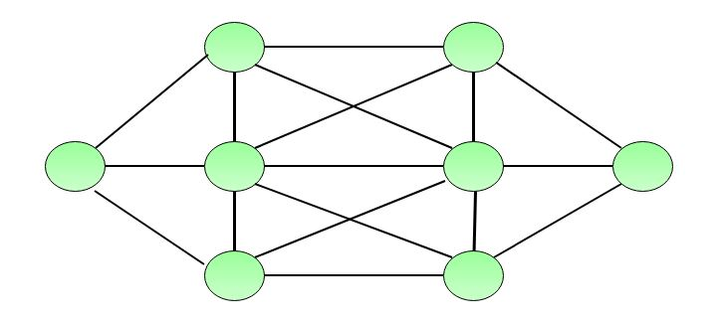

**Trivial Solution:**

Trying for 8!=40320 combination would be tedious task.

**Smart Solution:**

The easiest numbers to place are 1 and 8, because each has only one number to which it cannot be adjacent, namely, 2 and 7, respectively. ​

The hardest circles to fill are those in the middle, as each is adjacent to six others.

This suggests that we place 1 and 8 in the middle circles. If we place 1 to the left of 8, then the only possible positions for 2 and 7 are shown figure below:

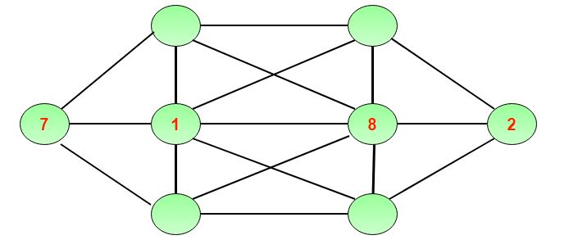

The number 3 must now be placed on the left-hand side of the diagram, and 6 must be placed on the right-hand side.

Now it is easy to place all the remaining number as shown in figure below:

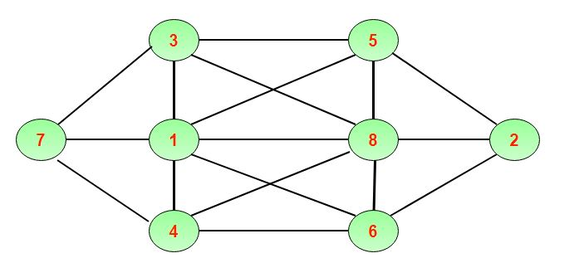

1. **Muddy Heads:**

**A mother tells her two children, a boy and a girl, to play without getting dirty.**

**However, while playing, both children get mud on their foreheads.**

**The mother says “At least one of you has a muddy forehead”. She then asks the children to answer “Yes” or “No” to the question: “Do you know whether you have a muddy forehead?”**

**The mother asks this question twice.**

**What will the children answer each time this question is asked, assuming that a child can see whether his/her sibling has a muddy forehead, but cannot see his or her own forehead? Assume that both children are honest and that the children answer each question simultaneously.**

**Solution:**

Let s be the statement that the son has a muddy forehead and let d be the statement that the daughter has a muddy forehead. When the mother says that at least one of the two children has a muddy forehead, she is stating that the disjunction s ∨ d is true.

Both children will answer “No” the first time the question is asked because each sees mud on the other child’s forehead. That is, the son knows that d is true, but does not know whether s is true, and the daughter knows that s is true, but does not know whether d is true.

After the son has answered “No” to the first question, the daughter can determine that d must be true. This follows because when the first question is asked, the son knows that s ∨ d is true, but cannot determine whether s is true. Using this information, the daughter can conclude that d must be true, for if d were false, the son could have reasoned that because s ∨ d is true, then s must be true, and he would have answered “Yes” to the first question. The son can reason in a similar way to determine that s must be true. It follows that both children answer “Yes” the second time the question is asked.

# Divide square land among 4 sons

There is an old man and he has four sons. The old man is in critical situation and his last wish is to divide his square land into 4 equal parts but according to some rules. Rules and the image of land is provided below:

Rules:

Each son should get one tree separately

Each son should have direct access to the well

Land can’t be divided diagonally

Each son should get his separate land i.e. there is no interaction between any other son’s land

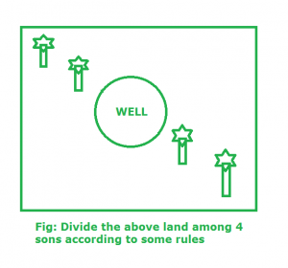

**Help old man to divide the land among his four sons.**

**Solution:**

We can divide the old man’s square land among his 4 sons with the given rules in following manner:

First, we should separate trees with two straight lines.

After that we should take care that all 4 sons should access well directly, so, we Should divide the well into 4 parts and join the line with the lines which separate the tress.

At last repeat the right side pattern with the left portion of the land. Finally, the land is divided into 4 equal parts with the given rules.

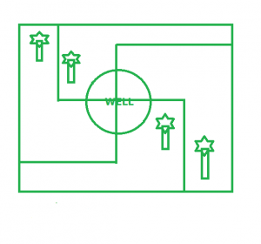

**49)Suppose we have 3 glasses and 10 coins. The problem is to place odd number of coins in each glass i.e. each glass should contain coins and the number of coins in each glass must be odd and total coins which will be used must be equal to 10.**

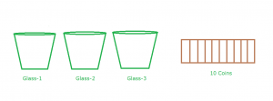

**Solution:** It is not possible to use all 10 coins with each glass having odd number of coins. Therefore, we must think out of box. In the 1st glass place 5 coins which is odd, after that in second glass place 2 coins and in the third glass place 3 coins which is odd. Now, place the entire 3rd glass inside 2nd glass. Indirectly, now 2nd glass contains 5 coins which is odd in nature.

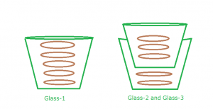

**50)3 cuts to cut round cake into 8 equal pieces**1. Cut the cake in quarters (4 pieces) using 2 of the cuts – one horizontally down the center of the cake and the other vertically down the center of the cake.

2. This will leave you with 4 pieces (or slices) of cake. Then, you can take all 4 pieces and arrange them in a stack that is 4 pieces high.

3)Finally, you can just cut that stack of 4 pieces in half – using your third and final cut – and then you will end up with 8 pieces of cake!

1. **Water Jug Problem:**it is kind of same as two hourglasss problem. Water jug problem can be solved using BFS.  
     
   (Now, there is an interesting solution related to one of the problems:   
     
   The water jug problem can  be solved using the extended-eucildean algorithm. Extended-euclidean  algorithm finds solution for diophantine equations. How does finding  solution of diophantine equation solves the water jug problem? Let me  demonstrate:  
   Imagine you have a jug of 5 liters ( A ) and 3 liters ( B ). You want  to make 1 liter of water with this 2 container. The the equation will  be, 5x + 3y = 1 ( Ax + By = 1 ). If we can find a solution this equation  then our problem is solved. Apply extended_euclidean algorithm on it  and you will find that the result is x = 2 and y = -3.  
   If we put value of x and y in the equation then we get 5 * 2 + 3 * (  -3 ) = 10 - 9 = 1. The equation is indeed solved. But what does x = 2  and y = -3 mean? It means, we need to fill our A bottle 2 times and  empty our B bottle 3 times.  
     
   **Now, what is a diophantine equation:**

A Diophantine equation is a polynomial equation, usually in two or more unknowns, such that only the integer solutions are sought or studied (an integer solution is a solution such that all the unknowns take integer values). A linear Diophantine equation equates the sum of two or more monomials, each of degree 1 in one of the variables, to a constant. An exponential Diophantine equation is one in which exponents on terms can be unknowns.

The simplest linear Diophantine equation takes the form ax + by = c, where a, b and c are given integers. The solutions are described by the following theorem:

This Diophantine equation has a solution (where x and y are integers) **if and only if c is a multiple of the greatest common divisor of a and b**. Moreover, if (x, y) is a solution, then the other solutions have the form (x + kv, y − ku), where k is an arbitrary integer, and u and v are the quotients of a and b (respectively) by the greatest common divisor of a and b.

From the Extended Euclidean Algorithm, given any integers a and b you can find integers s and t such that as+bt=gcd(a,b); the numbers s and t are not unique, but you only need one pair. Once you find s and t, since we are assuming that gcd(a,b) divides c, there exists an integer k such that gcd(a,b)k=c. Multiplying as+bt=gcd(a,b) through by k you get  
  
**a(sk)+b(tk)=gcd(a,b)k=c.**

Now suppose that ax1+by1=c is a solution, and ax+by=c is some other solution. Taking the difference between the two, we get

a(x1−x)+b(y1−y)=0.

**Now, what does that mean?  
  
That means,**a divides b(y1-y)

**Now, since, a divides b(y1-y)**

It also means  divides b(y1-y)  
  
**(since, a divides b(y1-y) and a is like m*gcd(a,b) I.e. m divides a, then m should also divide any number which can be divided by a)  
  
Now,**

a(x1−x)+b(y1−y)=0  
  
y-y1=  
  
  
  
r is a constant.  
  
Similary, we can obtain:  
  


**Thus, if for ** there exists another solution in the form of , then all solutions are of the form:

 and 

To give you an example of this in action, suppose we want to find all integer solutions to

258x+147y=369.

First, we use the Euclidean Algorithm to find gcd(147,258); the parenthetical equation on the far right is how we will use this equality after we are done with the computation.

258=147(1)+111

147=111(1)+36

111(1)=36(3)+3  
  
36=3(12)

So gcd(147,258)=3. Since 3|369, the equation has integral solutions.

Then we find a way of writing 3 as a linear combination of 147 and 258, using the Euclidean algorithm computation above, and the equalities on the far right. We have:

3=111−3(36)

=111−3(147−111)

=4(111)−3(147)

=4(258−147)−3(147)

=4(258)−7(147).

That is how, we can find the solution if a solutuon exists.

1. **Help the Women, Cross the River**

**Help the Women : There is a mother who wishes to cross a river but she is not alone. She also has 5 daughters of age 6, 7, 8, 9 and 10.There is only one boat available which can support the woman and either two of the daughters. So at a time, the boat can have only three objects (woman and two other). But the problem is that when the mother is absent, daughters with one year difference in age will fight each other.(For example:- When the mother is absent and has taken the daughter of age 6 and 8 with her, then the daughters of age 9 and 10 will fight each other. Similarly if mother has taken 6 and 7 with her, then daughters of age 8 and 9 will fight with each other.) The woman wants to cross the river with all her daughters. Only the mother can ride the boat. What strategy she should use to do so?**

**Solution :**

**Step 1:-** Firstly,mother will take daughters of age 7 and 9 with her.

**Step 2:-** She will leave the daughters and return.

**Step 3:-** Then she will take daughters of age 6 and 8 with her.

**Step 4:-** She will leave daughters of age 6 and 8 to the other side and take the daughters of age 7 and 9 with her.

**Step 5:-** Again she will leave daughters of age 7 and 9 and take the daughter of age 10 with her.

**Step 6:-** She will leave daughter of age 10 to the other side and return alone.

**Step 7:-** Finally she has taken the daughters of age 7 and 9 with her.

Now, finally she crosses the river with all daughters.

1. **Cross The River:**

There is a man who wishes to cross a river but he is not alone. He also has a dog, 2 tigers and 2 elephants along with him. There is only one boat available which can support the man and either one of the animal. So at a time, the boat can have only two objects (man and one other). But the problem is, if the tiger and dog are left alone (either in boat or on shore), the tiger will eat the dog. Similarly if the 2 tigers and 1 elephant are left alone, then 2 tigers will eat the elephant. The man wants to cross the river with all belongings. What strategy should he use to do so?

**Solution:**

Step 1:- First the man will take the dog to the other side and return. (One side = Dog, Other side = 2 tigers and 2 elephants)

Step 2:- He will take 1 tiger with him and return with dog.

Step 3:- He will leave the dog and take the another tiger with him and move to the other side.

Step 4:- He will take 1 elephant with him and return by taking one tiger with him.

Step 5:- He will take dog with him and go to the other side. Then he will leave the dog to the other side and

return by taking another tiger with him.

Step 6:- He will leave the tiger and take the elephant with him and return alone.

Step 7:- He will take one tiger with him, leave it there and return with dog.

Step 8:- He will take another tiger with him and return alone.

Step 9:- Finally, he will taken the dog with him.

Now, there ccould be more solutions. But the last step is he will taken the dog with him.

**54)Maximum number of Kings on Chessboard without under check**

**Prerequisite – The Pigeonhole Principle**

Problem statement – Given a 8×8 chessboard, figure out the maximum number of kings that can be placed on the chessboard so that no two kings attack each other, i.e., none of the kings is under check. A king can move only one step at a time any direction on the chessboard (horizontally, vertically and diagonally).

Explanation –

According to Pigeonhole principle if we have n+1 pigeons and we have n pigeon holes (or rather cages) then we must have one hole (or cage) with more than one pigeon.

For example if I had 6 balls and 5 boxes. I put all the balls in the boxes (any box can have any number of balls). Then the pigeonhole principle states that no matter how you put the balls inside the boxes, there will atleast be one box always that has more than one ball. It’s a very intuitive principle in mathematics and yet the problems associated with the principle are so hard to comprehend.

So, here’s the chessboard. Does this problem have anything to do with the pigeonhole principle?



Now, this is a chess board.

The answer to this problem is 16. But how do we arrive at this solution. The thing to note in this puzzle is that whenever we have two kings within a 2×2 square, they are always under check :

   
  
  
  
   
  
  
No matter how we place 2 kings within a 2×2 chessboard we will always have them under check. By this observation, we can easily conclude that we can have at max one king within a 2×2 square.

We can imagine a 2×2 square as a hole (cage) for our pigeon i.e. kings. So, a 2×2 square occupies 4 sq units of area. The total area for the square chess board is 64 square units (assuming the size of chessboard to be 8 units × 8 units). So, we have 64/4 = 16 cages or holes in this scenario.

1. **Who Murdered Rohan?**

**Rohan bought a new house. Everything in it was state of the art. The refrigerator was stainless steel, ovens were electric, even the windows were built to only open from them inside. Rohan planned a small get-together with his friends at his new house. He went to the store and bought some steaks, wine, and other things that he saw fit. He invited John, Mike and Marry. They talked about sports, news, and gossiped about people in town. After a while, Mike started to get a little tipsy and was getting a little rude. John politely asked him to settle down, but Mike got furious and tried to fight. After quite a brawl, Rohan got a taxi for Mike and everyone left. The same day at 8:00 P.M, police got a call that Rohan had been murdered. When the police arrived at the scene, they found Mike and Marry. The police officer decided to question them both at the station.**

**When the officer questioned Mike, he said: “I was talking to Marry on the phone when i told her i should go and apologize to Rohan. She said that she should come with me in case things got heated again, and i said that was fine. I got there about ten minutes after Marry did, and i noticed that the front door was locked.I decided to look through a window to see if they were there, when i saw Marry, blood soaked, tossing a knife into the sink. I quickly opened the window, crawled through and called the police. Marry killed Rohan”.**

**When the officer questioned Marry, she said “Mike called me and told me to meet him at Rohan’s house, so that he could apologize about our get together. I got there about ten minutes faster than Mike, so i decided to wait in the car for him . After a while, i got bored so i decided to go in and tell Rohan what was going to happen. I noticed the door was wide open, and i thought that was strange because Rohan is a very nervous man. So, i rang the doorbell, walked in, and locked the door.I saw Rohan lying dead on the floor. I was about to call the police when i saw Mike in the other room saying that i killed Rohan, and that he had called the police”. After investigating the crime scene, office found the murderer.**

**Who was the murderer?**

Mike murdered Rohan.

Explanation: In the beginning, it was mentioned that windows were designed to open only from the inside.

If Mike had tried to open the window, he would have found it that it wasn’t working and he would not have been able to get through the window without breaking it.