**Chapter 1**

**Introduction**

**1.1** **Ideal Situation**



Social Networking Service has gained great success in the past years. With the widespread use of mobile devices (e.g. smart phones and tablets), features such as portability, real-time content sharing , and utilizing location-based services, have brought many new social experiences.As social media sites become increasingly integrated into one’s daily life, the versions of oneself that is presented online might shape how others see us as well as how we perceive ourselves.

The differences between one’s ‘self’ and the presentation of others online creates a pressure to be more like the idealised versions of oneself. Studying how and why users interact on ShareCan can determine how users present themselves in an online environment and if this effects the ‘self’.

**1.2 Situation in reality**



ShareCan is based on one’s personal identity because it allows users to create a visual photo album of their lives. It’s increasingly common for one to heavily edit what is posted to ensure that the most appealing form of ‘self’ is portrayed to our ever-present audience

Facebook can be accessed from devices with Internet connectivity, such as personal computers, tablets and smartphones. After registering, users can create a profile revealing information about themselves. They can post text, photos and multimedia which are shared with any other users who have agreed to be their "friend" or, with different privacy settings, publicly. Users can also communicate directly with each other with Facebook Messenger, join common-interest groups, and receive notifications on the activities of their Facebook friends and pages they follow.

You can take a picture or video, then post to ShareCan, It’s easy, It is a fast, beautiful and fun way to share your life with friends and family, you can even share to Facebook, Twitter, Tumblr and it is a new way to see the world.

**1.3 Conequences of reality**



ShareCan is a valuable medium of social media in the future especially for the business purpose because the method of marketing and strategy are rigid but the feedbacks are higher and the positive impact was very good, and it is easy for the business owner to use.

The best features of ShareCan is the high visibility of a post, where every post of images can appear in the newsfeed or home of the followers, the hashtags strategic also enable the capabilities of ShareCan to give an impact to the posts to the new users or followers.The business through ShareCan can start and have a small community of customers and it will grow up rapidly, the seller of the product can manage a real attitude of the customer from a normal buyer to a regular buyer or customer, ShareCan can connect with the targeted audience

**1.4 Objective**

1. Adding some new features in the existing ShareCan application to make it more useful for users.

2. Providing well organized content and user friendly website.

3. Integrating with other social networking apps.

4. Providing better privacy to users.

Providing security to the images or posts, so that no one can use it without permission of owner

**1.5 Scope**

Features to add in ShareCan so that user will find it more interesting.

PRIVACY OF THE POST:

1. In this user can select to whom he/she wants their post to be seen by.

2. When someone will take screen shot or save image of the user. The user will came to know that he/she had taken the screen shot.

3. In ShareCan we are not able to see other’s profile picture as it appear very small. But by adding our’s feature the user will be able to open other’s profile picture as it will appear bigger than before.

4. User will be shown an option before seeing the stories of others.

a. Want’s to show that you had seen him/her story.

b. Do not want to show that you had seen him/her story.

**1.6 Proposal**



Our app in Python Django is a simple project developed using Python, Django Framework for back-end and HTML, CSS, Bootstrap for front-end.

The project provides features to add post and see other’s posts too.

This website also provides feature to update user’s profile and in profile section users can see all their previously posted pictures and manage them. User can also customize profile pictures just like ShareCan social media site. There is also an admin panel using which you can control all posts, users and their profiles.

**Chapter 2**

**Literature survey**

**2.1** **Introduction**

ShareCan provide login to insta account or login with facebook. Nowadays no one remember their facebook password because it has been a long time since the user had created the facebook account and may be he/she had forgotten the password too.

ShareCan doesn’t provide more features for privacy. As a user we all want our post or activities should only be shown to those people to whom we have to show. It must provide a option to user before posting any post that the user want this post to be private or public, but ShareCan doesn’t provide this feature.

It become very difficult to identify someone by username because our the profile picture appear too small that we can’t even see them. Also, doesn’t provide security of user chats or user’s call (mostly video call). Doesn’t tell that he/she had took the screenshot of your’s.

**2.2 Literature survey**

Many companies are now commonly using social media to promote their brands and to maintain a friendly relationship with their customers. According to an article published on BBC News (2012), study has said that a large number of the top brands around the world are using ShareCan as one of their marketing strategies. ShareCan can help a company to promote their products or services. The point that makes ShareCan different from other social media is that ShareCan is applying a visual based strategy. Everything about ShareCan is about photography. ShareCan marketing is an effective way to advertise a product as it is said that a picture speaks a thousand words. Additionally, ShareCan can help one in saving costs for brand designing. Every image taken for a product can be edited and filtered using the ShareCan functions. In the case of ShareCan, leaving comments and receiving comments on the photo posts can gain more feedback from the customers on the product. Followers are often interested to see the interaction between the organization and the users, so being attentive to the comments would help in improving the relationship with customers. Furthermore, ShareCan has included a function known as direct messaging.

Among the social networking sites being used, ShareCan is widely used through mobile devices as an application. It has created a different platform for marketers to interact with the customers. In addition, ShareCan can be used free of charge. ShareCan is a strong tool that is different from other social networking sites in social network marketing. It provides a better visual based platform and has made it convenient for the people to interact with each other. Yet, there is always risk when one is using a platform owned by others to perform certain activity, so it is very important to clearly understand the terms and conditions of the social networking sites before engaging in any business activities through the online platforms.

Through this research paper we can get the idea of how ShareCan is used for marketing purposes and what are the discrepancies in using ShareCan for marketing. So that we can try to remove those discrepancies in our proposed system. Our proposed system will get the negative points from this research paper and try to remove those points.

**2.3 Summary**

In this digital age we are living in, it is important to stay connected. People click their photos at some location (eg: Vacation destination, a famous hotel etc.) and sharing them with their friends or family will connect and strengthen their relationship irrespective of the time and their location. The software should be available on the most abundant and easy to own machines i.e. Smartphones. ShareCan is a social networking platform that allows users to upload photos with captions and location information which are uploaded. The uploaded posts can be shared publicly. Users can browse other users' content by viewing their profile page and can like and comment on others' photos and follow them to add their content to their feed. Users' and their followers' activities turn into notifications which can be viewed in the notifications section.

**Chapter 3**

**Proposed solution**

**3.1** **Proposed System**

In this digital age we are living in, it is important to stay connected. People click their photos at some location (eg: Vacation destination, a famous hotel etc.) and sharing them with their friends or family will connect and strengthen their relationship irrespective of the time and their location. A platform with a fast way to share short moments of someone's life digitally to other people must exist. Since everyone can be connected via the internet this should be simple platform where people from every age group can join, connect and communicate. This platform could also be used for easy branding since it's all about photos. The software should be available on the most abundant and easy to own machines i.e. Smartphones.

ShareCan is a social networking platform that allows users to upload photos with captions and location information which are uploaded. The uploaded posts can be shared publicly. Users can browse other users' content by viewing their profile page and can like and comment on others' photos and follow them to add their content to their feed. Users' and their followers' activities turn into notifications which can be viewed in the notifications section.

**3.2 The algorithm**

**3.3 Key functionalities of proposed system**

• Strong Data Validation

➢ Whenever user inputs the data in the data field the entered data should validate properly to avoid the inconsistency.

• Automatic Updation of the Database

➢ The Updation of the database after every transaction should be done without any inconsistency.

• Provide efficiency querying based on user request

➢ The major task of any application is to generate efficient report on any user request.

• User friendly interface

➢ The interface should be developed in such a manner that it not only improves the interaction but also saves data every time.

• Making well designed forms for capturing data

➢ The form used in the application are able to capture all the data in well-designed manner.

• Security

➢ All users are not allowed to access the database. The username and password helps to deny the unauthorized user. Each user is given the specific rights to access in Read Only, Read Write, Delete.

**3.4 Features of the proposed system**

This website also provides feature to update user’s profile and in profile section users can see all their previously posted pictures and manage them. User can also customize profile pictures just like ShareCan social media site. There is also an admin panel using which you can controll all posts, users and their profiles.

An application where users can:

* Sign up
* Sign in (authentication)
* Upload pictures
* Follow other users and see their pictures
* Like other users pictures
* Comment on other users' pictures

**3.5 Feasibilities studies**

• Android Studio is the official IDE from Google for developing android applications for android devices. It consists of the entire API required to create an app. It has emulators on which you can test the developed app.

• Android offers a unified approach to application development for mobile devices which means developers need only develop for Android, and their applications should be able to run on different devices powered by Android.

**3.6 Hardware and software requirements**

HARDWARE SPECIFICATION:

|  |  |  |  |
| --- | --- | --- | --- |
| Sr no. | Hardware Type | Hardware Specification | Minimum Requirement |
| 1 | Processor | Intel or any other | i3, 5th generation or newer |
| 2 | Hard Disk | Secondary Storage device | 1 GB available free space |
| 3 | RAM | Primary storage device | 2 GB available ram |

SOFTWARE SPECIFICATION:

|  |  |  |  |
| --- | --- | --- | --- |
| Sr no. | Software Type | Software Specification | Minimum version |
| 1 | Operating System | Windows x32 or x64 | 7 or 10 |
| 2 | Spyder/ Idle/ PyCharm | Program | v3.6 |
| 3 | Django Framework | Web framework | v3.6 |
| 4 | SQLite | Database | v3.22 |

**Chapter 4**

**System Diagrams**

**4.1 The implementation plan (Gantt chart)**



Figure 4.1 Gantt Chart

**4.2 Flow Chart**

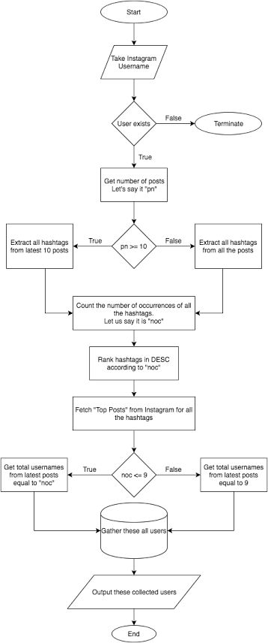

**4.3 Use Case Diagram**

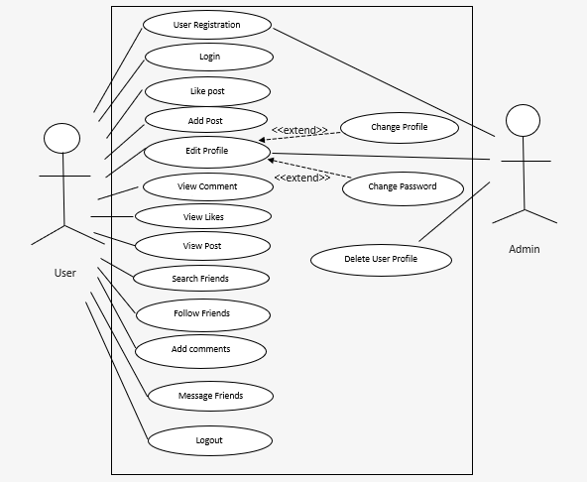

Figure 4.2 Use case diagram

**Chapter 5**

**The Implemented System**

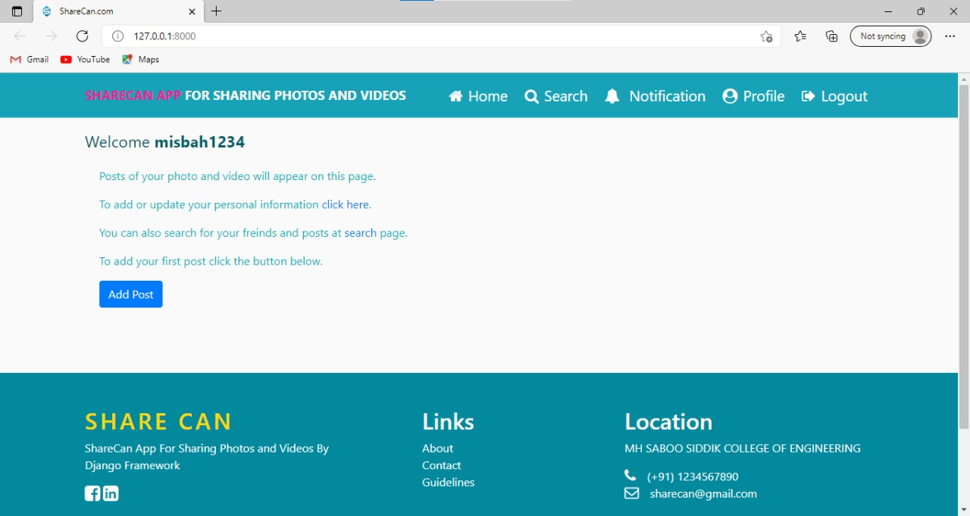

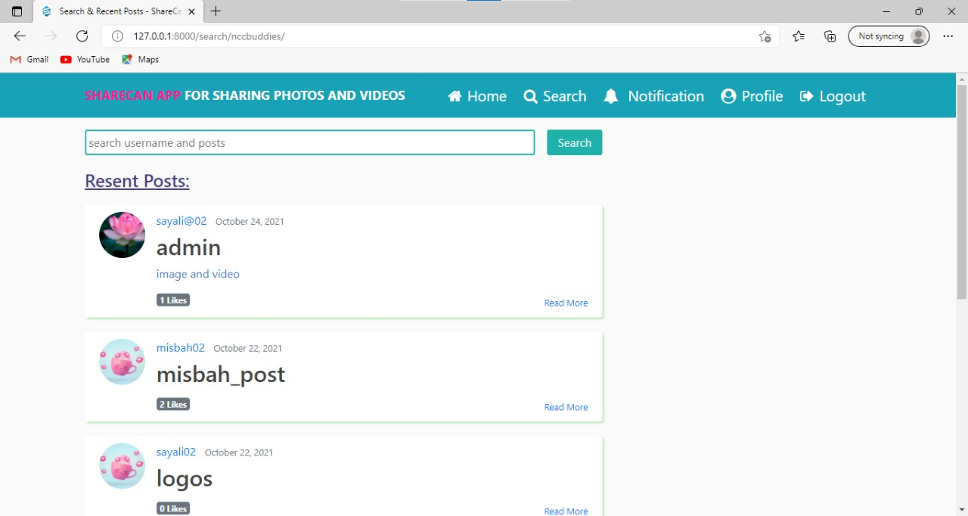

**Chapter 6**

**Conclusion**

Nowadays we rely more on social networking apps. For sharing photos, videos we use various social media apps. Hence our app will also contribute in sharing photos, videos among friends, family members and with others. Through this app we can not only post videos or photos but also we can like or comment on other’s post. This will help people build relationship with each other. We can also do business using this app by sharing contents relevant to our business. We can promote our business using this app by sharing photos of our products. We can advertise our product on this platform. This app will help us to share photos and videos with the people all over the world who are using this application. User can connect with more and more people over the world to create a long network.

**Chapter 7**

**References**

[1]How to build a Social network site using Django- Quora. https://www.quora.com/How-do-I-build-a-Social-network-site-using-Django [Accessed: DD- MMM- YYYY].

[2]Django(webframework)-Wikipedia https://en.m.wikipedia.org/wiki/Django_(web_framework) [Accessed: DD- MMM- YYYY].

[3] William S. Vincent , “Django for Beginners: Build websites with Python and Django”, pp 1-79, 2018.

[4] The web framework for perfectionist with deadlines | Django https://www.djangoproject.com/ [Accessed: DD- MMM- YYYY].