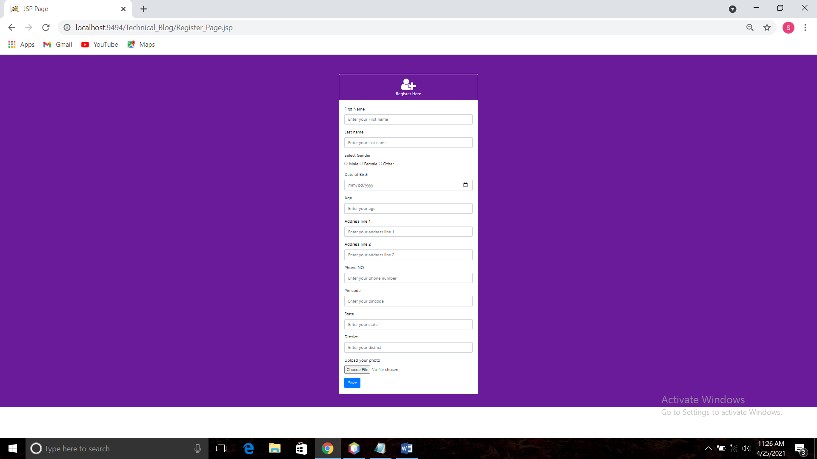

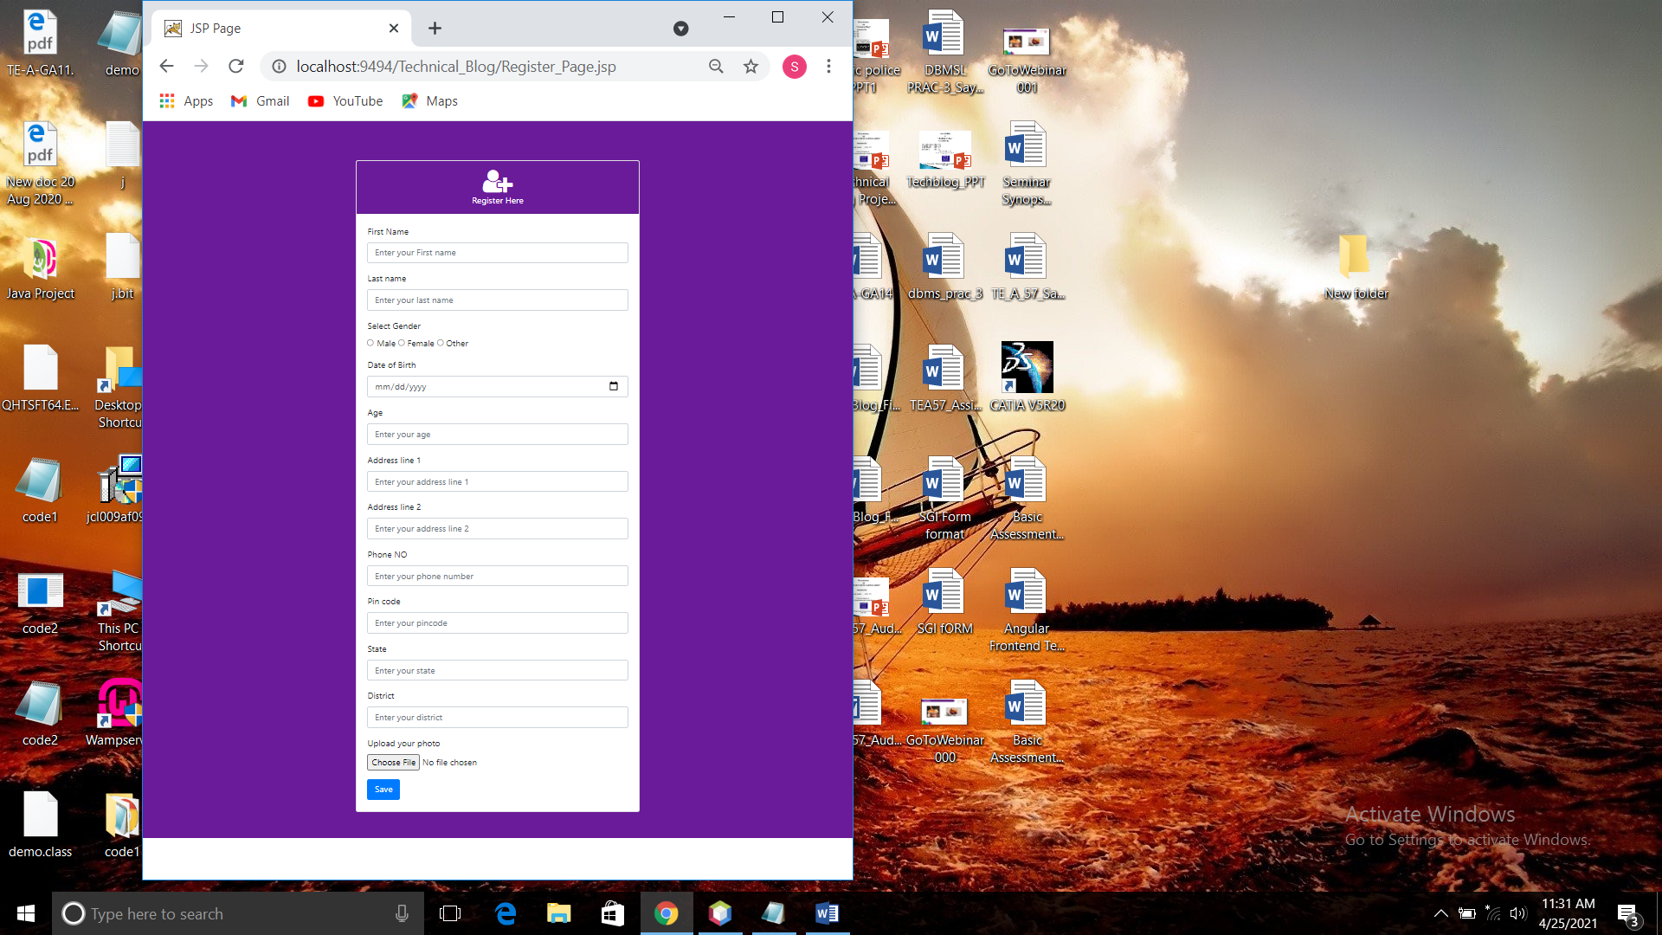

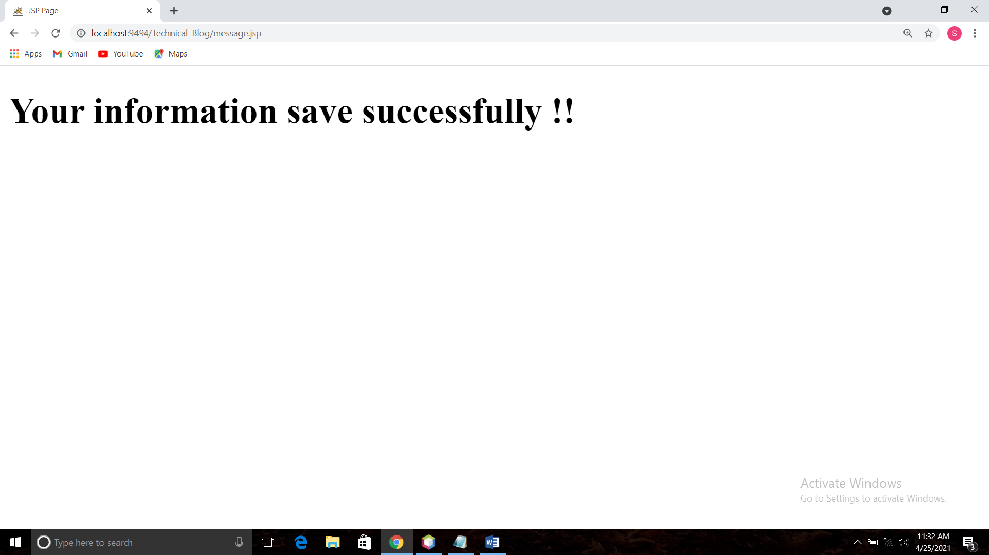

**Code**:

<!DOCTYPE html>

<html>

<head>

<meta http-equiv="Content-Type" content="text/html; charset=UTF-8">

<title>JSP Page</title>

<!----css--->

<link rel="stylesheet" href="https://maxcdn.bootstrapcdn.com/bootstrap/4.0.0/css/bootstrap.min.css" integrity="sha384-Gn5384xqQ1aoWXA+058RXPxPg6fy4IWvTNh0E263XmFcJlSAwiGgFAW/dAiS6JXm" crossorigin="anonymous">

<link href="css/Mystyle.css" rel="stylesheet" type="text/css"/>

<!---- Font awesome --->

<link rel="stylesheet" href="https://cdnjs.cloudflare.com/ajax/libs/font-awesome/4.7.0/css/font-awesome.min.css">

</head>

<body>

<!------navbar------>

<main class="primary-background p-5 banner-background">

<br>

<div class="container">

<div class="col-md-6 offset-md-3">

<div class="card">

<div class="card-header text-center primary-background text-white">

<span class="fa fa-3x fa-user-plus"></span>

<br>

Register Here

</div>

<div class="card-body">

<form action="message.jsp" method="post">

<div class="form-group">

<label for="name">First Name </label>

<input type="name" class="form-control" id="name" aria-describedby="" placeholder="Enter your First name">

</div>

<div class="form-group">

<label for="name">Last name </label>

<input type="name" class="form-control" id="name" aria-describedby="" placeholder="Enter your last name">

</div>

<div class="form-group">

<label for="gender">Select Gender</label>

<br>

<input type="radio" id="gender" name="gender"value="male" > Male

<input type="radio" id="gender" name="gender" value="female" > Female

<input type="radio" id="gender" name="gender" value="other" > Other

</div>

<div class="form-group">

<label for="date">Date of Birth </label>

<input type="date" class="form-control" id="date" aria-describedby="" placeholder="">

</div>

<div class="form-group">

<label for="number">Age </label>

<input type="number" class="form-control" id="date" aria-describedby="" placeholder="Enter your age">

</div>

<div class="form-group">

<label for="name">Address line 1 </label>

<input type="name" class="form-control" id="name" aria-describedby="" placeholder="Enter your address line 1">

</div>

<div class="form-group">

<label for="name">Address line 2 </label>

<input type="name" class="form-control" id="name" aria-describedby="" placeholder="Enter your address line 2">

</div>

<div class="form-group">

<label for="">Phone NO </label>

<input type="" class="form-control" id="name" aria-describedby="" placeholder="Enter your phone number">

</div>

<div class="form-group">

<label for="">Pin code</label>

<input type="" class="form-control" id="name" aria-describedby="" placeholder="Enter your pincode">

</div>

<div class="form-group">

<label for="name">State</label>

<input type="name" class="form-control" id="name" aria-describedby="" placeholder="Enter your state">

</div>

<div class="form-group">

<label for="name">District</label>

<input type="name" class="form-control" id="name" aria-describedby="" placeholder="Enter your district">

</div> <form>

<div class="form-group">

<label for="exampleFormControlFile1">Upload your photo</label>

<input type="file" class="form-control-file" id="exampleFormControlFile1">

</div>

<button id="sumbit" type="submit" class="btn btn-primary">Save</button>

</form>

</div>

</div>

</div>

</div>

</main>