PCA Summary Report

1. Why we used PCA
We described each employee with 20 features. Many of them are related to each other, for example job level, income, total working years and years at company. PCA (Principal Component Analysis) combines such related features into fewer new features called components, and it keeps most of the information. We used the components as input for the clustering and also to plot the employee groups.

2. What we did
- We created four new features: IncomeToLevel, TenureRatio, PromotionGap and SatisfactionIndex. The four satisfaction and work-life balance columns were merged into SatisfactionIndex.
- We used 20 features in total. Attrition, PerformanceRating and PercentSalaryHike were not used.
- We scaled the features with StandardScaler.
- We applied PCA and checked the explained variance of each component.
- We kept the number of components needed for 90% of the variance and used them for K-Means and Hierarchical clustering.

3. How many components we kept
Ten components explain at least 80% of the variance and 13 components explain 90%. We kept 13 components, which explain 92.7% of the variance. So we reduced 20 features to 13 and lost about 7% of the information.
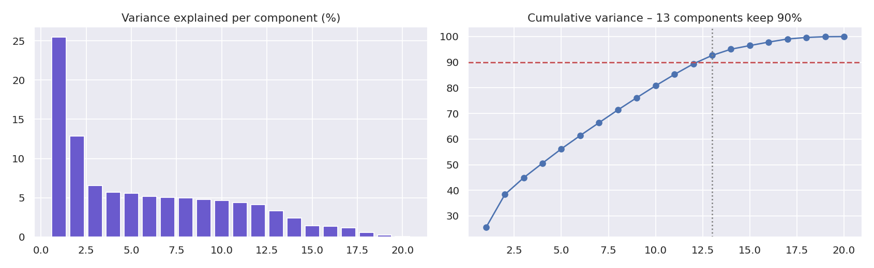
Figure 1: Variance explained per component and cumulative variance

4. What the first three components mean
Component | Variance | Features with the highest loadings
PC1 | 25.5% | YearsAtCompany (0.38), TotalWorkingYears (0.36), MonthlyIncome (0.35), JobLevel (0.35)
PC2 | 12.9% | TenureRatio (0.51), NumCompaniesWorked (−0.38), Age (−0.33), MonthlyIncome (−0.27)
PC3 | 6.6% | PromotionGap (0.72), YearsSinceLastPromotion (0.47), NumCompaniesWorked (0.28), TenureRatio (−0.20)

- PC1 is about experience and seniority: a high PC1 means a long career, a high job level and a high income.
- PC2 separates employees who spent most of their career in this company (high TenureRatio) from older employees who worked in many companies and who joined recently.
- PC3 is about promotion. It is high for employees who have waited a long time since their last promotion.
The new features we created are among the highest loadings (TenureRatio on PC2 and PromotionGap on PC3), which shows that they brought new information that the original columns did not have.
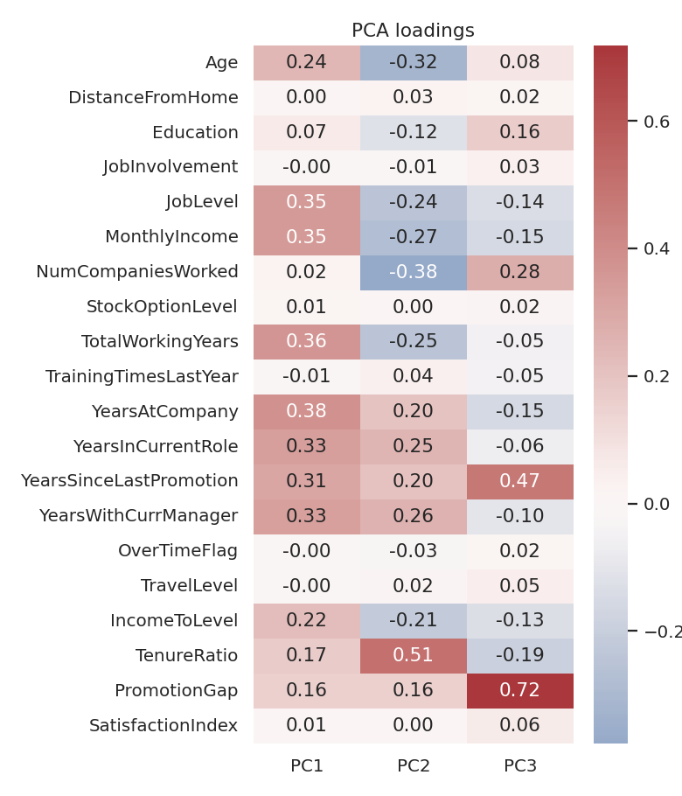
Figure 2: Loadings of the first three components

5. Using PCA to see the employee groups
We plotted the employees on PC1 and PC2 and coloured them by K-Means segment. The four segments are shown in different parts of the plot, with some overlap at the borders. This matches the low silhouette score of the clustering (about 0.12).
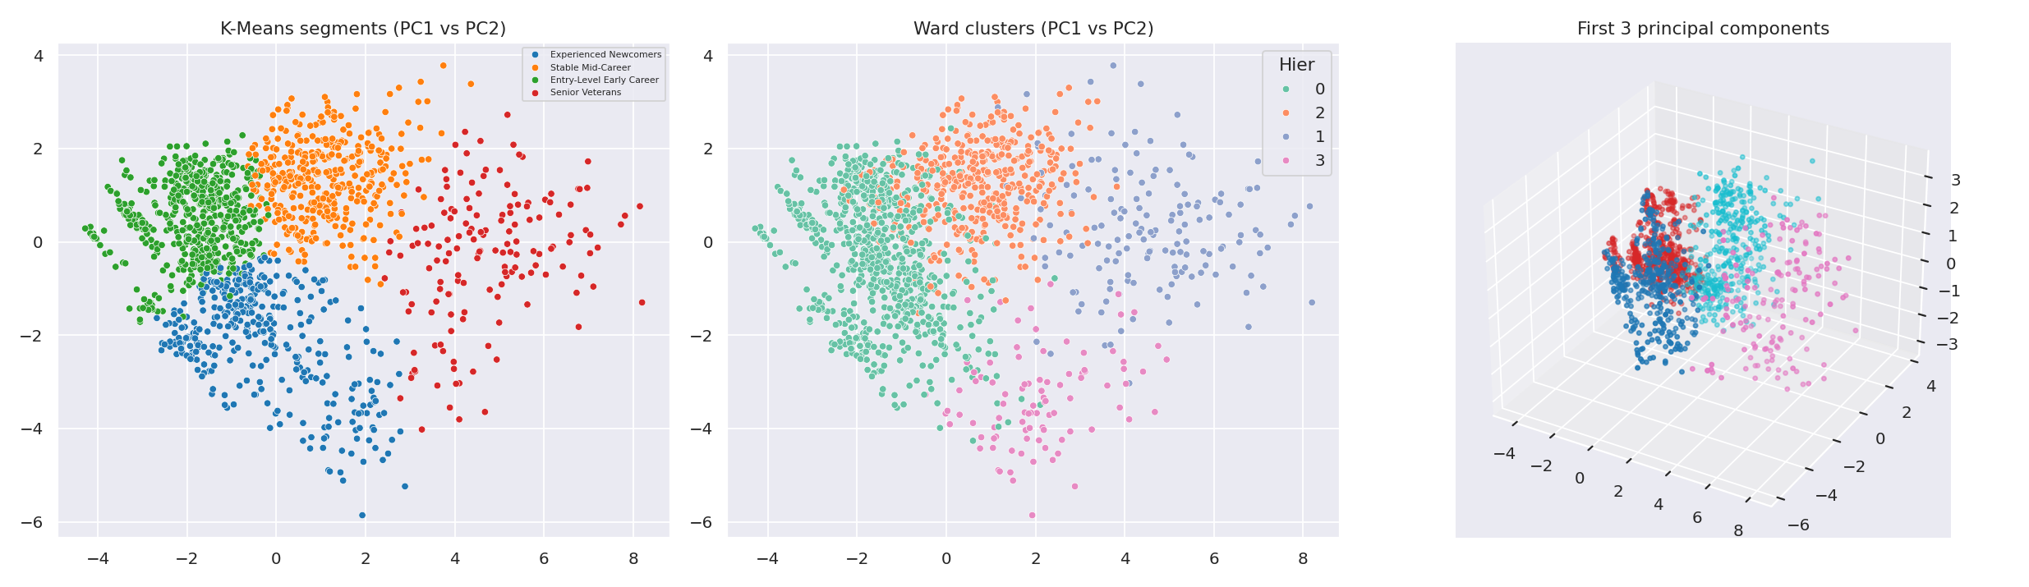
Figure 3: Employees on the first two principal components

6. Limitations
- The components are mixtures of features, so they are harder to explain than the original columns.
- The first three components explain 45.0% of the variance (25.5% + 12.9% + 6.6%), so a 2D plot does not show everything.
- PCA works on linear relations only.

7. Conclusion
PCA reduced 20 features to 13 components and kept 92.7% of the variance. The first component is about seniority and the next ones are about career history and promotion. The 13 components were used for K-Means (k = 4) and Hierarchical clustering.

