Evaluation Report

1. Objective
Build and compare four classifiers (Logistic Regression, Decision Tree, Random Forest, XGBoost) to predict employee attrition, evaluate them with Accuracy, Precision, Recall, F1 and ROC-AUC, and improve them with cross-validation, hyperparameter tuning and feature importance. An optional regression task predicts PerformanceRating (3–4).

2. Dataset
IBM HR Analytics Employee Attrition dataset: 1470 employees, 35 original columns, no missing values. Only 16.1% of employees left, so the classes are imbalanced (about 1 leaver per 5 stayers). Because of this imbalance, accuracy alone is misleading, so recall, F1 and ROC-AUC are emphasised. Constant or ID columns (EmployeeCount, EmployeeNumber, StandardHours, Over18) were removed.

3. Method
- Stratified 75/25 train–test split (random_state=7).
- Feature engineering: IncomeToLevel, TenureRatio, PromotionGap, StabilityScore and SatisfactionIndex (average of four satisfaction scores).
- One-hot encoding + scaling inside pipelines; imbalance handled with balanced class weights and scale_pos_weight.
- 10-fold stratified cross-validation, then RandomizedSearchCV (25 candidates per model) optimising ROC-AUC.
- Decision-threshold tuning on out-of-fold predictions; permutation importance on the test set in addition to model-based importance.

Baseline results (test set)

Model | Accuracy | Precision | Recall | F1 | ROC-AUC
Logistic Regression | 0.769 | 0.390 | 0.780 | 0.520 | 0.853
Decision Tree | 0.799 | 0.407 | 0.559 | 0.471 | 0.661
Random Forest | 0.861 | 0.654 | 0.288 | 0.400 | 0.837
XGBoost | 0.848 | 0.523 | 0.576 | 0.548 | 0.849

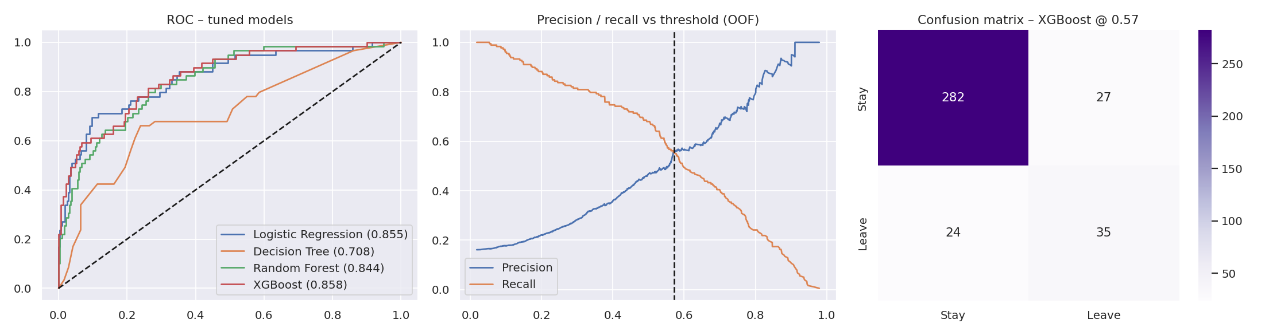

Cross-validation (training set, mean ± std)

Model | accuracy | precision | recall | f1 | roc_auc
Logistic Regression | 0.778 ± 0.049 | 0.406 ± 0.089 | 0.720 ± 0.107 | 0.515 ± 0.087 | 0.818 ± 0.046
Decision Tree | 0.774 ± 0.041 | 0.381 ± 0.056 | 0.574 ± 0.127 | 0.449 ± 0.049 | 0.726 ± 0.061
Random Forest | 0.864 ± 0.023 | 0.711 ± 0.201 | 0.291 ± 0.087 | 0.406 ± 0.104 | 0.792 ± 0.035
XGBoost | 0.844 ± 0.022 | 0.520 ± 0.075 | 0.551 ± 0.097 | 0.530 ± 0.071 | 0.793 ± 0.040

Logistic Regression, Random Forest and XGBoost reach cross-validated ROC-AUC of about 0.79–0.82; the single Decision Tree is the weakest (≈0.73) and Random Forest has very low recall (≈0.29) at the default cut-off.

After hyperparameter tuning (test set)

Model | Accuracy | Precision | Recall | F1 | ROC-AUC
Logistic Regression | 0.766 | 0.387 | 0.780 | 0.517 | 0.855
Decision Tree | 0.745 | 0.345 | 0.661 | 0.453 | 0.708
Random Forest | 0.872 | 0.667 | 0.407 | 0.505 | 0.844
XGBoost | 0.815 | 0.446 | 0.627 | 0.521 | 0.858

Best parameters found: Logistic Regression: {'C': 0.2525, 'penalty': 'l2'}; Decision Tree: {'criterion': 'entropy', 'max_depth': 6, 'min_samples_leaf': 17}; Random Forest: {'max_depth': 8, 'max_features': 'log2', 'min_samples_leaf': 4, 'n_estimators': 454}; XGBoost: {'colsample_bytree': 0.6744, 'learning_rate': 0.0229, 'max_depth': 2, 'min_child_weight': 6, 'n_estimators': 491, 'subsample': 0.7256}

7. Decision-threshold tuning
For the best model (XGBoost) the decision threshold was chosen on out-of-fold training predictions (threshold = 0.57) and applied once to the test set:
Setting | Accuracy | Precision | Recall | F1 | ROC-AUC
Default (0.50) | 0.815 | 0.446 | 0.627 | 0.521 | 0.858
Tuned (0.57) | 0.861 | 0.565 | 0.593 | 0.579 | 0.858

8. Feature importance
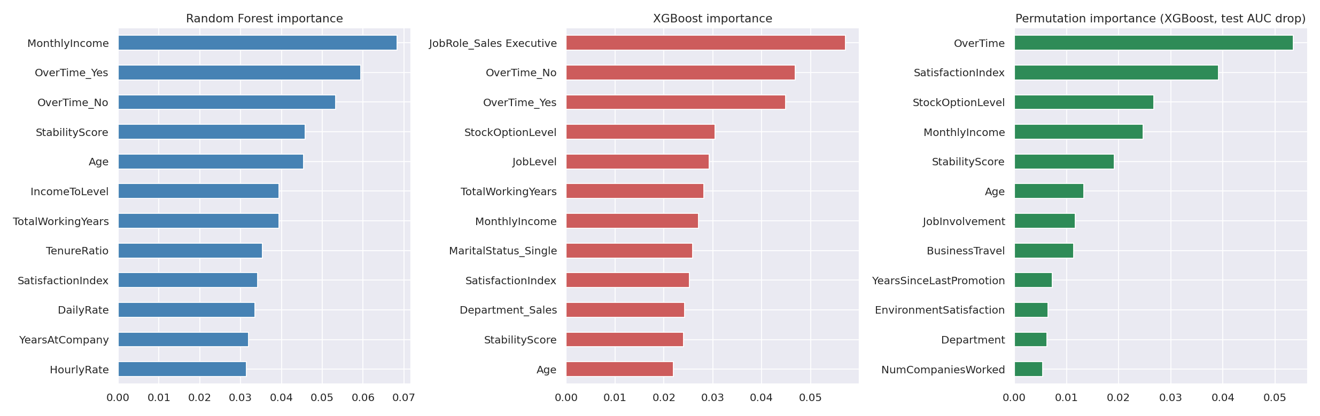
MonthlyIncome, OverTime, Age, StabilityScore and IncomeToLevel appear in the top features of the tree ensembles. Permutation importance on the test set confirms OverTime and the engineered SatisfactionIndex as the strongest drivers, followed by StockOptionLevel and MonthlyIncome. Several engineered features (StabilityScore, IncomeToLevel, SatisfactionIndex) rank among the top features, so they carry useful information.

9. Optional regression: PerformanceRating (3–4)
Model | MAE | RMSE | R2 (test) | R2 (5-fold CV)
Ridge | 0.260 | 0.364 | -0.043 | -0.030
Gradient Boosting Reg. | 0.260 | 0.364 | -0.044 | -0.034
Random Forest Reg. | 0.260 | 0.366 | -0.057 | -0.010
XGBoost Reg. | 0.260 | 0.366 | -0.052 | -0.032

A first run produced R² = 1.0, which we investigated: PerformanceRating is completely determined by PercentSalaryHike in this dataset (rating 4 only when the hike is 15% or more). That column was removed to avoid data leakage. Without it, every model has R² ≈ 0 and MAE ≈ 0.26, the same as predicting the mean, so performance rating cannot be predicted from the other fields.

10. Conclusion
XGBoost gave the best ROC-AUC (0.858) with recall 0.627, precision 0.446 and F1 0.521 on the held-out test set. XGBoost achieved the best ROC-AUC after tuning. Moving the decision threshold from 0.50 to the tuned value raised precision (0.45 to 0.57) and F1 (0.52 to 0.58) at a small cost in recall (0.63 to 0.59), giving a better balance between missed leavers and false alarms.

11. Limitations
- Small dataset (1,470 rows, ~237 leavers) so metrics vary between splits; cross-validation standard deviations show this.
- The dataset is a fictional IBM sample; real-world results may differ.
- Models show association, not causation (e.g. overtime may be a symptom, not only a cause).

