Employee Attrition Analytics Platform

Sayali Chimbalkar
PRN: 2124UDSF2014
Item | Link
GitHub repository | https://github.com/sayali150906/attrition-platform
Dashboard (Streamlit) | https://attrition-platform-nisgtceckca5oum9fw7blv.streamlit.app/
REST API documentation (Render) | https://attrition-platform.onrender.com/docs
Retraining run (GitHub Actions) | https://github.com/sayali150906/attrition-platform/actions/runs/39926796484

1. Business Problem
When an employee resigns, the company has to spend time and money on hiring and training a replacement, and the team loses work in the meantime. HR usually finds out only after the resignation letter arrives. In the IBM HR Analytics dataset that I used, 237 out of 1470 employees (16.1%) have left the company.
The aim of this project is to predict which employees are likely to leave, so that HR can talk to them early. I built a model that gives each employee a risk score, put the scores in a dashboard, and deployed the model as a small web API. Because only about one in six employees leaves, I judged the model mainly on recall, F1 and ROC-AUC instead of plain accuracy.

2. Workflow
The work was done in the following order.
- Loaded the IBM HR Attrition data (1,470 rows, 35 columns, no missing values).
- Cleaned it and made a few new features (earlier EDA and data preparation notebooks).
- Trained seven models with 5-fold cross-validation: Logistic Regression, Random Forest, XGBoost, a neural network, Naive Bayes, LDA and QDA.
- Picked the best model on cross-validated AUC, tuned it and chose a decision threshold.
- Gave every employee a risk score and a Low, Medium or High band.
- Deployed a dashboard and an API, and set up weekly retraining.

3. Data and Preprocessing
The target column is Attrition, and 16.1% of the rows are "Yes". I removed four columns that carry no information: EmployeeCount, StandardHours and Over18 are the same for everyone, and EmployeeNumber is just an ID.
I then added five features: IncomeToLevel (income divided by job level), TenureRatio (years at company over total working years), PromotionGap, StabilityScore (years at company over number of companies worked) and SatisfactionIndex, which is the mean of the four satisfaction ratings. Numeric columns were standardised and text columns were one-hot encoded. The train and test split is stratified, so both parts keep the same 16% share of leavers.
All of this feature code is in one file, hr_features.py. The notebook, the dashboard and the API all import it, so a new employee record is processed exactly the same way as the training data.

4. Advanced Analytics

4.1 Classical models and the neural network
I compared Logistic Regression, Random Forest and XGBoost with a Multi-Layer Perceptron that has two hidden layers. My first version of the network used early stopping and it stopped after about 14 iterations and scored close to random (AUC about 0.5). Turning early stopping off and using strong L2 regularisation fixed it, and the final network scores about 0.82 in cross-validation.
Model | Accuracy | Precision | Recall | F1 | Test AUC | CV AUC
Logistic Regression | 0.752 | 0.349 | 0.638 | 0.451 | 0.806 | 0.83
Neural Network (MLP) | 0.871 | 0.655 | 0.404 | 0.5 | 0.771 | 0.823
XGBoost | 0.806 | 0.407 | 0.468 | 0.436 | 0.774 | 0.821
Random Forest | 0.82 | 0.364 | 0.17 | 0.232 | 0.774 | 0.811
LDA | 0.85 | 0.579 | 0.234 | 0.333 | 0.707 | 0.753
QDA | 0.806 | 0.353 | 0.255 | 0.296 | 0.686 | 0.747
Gaussian Naive Bayes | 0.616 | 0.225 | 0.574 | 0.323 | 0.672 | 0.734
Table 1. Test results at threshold 0.50 and cross-validated AUC on the training data. The best model is shaded.

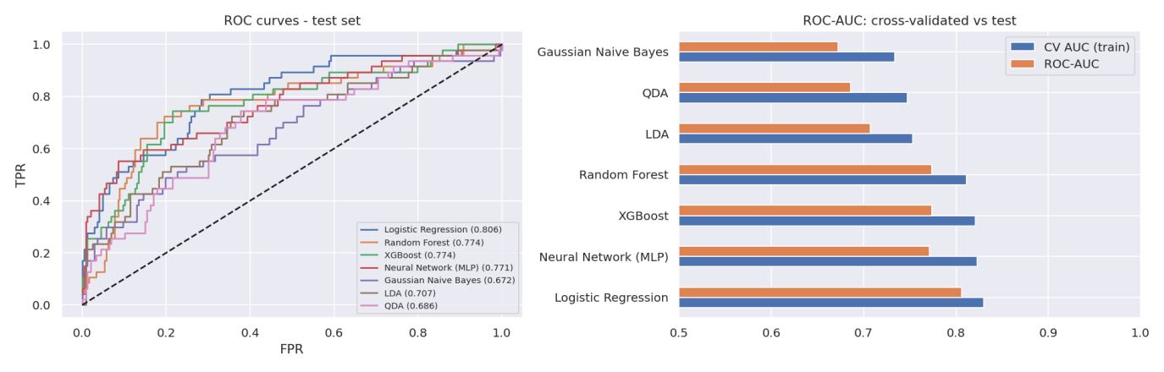
Figure 1. ROC curves and AUC of all models.
Logistic Regression gave the best cross-validated AUC (0.83). The neural network was close (0.823) but I cannot explain its predictions as easily, and it did not do better on only 1470 rows. Random Forest and XGBoost also did not beat the simple model. I think this is because the relationships in this data are mostly additive, for example overtime and low pay each add to the risk.

4.2 Bayesian classification
Naive Bayes uses Bayes theorem. It starts from the prior probability of leaving, which is 16.2%, and updates it using how likely each feature value is for leavers and for stayers. It assumes that the features are independent of each other once the class is known.
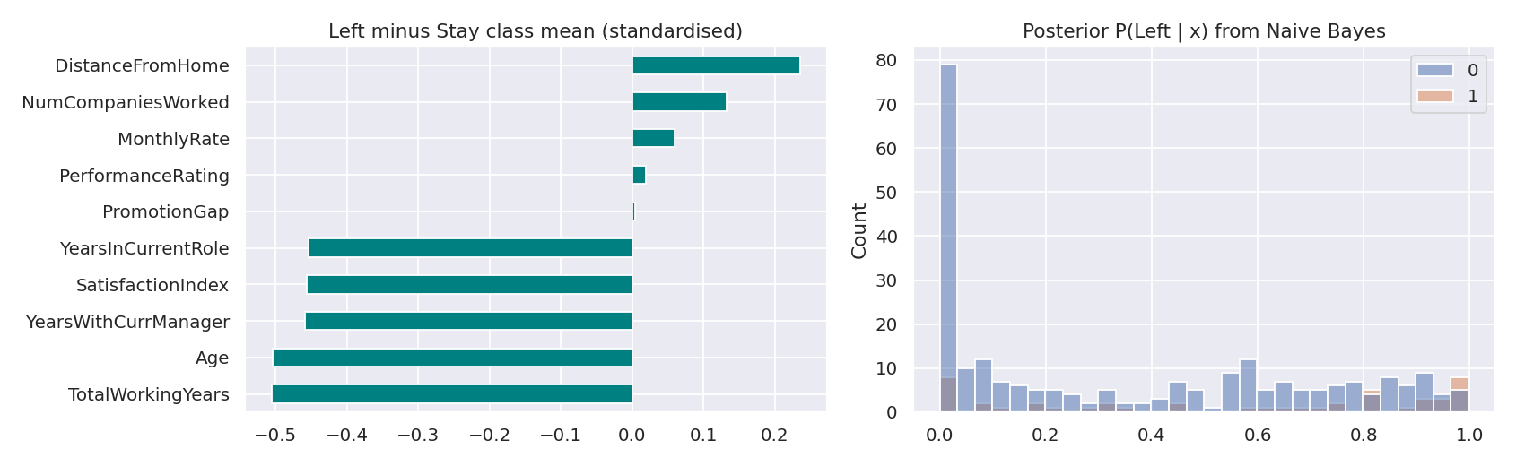
Figure 2. Difference between class means (left) and predicted probabilities from Naive Bayes (right).
The model shows that employees who left are younger, have fewer total working years, fewer years with the current manager and lower satisfaction, and they live a bit farther from the office. Recall is fairly high (0.574) but precision is low (0.225), and the test AUC is the lowest of all models (0.672). The likely reason is that age, experience and income move together, which breaks the independence assumption.

4.3 Discriminant analysis
LDA tries to find the straight line (direction) that separates leavers from stayers best. It assumes that each class is normally distributed with the same covariance. QDA allows a different covariance for each class. I used only the numeric columns for both.
I checked the assumptions before trusting the results. Several columns are heavily skewed: StabilityScore has a skewness of about 3, YearsSinceLastPromotion about 2 and YearsAtCompany about 1.7, so the normality assumption does not hold. The covariance matrices of the two classes are fairly close (relative difference 0.16), which is the one point in favour of LDA.
The results were weaker than Logistic Regression: LDA reached a test AUC of 0.707 with recall 0.234, and QDA reached 0.686 with recall 0.255. So discriminant analysis is only a rough fit for this kind of HR data, and I used it for comparison and not for deployment.
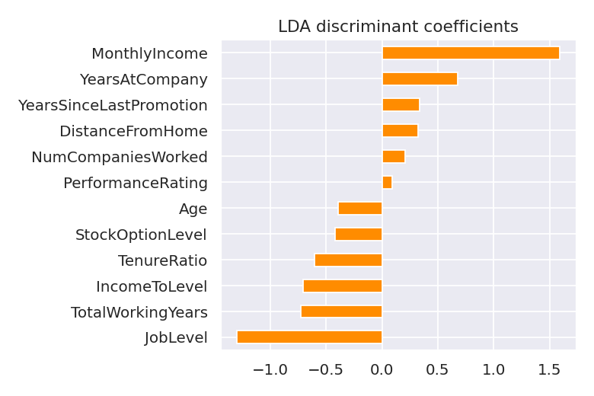
Figure 3. LDA coefficients.

4.4 Choosing the final model and threshold
I selected the model using the cross-validated AUC on the training set, not the test set, so the test set stayed unseen. Logistic Regression won, and a randomised search gave the regularisation strength C = 0.053.
For the threshold, a missed leaver is more costly than a conversation with someone who would have stayed. I assumed a missed leaver costs five times as much and picked the threshold that gave the lowest expected cost (5 x false negatives + false positives) on out-of-fold predictions. This gave 0.60. It improved precision from 0.38 to 0.52 and F1 from 0.47 to 0.55, while recall dropped only a little from 0.64 to 0.60.
Setting | Accuracy | Precision | Recall | F1 | ROC-AUC
Default (0.50) | 0.772 | 0.375 | 0.638 | 0.472 | 0.808
Tuned (0.60) | 0.847 | 0.519 | 0.596 | 0.554 | 0.808
Table 2. Final test results before and after tuning the threshold.
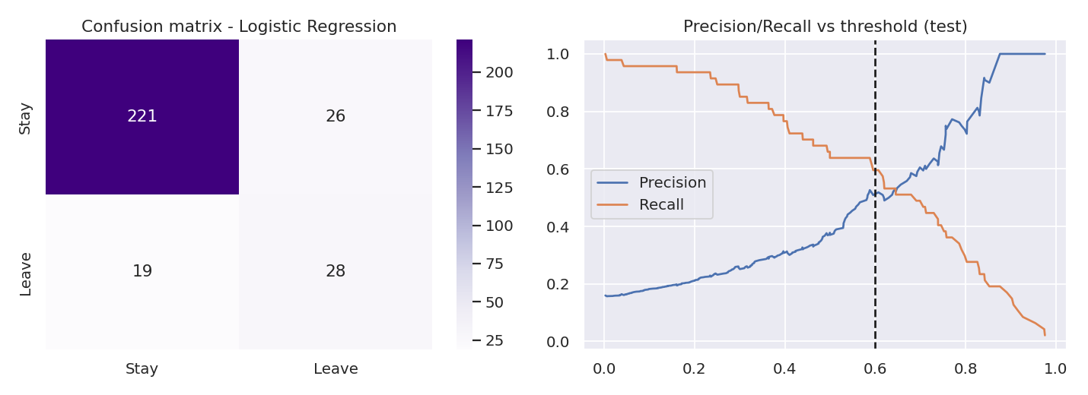
Figure 4. Confusion matrix and precision/recall curve.
Employees were put in bands using the threshold: High if the probability is at or above 0.60, Medium if it is at least 0.30, and Low otherwise. To avoid scoring people with a model that had already seen them, every score is an out-of-fold prediction.
Risk band | Employees | Actual attrition rate
Low | 655 | 4.1%
Medium | 498 | 12.4%
High | 317 | 46.7%
Table 3. Employees in the High band left about 11 times as often as those in the Low band.

5. Deployment
What was needed | What I used | Link
Deployed model with a prediction page | Streamlit Community Cloud | https://attrition-platform-nisgtceckca5oum9fw7blv.streamlit.app/
REST API with documentation | FastAPI on Render | https://attrition-platform.onrender.com/docs
Automatic retraining | GitHub Actions | .github/workflows/retrain.yml
Version control | Git and GitHub | https://github.com/sayali150906/attrition-platform

5.1 The saved model
The trained pipeline is saved with joblib. I ran into an error where the model saved on one machine would not run on another because their scikit-learn versions were different. To avoid this, model_utils.py tests the saved model when the app starts, and if it fails it trains the model again from the dataset.

5.2 REST API
The API is built with FastAPI, which also creates an interactive documentation page at /docs. There are two endpoints.
Item | Details
Base URL | https://attrition-platform.onrender.com
GET /health | Returns the status, the model name and the threshold.
POST /predict | Takes one or more employees and returns the probability of leaving.
Request | {"employees":[{"Age":24,"OverTime":"Yes","MonthlyIncome":2200,"JobLevel":1,"Department":"Sales"}]} Fields that are left out are filled with typical values.
Response | {"predictions":[{"probability_of_leaving":0.63,"risk":"High","will_leave_prediction":true}]}
Errors | 422 if a field has the wrong type. On the free plan the first call after an idle period can take about a minute.

[SCREENSHOT] Insert the Render /docs page and the POST /predict result here.

5.3 Retraining
A GitHub Actions workflow runs every Monday and can also be started by hand from the Actions tab. It retrains the model on the latest data and calculates the cross-validated AUC. If the new AUC is more than 0.01 lower than the stored one, the run is made to fail so the old model stays. Otherwise the new model is committed back to the repository. Workflow run: https://github.com/sayali150906/attrition-platform/actions/runs/39926796484
[SCREENSHOT] Insert the green GitHub Actions run here.

6. Dashboard
The dashboard has a department filter and a risk filter on the side and five tabs: https://attrition-platform-nisgtceckca5oum9fw7blv.streamlit.app/

Tab | What it shows
HR KPIs | Headcount, number who left, attrition rate, retention rate, high-risk count, department table and attrition by tenure.
Attrition & Risk | Attrition by department and job role, a donut chart of risk bands and the 25 highest-risk employees.
Workforce Demographics | Age, gender, marital status, tenure, overtime and income.
Model Performance | Chosen model, metrics before and after the threshold, AUC of every model, confusion matrix.
Predict Attrition | A form where HR enters ten key details of an employee and gets a probability and risk band.

The KPIs are calculated as attrition rate = employees who left / headcount x 100, and retention rate = 100 - attrition rate.

Department | Headcount | Left | Attrition % | Average risk score
Human Resources | 63 | 12 | 19 | 0.415
Research & Development | 961 | 133 | 13.8 | 0.349
Sales | 446 | 92 | 20.6 | 0.438
Table 4. KPIs by department.
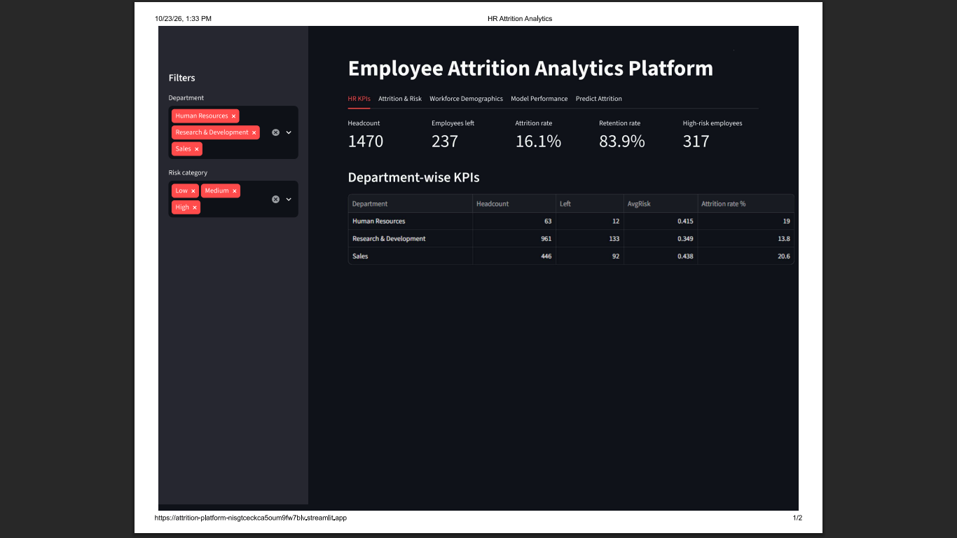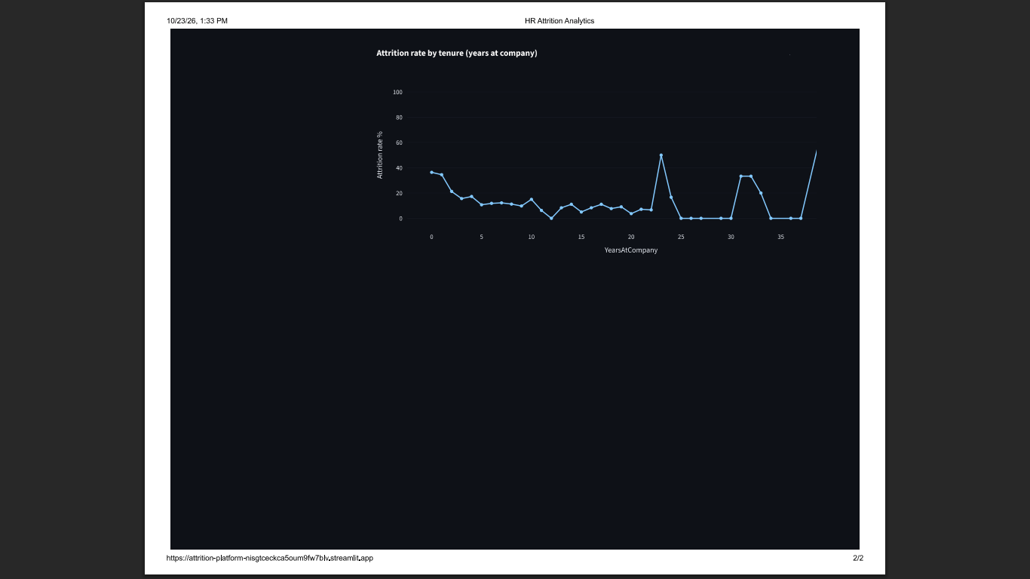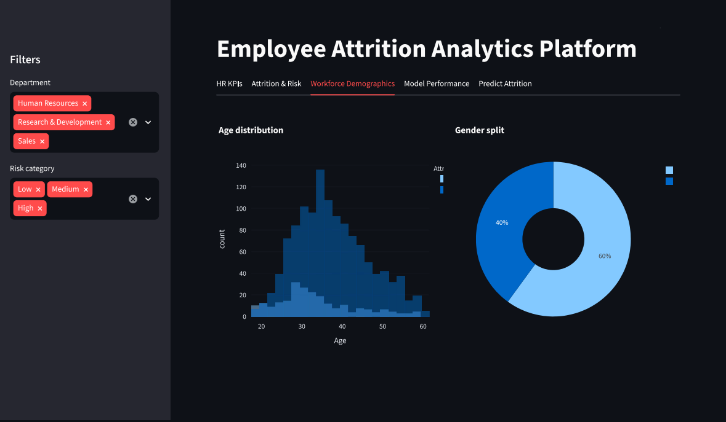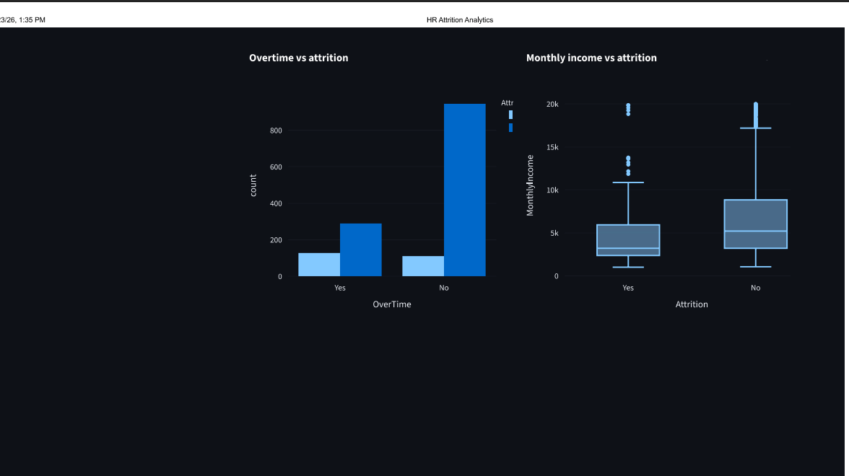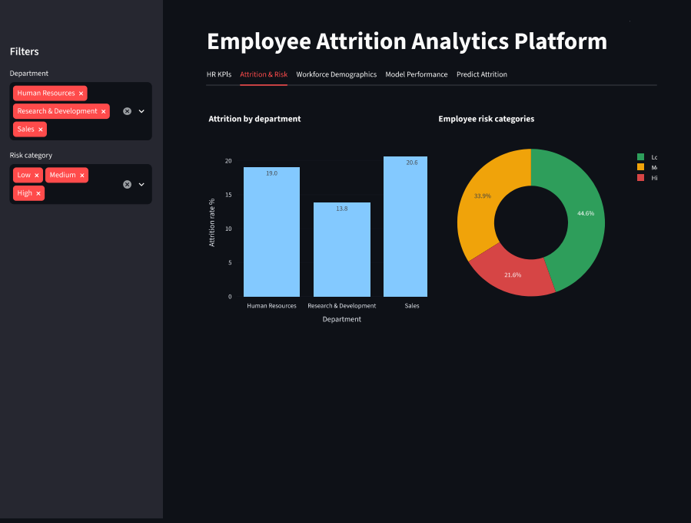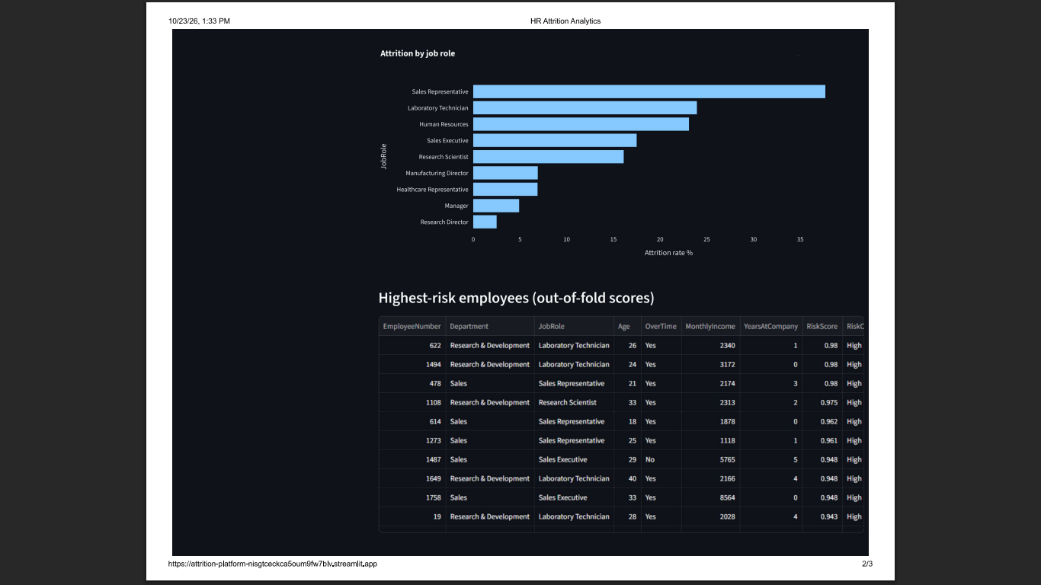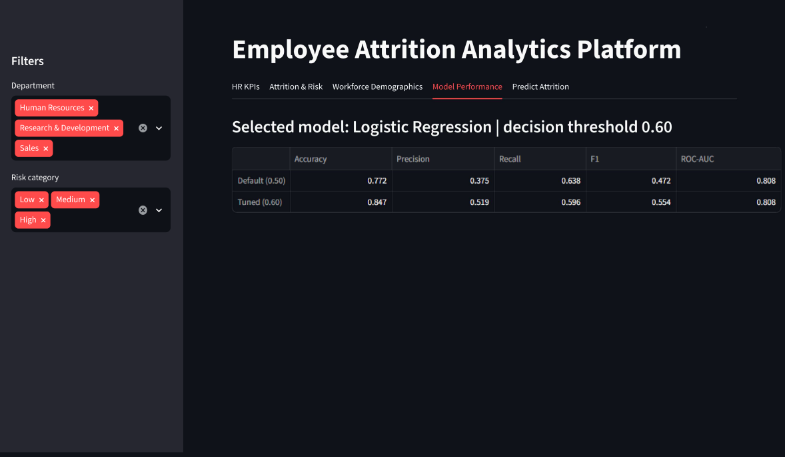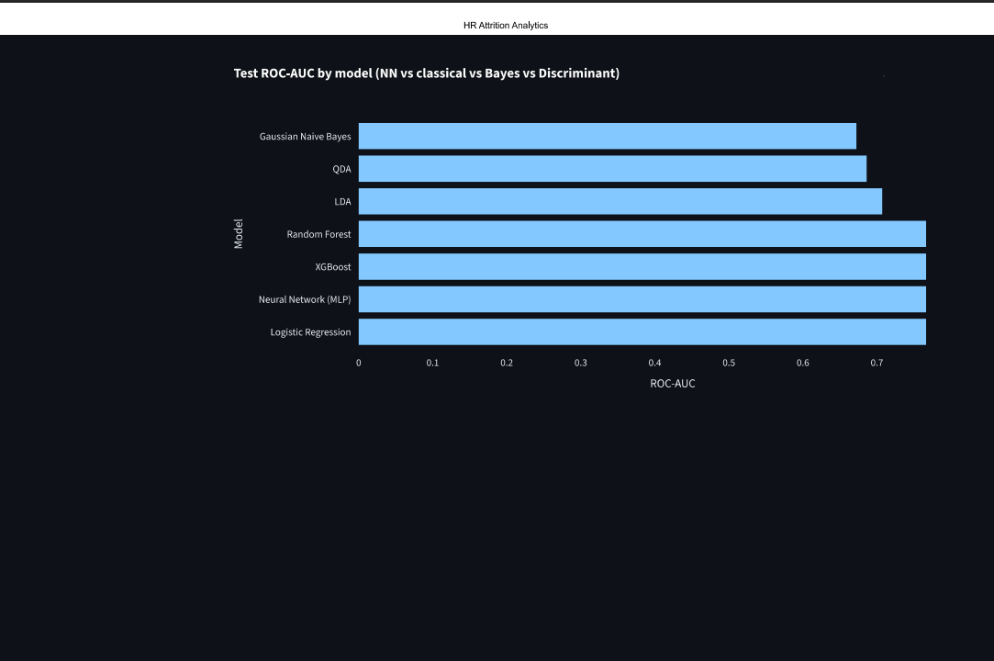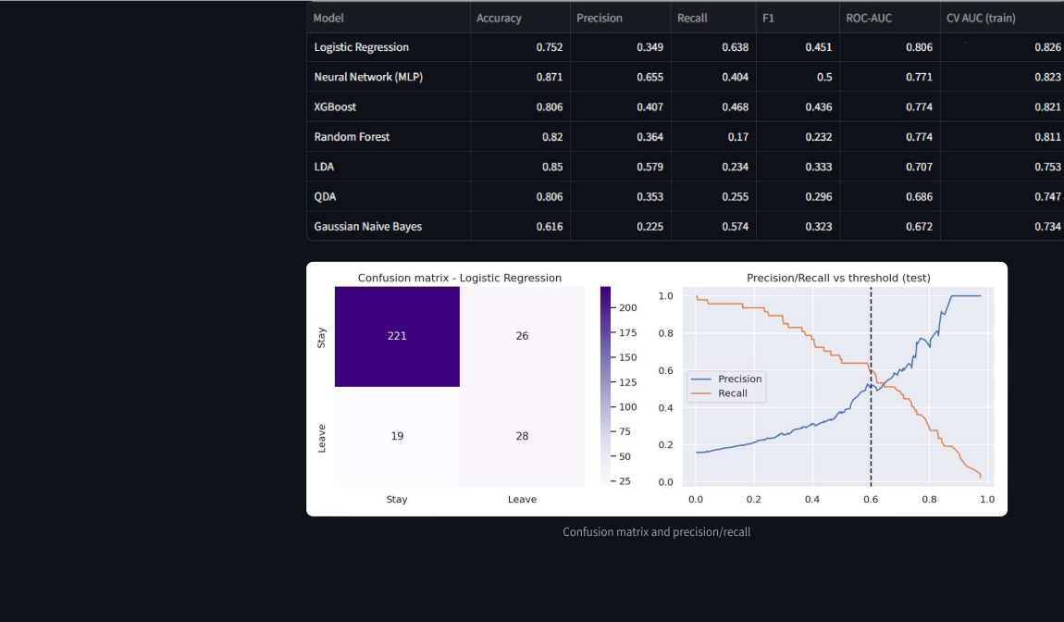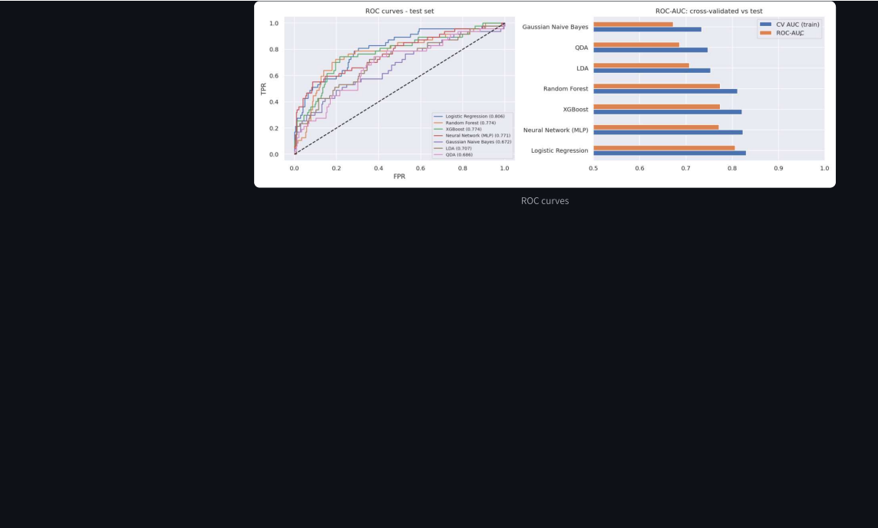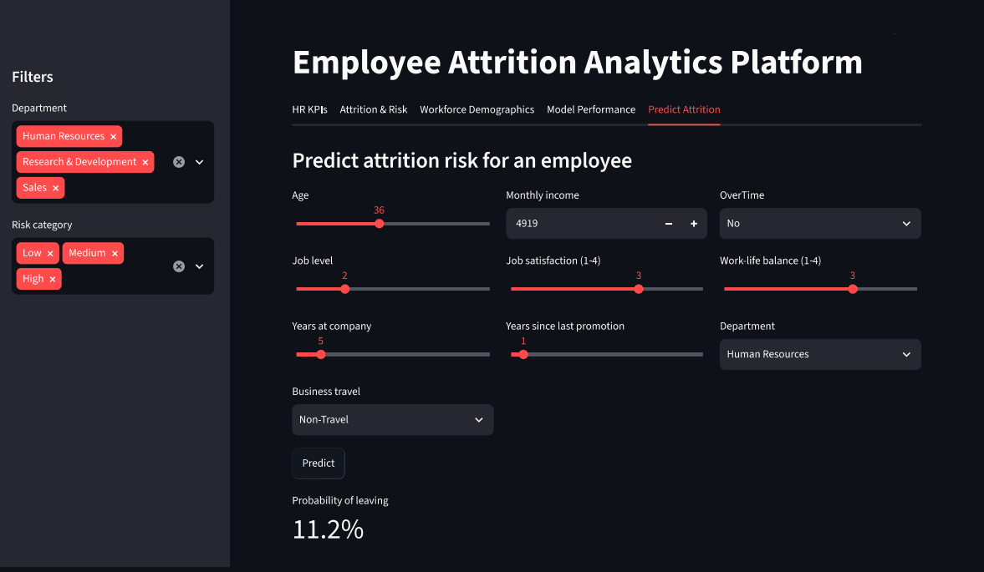

7. Key Insights
- Overtime is the clearest warning sign. 30.5% of employees who work overtime left, compared with 10.4% of those who do not, which is about 2.9 times higher.
- Younger and newer employees leave more. By age band, attrition is 18-25 35.8%, 26-35 19.1%, 36-45 9.2%, 46-60 12.5%, and by years at the company it is 0-2 yrs 29.8%, 3-5 yrs 13.8%, 6-10 yrs 12.3%, 11+ yrs 8.1%. Pay shows the same pattern: 29.3% in the lowest income quarter against 10.3% in the highest.
- Single employees (25.5%) and people who travel frequently (24.9%) leave much more than married employees (12.5%) and those who do not travel (8%). Stock options also seem to help: attrition is 24.4% with no stock options and 9.4% at level 1.
- The job role matters a lot. Sales Representatives have 39.8% attrition and Laboratory Technicians 23.9%, while Research Directors have 2.5% and Managers 4.9%. Low job satisfaction adds to the risk (22.8% at the lowest rating, 11.3% at the highest).

8. Recommendations
Based on the above, I would suggest the following to HR.
- Control overtime. Track it for each team and rebalance work where many employees are high-risk.
- Pay special attention to employees in their first two years, for example with a mentor and a check-in after six months.
- Compare pay for Sales Representatives and Laboratory Technicians with the market.
- Offer stock options or a retention bonus to high-risk employees who have none.
- Reduce travel for people who travel frequently, by rotating trips or using online meetings.
- Use the High-risk list once a month to start conversations. The score should be used to support employees, not to treat them unfairly.

9. Expected Impact
The model puts 317 employees in the High band, and about 148 of them actually left. As an example, suppose HR keeps 25% of these likely leavers. That is about 37 fewer exits. Leavers earned an average of about 4,787 a month (57,444 a year), and if replacing someone costs about half of the yearly salary, the saving would be around 1,062,714. The 25% and the 50% are only my assumptions to show how the model could be valued, and a company should use its own figures.

10. Limitations and Future Work
The dataset is a public sample taken at one point in time, so it has no information about when people left or why. The precision is about 0.5, which means roughly half of the High-risk flags are false alarms, so the list should only start a conversation. The free hosting also sleeps when it is idle.
In future I would add SHAP explanations for each employee, check the model for fairness across gender and age, use survival analysis to predict when someone may leave, and connect the dashboard to live HR data.

11. Repository
attrition-platform/
Attrition_Advanced_Analytics_B.ipynb analysis and models
hr_features.py shared feature code
model_utils.py loads or rebuilds the model
api.py FastAPI service
dashboard_app.py Streamlit dashboard
retrain_local.py retraining script
.github/workflows/retrain.yml weekly schedule
outputs/ model, metrics, charts, data
requirements.txt README.md
Repository: https://github.com/sayali150906/attrition-platform

