**SWIGGY SALES ANALYSIS USING SQL**

**Q1 How many restaurants have a rating greater than 4.5?**

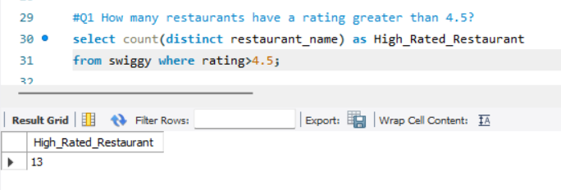

**Q2 Which is the top 1 city with highest number of restaurants?**

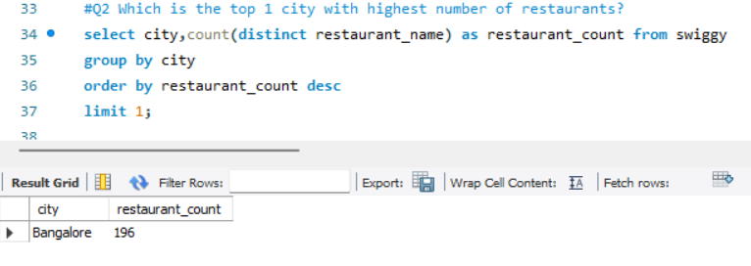

**Q3. How many restaurants have the word 'pizza' in their name?**

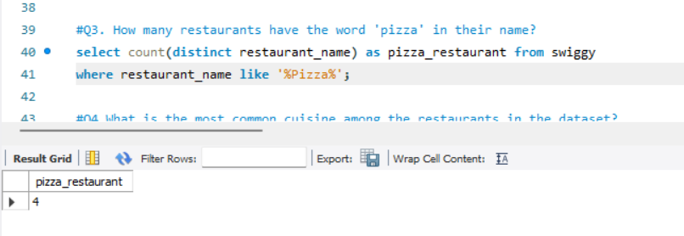

**Q4 What is the most common cuisine among the restaurants in the dataset?**

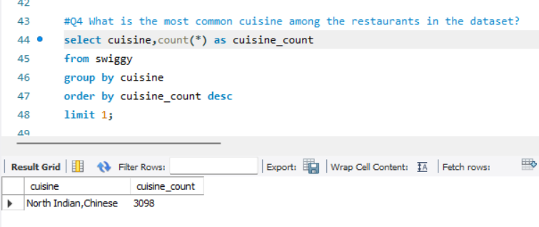

**Q5 What is the average rating of restaurants in each city?**

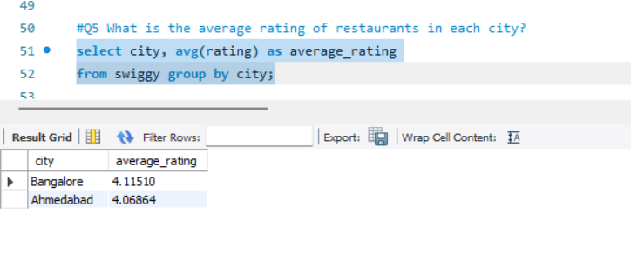

**Q6 What is the highest price of item under the 'Recommended' menu category for each restaurant?**

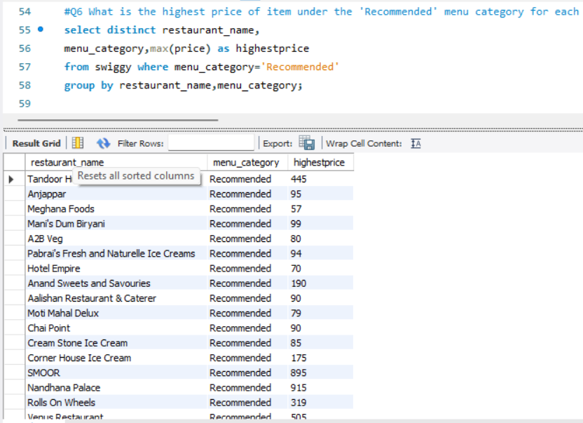

**Q7 Find the top 5 most expensive restaurants that offer cuisine other than Indian cuisine?**

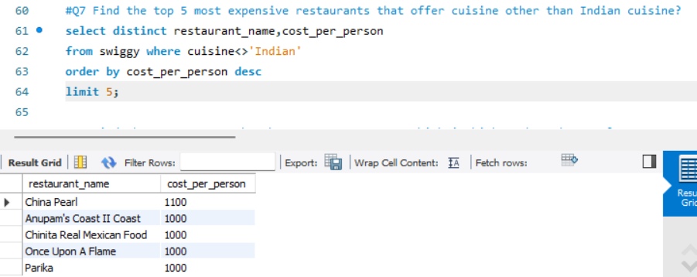

**Q8 Find the restaurants that have an average cost which is higher than the total average cost of all restaurants together?**

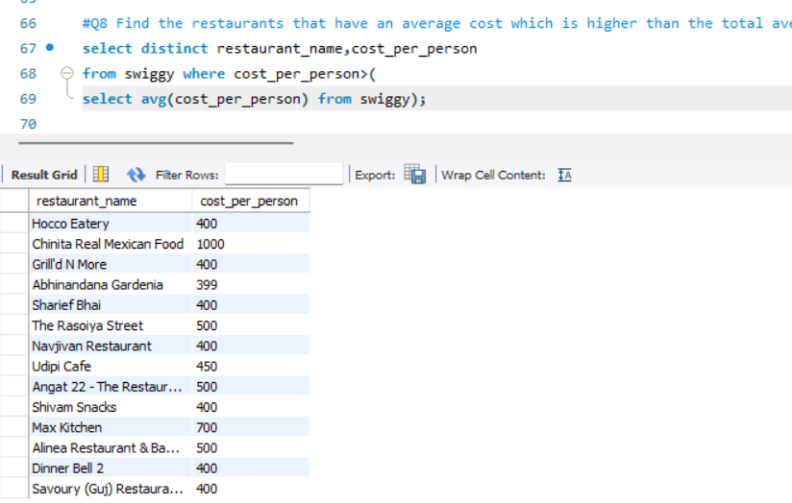

**Q9 Retrieve the details of restaurants that have the same name but are located in different cities?**

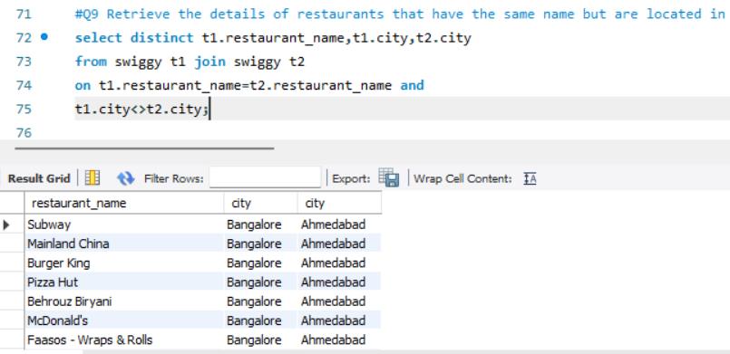

**Q10 Which restaurant offers the most number of items in the 'Main Course' category?**

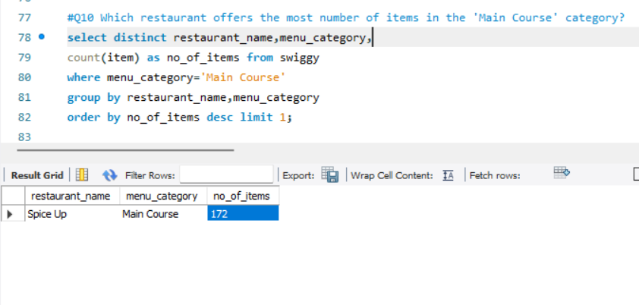

**Q11 List the names of restaurants that are 100% vegeatarian in alphabetical order of restaurant name?**

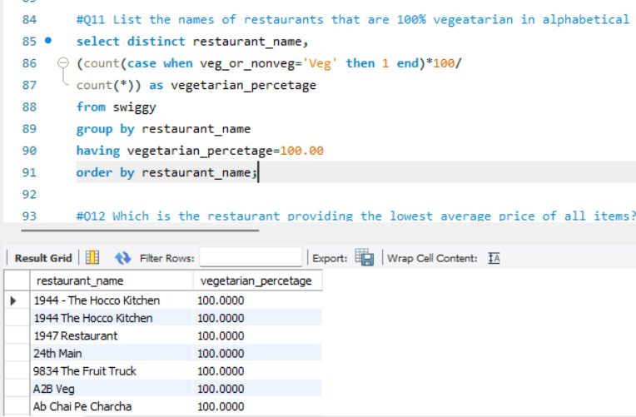

**Q12 Which is the restaurant providing the lowest average price of all items?**

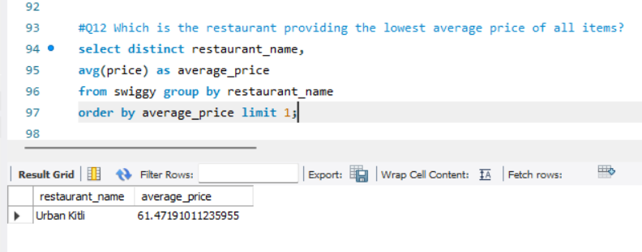

**Q13 Which top 5 restaurant offers hughest number of categories?**

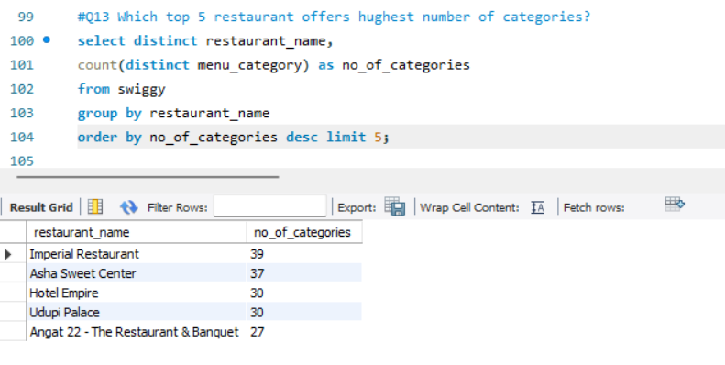

**Q14 Which restaurant provides the highest percentage of Non-vegeatarian food?**

