VITyarthi
Build Your Own Project
Course Project Report
Project Title: Task Manager Application
Submitted By: Sayali Rajesh Khachane
Registration Number: 25BAC10008
Program: B. Tech
Course Code: CSE1021
Course Name: Electrical and Communication Engineering (AI and Cybernetics)
Faculty: R. Sukumar
Institution: Vellore Institute of Technology, Bhopal
Academic Year: 2025-29

Introduction
Managing daily activities effectively has become an important part of maintaining productivity, especially for students and working individuals. With classes, assignments, deadlines, and personal responsibilities piling up, it often becomes difficult to keep track of everything. Many existing task management tools provide more features than necessary, making them difficult for beginners or casual users to adopt.
To address this, the Task Manager Application was developed as a simple and lightweight command-line tool using Python. The goal of this project is to offer a minimalistic yet effective solution to help users create, view, update, delete, and keep track of tasks in an organized manner. The application stores tasks in a local JSON file so that data remains available even after restarting the program.
Throughout this project, concepts such as modular programming, file handling, object-oriented programming, and data persistence were applied. In addition, the project includes requirement analysis, UML diagrams, and system architecture design following software engineering practices. Overall, this project provides a foundational understanding of building small, practical Python applications while improving real-world problem-solving skills.

Problem Statement
People often need a simple way to track their daily tasks, due dates, and priorities. Existing applications can be overwhelming or require a login, internet, or unnecessary features. Therefore, there is a need for a basic task manager that runs on any system, does not require installation, and performs essential task operations.
The objective of this project is to build a Python-based Task Manager that allows users to organize tasks with ease through a command-line interface while ensuring data is stored safely and persistently.

Objectives
- To develop an easy-to-use command-line based task management tool.
- To provide basic functionalities such as adding, editing, deleting, and viewing tasks.
- To store all tasks using a JSON-based file system for persistence.
- To implement the project using a clean, modular Python design.
- To understand and apply core Python concepts such as OOP and file handling.

Functional Requirements
Module 1: Task Creation
- Add new tasks with title, description, due date, and priority.
Module 2: Task Management
- Edit an existing task
- Delete a task
- Mark a task as completed
Module 3: Task Viewing
- View all tasks
- View pending tasks
- View completed tasks
- View tasks by priority

Non-Functional Requirements
- Usability: Simple CLI menu with intuitive options.
- Performance: Fast load and save operations for small datasets.
- Maintainability: Modular code structure and separation of concerns.
- Reliability: Ensures data accuracy through safe file operations.
- Error Handling: Input validation and proper exception handling.

System Architecture
The system is divided into three main components:
- User Interface (CLI)
  - Displays menu options
  - Captures user input
  - Shows task outputs
- Task Manager Logic
  - Handles operations like add, edit, delete, view
  - Manages task objects
- Storage Module
  - Reads task data from JSON file
  - Writes updated tasks to file

- Architecture Flow:
User → CLI → Task Logic → Storage → Output to User

Design Diagrams
1. Use Case Diagram

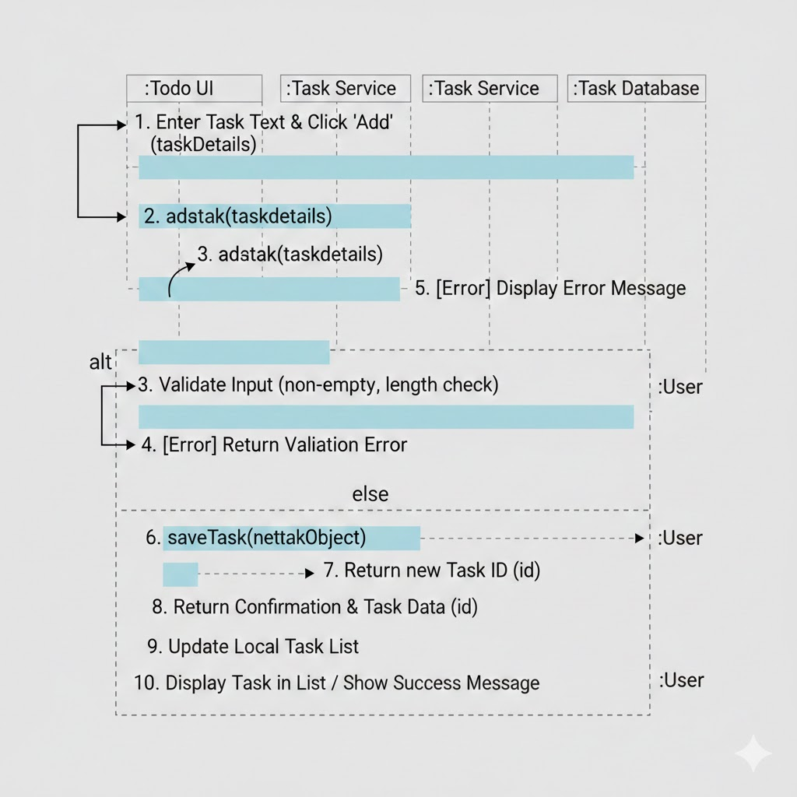
2. Sequence Diagram
3. Class Diagram
Task
- id
- title
- description
- due_date
- priority
- completed

TaskManager
- tasks_list
+ add_task()
+ edit_task()
+ delete_task()
+ mark_complete()
+ view_tasks()
+ load_tasks()
+ save_tasks()

Storage
+ load_tasks()
+ save_tasks()

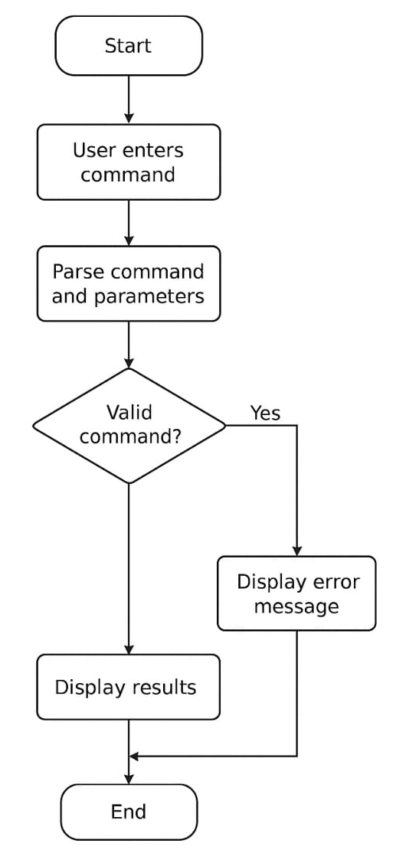
4. Workflow Diagram

Algorithm
- Start the program.
- Set things up. The app checks if the database exists. If it doesn’t, it creates one. It also makes sure the tables for tasks and categories are ready.
- Show the user the available options. For example: Add a task, Edit a task, Delete a task, Mark a task as completed, View tasks, View overdue tasks, Manage categories
- Wait for the user to choose a command.
- Read and understand the user’s command the app extracts details such as the title, due date, priority, and category.
- Check if the input is valid, if something important is missing → show an error message. If the date or priority is invalid → show an error.
- Perform the action based on the command
- Add Task: Save the task into the database.
- Edit Task: Find the task and update the details.
- Delete Task: Remove the task from the database.
- Mark Complete: Change the task’s status to ‘completed’.
- List Tasks: Fetch and display all tasks (with or without filters).
- Overdue Tasks: Show tasks whose due date has passed.
- Manage Categories: Add, list, or delete a category.
- Show the result to the user A success message, an updated task list, or an error message if something went wrong.
- Ask the user if they want to continue.
- If they say yes, repeat the process from Step 3.
- If they say no, close the application.
- End.

Design Decisions & Rationale
- JSON as the storage method: JSON was chosen because it is simple, readable, and does not require database setup.

- Modular code structure: Helps maintain clarity and allows easy future improvements.

- CLI-based design: Keeps the project lightweight and avoids GUI complexity.

- UUID for task IDs: Ensures every task is uniquely identifiable

Implementation Details
Technologies Used
- Python 3
- JSON file for storage
- UUID library
- Object-Oriented Programming
Modules Developed
- task.py — Task model
- task_manager.py — Core logic
- storage.py — File read/write
- main.py — CLI interface
The application is easy to run and requires no additional installations besides Python.

Testing Approach
- Tried every menu option one by one to make sure each feature worked properly — such as adding tasks, editing them, marking them complete, and deleting them.
- Checked how the program reacts to mistakes, like entering an invalid task ID, typing a wrong priority, or leaving required fields empty.
- Added multiple tasks and then viewed them to confirm that they were displayed correctly in different categories (all, pending, completed, or by priority).
- Tested editing and deleting tasks to verify that changes were saved correctly without affecting other tasks.
- Restarted the program several times to ensure that tasks were being properly saved in the JSON file and loaded again when the application starts.
- Watched how the program handled edge cases, such as an empty task list or a brand-new JSON file, to make sure it didn’t crash.

Screenshots / Output
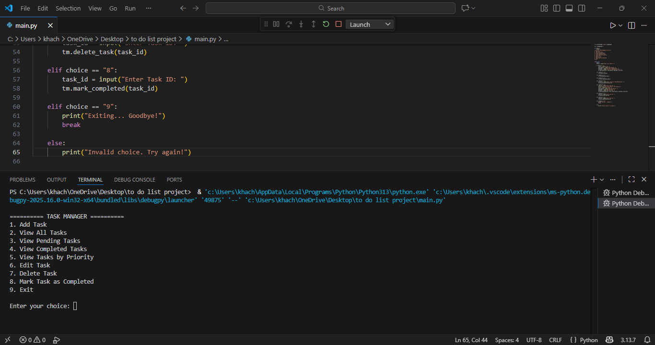
After running the code of the to do list application the output is shown:

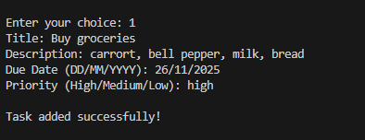
Add a task named ‘Buy groceries’ and enter its description, due date, etc. option given. Then review options given in the task manager:
The task added:
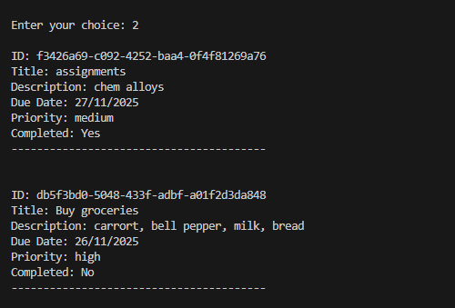
View all tasks:
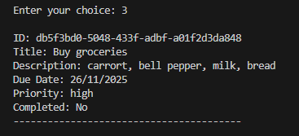
View pending tasks:
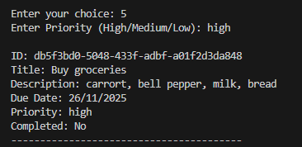
View tasks as priority:
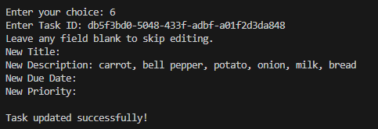
Edit task:

Delete task:
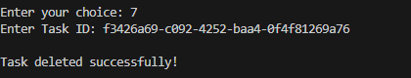
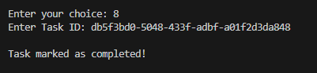
Task marked as complete:
View completed tasks:
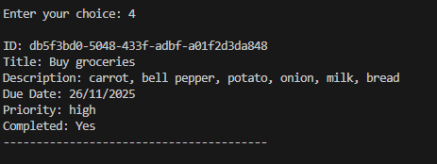

Challenges Faced
Working on this project was a great learning experience, but it also came with a few challenges. One of the earliest difficulties was handling unexpected or incorrect user inputs. For example, users sometimes entered blank task titles or invalid task IDs, and the program needed to respond gracefully instead of crashing. Another challenge involved managing the JSON file that stores the tasks. When the file was empty or newly created, loading the data without errors required extra care. Additionally, breaking the entire project into separate Python modules—Task, TaskManager, Storage, and the main interface—took thoughtful planning to make sure everything worked smoothly together. Although these hurdles were sometimes frustrating, overcoming them strengthened the overall design of the application and helped build a more reliable system.
Learnings & Key Takeaways
This project provided many valuable insights beyond just writing code. One of the biggest learnings was understanding how modular programming and object-oriented principles make a project easier to expand and maintain. Working with JSON files deepened my understanding of data persistence and how applications can store information between sessions. Creating diagrams and documenting the system also emphasized the importance of planning before coding—something that helped guide development and prevent confusion later. Most importantly, the project highlighted how essential it is to think from a user’s perspective: anticipating mistakes, designing simple workflows, and creating a smooth experience. These lessons will definitely help in future software projects.

Future Enhancements
While the current version of the Task Manager covers all the basic features, there are several exciting ways it could be improved in the future. Adding a graphical user interface would make the application more appealing and easier to use, especially for people who prefer buttons over command-line inputs. Features like sorting, searching, and advanced filtering could make task management much faster for users with long lists. Introducing user accounts would allow multiple people to use the same program without mixing up their tasks. Export options such as PDF or CSV would be great for students or professionals who want to share or submit their task lists. In the long run, adding reminder notifications or alerts for upcoming deadlines would make the tool even more helpful in managing daily activities.

References
- Python Official Documentation
- GeeksforGeeks — Python File Handling
- W3Schools — JSON and Python Basics

