**Homework 1 – Data visualizations**

This dataset contains information about all evets associated with terrorism starting 1970 until 2017. There are 181692 records and 135columns including date, time, location, number of hostages, killed, wounded, if there was a ransom, the outcome, if there was a suicide attack, claims, weapons used etc.

We chose this data set as it contained all kind of data and it could help perform analysis viz-a-viz different parameters. Initially we studied the difference between the three visualization libraries and then decided what kind of visualizations can be done using each library.

Initially we began with a single pie chart which was one of the simplest tasks to perform. By analyzing the data, we calculated the number of attacks which were created using basic python operations and plotted a pie chart which indicated the number of attacks where suicide was used and attacks where there was no suicide. We analyzed that out of all attacks 6% involved suicide bombers.

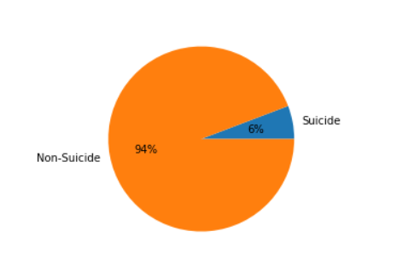

Our second visualizations included a simple bar graph with the number of kills which have been drastically increasing through the years. We noticed the highest were in 2014. However, this was not as simple as the pie chart as we had to use group by like we did analysis using SQL and plotted a bar graph. Upon studying the other libraries, we realized that this was trickier in matplotlib and we had to put in more effort towards it.

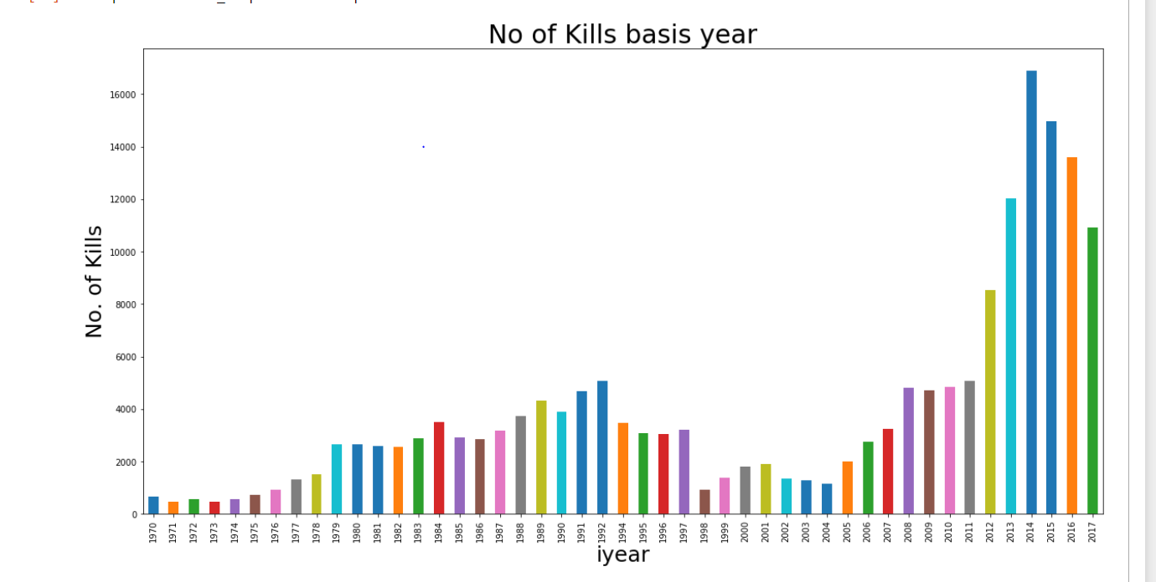

DEsciription

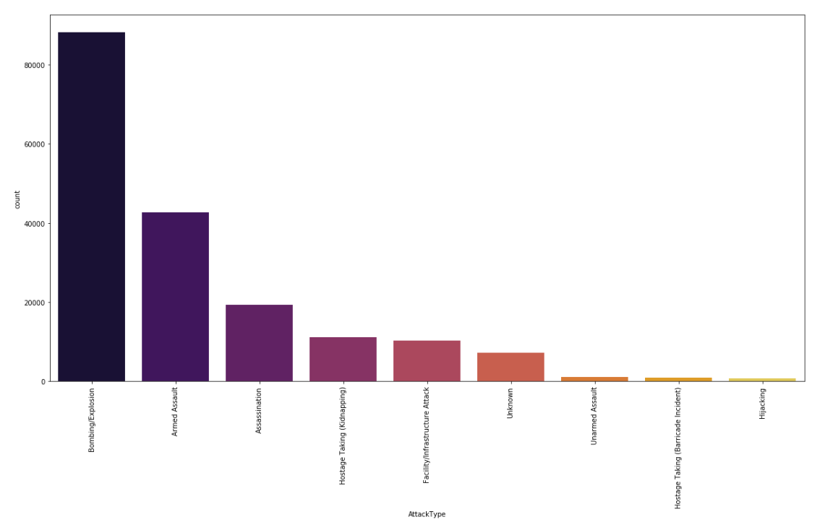

Description

