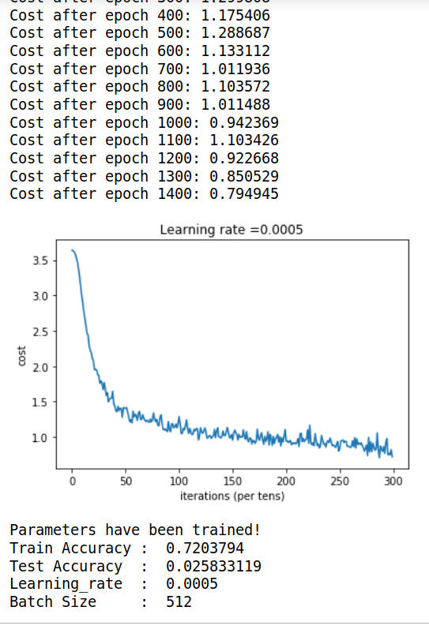
1. No of epochs = 1500
Time taken = 15 min
No of Layers = 20
No of Internal nodes =100

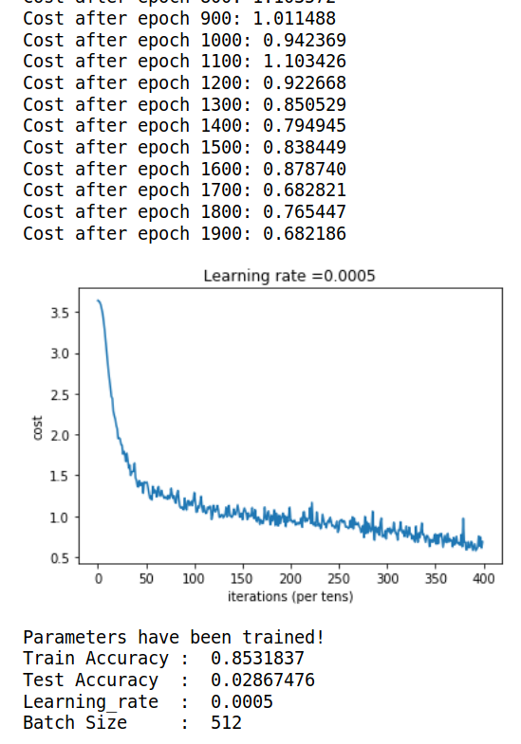
2. No of epochs = 2000
Time taken = 20 min
No of Layers = 20
No of Internal nodes =100

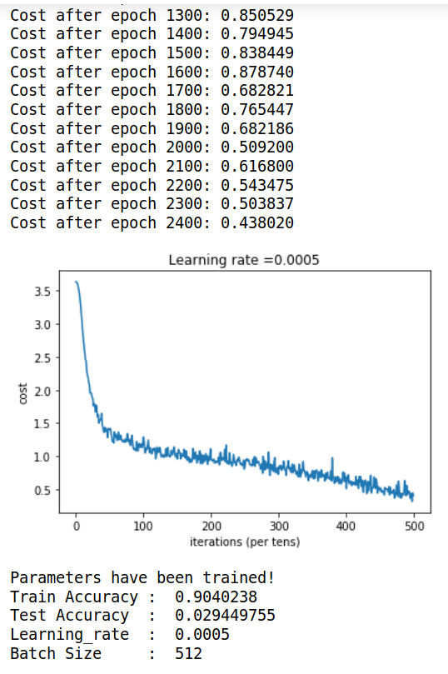
3. No of epochs = 2500
Time taken = 25 min
No of Layers = 20
No of Internal nodes =100

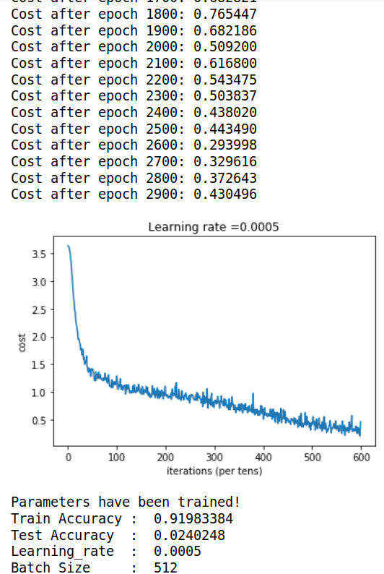
4. No of epochs = 3000
Time taken = 40 min
No of Layers = 20
No of Internal nodes =100

II ] 75% train, 20% test

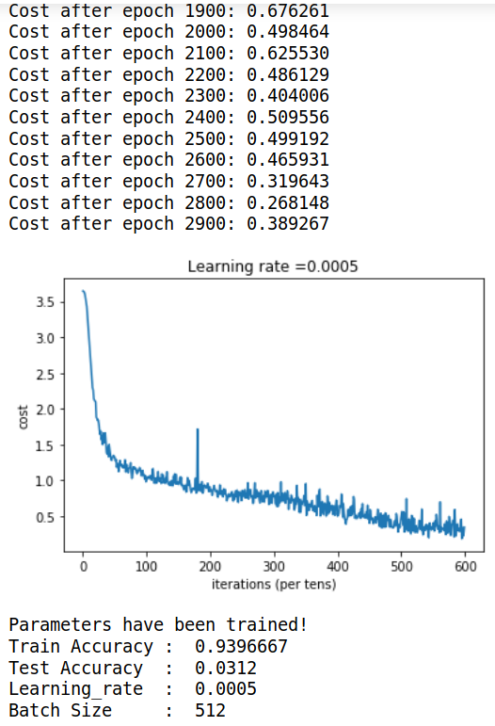
5. No of epochs = 3000
Time taken = 25 min
No of Layers = 20
No of Internal nodes =100

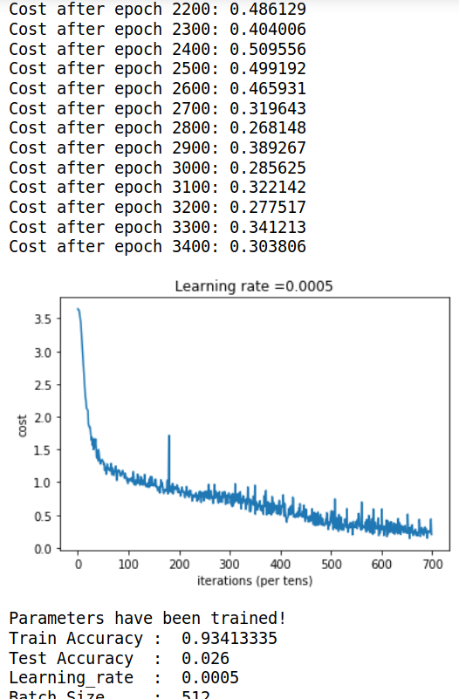
6. No of epochs = 3500
Time taken = 30 min
No of Layers = 20
No of Internal nodes =100

After distribution :
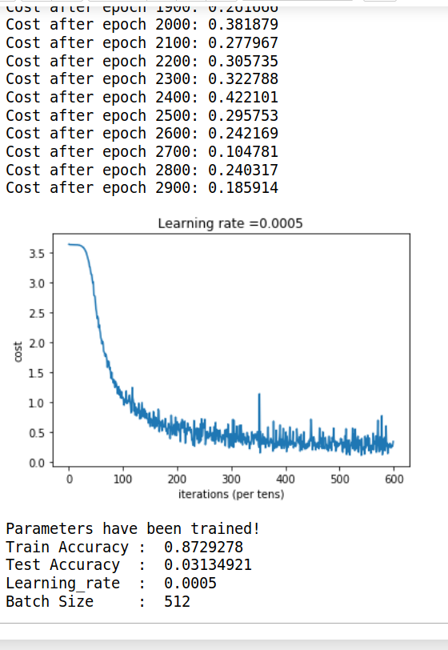
7. No of epochs = 3000
Time taken = 30 min
No of Layers = 20
No of Internal nodes =100

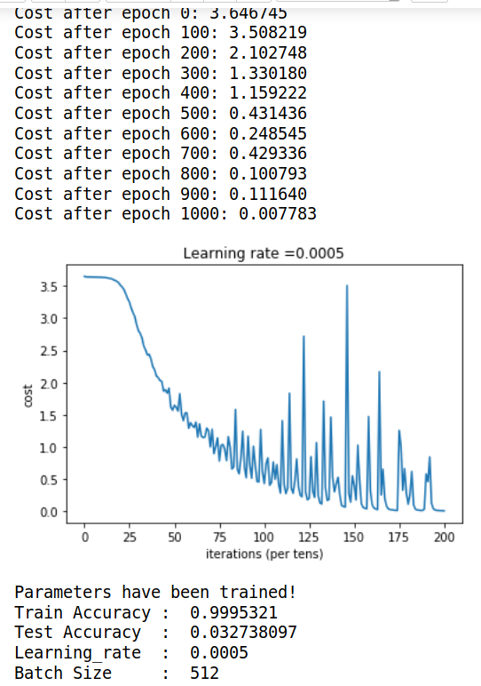

8. No of epochs = 1001
Time taken = -
No of Layers = 15
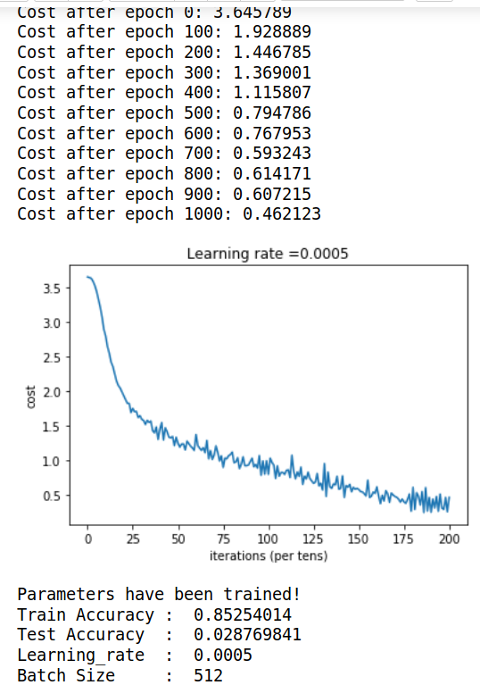
No of Internal nodes =100

After making myu sig changes in original data -

9. No of epochs = 1001
Time taken = 10 mins
No of Layers = 15
No of Internal nodes =100

Changing formula by subtracting mean & softmax_v2-
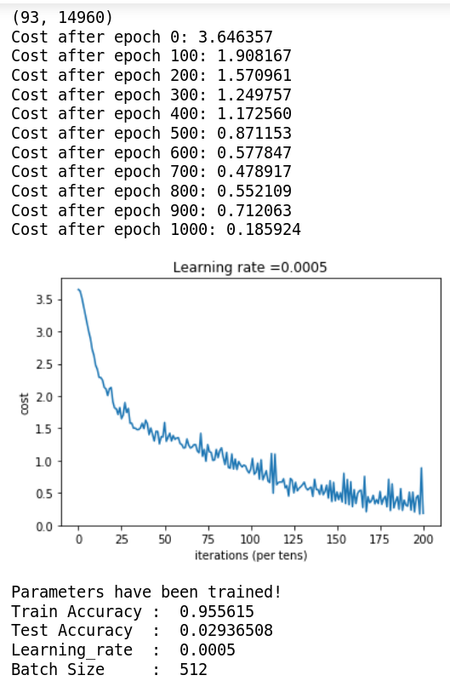

10. No of epochs = 1001
Time taken = 10 mins
No of Layers = 15
No of Internal nodes =100

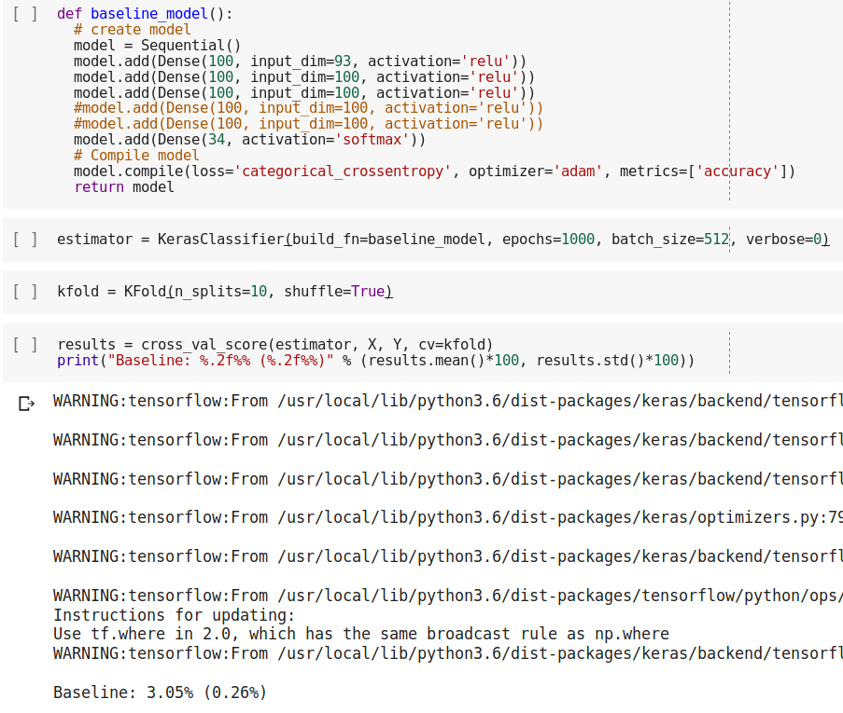

11. No of epochs = 1000
Time taken = 60 mins
No of Layers = 6
No of Internal nodes =100

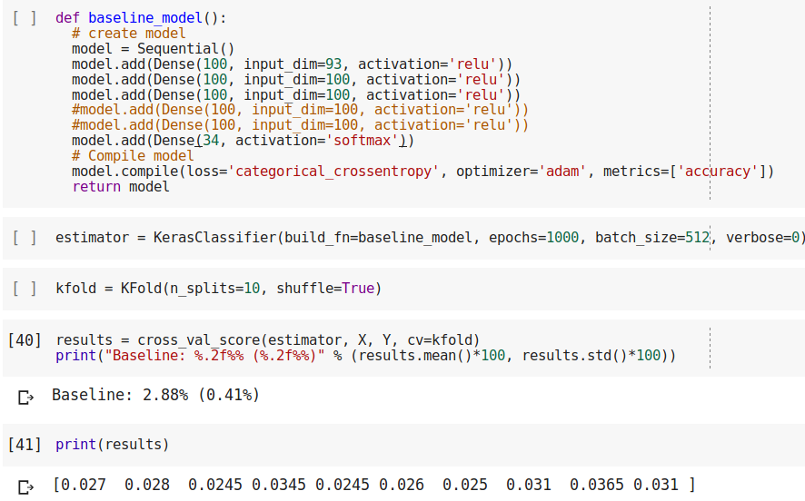
12. No of epochs = 1000
Time taken = 45 mins
No of Layers = 4
No of Internal nodes =100

