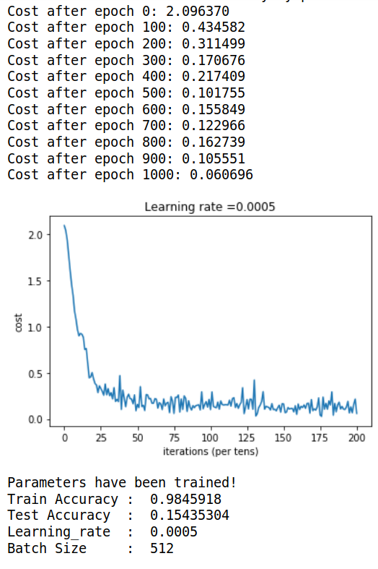
1. No of epochs = 1000
Time taken = 10 min
No of Layers = 15
No of Internal nodes =100

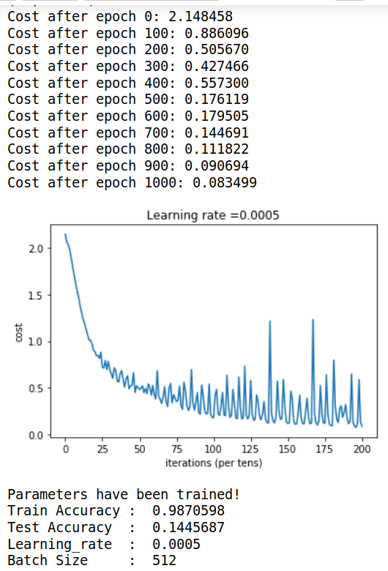

2. No of epochs = 1000
Time taken = 10 min
No of Layers = 15
No of Internal nodes =100

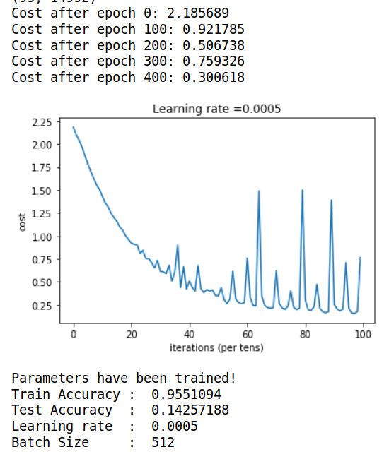

3. No of epochs = 500
Time taken = 3 min
No of Layers = 15
No of Internal nodes =80 (-10)

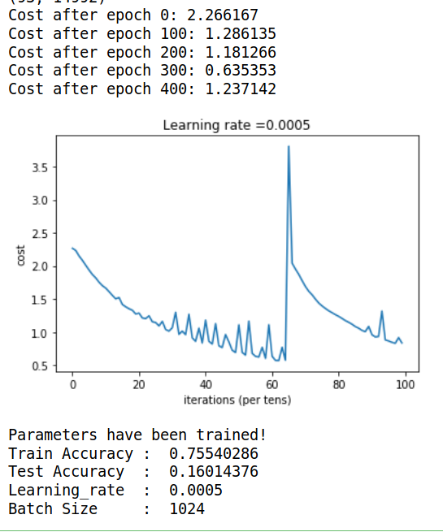
4. No of epochs = 500
Time taken = 3 min
No of Layers = 15
No of Internal nodes =80 (-10)
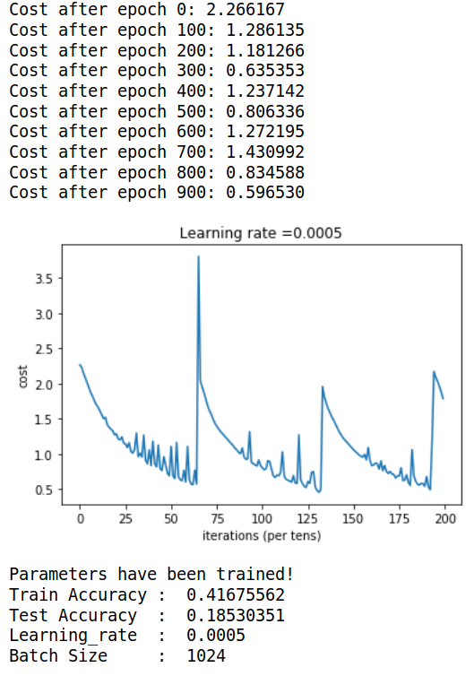
5. No of epochs = 1000
Time taken = 3 min
No of Layers = 15
No of Internal nodes =80 (-10)

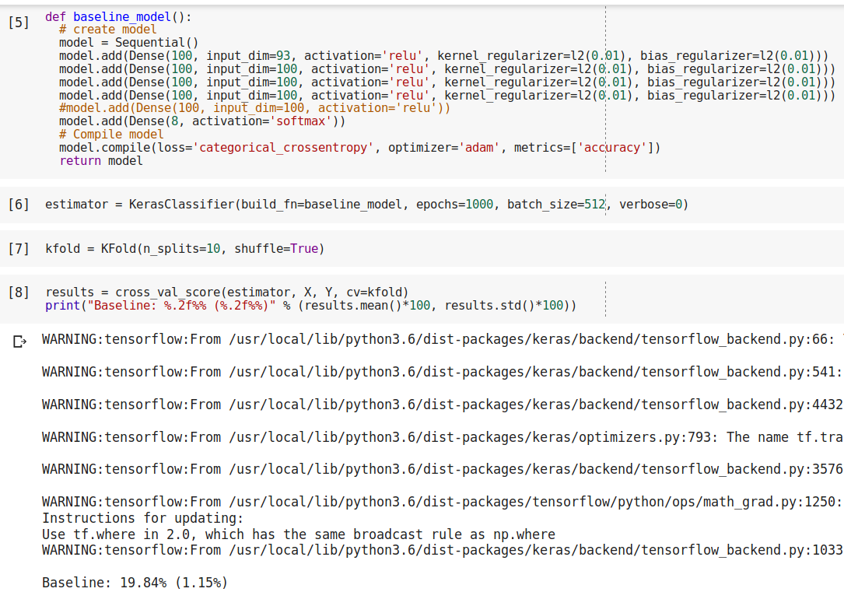

6. No of epochs = 1000
Time taken = 3 min
No of Layers = 15
No of Internal nodes =80 (-10)

After reducing input to 68
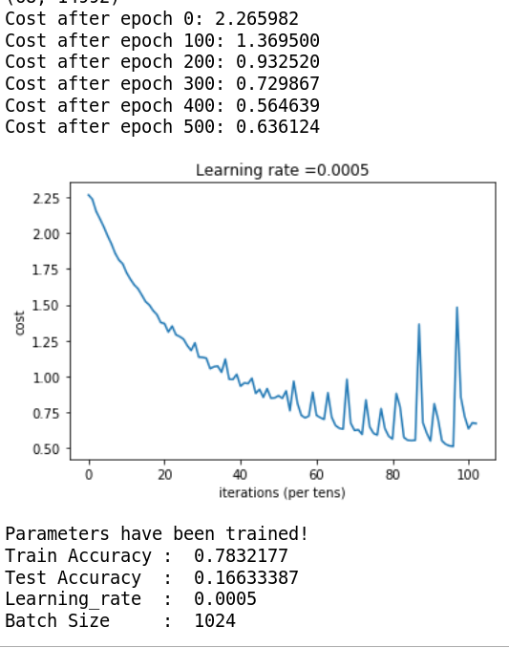
7. No of epochs = 512
Time taken = 3 min
No of Layers = 15
No of Internal nodes =80 (-10)

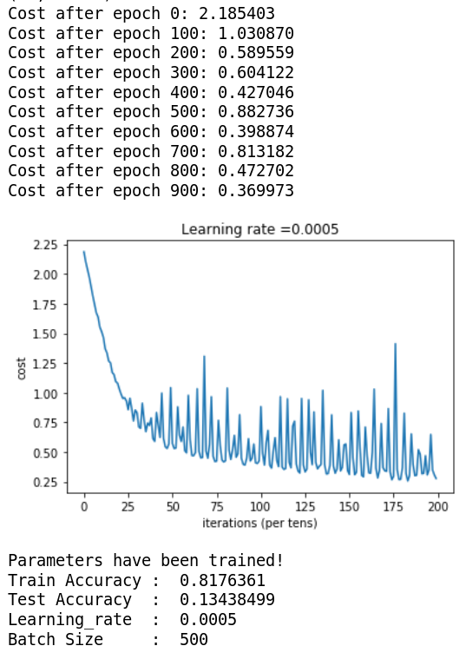
8. No of epochs = 1000
Time taken = 3 min
No of Layers = 15
No of Internal nodes =80 (-10)

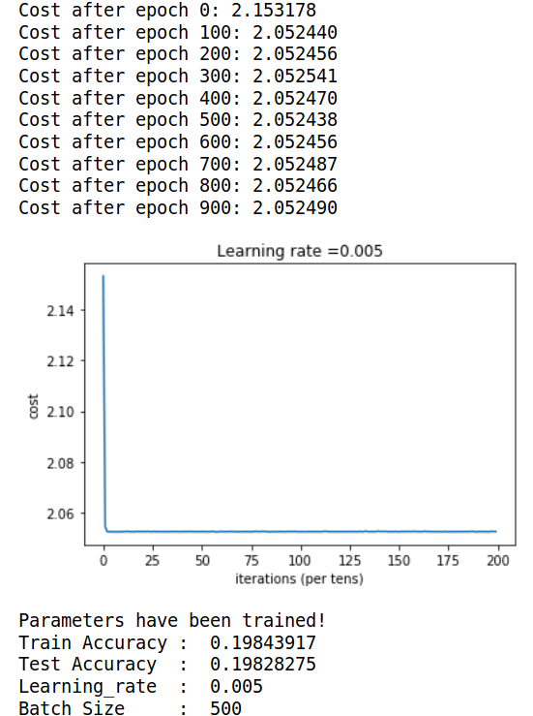
9. No of epochs = 1000
Time taken = 3 min
No of Layers = 15
No of Internal nodes =80 (-10)

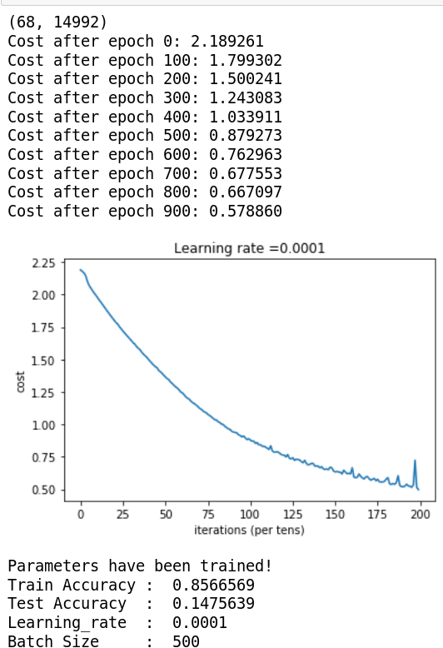

9. No of epochs = 1000
Time taken = 3 min
No of Layers = 15
No of Internal nodes =80 (-10)

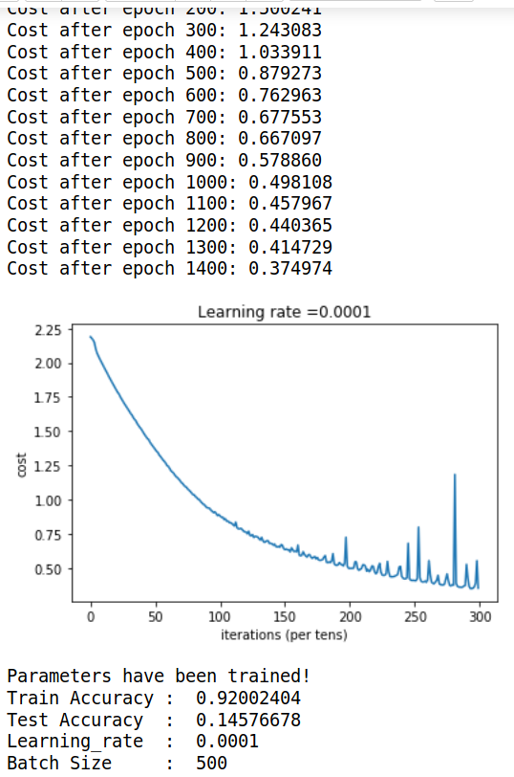
10. No of epochs = 1500
Time taken = 3 min
No of Layers = 15
No of Internal nodes =80 (-10)

After reducing input to 58
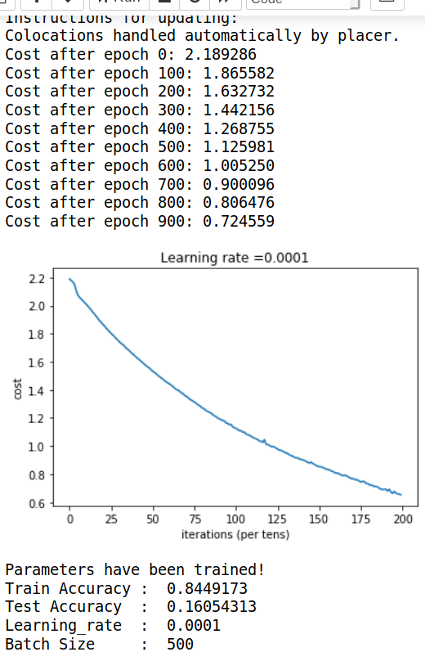
11. No of epochs = 1000
Time taken = 3 min
No of Layers = 15
No of Internal nodes =80 (-10)

