**D. Y. Patil College of Engineering and Technology, Kolhapur**

**Department of Computer Science & Engineering**

**Class: SY-A                  Subject: AOOC**

**Experiment No.: 15               Mini Project**

**Title: Employee Payroll Management System**

**Problem Statement:**

To design and implement a Java-based Employee Payroll Management System that automates employee information management, salary calculation, attendance tracking, and report generation, thereby minimizing manual effort and reducing errors in payroll processing.

**Introduction:**

Payroll management is a core function in every organization, involving the collection and processing of employee details, salary components, attendance records, and applicable tax deductions. Performing these operations manually is time-consuming, increases the risk of human error, and lacks efficiency.

This project presents an **automated Employee Management System** that streamlines the payroll process through digital employee data entry, salary and attendance tracking, and payslip generation. It not only reduces errors and saves time but also improves overall management and transparency.

The system is developed using **Java Swing** for the user interface, **Java** for business logic, **JDBC** for database connectivity, and **MySQL** for secure data storage. Additional integrated tools such as Notepad, Calculator, and Chrome Browser enhance user convenience, making the system a comprehensive solution for day-to-day administrative tasks.

**Tech Stack:**

💻 Frontend (User Interface):

* Java Swing GUI

💻 Backend (Application Logic):

* Java

🔌 Middleware:

* JDBC (Java Database Connectivity)

🗄️ Database:

* MySQL

**System Architecture:**

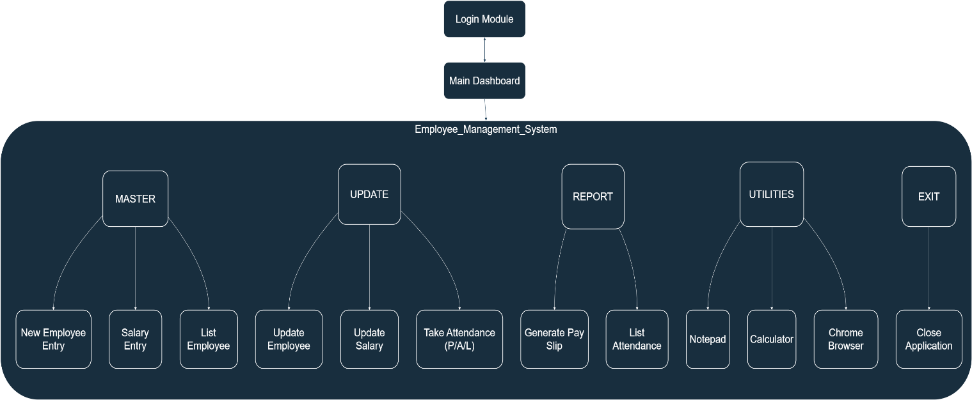

**Working of the System:**

1. Master Tab

* New Employee Entry: Inputs and saves employee personal details.
* Salary Entry: Assigns salary components including Basic Salary, HRA, DA, MED, and PF.
* List Employee: Displays all employee records for review.

2. Update Tab

* Update Employee: Edits employee personal information.
* Update Salary: Modifies salary components as per revisions or promotions.
* Take Attendance: Records attendance status — Present, Half Day, or Leave.

3. Report Tab

* Generate Pay Slip: Produces detailed payslips showing salary breakdown, tax, gross, and net salary.
* List Attendance: Displays monthly or periodic attendance reports.

4. Utilities Tab

* Notepad: Opens a text editor for quick notes.
* Calculator: Launches calculator for manual computations.
* Chrome: Opens Google Chrome for browsing needs.

5. Exit Tab

* Closes the application, ensuring data integrity by prompting to save unsaved changes.

**Salary Calculation Logic:**

* Gross Salary = Basic Salary + HRA + DA + MED + PF
* Tax Deduction = 2.1% of Gross Salary
* Net Salary = Gross Salary − Tax

Example:  
For an employee with all components as ₹1000 each:

* Gross Salary = 1000 + 1000 + 1000 + 1000 + 1000 = ₹5000
* Tax = 2.1% of 5000 = ₹105
* Net Salary = 5000 − 105 = ₹4895

**Screenshots:**

✅ Login: ✅ Dashboard:

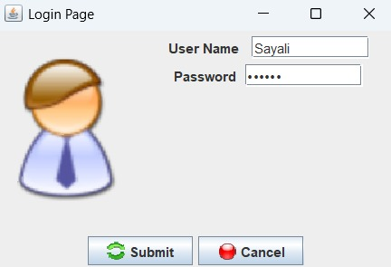 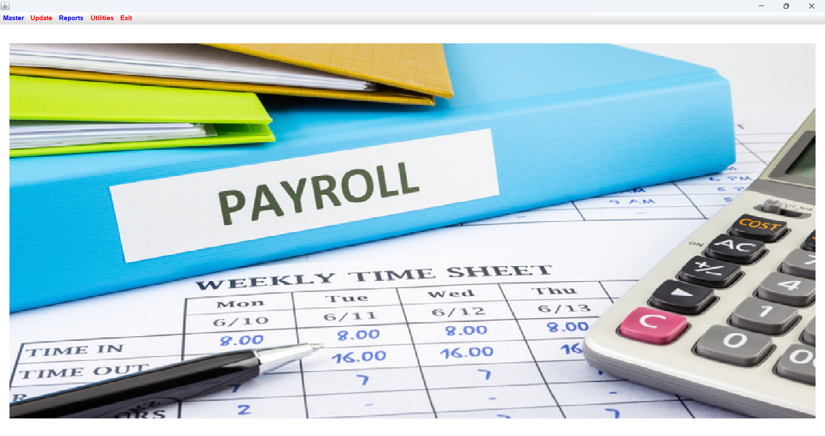

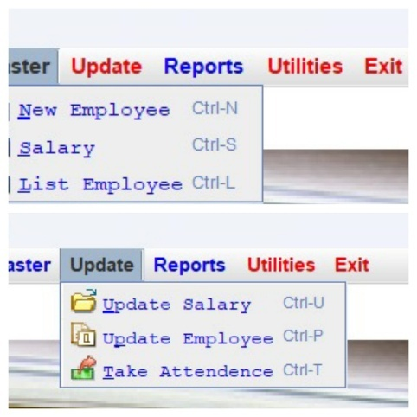 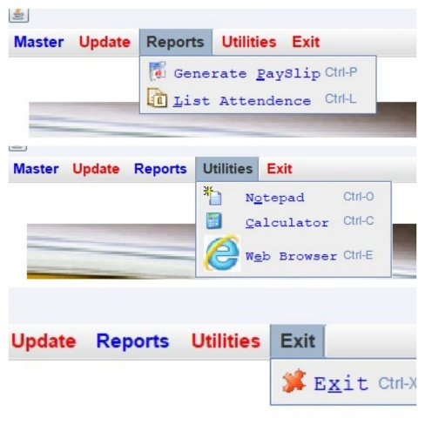

✅ Employee Registartion: ✅ Pay Slip Genration:

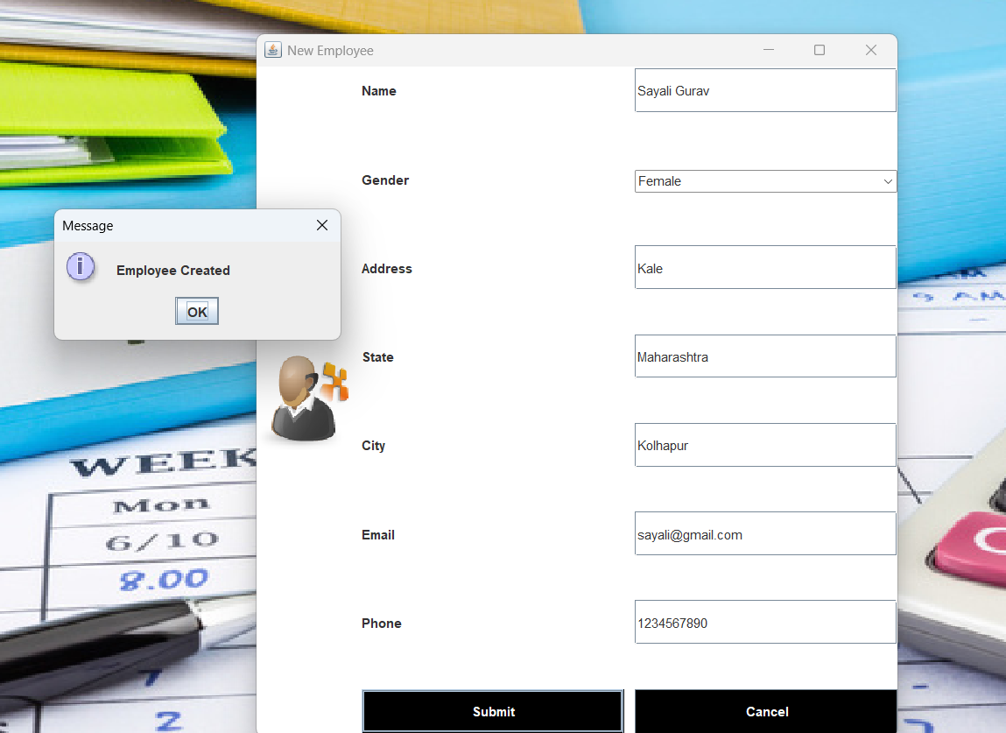 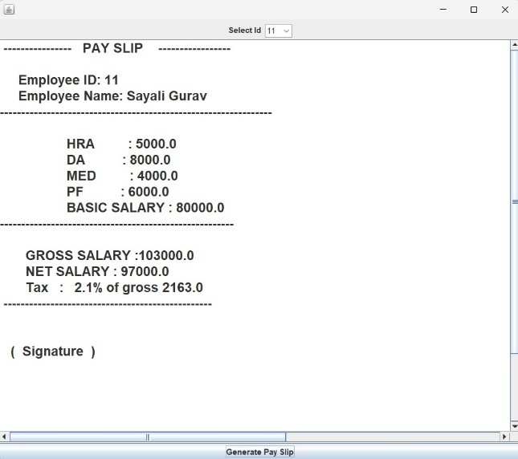

✅ Attendance List:

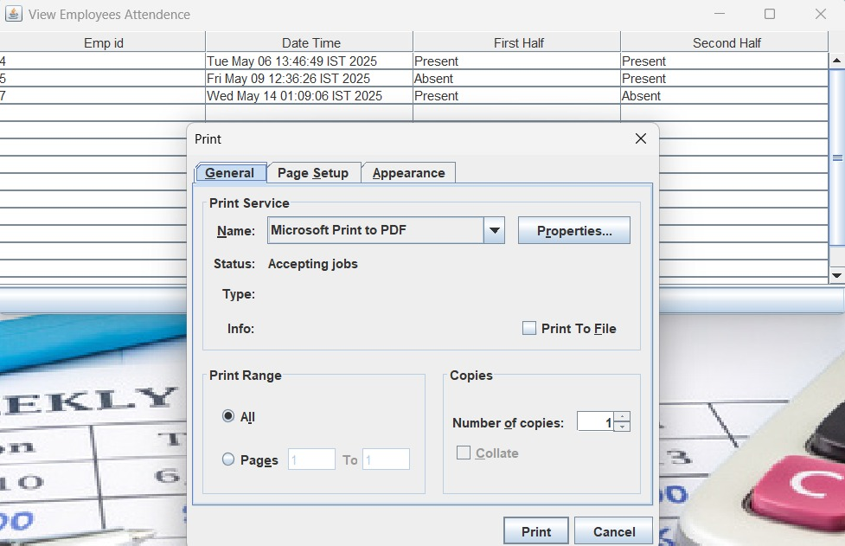

**Group Members:**

|  |  |  |  |
| --- | --- | --- | --- |
| **Unique id** | **Roll No** | **Name of Student** | **Sign** |
| EN23250711 | 127 | Snehal Dattatray Kumbhar |  |
| EN23103452 | 128 | Riya Kiran Kamble |  |
| EN23208080 | 130 | Sayali Shankar Gurav |  |
| EN23221773 | 135 | Ankita Ankush Ghunake |  |

|  |  |  |  |
| --- | --- | --- | --- |
|  |  |  |  |
|  |  |  |  |
|  |  |  |  |
|  |  |  |  |