**Aim**: Case Study on Smart City

# Theory/Case Study:

**Smart cities** integrate digital technologies to improve the quality of life for residents, manage urban services more efficiently, and promote sustainability. A key enabler of smart cities is the Internet of Things (IoT), which involves interconnected devices collecting and exchanging data. Technologies like **Edge** and **Fog computing** are critical for processing this vast data effectively and providing real-time solutions.

**Edge computing** processes data at the network's edge, near the source of data generation (e.g., IoT sensors), rather than sending it to a central cloud. This approach reduces latency and allows for real- time decision-making. For example, in smart transportation systems, edge devices such as traffic cameras can immediately process and act on traffic data to manage congestion or accidents, reducing the need for data transmission to cloud servers.

**Fog computing** complements edge computing by extending cloud services closer to the data source, acting as an intermediary between edge devices and the cloud. It allows for distributed processing and storage at various points along the network, optimizing bandwidth use. In smart city applications, Fog nodes can process data from multiple sources, such as traffic lights, weather stations, and surveillance cameras, making decisions locally while sending essential data to the cloud for further analysis.

# Case Study: Barcelona, Spain – A Smart City Powered by IoT and Edge/Fog Computing

Barcelona is one of the leading smart cities globally, utilizing IoT, Edge, and Fog computing technologies across various sectors:

1. **Smart Lighting**: Barcelona uses streetlights with embedded IoT sensors that adjust brightness based on pedestrian activity. Edge devices process data locally to make immediate adjustments, optimizing energy usage and enhancing safety.
2. **Smart Waste Management**: The city has implemented a smart waste collection system where IoT-enabled bins monitor waste levels. Fog nodes process data from bins to optimize collection routes, reducing fuel consumption and operational costs.
3. **Smart Parking**: IoT sensors detect available parking spaces, and the information is processed using Fog computing, which then sends real-time updates to a mobile app. This minimizes traffic congestion caused by drivers searching for parking.
4. **Urban Mobility**: Barcelona's public transportation system uses IoT and Edge computing to monitor vehicle locations, traffic conditions, and passenger data in real time. This helps optimize routes and schedules, ensuring timely services and reducing congestion.

These case studies show how Barcelona’s use of Edge and Fog computing technologies improves resource management, reduces operational costs, and enhances the quality of life for its residents.

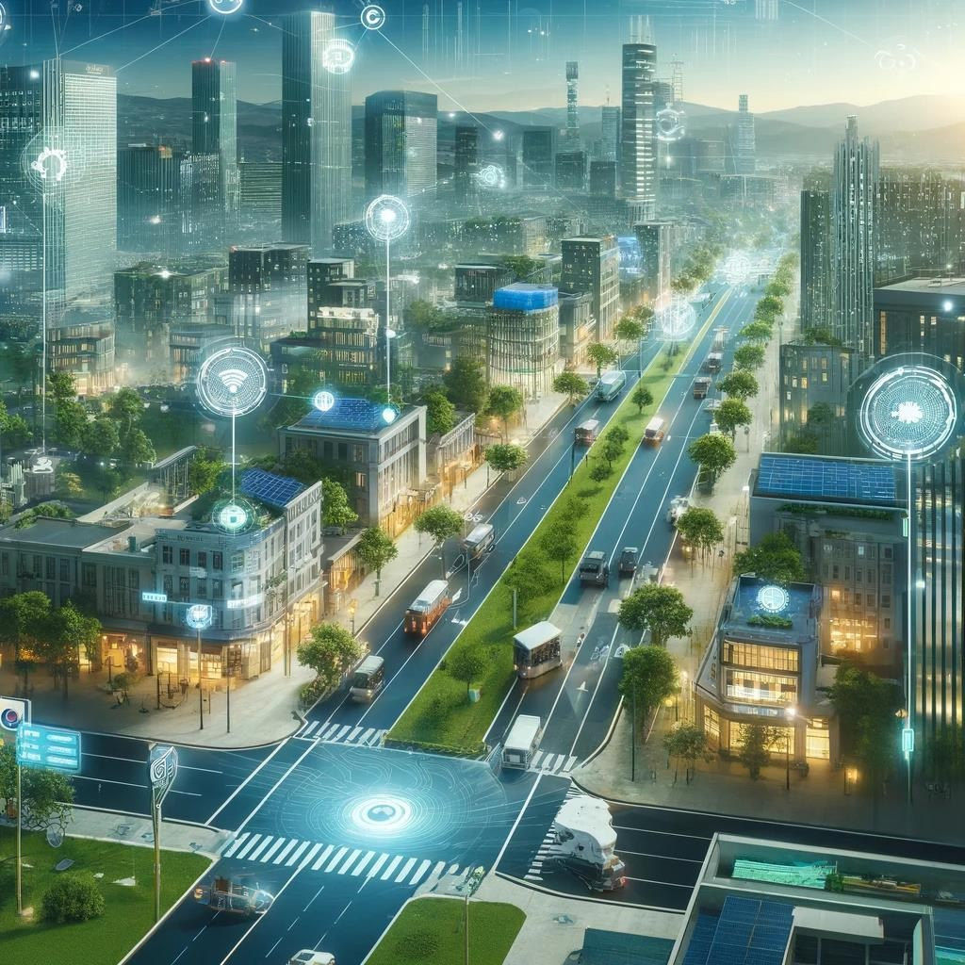

Here is the image of a futuristic smart city, showcasing modern infrastructure with IoT-enabled streetlights, smart waste management systems, and energy-efficient designs. The city features real- time data analytics and smooth urban operations.

# Conclusion:

The deployment of Edge and Fog computing in smart cities provides a scalable, efficient, and low- latency approach to managing and processing the vast amounts of data generated by IoT devices. By processing data closer to its source, these technologies significantly reduce latency and bandwidth consumption while improving real-time decision-making, enabling smart cities to deliver enhanced services to their residents. This decentralized architecture optimizes infrastructure costs and helps build sustainable, smart environments that can dynamically respond to the needs of citizens.