Title: Fog computing architecture

Aim : Design and deploy a fog computing architecture using simulators such as iFogSim

Theory:

With the increasing advancement in the applications of the Internet of Things(IoT), the integrated Cloud Computing(CC) faces numerous threats such as performance, security, latency, and network breakdown. With the discovery of Fog Computing these issues are addressed by taking CC nearer to the Internet of Things (IoT). The key functionality of the fog is to provide the data generated by the IoT devices near the edge. Processing of the data and data storage is done locally at the fog node rather than moving the information to the cloud server. In comparison with the cloud, Fog Computing delivers services with high quality and quick response time. Hence, Fog Computing might be the optimal option to allow the Internet of Things to deliver an efficient and highly secured service to numerous IoT clients. It allows the administration of the services and resource provisioning outside CC, nearer to devices, at the network edge, or ultimately at places specified by Service Level Agreements (SLA’s). Fog Computing is not a replacement to CC, but a prevailing component. It allows the processing of the information at the edge though still delivering the option to connect with the data center of the cloud. In this paper, we put forward various computing paradigms, features of fog computing, an in-depth reference architecture of fog with its various levels, a detailed analysis of fog with IoT, various fog system algorithms and also systematically examine the challenges in Fog Computing which acts as a middle layer between IoT sensors or devices and data centers of the cloud.

Definition of Fog Computing

Fog computing is defined as “an extremely virtualized environment that delivers networking, storage, and compute resources between outdated CC information centers, usually, but not entirely situated at the network edge”. A fog structure contains various edge nodes with few processing competences, which are frequently called fog nodes. These nodes of fog have less processing facilities and storage. In fog network, sometimes edge and many servers are called cloudlets,which take part in the shared computing surroundings, not outside the network edge. By using these devices of fog, the clients might obtain a real-time response for sensitive latency applications. Even though the phrase was initially devised by Cisco.various researchers and industries defined fog computing from many different perspectives. A broad spectrum of Fog computing is provided by Yi et al.. It is specified as “geographically shared computing framework with a pool of requirements that contains different universally linked heterogeneous computing devices at the network edge and not entirely flawlessly supported by services of cloud to collectively offer transmission, storage and elastic computation in remote surroundings to an enormous scale of users in closeness”. A spectrum of Fog Computing is provided by OpenFog Consortium as “system-level flat framework that divides storage, resources,

computing services, and networking from every place along with the range from Cloud to Things” Fog Computing Architecture

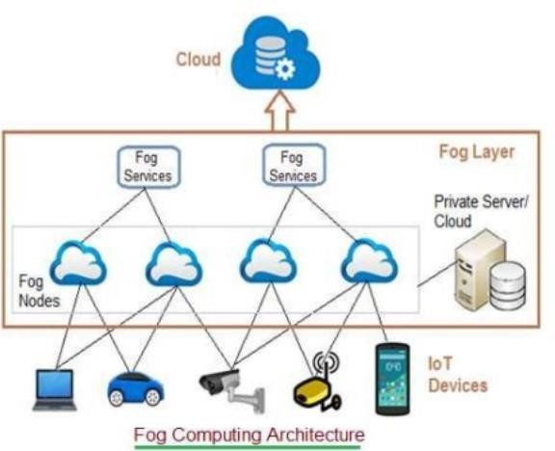The Fog computing architecture consists of physical and logical elements in the form of hardware and software to implement IoT (Internet of Things) network. As shown in figure-2, it is composed of IoT devices, fog nodes, fog aggregation nodes with the help of fog data services, remote cloud storage and local data storage server/cloud. Let us understand fog computing architecture components.

IoT devices: These are devices connected on IoT network using various wired and wireless technologies. These devices produce data regularly in huge amount. There are numerous wireless technologies used in IoT which include Zigbee, Zwave, RFID, 6LoWPAN, HART, NFC, Bluetooth, BLE, NFC, ISA-100.11A etc. IoT protocols used include IPv4, IPv6, MQTT, CoAP, XMPP, AMQP etc.

Fog Nodes:

The fog node is the core component of the fog computing architecture. Fog nodes are either physical components (e.g. gateways, switches, routers, servers, etc.) or virtual components (e.g. virtualized

switches, virtual machines, cloudlets9 , etc.) that are tightly coupled with the smart enddevices or access networks, and provide computing resources to these devices. A fog node is aware of its geographical distribution and logical location within the context of its cluster. Additionally, fog nodes provide some form of data management and communication services between network’s edge layer where end-devices reside, and the fog computing service or the centralized (cloud) computing resources, when needed. To deploy a given fog computing capability, fog nodes operate in centralized or decentralized manner and can be configured as standalone fog nodes that communicate among them to deliver the service or can be federated to form clusters that provide horizontal scalability over disperse geolocations, through mirroring or extension mechanisms.

**Procedure:**

**Step 1: Open ifogsimulator**

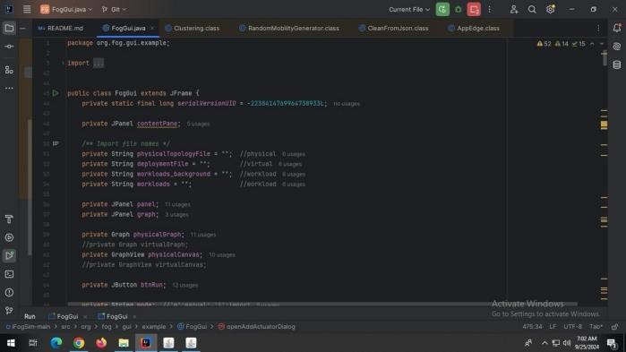

**Step 2 :** AFTER GETTING OUTPUT WINDOW (FOG TOPOLOGY CREATOR)

ADD FOG DEVICE with required specification NAME: DATA CENTER 1

LEVEL: 0

UPLINK Bw: 100000

Download Bw:10000 Mips:1000 Ram:1000 Rate/MIPS:1000

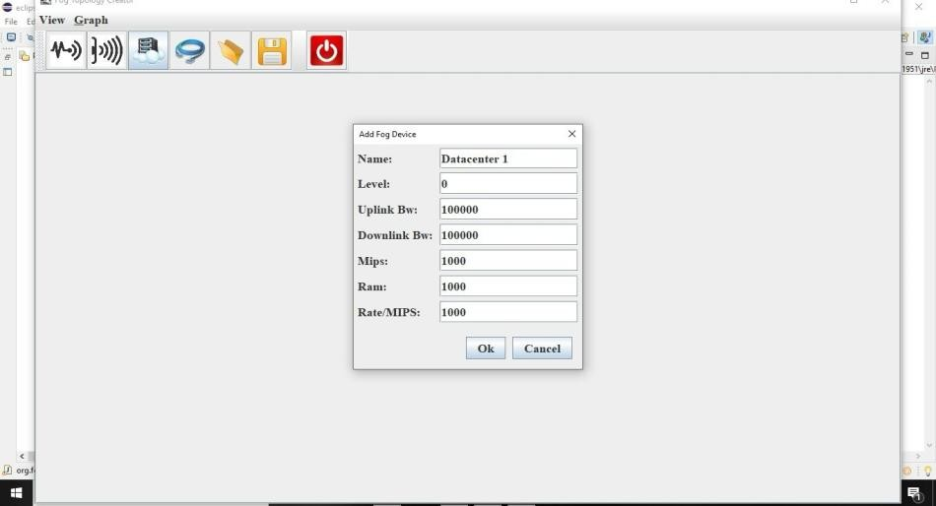

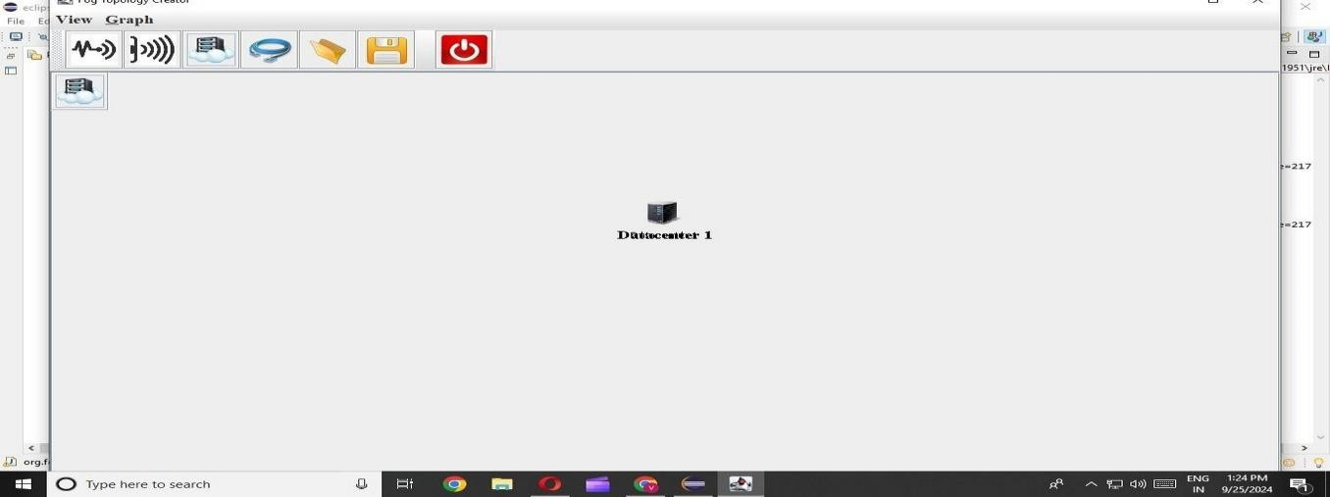

**Step3)Add fog device NAME: gate way 0 LEVEL: 1**

**UPLINK Bw: 1000**

**Download Bw:1000 Mips:100 Ram:1000**

**Rate/MIPS:10**

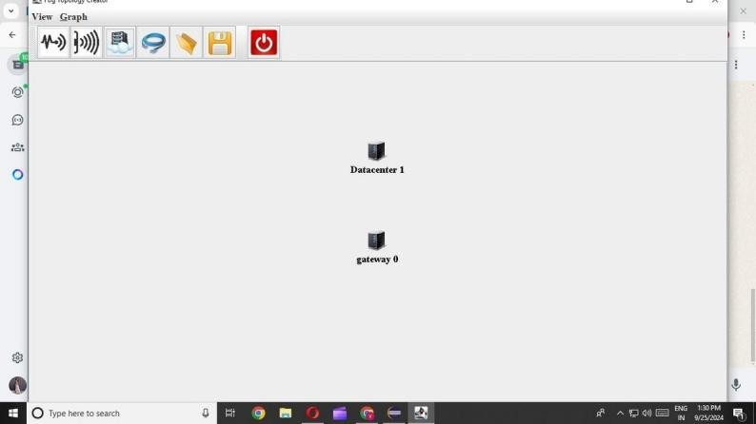

Repeat step 3

**Step 5) add actuator Name: actuator0 Actuator type: actuator0**

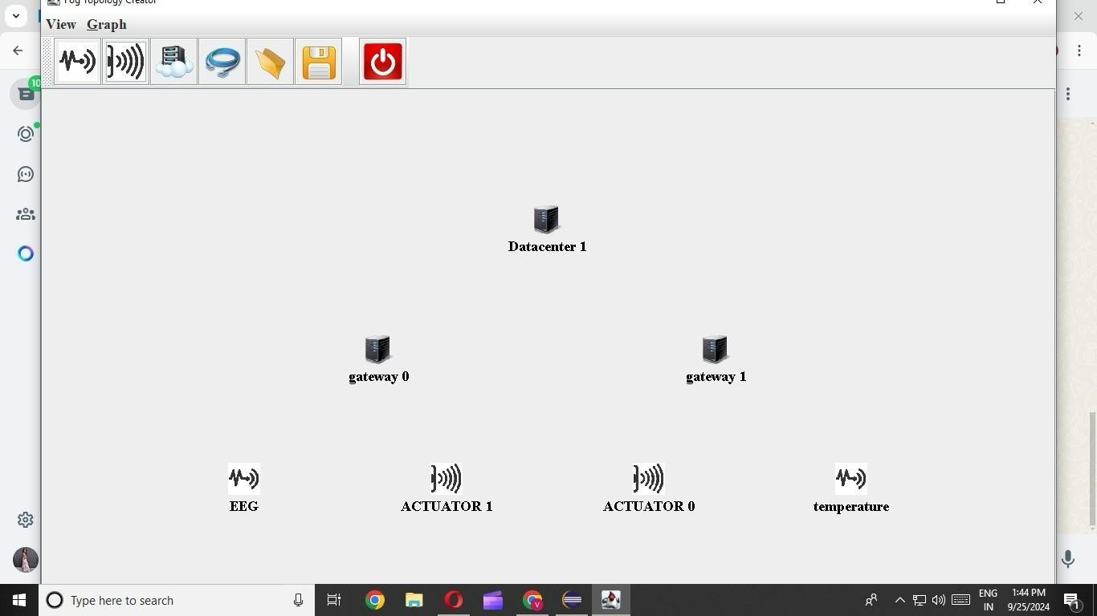

**Step8) add link Datacenter 1 -> gateway 0**

**Latency: 100**

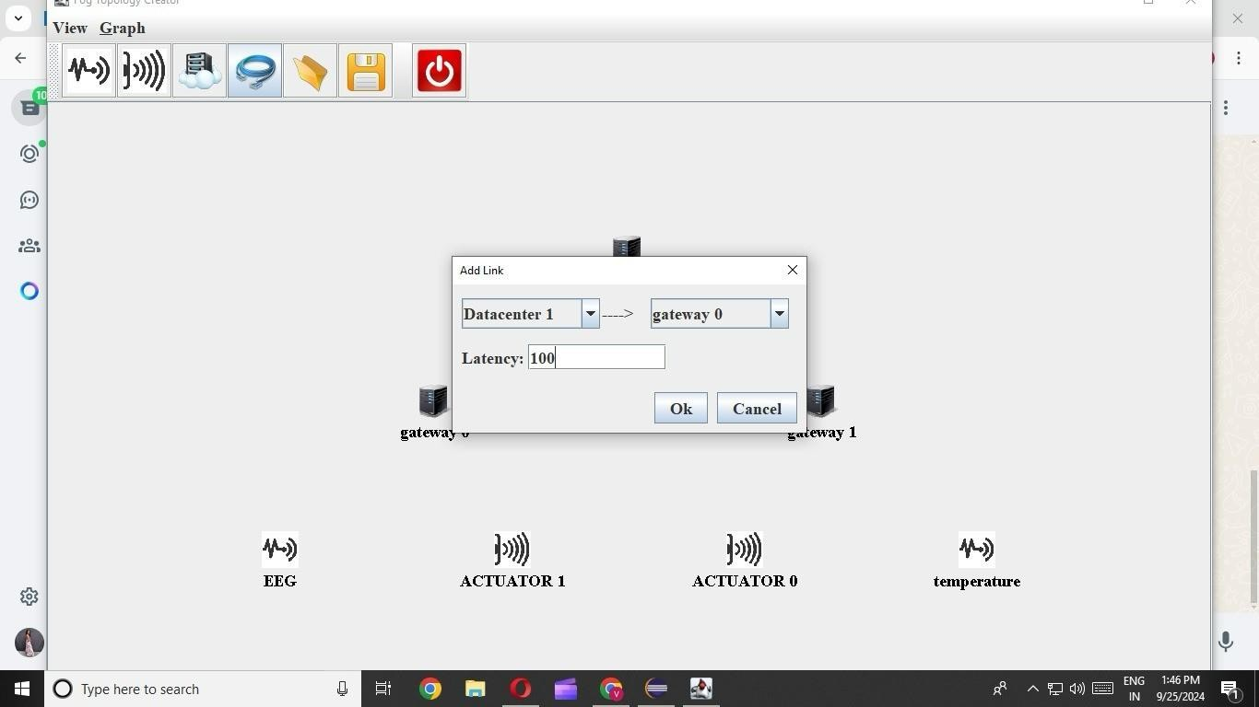

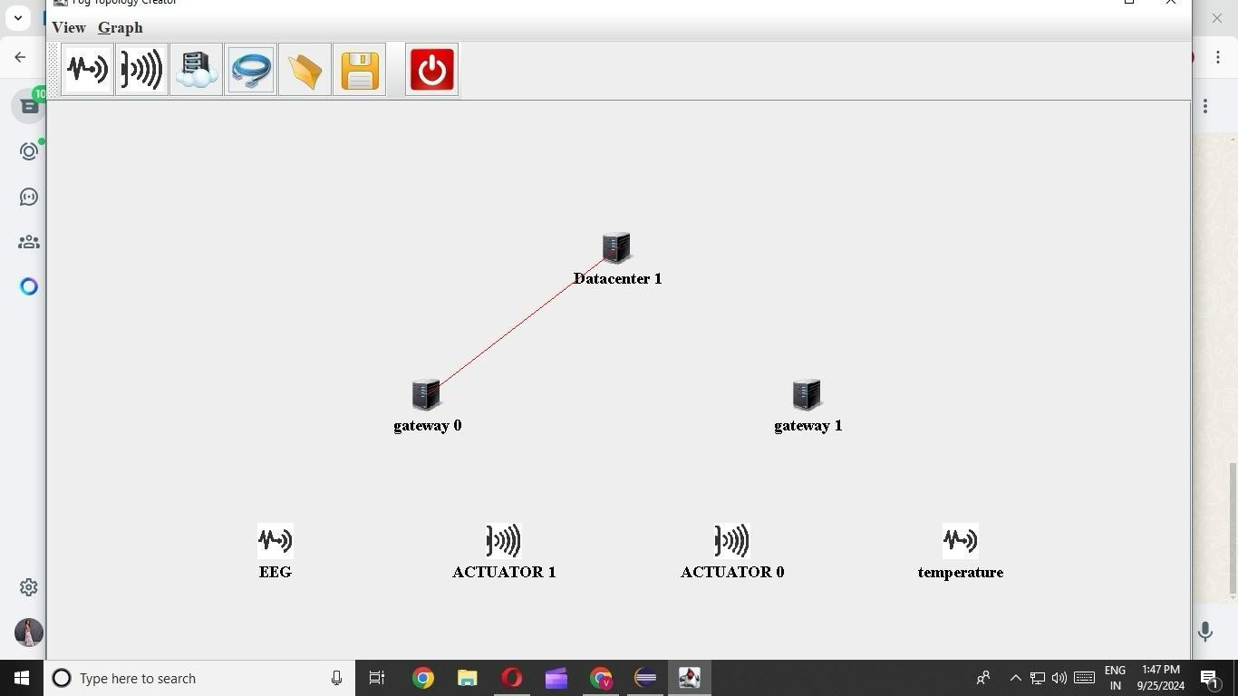**Step9) Continue linking**

Fog Architechture

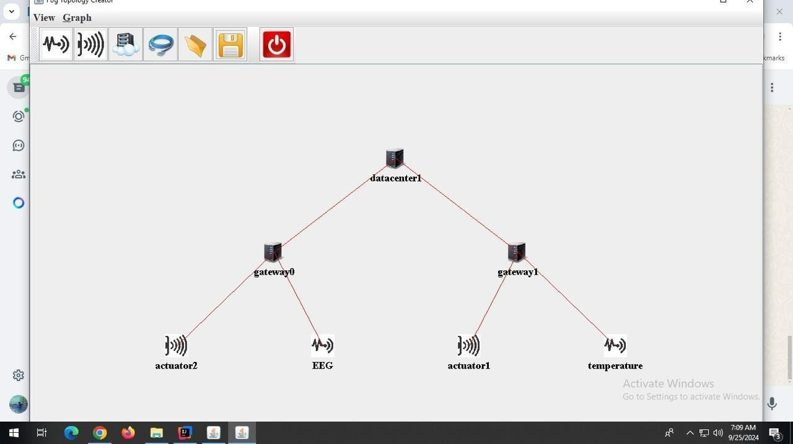

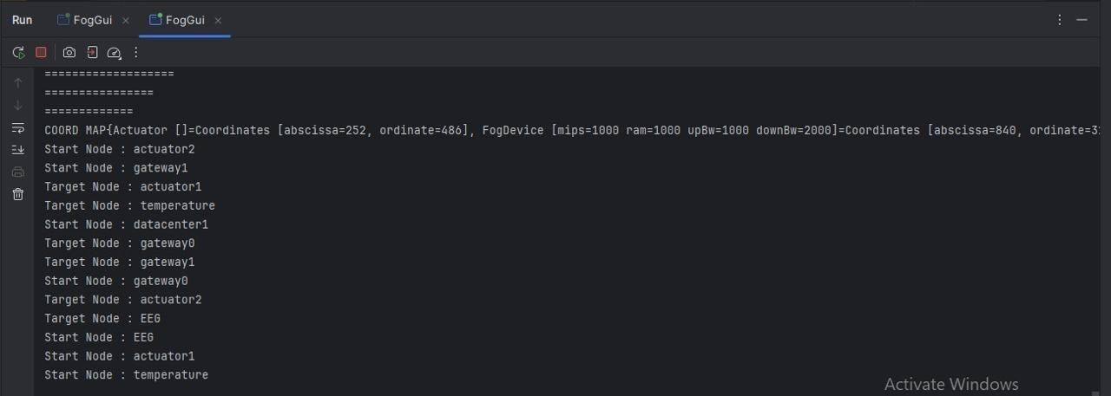Result:

**Conclusion** :

In this experiment, we successfully designed and deployed a fog computing architecture using the iFogSim simulator. The fog computing architecture bridges the gap between IoT devices and cloud computing by bringing data processing closer to the edge, reducing latency and improving performance. By configuring fog nodes, gateways, and actuators, we demonstrated how fog computing can efficiently handle large amounts of data generated by IoT devices in real-time, while maintaining scalability and minimizing reliance on cloud resources. This architecture provides a practical solution to address challenges like network breakdowns and latency in IoT systems.