Aim : Study on Healthcare in IoT using ifogsim Theory:

The history of human development has proven that medical and healthcare applications for

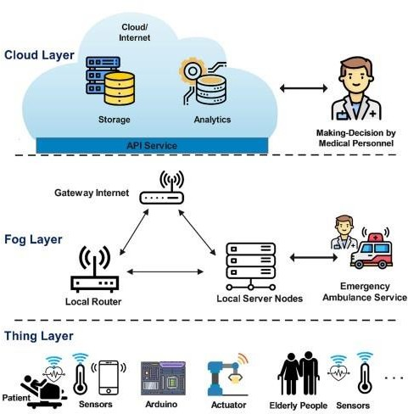humanity always are the main driving force behind the development of science and technology. The advent of Cloud technology for the first time allows providing systems infrastructure as a service, platform as a service and software as a service. Cloud technology has dominated healthcare information systems for decades now. However, one limitation of cloud-based applications is the high service response time. In some emergency scenarios, the control and monitoring of patient status, decision-making with related resources are limited such as hospital, ambulance, doctor, medical conditions in seconds and has a direct impact on the life of patients. To solve these challenges, optimal computing technologies have been proposed such as cloud computing, edge computing, and fog computing technologies. In this article, we make a comparison between computing technologies. Then, we present a common architectural framework based on fog computing for Internet of Health Things (Fog-IoHT) applications. Besides, we also indicate possible applications and challenges in integrating fog computing into IoT Healthcare applications. The analysis results indicated that there is huge potential for IoHT applications based on fog computing. We hope, this study will be an important guide for the future development of fog-based Healthcare IoT applications.

The robust increase of Cloud-based healthcare IoT applications leads to the consumption of amount huge energy. According to energy efficiency direction proposed a fog computing-based architecture for healthcare IoT applications to saving and optimise energy consumption. Specifically, they proposed an efficient energy fog-based computing model, called EEFC to optimize the location and number of fog servers at the edge layer. Experiment results demonstrated the efficiency of the proposed solution compared to existing cloud-based solutions when it saving energy up to 36% and 52%, respectively with low and high data speed scenarios. Cloud-based IoT applications have been successfully deployed in the last decade, however,demonstrated that existing IoHT applications based on the cloud have limited scalability and high service response time. To solve these challenges, the authors proposed a novel IoHT architecture based on fog computing and deep learning to real-time analysis and diagnostic for heart patients. Simulation results indicated that the proposed framework improved in terms of energy consumption, bandwidth, accuracy, delay, and execution time in different fog-based IoHT scenarios. The integration of fog computing into healthcare IoT applications aim to make these real-time eHealth applications is the inevitable trend. However, the breakout of IoT devices will lead to overload. To solve this problem, an efficient offloading schema for fog servers in real-time eHealth systems. Specifically, they consider the offloading problem as multi- stage stochastic programming that aims to minimize the total delay to determine the optimal offload plan based on system resources. Experiment results indicated that the proposed solution can rapid be led to the approximate optimal results.l results. For the purpose design a privacy and security healthcare IoT system to diagnostic accuracy diabetic and cardio disease, Shynu et al. [46] proposed an integrated solution between healthcare IoT application, blockchain and fog computing technologies. Specifically, sensors will collect patient data and storage on the blockchain. Then the patient health records will be grouped, and finally, an adaptive neuro fuzzy inference system is used for making-decision diagnostic based on fog computing. Experiment results indicated that the efficiency of the proposed solution when it improved accurate diagnosis rate up to 81% compared to existing solutions.

**Procedure:**

**Step 1: Open ifogsimulator**



**Step 2 :** Open examples of cardiovascular from iFog.jar file

**Step3) Exicute that file**

**Conclusion :**

In this experiment, we explored the application of fog computing in healthcare IoT using the iFogSim simulator. By simulating a cardiovascular healthcare scenario, we demonstrated how fog computing can address the limitations of cloud-based healthcare systems, such as high latency and energy consumption. The experiment showed that fog computing provides quicker response times and energy-efficient solutions, crucial for real-time health monitoring and decision-making in critical situations. This integration of fog computing into IoT healthcare applications presents a promising approach for improving patient care and system efficiency, making it a vital trend for future healthcare systems.