**#This File is written by Sayali Jadhav**

**1)What is a package manager in Linux?**

In simpler words, a package manager is a tool that allows users to install, remove, upgrade, configure and manage software packages on an operating system. The package manager can be a graphical application like a software center or a command lines tool like apt-get or Pacman.

You’ll often find me using the term ‘package’ in tutorials and articles, To understand package manager, you must understand what a package is.

**2)What is a package?**

A package is usually referred to as an application but it could be a GUI application, command line tool, or a software library (required by other software programs). A package is essentially an archive file containing the binary executable, configuration file, and sometimes information about the dependencies.

**3)Different kinds of package managers**

Based on the linux distro that you are using it will have a different package manager. Also a linux distro can have different package managers as well. Following is the list of linux distros and their respective package managers:

**Debian and ubuntu => apt  
CentOs and RHEL => yum, dnf**

**4)You have to install docker and Jenkins in your system from your terminal using package managers**

**I)To install Docker on Ubuntu, follow these steps:**

1.Install & Update the package index:

**sudo apt install  
sudo apt update**

2.Install Docker:

**sudo apt install docker.io**

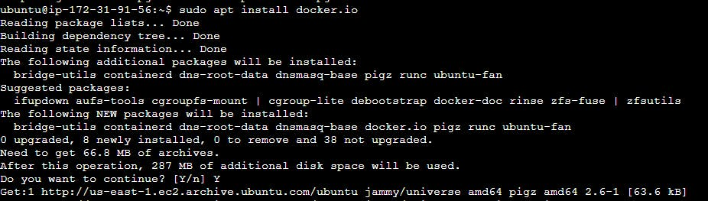

once installation starts; it asks if we want to continue; type ‘y’ and enter.

once installtion is done we can chcek by command ;docker — version.



**II)To install Jenkins on Ubuntu, follow these steps:**

Since Jenkins is written in Java, the first step is to install Java.

Update the package index:

**sudo apt update**

Install Jenkins:

**sudo apt install jenkins**

Start the Jenkins daemon:

**sudo systemctl start jenkins**

To enable the Jenkins daemon to start on boot:

**sudo systemctl enable jenkins**

**5)Difference in systemctl and systemd**

**systemd** is a system and service manager for Linux systems that provides many powerful features for managing processes and system resources. **systemctl** is a command-line utility that is used to control and manage the **systemd** system and service manager.

With **systemctl**, you can start, stop, and restart services, enable and disable them to start at boot, and check the status of services. You can also use **systemctl** to view and manage system logs, configure system startup and shutdown, and set system-wide environment variables.

**systemd** gives us the **systemctl** commands suite which is mostly used to enable services to start at boot time. We can also start, stop, reload, restart and check status of services with the help of **systemctl ; Whileas service** command is a wrapper script that allows system administrators to start, stop, and check the status of services without worrying too much about the actual init system being used.