**Day10:Advance Git & GitHub for DevOps Engineers.**

**Git Branching**

Use a branch to isolate development work without affecting other branches in the repository. Each repository has one default branch and can have multiple other branches. You can merge a branch into another branch using a pull request.

Branches allow you to develop features, fix bugs, or safely experiment with new ideas in a contained area of your repository.

**Git Revert and Reset**

Two commonly used tools that git users will encounter are git reset and git revert. The benefit of both of these commands is that you can use them to remove or edit changes you’ve made in the code in previous commits.

**Git Rebase and Merge**

**What Is Git Rebase?**

Git rebase is a command that lets users integrate changes from one branch to another, and the logs are modified once the action is complete. Git rebase was developed to overcome merging’s shortcomings, specifically regarding logs.

**What Is Git Merge?**

Git merge is a command that allows developers to merge Git branches while the logs of commits on branches remain intact.

The merge wording can be confusing because we have two methods of merging branches, and one of those ways is actually called “merge,” even though both procedures do essentially the same thing.

**Task 1:**

**1.Add a text file called version01.txt inside the Devops/Git/ with “This is first feature of our application” written inside. This should be in a branch coming from** **master, [hint try** **git checkout -b dev], swithch to** **dev** **branch ( Make sure your commit message will reflect as "Added new feature"). [Hint use your knowledge of creating branches and Git commit command]**

**version01.txt should reflect at local repo first followed by Remote repo for review. [Hint use your knowledge of Git push and git pull commands here]**

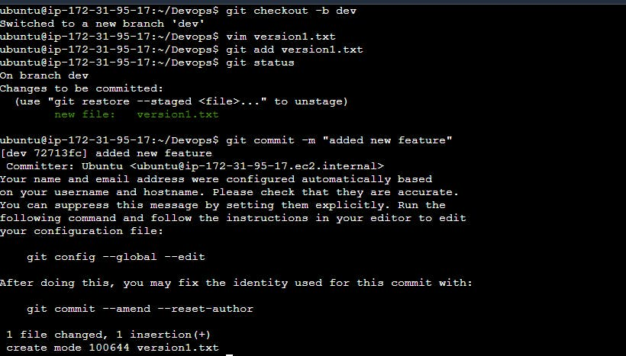

**2.Add new commit in** **dev** **branch after adding below mentioned content in Devops/Git/version01.txt: While writing the file make sure you write these lines**

Doing changes in the file version01.txt

1st line>> This is the bug fix in development branch

Commit this with message “Added feature2 in development branch”

Doing changes in the file version01.txt

2nd line>> This is gadbad code

Commit this with message “Added feature3 in development branch”

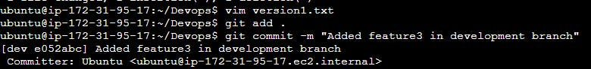

Doing changes in the file version01.txt

3rd line>> This feature will gadbad everything from now

Commit with message “ Added feature4 in development branch

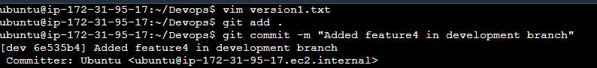

Checking “git log”

Restoring the file to a previous version where the content should be “This is the bug fix in development branch”

git reset id [refer the commit msg for the id ]

**Task 2:**

**Demonstrate the concept of branches with 2 or more branches with screenshot.**

Each task has one seperate branch. Finally, merge all branches. Useful when you want to work parellely.Can create one branch based on another branch. Changes are personal to that particular branch. The default branch is '**Master**'.

The file created in the workspace will be visible in any of the branch workspaces until you commit. Once you commit, then that file belongs to that particular branch.

**add some changes to** **dev** **branch and merge that branch in** **master**

we created a new branch, modified the files, committed message, push the branch.

**As a practice try git rebase too, see what difference you get.**

Create some changes into new_file.txt

git add .

git commit -m

git log --oneline

git rebase dev_branch

Now we have successfully rebased to the master branch.