**#This File is Written by Sayali Jadhav**

**Day13**: **Getting started with Python**

**What is Python?**

* Python is Open source, general purpose, high-level, and object-oriented programming language.
* Guido van Rossum developed Python
* Python consists of vast libraries and various frameworks like Django, TensorFlow, Flask, Pandas, Keras, etc.

**How to Install Python?**

You can install Python in your System whether it is window, MacOS, ubuntu, centos etc. Below are the links for the installation:

[Windows Installation](https://www.python.org/downloads/)

Ubuntu: apt-get install python3.6

**Task1:**

**1. Install Python in your respective OS and check the version.**

Follow the installation steps for an ubuntu machine.

1)sudo apt-get update

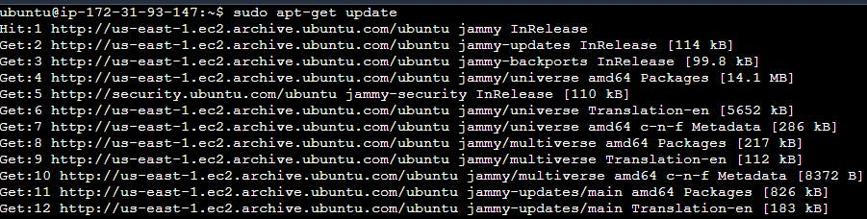

1. sudo apt-get install python3.

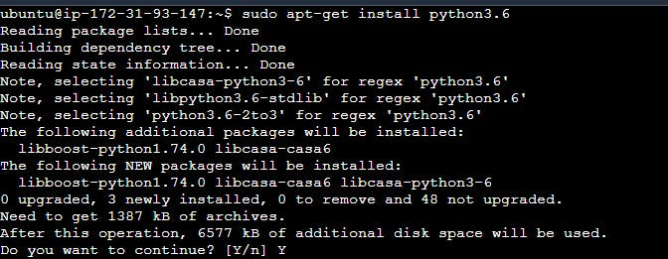

3)sudo apt install python3-pip

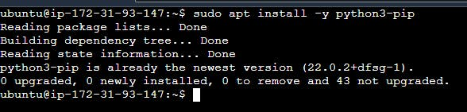

4)python3 --version



Now you have successfully installed Python on your ubuntu machine.

**2. Read about different Data Types in Python.**

**1. Numeric Data Type**

* **Numeric data types**: *int, float, long, complex*
* Python numeric data type is used to hold numeric values like;
  1. int - holds signed integers of non-limited length. ex=10
  2. long- holds long integers (exists in Python 2.x, deprecated in Python 3.x).
  3. float- holds floating precision numbers and it’s accurate up to 15 decimal places. ex=15.25
  4. complex- holds complex numbers. ex=100+3j

**2. Python String Data Type: Str**

The string is a sequence of characters. Python supports Unicode characters. Generally, strings are represented by either single or double quotes.

For example,

a = "string in a double quote"

b= 'string in a single quote'

print(a) print(b)

**3. Python List Data Type:**

Lists are just like arrays, declared in other languages which is an ordered collection of data. It is very flexible as the items in a list do not need to be of the same type. Lists are mutable.

Lists in Python can be created by just placing the sequence inside the square brackets [].

For example,

1)list of having only integers

a= [1,2,3,4,5,6] print(a)

2)list of having only strings

b=["hello","sayali","tom"] print(b)

**4. Python Tuple:**

The tuple is another data type which is a sequence of data like a list. But it is immutable. That means data in a tuple is write-protected. Data in a tuple is written using parenthesis ( ) and commas.

For example,

#tuple having multiple type of data.

b=("hello", 1,2,3,"go")

print(b) #prints the whole tuple

**5. Python Dictionary:**

Python Dictionary is an unordered sequence of data of key-value pair form. It is similar to the hash table type. Dictionaries are written within curly braces in the form key: value. It is very useful to retrieve data in an optimized way among a large amount of data.

For example,

a = {1:"first name",2:"last name", "age":33}