#This File is written by Sayali Jadhav

**Day 14: Python Data Types and Data Structures**

**Data Types**

* Data types are the classification or categorization of data items. It represents the kind of value that tells what operations can be performed on a particular data.
* Since everything is an object in Python programming, data types are classes and variables are instances (objects) of these classes.
* Python has the following data types built-in by default: Numeric (Integer, complex, float), Sequential(string, lists, tuples), Boolean, Set, Dictionaries, etc

To check what is the data type of the variable used, we can simply write:your_variable=100 type(your_variable)

**Data Structures**

Data Structures are a way of organizing data so that it can be accessed more efficiently depending on the situation. Data Structures are fundamentals of any programming language around which a program is built. Python helps to learn the fundamental of these data structures more simply as compared to other programming languages.

* Lists: Python Lists are just like arrays, declared in other languages which is an ordered collection of data. It is very flexible as the items in a list do not need to be of the same type.
* Tuple: Python Tuple is a collection of Python objects much like a list but Tuples are immutable in nature i.e. the elements in the tuple cannot be added or removed once created. Just like a List, a Tuple can also contain elements of various types.
* Dictionary: Python dictionary is like hash tables in any other language with the time complexity of O(1). It is an unordered collection of data values, used to store data values like a map, which, unlike other Data Types that hold only a single value as an element, a Dictionary holds the key: value pair. Key-value is provided in the dictionary to make it more optimized.

**Tasks**

**1)Give the Difference between List, Tuple, and set. Do Handson and put screenshots as per your understanding.**

**List**

Lists are used to store multiple items in a single variable. Lists are one of 4 built-in data types in Python used to store collections of data. List items are ordered, changeable, and allow duplicate values. List items are indexed, the first item has an index [0], the second item has an index [1] etc.

**For example,**

List of having only strings

b=["hello","john","reese"]

print(b)

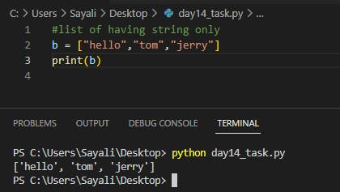

**Tuple**

Tuples are used to store multiple items in a single variable. Tuple is one of 4 built-in data types in Python used to store collections of data. A tuple is a collection that is ordered and **unchangeable**. Tuples are written with round brackets.

**For example**

#tuple having multiple type of data.

b=["hello", 1,2,3,"sayali"]

print(b)

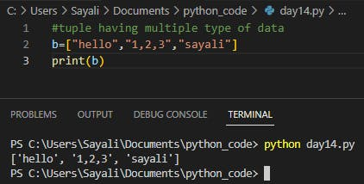

**Set**

Python Set is the unordered collection of the data type. It may change after creation and has unique elements. In a set, the order of the elements is undefined; it may return the changed sequence of the element. The set is created by using a built-in function **set(),** or a sequence of elements is passed in the curly braces and separated by the comma.

**For example,**

set1={1,2,3,4,5}

print(set1)

set2={2,4,6,8,4}

print(set2)

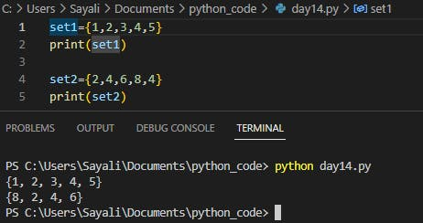

**2. Create the below Dictionary and use Dictionary methods to print your favorite tool just by using the keys of the Dictionary.**

fav_tools = { 1:"Linux", 2:"Git", 3:"Docker", 4:"Kubernetes", 5:"Terraform", 6:"Ansible", 7:"Chef" }

**3. Create a List of cloud service providers**

eg. cloud_providers = ["AWS","GCP","Azure"]

**Write a program to add** Digital Ocean **to the list of cloud_providers and sort the list in alphabetical order.**

