#This File is written by Sayali Jadhav

**Day 15: Python Libraries for DevOps**

**Reading JSON and YAML in Python**

* As a DevOps Engineer, you should be able to parse files, be it txt, json, yaml, etc.
* You should know what all libraries one should use in Python for DevOps.
* Python has numerous libraries like os, sys, json, yaml etc that a DevOps Engineer uses in day-to-day tasks.

**Tasks**

**1)Create a Dictionary in Python and write it to a json File.**

To create a dictionary in Python and write it to a json file, you can use the json module:

**json.dumps()** : It is used to convert a dictionary to JSON string.

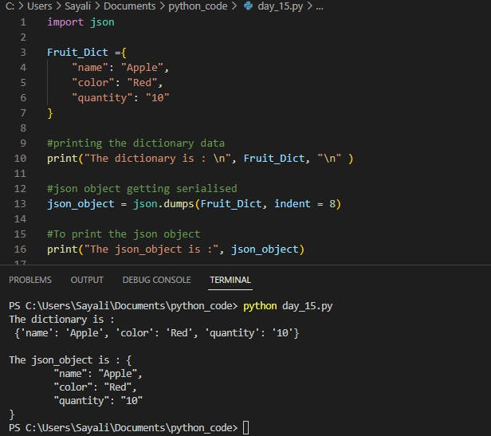

**2)Read a json file services.json kept in this folder and print the service names of every cloud service provider.**

**json.load():** json.load() accepts file object, parses the JSON data, populates a Python dictionary with the data and returns it back to you.

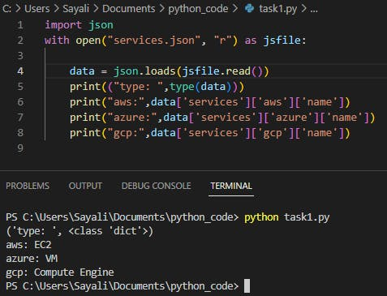

**3)Read the YAML file using python file “services.yaml” and read the contents to convert YAML to JSON**

We can **read the YAML file** using the **PyYAML** module’s **yaml.load()** function. This function parse and converts a YAML object to a Python dictionary (dict object).

To install the PyYAML module, you’ll need to run the pip command, which is the package installer for Python. below command installs the PyYAML module.

**pip install pyyaml**

below code read services.yaml file using python

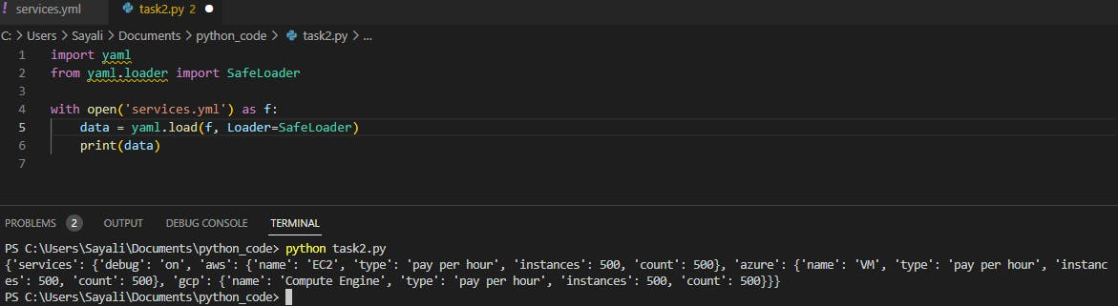

* First import yaml module using import statement
* Read the file using the open method
* safeloader method read the file content and converts it to a dictionary python object

**Convert yaml to json:**

**json.dumps()** function will convert a subset of Python objects into a json string.

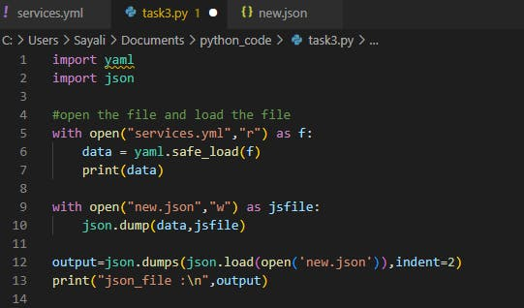

**output:**

