Game Design Document

Fill up the Following document

1. Write the title of your project.

Flying Bot

1. What is the goal of the game?

Flying up in the sky and reach to the sky(**GOAL**)

1. Write a brief story of your game?

There is bot and the mazes the bot wants to reach high up in the sky But he cant there are the mazes spawning from the up but he is confused to which maze he should jump can you help bot and there are his enemies also the monsters so you have to help bot and reach him to the and he is hungry also so also keep collecting food , food can increase the lives .**All the Best!!!**

1. Which are the playing characters of this game?

* Playing characters are the ones which respond to the user based on the input from the user
* Cars, monkeys, dinos, wizards etc, are the playing characters in the game.

|  |  |  |
| --- | --- | --- |
| Number | Character Name | What can this character do? |
| 1 | Bot | Eat the food when hungry |
| 2 |  |  |
| 3 |  |  |
| 4 |  |  |
| 5 |  |  |
| 6 |  |  |
| 7 |  |  |
| 8 |  |  |

1. Which are the Non Playing Characters of this game?

* Non Playing characters are the ones which don't have an action or a behaviour when the user interacts with the game.
* Hurdles, stones, bananas, coins, etc are non playing characters in the game.

|  |  |  |
| --- | --- | --- |
| Number | Character Name | What can this character do? |
| 1 | Monsters | Eat up the Bot |
| 2 | Mazes | Helps bot to reach the goal |
| 3 | Food | The bot eats food and get the health |
| 4 |  |  |
| 5 |  |  |
| 6 |  |  |
| 7 |  |  |
| 8 |  |  |

Draw your imagination of this game. What does this game look like?

* Draw the game either on your computer or on paper,
* Add images of scenes of the game to show each of the playing and non-playing characters at least once.

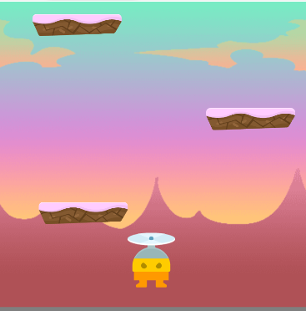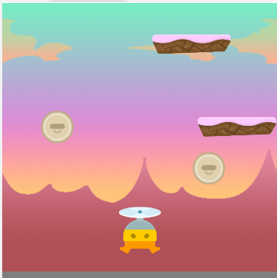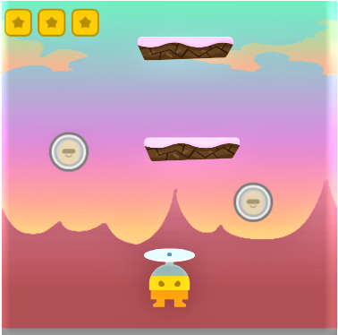

How do you plan to make your game engaging?

Player will be engaged in a way that he will be focusing the game as he in goes on increasing the score the speed of the mazes monsters and food will be increasing in a certain condition.